Guide to Completing an Event Risk Assessment
A risk assessment is a document used to identify potential hazards, assess the level of risk and outline control measures to reduce those risks. Common event risks may include:
- Extreme weather
- Slips, trips and falls
- Traffic and vehicle movement
- Electrical hazards
- Temporary structures
- Crowd management issues
- Fireworks and other high-risk activities
- Food safety
- Fire and gas safety risks
- Medical emergencies
- Manual handling
- Reputational or operational issues

Risk assessments must be documented and regularly reviewed throughout the planning and delivery of your event.

Step 1: Understand Your Event

Before identifying risks, consider the key details of your event:
- What activities will take place?
- How many people are expected to attend?
- Who will be attending (families, children, older adults, etc.)?
- Where will the event be held?
- What infrastructure, equipment or services will be used?
The size, location and nature of your event will influence the types of risks you need to consider

Step 2: Identify Potential Hazards
Think about anything that could cause injury, illness, property damage or disruption to the event. Consider all stages of the event, including bump in, event operations and bump out.
Step 3: Assess the Risks
For each hazard, consider:
- How likely is it to occur?
- What could happen if it does occur?
- Who could be affected?

Use the Risk Matrix to determine the risk rating and record the ratings in your risk assessment table. This will help you determine which risks require the most attention and control measures.
Tip: Focus on the hazards that are reasonably foreseeable for your event. A well-considered risk assessment does not eliminate all risk, but it helps ensure risks are identified, understood and managed appropriately.

Step 4: Identify Control Measures
Determine what actions can be taken to eliminate or reduce each risk. Examples include:
- Installing barriers around hazards
- Providing adequate lighting
- Developing a traffic management plan
- Engaging qualified contractors and checking their credentials
- Providing first aid services
- Monitoring weather conditions
- Ensuring staff and volunteers are appropriately trained
Controls should be practical, effective and appropriate for the event.
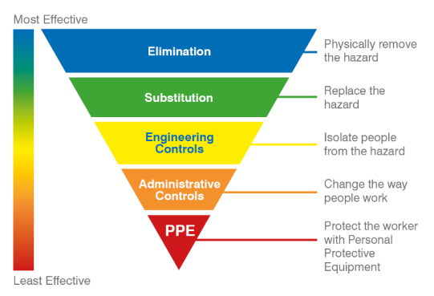
Step 5: Record the Assessment
Document each identified hazard, the associated risks, the risk ratings and the control measures that will be implemented. Each hazard should also have a designated responsible person who will ensure the controls are implemented.
Keeping a written record helps demonstrate that risks have been considered and provides a useful reference for staff, volunteers, contractors and stakeholders.

Step 6: Review and Update
Risk assessments should not be completed once and forgotten. Risk management is an ongoing process throughout the event lifecycle. Review and update the assessment:
- During event planning
- When event details change
- If new hazards are identified
- Following incidents or near misses
- Before the event begins

Event Risk Assessment - Template

Event Risk Management Process – Overview

RISK ASSESSMENT
IDENTIFY HAZARDS
Associated with the activities
IDENTIFY RISKS
Associated with each hazard
ANALYSE RISKS
Decide on the need to treat
TREAT RISKS
Introduce control measures
ESTABLISH THE CONTEXT
Purpose of the Risk Assessment
Stakeholders and Event Management
COMMUNICATE AND CONSULT
MONITOR AND REVIEW
Stakeholders and Event Management
EVALUATE RISKS
Identify existing process

Risk Matrix
 |  | Consequence
 |  | Negligible  Injuries or ailments not requiring medical treatment | Minor  Minor injury; First Aid Treatment case or short term medical intervention | Moderate  Serious injury causing hospitalisation or multiple medical treatment cases; short-term rehabilitation | Major  Life threatening or multiple serious injuries causing hospitalisation; significant impairment; long-term rehabilitation | Catastrophic  Death or multiple life threatening injuries; permanent disability
 |  | 1 | 2 | 3 | 4 | 5
Likelihood
Almost Certain  Expected to occur in most circumstances | A | Medium | Medium | High | Very High | Very High
Likely  Will probably occur in most circumstances | B | Medium | Medium | High | High | Very High
Possible  Should occur at some time | C | Low | Medium | Medium | High | High
Unlikely  Could occur at some time | D | Low | Low | Medium | Medium | High
Rare  May occur only in exceptional circumstances | E | Low | Low | Medium | Medium | Medium

SAMPLE ONLY – HAZARDS, CONTROLS AND RISK RATINGS MUST BE REVIEWED FOR EACH EVENT. ADD CONTENT TO SUIT YOUR EVENT

Name and position of persons who completed this risk assessment: | Date:

Category/Task/  Activity | Hazard  (What could happen) | Risk  Rating  (With no controls) | Hazard Controls  (List what you will do/put in place to reduce the risk) | Residual Risk  Rating  (Considering controls outlined) | Responsible Persons  (Who is responsible for ensuring the controls are in place?)
Example  Permits & Approvals | Venue permit application approval process is delayed.  Conditions of venue permit restrict format of activities.  Council POPE application approval process is delayed. | C3  MED | Contact venue and Council early in the planning process.  Commence application process for venue and POPE within required timeframes for permits.  Consultation with Council early in event planning to help inform event format and activities that will be allowed.  Required documentation sought in advance and prepared and provided in a timely manner.  Copies of permits printed and held with Event Manager and Site Manager. | E3  MED | Event Manager
Example  Onsite contractor management | Damage caused to the park grounds, assets or persons caused by suppliers work or vehicles. | D4  HIGH | Collect copies of suppliers JSA, SWMS, PLI and WorkCover Insurance where applicable.  Suppliers must complete a supplier induction ahead of arriving at the site which details all requirements of them while onsite, including site rules and vehicle movement.  Any licencing or competencies required to undertake works by parties will be reviewed and verified prior to works commencing. | E3  MED | Event Manager  Site Manager  Safety Officer

