Planning and Environment Act 1987

Wyndham Planning Scheme

Amendment C267wynd

Explanatory Report

Overview
Amendment C267wynd implements the Wyndham Industrial Land-Use Strategy (Wyndham City Council, 2025) (WILUS) in the Wyndham Planning Scheme by updating the Metropolitan Planning Strategy and local planning policy, inserting the WILUS as a background document, and inserting further strategic work that would further implement the WILUS in the future. The amendment will guide decision-making in relation to land-use and development proposals affecting Wyndham’s industrial zoned land.

Where you may inspect this amendment
The amendment can be inspected free of charge at the Wyndham City Council website at https://www.wyndham.vic.gov.au/services/building-planning/planning-scheme-amendments/current-planning-scheme-amendments
And/or
The amendment is available for public inspection, free of charge, during office hours at the following place:
Wyndham City Council, 45 Princes Highway, Werribee
The amendment can also be inspected free of charge at the Department of Transport and Planning website at planning.vic.gov.au/public-inspection or by contacting the office on 1800 789 386 to arrange a time to view the amendment documentation.

Details of the amendment

Who is the planning authority?
This amendment has been prepared by the Wyndham City Council, which is the planning authority for this amendment.
The amendment has been made at the request of Wyndham City Council.

Land affected by the amendment
The amendment applies to existing and future industrial zoned land within the City of Wyndham municipal boundary, indicated on Map 1.
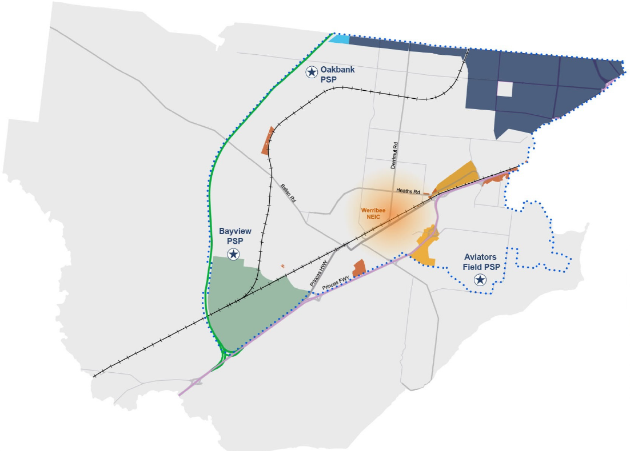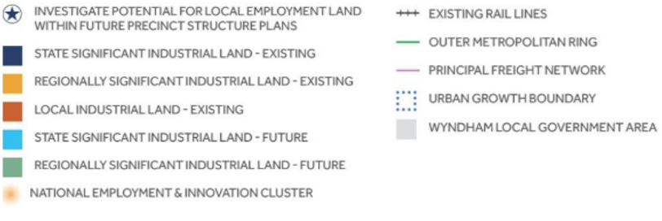
Map 1: Wyndham Industrial Land Strategy Framework Plan

What the amendment does
The amendment implements the Wyndham Industrial Land-Use Strategy (Wyndham City Council, 2025) (WILUS) by inserting new strategic directions and an industrial land strategy framework plan in Clauses 02.03 and 02.04 of the Municipal Planning Strategy, updating local policy in Clause 17.03-1L Industrial land supply, listing the WILUS as a background document in the Schedule to Clause 72.08 Background documents, and updating the Schedule to Clause 74.02 Further strategic work in the Wyndham Planning Scheme.
Specifically, the amendment makes the following ordinance changes to the Wyndham Planning Scheme.
- In Clause 02.03 Strategic directions:
  - Inserts context about, and strategic directions relating to, Wyndham’s industrial land and opportunities for economic growth and employment.
- In Clause 02.04 Strategic framework plan:
  - Inserts the Wyndham Industrial Strategy Framework Plan as Map 7.
- In Clause 17.03-1L Industrial land supply:
  - Deletes existing and inserts new strategies relating to the retention of industrial land use in industrial areas, preventing encroachment of inappropriate uses, and providing and improving transport options to support the provision of industrial land.
  - Includes the WILUS as a Policy document.
- In the Schedule to Clause 72.08 Background documents:
  - Inserts the Wyndham Industrial Land-Use Strategy (Wyndham City Council, 2025).
- In the Schedule to Clause 74.02 Further strategic work, inserts future actions for the council to further implement the WILUS, including to:
  - Prepare structure plans for the Hoppers Crossing, Point Cook and Laverton industrial precincts.
  - Develop new planning policies to guide decision-making for Section 2 uses in industrial precincts, promote the establishment of industries that offer high job density, and address the proliferation of non-industrial uses in the Industrial 3 Zone (IN3Z).
  - Review commercial zones currently applying to industrial areas and activity centres.
  - Investigate the provision of local employment land in the Aviators Field, Oakbank and Bayview PSPs.
Strategic assessment of the amendment

Why is the amendment required?
Adopted by Council on 25 October 2022, the WILUS is a strategic document that focuses on the use and development of industrial land over a 20-year period in Wyndham. The intent (vision) of the WILUS is that “Wyndham will provide serviced, accessible, and connected industrial land in appropriate locations to accommodate current and future demand and enhance employment and economic contributions both to Wyndham and Victoria. Our proactive approach to planning, together with our high amenity industrial areas designed with a focus on innovation and sustainability will attract a diverse range of industries and businesses.”
The amendment ensures that objectives of the WILUS are reflected appropriately in local policy in the Wyndham Planning Scheme.
The WILUS includes an implementation plan with the following objectives:
- To ensure that adequate industrial land will be provided for the next 20 years
- To protect core industrial areas from the encroachment of sensitive uses.
- To provide a planning framework which allows for clarity and certainty to attract more investments and employment to Wyndham
- To attract investment, support innovation and create jobs in Wyndham’s industrial areas.
- To enhance the appearance, environmental performance and connectivity of industrial areas in Wyndham.
- To ensure that the Wyndham Planning Scheme will reflect the changes recommended in this Strategy.
The intention of implementing the WILUS in the Wyndham Planning Scheme is to further facilitate and encourage the provision of appropriately located industrial land that is well serviced, suitably connected and easily accessible. Stronger planning policy will enable Wyndham to effectively plan for and accommodate growth within the region and encourage the economic and employment opportunities that industry provides. Furthermore, the inclusion of the WILUS as a background document will enable the strategic direction and objectives outlined in the WILUS to be considered.

How does the amendment implement the objectives of planning in Victoria?
The amendment supports objective 4(1)(a) of the Planning and Environment Act 1987 (PE Act) for planning in Victoria ‘to provide for the fair, orderly, economic and sustainable use, and development of land’ by providing local guidance on industrial land use in Wyndham.

How does the amendment address any environmental, social and economic effects?
The amendment will have no adverse environmental effects. The amendment could assist in the concentration of uses in preferred locations. It also makes planning for transport infrastructure and services more effective and reinforces rather than undermines preferred transport networks by encouraging the appropriate location of uses. The distribution of non-industrial uses into industrial precincts disperses activity in a manner that is counter-productive and will result in increased vehicular movements across the city adding to already significant levels of traffic congestion and emissions. The amendment could assist in alleviating this. Furthermore, the amendment will enable the better management, planning and protection of existing and future industrial land and will have a positive impact on job creation and diversity in the municipality.

Does the amendment address relevant bushfire risk?
No bushfire risk has been identified in relation to the amendment.

Does the amendment comply with the requirements of any Minister’s Direction applicable to the amendment?
Section 12(2)(a) of the PE Act requires that in preparing a planning scheme amendment, a planning authority must have regard to the Minister’s Directions. The following Minister’s directions are relevant to this amendment:
Ministerial Direction – The Form and Content of Planning Schemes
The amendment is consistent with the Ministerial Direction on the Form and Content of Planning Schemes under section 7(5) of the PE Act.
Ministerial Direction No. 11 Strategic Assessment of Amendments (MD 11)
The amendment has been prepared having regard to MD 11 and Planning Practice Note 46: Strategic Assessment Guidelines.
Ministerial Direction No. 15 The Planning Scheme Amendment Process (MD 15)
The amendment was prepared in accordance with MD 15 that seeks to set times for completing steps in the planning scheme amendment process.
Ministerial Direction No. 22 - Climate Change Consideration (MD 22)
MD 22, which specifies matters relating to climate change that a planning authority must have regard to in preparing a planning scheme amendment in accordance with Section 12(2A) of the PE Act, does not apply to the amendment. Per the transitional provisions in Section 230 of the PE Act, Section 12(2A) does not apply if the planning authority has given notice of the preparation of the amendment in accordance with Section 19 before Section 17 of the Climate Change and Energy Legislation Amendment (Renewable Energy and Storage Targets) Act 2024 came into operation (on 26 March 2025). Notice of the preparation of the amendment was given on 1 February 2024.

How does the amendment support or implement the Planning Policy Framework and any adopted State policy?
The amendment is consistent with the Planning Policy Framework as follows.
Clause 17.03-1S (Industrial land supply)

The amendment supports the objective to ensure availability of land for industry and assists in implementing the following strategies:

- Provide an adequate supply of industrial land in appropriate locations including sufficient stocks of large sites for strategic investment.
- Protect and carefully plan existing industrial areas to, where possible, facilitate further industrial development.
- Preserve locally significant industrial land for industrial or employment generating uses, unless long-term demand for these uses can be demonstrably met elsewhere.
- Avoid approving non-industrial land uses that will prejudice the availability of land in identified industrial areas for future industrial use.

Clause 17.03-2S (Sustainable industry)

The amendment supports the objective to facilitate the sustainable operation of industry and assists in implementing the following strategy:

- Protect industrial activity in industrial zones from the encroachment of commercial, residential and other sensitive uses that would adversely affect industry viability.

Clause 17.03-3S (State significant industrial land)

The amendment supports the objective to protect significant industrial land and assists in implementing the following strategy:

- Protect state significant industrial precincts from incompatible land uses to allow for future growth … [ including the] Western Industrial Precinct - Laverton North and Derrimut.

The amendment is also consistent with the Melbourne Industrial and Commercial Land Use Plan (MICLUP), which is listed in Clause 17.03-3S as a Policy document. MICLUP seeks to retain and protect land identified for strategic long-term growth for its intended purposes and ensure that industrial areas support their intended function and user needs. State Significant Industrial precincts provide strategically located land for major industrial development links to the Principal Freight Network and transport gateways. MICLUP outlines that they must be protected from incompatible land uses to allow for continual growth in freight, logistics and manufacturing investment.

Is the amendment consistent with the delivery of the relevant housing target set out in the Planning Policy Framework?
The amendment does not impact existing land available for housing in Wyndham. It inserts further strategic work to investigate the provision of local employment land in the Aviators Field, Oakbank and Bayview PSPs. Future planning processes will determine the location and extent employment, residential, and other land in these PSPs, and assess how each PSP will contribute to the delivery of Wyndham’s housing target.

If the planning scheme includes a Municipal Planning Strategy, how does the amendment support or implement the Municipal Planning Strategy?
This amendment is consistent with the vision and strategic directions at Clause 02 of the Wyndham Planning Scheme, in particular:
Clause 02.02 (Vision)
The amendment supports Wyndham City Council’s planning vision for a healthy, liveable city that:
- Is future-focused and plans for sustainable development.
- Consists of connected, vibrant neighbourhoods that provide for the cultural, social, economic and recreational needs of the community.
Clause 02.03-1 (Settlement)
This amendment supports the strategic directions around land use and development in urban growth areas, in particular:
- Protect industrial and residential activities from encroaching on each other.
- Providing jobs closer to where people live especially in the new employment corridor.
Clause 02.03-7 (Economic development – Industry)
The amendment updates Clause 02.03-7 to reference and align with the WILUS.
Clause 02.04 (Strategic framework plan)
The amendment updates clause 02.04 with the addition of Map 7 – Wyndham Industrial Precincts.

Does the amendment make proper use of the Victoria Planning Provisions?
Updating the Schedule to Clause 72.08 (Background documents) to include the WILUS is the appropriate mechanism to ensure that the WILUS is a background document in the Wyndham Planning Scheme.

How does the amendment address the views of any relevant agency?
The Department of Energy, Environment and Climate Action, Melton City Council and Hobsons Bay City Council made submissions which either supported or did not object to the amendment.

Does the amendment address relevant requirements of the Transport Integration Act 2010?
As the amendment is not anticipated to have a significant impact on the transport system, no further assessment is required.

How does the amendment have regard to the principles set out in the Yarra River Protection (Wilip-gin Birrarung murron) Act 2017 in relation to Yarra River land and other land, the use of development of which may affect Yarra River land?
The amendment does not affect Yarra River land or change planning provisions for other land in a manner that may affect Yarra River land. Therefore, the amendment does not consider the principles in Part 2 of the Yarra River Protection (Wilip-gin Birrarung murron) Act 2017.

Resource and administrative costs

What impact will the new planning provisions have on the resource and administrative costs of the responsible authority?
The amendment will have minimal impact on Council’s resource and administrative costs. It is not expected to increase the number of planning applications within the municipality to a significant extent. No additional staff resources will be required because of the implementation of this amendment.

