2





**EARLY YEARS SNAPSHOT**

**QUARTER 2 | APRIL TO JUNE 2024**

# Wyndham’s Predicted Population for births, three-year-olds and four-year- olds over the next five (5) years

|  |  |  |  |  |  |  |
| --- | --- | --- | --- | --- | --- | --- |
| SUBURB | AGE | 2024 | 2025 | 2026 | 2027 | 2028 |
| Werribee | 0yo | 775 | 792 | 807 | 825 | 880 |
| 3yo | 911 | 859 | 892 | 906 | 956 |
| 4yo | 892 | 935 | 890 | 921 | 968 |
| Hoppers Crossing | 0yo | 495 | 488 | 484 | 479 | 474 |
| 3yo | 396 | 466 | 449 | 447 | 442 |
| 4yo | 432 | 394 | 455 | 441 | 438 |
| Point Cook | 0yo | 1,227 | 1,212 | 1,201 | 1,197 | 1,193 |
| 3yo | 1,079 | 1,258 | 1,214 | 1,211 | 1,204 |
| 4yo | 1,132 | 1,103 | 1,258 | 1,223 | 1,220 |
| Tarneit | 0yo | 1,377 | 1,461 | 1,546 | 1,628 | 1,711 |
| 3yo | 1,399 | 1,527 | 1,606 | 1,695 | 1,778 |
| 4yo | 1,391 | 1,469 | 1,588 | 1,668 | 1,756 |
| Truganina / Williams Landing | 0yo | 1,175 | 1,197 | 1,199 | 1,188 | 1,181 |
| 3yo | 1,187 | 1,221 | 1,233 | 1,226 | 1,219 |
| 4yo | 1,163 | 1,199 | 1,217 | 1,220 | 1,215 |
| Wyndham Vale | 0yo | 547 | 581 | 616 | 652 | 681 |
| 3yo | 441 | 515 | 538 | 569 | 597 |
| 4yo | 437 | 444 | 512 | 534 | 561 |
| Manor Lakes * | 0yo | 339 | 392 | 453 | 497 | 528 |
| 3yo | 303 | 391 | 441 | 489 | 526 |
| 4yo | 333 | 343 | 432 | 473 | 512 |
| Little River | 0yo | 6 | 9 | 14 | 21 | 31 |
| 3yo | 2 | 8 | 13 | 19 | 29 |
| 4yo | 3 | 4 | 12 | 18 | 26 |
| Total | 0yo | 5,941 | 6,132 | 6,320 | 6,487 | 6,679 |
| 3yo | 5,718 | 6,245 | 6,386 | 6,562 | 6,751 |
| 4yo | 5,783 | 5,891 | 6,364 | 6,498 | 6,696 |

Source: id. Forecast as at January 2024 Update

* Population for Mambourin is captured in Manor Lakes.

**Current number of early years services in Wyndham**

|  |  |  |  |  |  |  |  |
| --- | --- | --- | --- | --- | --- | --- | --- |
| NUMBER OF APPROVED NQF SERVICES IN Q2 2024 | | | | | | PERCENTAGE CHANGE FROM LAST QUARTER | |
| Childcare (Long Day Care) & |  |  | 106 |  |  | 6% | (up from 102) |
| 32  Kindergarten (Standalone) |  |  |  |  |  | 0% %%%%%%%%%%% | (no change) |
| Kindergarten on School Site |  | 11 |  |  |  | 0% %%%%%%%%%%% | (no change) |
| Out of School Hours Care $ | 52 |  |  |  |  | -6% %%%%%%%%%% | (down from 55) |
| 28  Family Day Care |  |  |  |  |  | 21% %%%%%%%%%%% | (up from 23) |

0 25 50 75 100 125

**Current number of approved National Quality Framework (NQF) places by care type in Wyndham**

|  |  |  |  |  |  |  |  |
| --- | --- | --- | --- | --- | --- | --- | --- |
| NUMBER OF APPROVED NQF PLACES IN Q2 2024  (LICENCED CAPACITY) | | | | | | PERCENTAGE CHANGE FROM LAST QUARTER | |
| Childcare (Long Day Care) & |  |  | 12305 |  |  | 4% %%%%%%%%% | (up from 11745) |
| 2315  Kindergarten (Standalone) |  |  |  |  |  | 1% %%%%%%%%%%% | (up from 2282) |
| 849  Kindergarten on School Site |  |  |  |  |  | 4% %%%%%%%%%%% | (up from 816) |
| 5006  Out of School Hours Care $ |  |  |  |  |  | 3% %%%%%%%%%% | (up from 4835) |

0 1500 3000 4500 6000 // 12500

Source: [www.acecqa.gov.au/nqf/snapshots](http://www.acecqa.gov.au/nqf/snapshots)

& may include centres that offer additional early years services

$ includes services that offer Out of School Hours Care only

**Historical Data: Number of Childcare (Long Day Care) Centres per Suburb**

|  |  |  |  |  |  |  |  |  |  |  |  |
| --- | --- | --- | --- | --- | --- | --- | --- | --- | --- | --- | --- |
| SUBURB | 2014 | 2015 | 2016 | 2017 | 2018 | 2019 | 2020 | 2021 | 2022 | 2023 | 2024 (YTD) |
| Hoppers Crossing | 10 | 9 | 8 | 10 | 11 | 13 | 14 | 14 | 14 | 15 | 15 |
| Manor Lakes | 1 | 1 | 1 | 1 | 1 | 1 | 1 | 1 | 1 | 1 | 1 |
| Mount Cottrell | 0 | 0 | 0 | 0 | 0 | 0 | 0 | 0 | 0 | 1 | 1 |
| Point Cook | 12 | 14 | 15 | 16 | 17 | 20 | 22 | 24 | 24 | 24 | 24 |
| Tarneit | 6 | 7 | 8 | 11 | 11 | 11 | 13 | 14 | 15 | 20 | 20 |
| Truganina | 3 | 3 | 5 | 5 | 6 | 8 | 9 | 9 | 11 | 11 | 11 |
| Werribee | 8 | 8 | 9 | 10 | 10 | 10 | 12 | 12 | 14 | 17 | 18 |
| Williams Landing | 1 | 1 | 1 | 2 | 3 | 3 | 4 | 4 | 4 | 4 | 4 |
| Wyndham Vale | 1 | 1 | 1 | 3 | 4 | 5 | 7 | 7 | 9 | 9 | 12 |
| Total | 42 | 44 | 48 | 58 | 63 | 71 | 82 | 85 | 92 | 101 | 106 |

Source: [www.acecqa.gov.au/nqf/snapshots](http://www.acecqa.gov.au/nqf/snapshots)

**Pre School Support Provided by Wyndham City Council**

|  |  |
| --- | --- |
| SUPPORT TYPE | YEAR TO DATE |
| Number of 3- and 4-year-old funded kindergarten services supported by Wyndham City Council’s Pre School Field Officer Service | 142 services |
| Number of Requests for Support from Educators (council and non-council services) | 3-Year-Old: 100  4-Year-Old: 129 |

Source: Family & Sector Partnerships Team, Wyndham City Council

**Babies and Children Health provided by Wyndham City Council**

|  |  |
| --- | --- |
| BABIES | YEAR TO DATE |
| Number of Birth Notices received | 1308 birth notices |
| Number of Transfers of families moved into Wyndham Local Government Area | 280 children |
| Number of Transfers of families moved out of Wyndham Local Government Area | 266 children |
| Current MCH nurses across Universal and Enhanced team EFT* | 49.91 EFT |
| Number of Extra EFT of MCH nurses across Universal and Enhanced team required ** | 11.21 EFT |

Source: Family & Sector Partnerships Team, Wyndham City Council

Source: Family & Sector Partnerships Team, Wyndham City

*Current EFT is the number of EFT that was occupying posi for short-term acting roles. **Extra staff needed is the gap chart at the time.

Council

tions at that time, ignoring any instances where people may have vacated their role between the hours filled and the total hours across all approved positions in the org

*Current EFT is the number of EFT that was occupying positions at that time, ignoring any instances where people may have vacated their role for short- term acting roles.

**Extra staff needed is the gap between the hours filled and the total hours across all approved positions in the organisation chart at the time.

**New Sessional Kindergarten Services**

Opened in 2024

|  |  |  |  |
| --- | --- | --- | --- |
| SERVICE NAME | PROJECT TYPE | SUBURB | TOTAL LICENSED CAPACITY |
| Hoppers Crossing Children's Centre | Integrated Children's Centre | Hoppers Crossing | 99 |
| Wimba Primary School Kindergarten | Kindergarten on School Site | Tarneit | 66 |
| Warreen Primary School Kindergarten | Kindergarten on School Site | Truganina | 66 |
| Laa Yulta Primary School Kindergarten | Kindergarten on School Site | Mambourin | 99 |

**Known Future Sessional Kindergarten Services**

Proposed for 2025

|  |  |  |  |
| --- | --- | --- | --- |
| SERVICE NAME | PROJECT TYPE | SUBURB | TOTAL LICENSED CAPACITY |
| Lollypop Community Centre | Integrated Children’s Centre | Werribee | 99 |
| Truganina Community Centre | Integrated Children’s Centre | Truganina | 99 |
| Barayip Primary School Kindergarten | Kindergarten on School Site | Tarneit | 132 |

**Anticipated Future Early Years Services in Council’s Pipeline**

2026 and beyond

Please note: the below services are subject to change and do not include Kindergartens on School Sites delivered by the State Government

|  |  |
| --- | --- |
| SERVICE NAME | SUBURB |
| Manor Lakes Community Centre - Southern Hub | Manor Lakes |
| Jamieson Way Redevelopment | Point Cook |
| Point Cook Southwest | Point Cook |
| Riverdale Children's Centre | Tarneit |
| Riverdale Community Centre & Library | Tarneit |
| Tarneit North Community Centre & Library | Tarneit |
| Tarneit North Multi-Purpose Community Centre | Tarneit |
| Truganina Children's Centre | Truganina |
| Truganina Community Centre | Truganina |
| Bayview Children’s Centre | Werribee |
| Riverwalk Community Centre | Werribee |
| Wattle Village Multi-Purpose Community Centre | Werribee |
| Ballan Road Children's Centre | Wyndham Vale |
| Black Forest Road North Children's Centre | Wyndham Vale |
| Black Forest Road North Community Centre & Library | Wyndham Vale |
| Westbrook Children's Centre | Wyndham Vale |
| Westbrook Community Centre | Wyndham Vale |

# Wyndham Population

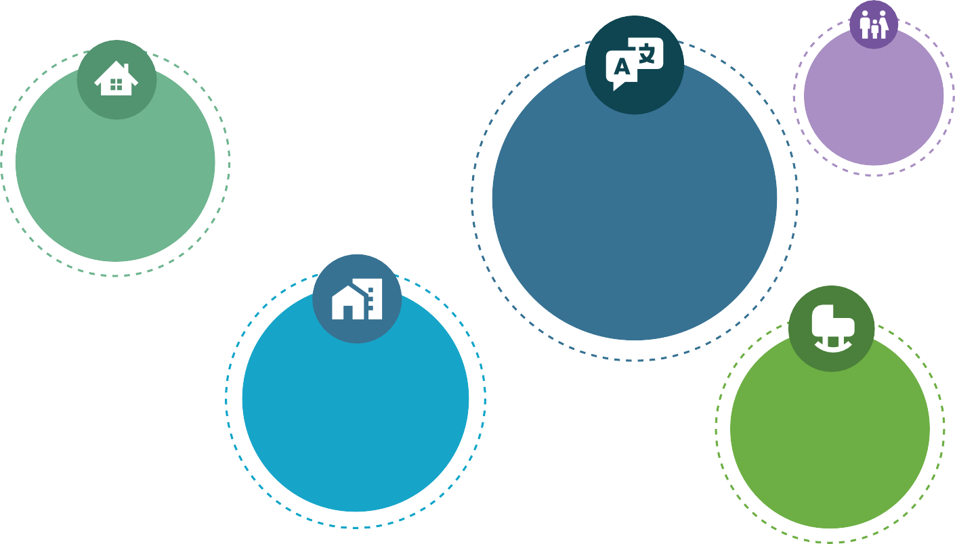

People

**31%**

FAMILIES WITH CHILDREN

**292,010**

CALLED **WYNDHAM HOME** IN 2021

**2,567**

**FIRST NATIONS PEOPLE** CALL WYNDHAM

HOME

**49.8% OF THE**

**POPULATIONS**

**PRIMARY LANGUAGE**

IS NON-ENGLISH, PRIMARILY PUNJABI, HINDI, MANDARIN, URDU

AND TELUGU

**48% OF THE**

**POPULATION**

WAS BORN OVERSEAS

**505,822**

PEOPLE ARE ESTIMATED TO CALL **WYNDHAM**

**HOME** BY 2040

**4.1%**

OF PEOPLE **LIVING WITH DISABILITY**

**12 %**

OF THOSE **BORN OVERSEAS** ARRIVED IN THE LAST

5 YEARS

Source: 2021 Census – abs.gov.au/census

Places & Spaces

**91%**

OF PEOPLE WHO OWN A CAR

**94,200**

HOUSEHOLDS IN

**WYNDHAM CITY COUNCIL**

**63%**

OF RESIDENTS EITHER FULL OWN OR ARE PURCHASING THEIR

HOME

**28%**

ARE RENTING PRIVATELY