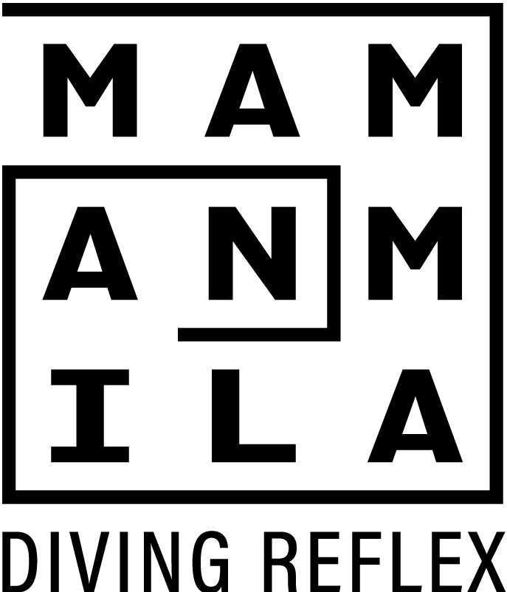

**Performer Agreement for**

**Workshops and Performances of “*Nightwalks with Teenagers*”**

### ART IS HARD

* I agree that *Nightwalks with Teenagers* will sometimes be hard work.
* I agree that making good art is hard work.
* I agree that sometimes I will feel exhilaratingly exhausted from all my hard work.

1. **ART IS CHALLENGING**

* I agree to have open conversations and that no topics are off-limits.
* I agree that if I’m unhappy or uncomfortable about a topic, I will let Mammalian know.
* I agree that sometimes things might get a bit energetic and wild.
* I agree that if I’m stressed out by things, I will let Mammalian know.
* I agree that we are making an adventurous walk in a public space with the public.
* I agree to respect my peers and their ideas, even if I don't always vibe with them.
* I agree to respect others boundaries.
* I agree to let Mammalian know if someone in the group is making me uncomfortable.
* I agree to not exclude my peers from anything and understand this show is a creation of everyone's shared ideas.
* I agree to interact with the public.
* I agree that if anything about the public stresses me out, I will let Mammalian know.

### I AM PART OF THE ART

* I agree that Mammalian will take photos but that I can ask for the images not to be shared publicly.
* I agree that the public might take my photo and I will have no control of those photos, which I accept since I am, after all, performing in public in a show for the public.

### I AM MY OWN BOSS

* I agree that, ultimately, I don’t have to do anything I don’t want to do.
* I agree that I can suggest we do anything I feel like doing.
* I agree that we all make the final call, and that my suggestions may be rejected and understand that rejection is a normal part of the creative process.
* I agree that I am free to drop out at any time, not a problem.

### ART IS AMAZING

* I agree that *Nightwalks with Teenagers* will be something I will probably remember for the rest of my life.

**Name of Performer**  ___________________________________________

Signature: ___________________________________________

Date: _________________________

On behalf **of Mammalian Diving Reflex:** ___________________________________________

Signature: ___________________________________________

Date: _________________________