

# Tarneit Community Learning Centre Activity Priorities Fact Sheet

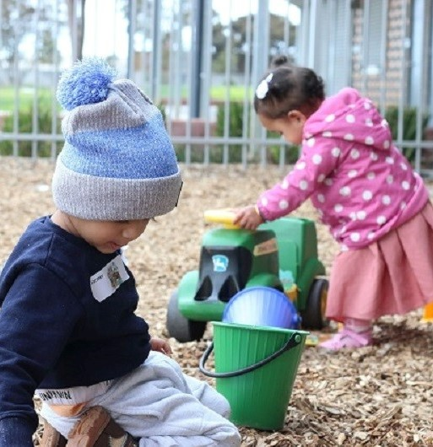Wyndham City works to ensure activities in community centres meet local needs and interests. With projected growth in population in the coming years, we are focussed on reaching out to new residents and communities who we haven’t met yet. Priorities for activities have been developed for each community centre based on local demographic data, what residents have told us is important to them along with an assessment of current activities.

|  |
| --- |
| **Who Lives in and Around Tarneit?** |

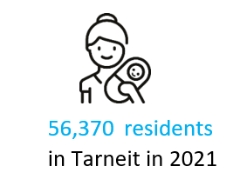

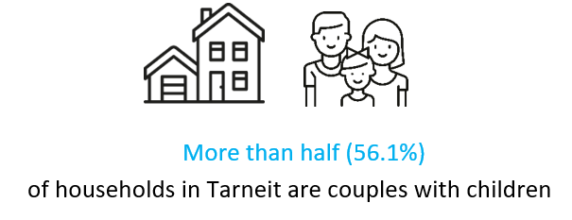



|  |  |
| --- | --- |
| **Tarneit Residents Value**   * Physical and Mental Wellbeing * Connecting socially * Education and opportunities to learn. * Having access to Local Support Services * Wyndham 2040   **What We’re Hearing…**   * Diversity is important to us, and we want to share and preserve our cultures and learn from each other. * I want to build up my skills and need help with employment. * I want to attend activities that support my health and wellbeing. * I want to connect with others socially. * Sometimes we need support to help us with managing the cost of living. | **Neighbourhood Activity Priorities for 2025**   * Programs and events that promote friendships, connections, sharing culture and social inclusion for locals. * Inclusive and diverse range of activities that offer access to education and lifelong learning opportunities for all ages and abilities. * Opportunities for local support to encourage positive mental and physical wellbeing. * Opportunities for services that provide emergency relief and assistance. |

  
This information can be translated by contacting Translating and Interpreting Services on 131 450 and asking to be connected to Wyndham City on 1300 023 411