What is a home-based food business?

Home-based Food Businesses
A Guide to the Requirements
A home-based food business is any business associated with food for sale that is either stored, prepared, cooked or repackaged from home. There are many benefits of operating a home-based food business, however they are generally only suitable for small scale businesses, as residential kitchens are intended for domestic use and are not suitable for running large commercial businesses in.

Do I need to be registered?
If you are intending to operate a home-based food business, you must register with Council prior to operating and ensure you have approval from the Planning Department, Environmental Health Services and Building Services.

What Class is my food business?
Your food safety classification will depend on the type of food you are intending to produce and sell. It is important to consider all the products you will be looking to sell on your menu prior to lodging your application to Council as this information is required to make a proper assessment of your Class.

Some common examples of home-based food businesses and their classifications can be found in the table below:

Class | Types of food
Class 2 Preparation/handling of unpackaged potentially hazardous foods | - Catering/take-away business – ready-to-eat meals of rice, curries, meat dishes, noodles, vegetable dishes, soups, pastas.  - Cake business – cakes or baked goods containing custard, fresh cream, cut fruit or ganache etc. and need to be stored under refrigeration after preparation to be safe for consumption.  - Ice cream/soft serves.  - Cutting/preparing ingredients for a mobile or temporary food premises.

Class 3 Preparation/handling of unpackaged low risk foods OR sale of pre-packaged potentially hazardous foods OR baking of certain sweets and savory goods which can be stored out of temperature control for greater than 24 hours. | - Shelf stable baked goods – bread, biscuits, cupcakes, cakes, donuts, chocolate etc. that can be stored at room temperature.  - Repackaging dry goods – purchasing large quantities of dry goods such as lentils, flour, lollies, chocolates and spices and repackaging them into smaller quantities.  - Packaged foods that are not opened or handled and require temperature control.  - Coffee roasting, breweries, alcoholic drinks.  - Storage of packaged potentially hazardous or prepared foods that are packaged and will not be handled within the home-based business, intended to be sold from a mobile or temporary food stall.  - Certain baked sweet and savory foods that can be kept out of temperature control for greater than 24 hours. Examples:  - (i) uncooked and that may or may not contain dry nuts (whole or crushed), seeds, dry fruits, protein powder (or similar supplement), and other low risk ingredients; or  - (ii) after baking, are a low-risk food, including but not limited to cakes (including fruit cakes), cupcakes (with or without icing), bread, biscuits, crackers, muffins, croissants, and other pastry where all the ingredients are cooked; and  - (iii) have no potentially hazardous foods added to the product after baking (e.g. fresh cream, custard).
Class 3A  Producing packaged foods that use a cook-fill process such as chutney, salsa, relish, and tomato sauce. | - Food made using a hot-fill process resulting in a product such as chutney, relish, salsa, tomato sauce or any other similar food, that:  (i) has been heat treated to a temperature of not less than 85°C and then filled and sealed hot into its packaging; and  (ii) is acidic (pH of less than 4.6); and  (iii) has salt or sugar or any other preservative added.
Class 4  Pre-packaged low risk food | - Packaged shelf stable foods that are not opened or handled before being sold such as lollies, spices, lentils and teas.

Do I need a Food Safety Supervisor Certificate?
You will need to complete Food Safety Supervisor training if your food business falls into the Class Class 2 or Class 3A category; depending on the type of food sector your business falls under, you will need to complete the correlating training:
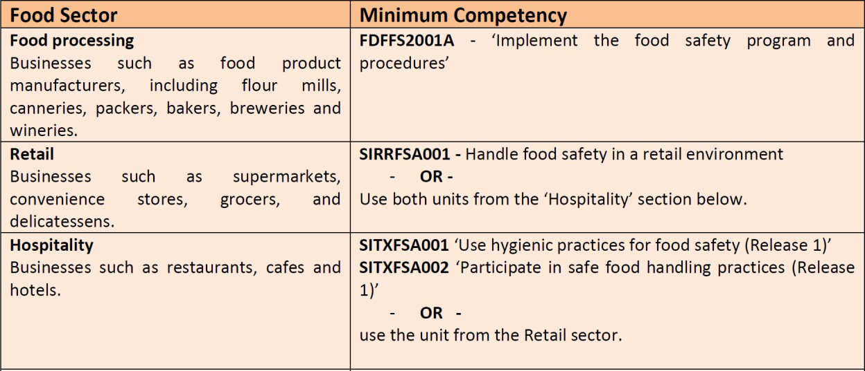

What are the fit-out requirements?
The fit-out requirements of a home-based food business varies depending on your Class. Hence why it is important to consider all the foods you are planning on selling before making changes to your kitchen. You are encouraged to submit a plans assessment application so that an Environmental Health Officer can thoroughly assess your plans prior to you conducting works, however this is not compulsory.

The minimum requirements for a home-based food business are as follows, however you will need to discuss your options with an Environmental Health Officer to establish which option is suitable for your business:

Class 2 – Minimum Requirements

Option 1: Double bowl sink (one side to be used for cleaning equipment and one side for sanitising) AND separate hand washing basin
Option 2: Single bowl sink AND a dishwasher AND a separate hand washing sink

Class 3 and 3A – Minimum Requirements

Option 1: Double bowl sink (one sink to be used for hand washing only and the other for washing equipment) AND a dishwasher for sanitising
Option 2: Double bowl sink for washing and sanitising equipment AND separate hand washing sink
Option 3: Single bowl sink AND a dishwasher AND a separate hand washing sink

Important Considerations:

- The handwashing basin must be within the immediate food handling area and cannot be a laundry or bathroom sink in a nearby room. It must be a minimum of 11L in capacity and be able to provide warm running water from a single spout, using a flick mixer to adjust the temperature.
- The dishwasher must be able to reach a minimum of 77 degrees Celsius or above in the wash cycle and all equipment must be able to fit in the dishwasher to be cleaned and sanitised
- You must have separate storage areas for ingredients and equipment for your business and personal use.

Do I need to submit plans?
As part of your application, you will be required to submit plans of your proposal. These do not need to be drawn by a draftsperson or an architect, however they will need to clearly demonstrate the proposed locations of all your fixtures and fittings and specify the materials/finishes used.

If you are planning on registering your existing domestic kitchen, it is helpful to provide photographs so that the Environmental Health Officer can determine if it is suitable and provide suggestions for where new fittings should be installed.

An example of a hand drawn plan using ‘Paint’ can be found at the end of this factsheet.

Do I need to provide food labels?
If you are preparing food that is not ‘ready-to-eat’ (i.e. take away meals or cakes) and intend for your product to stored and consumed at a later date (such as packaged frozen meals or packaged products) you may be required to provide ingredient and nutritional panel labelling. This may include conducting shelf-life testing to determine the use-by and best-before date of your product. Our Environmental Health Officers can to assist you with this process, however information on labelling requirements can
Be found at the following website: https://www.foodstandards.gov.au/industry/labelling/pages/default.aspx

Do I need a Streatrader Registration?
If you intend on selling any food from a Mobile Food Vehicle or Food Stall at an event, you will need a Streatrader Registration. You can apply for a Streatrader Registration here: https://streatrader.health.vic.gov.au/

Floor Plans

Example Plans:
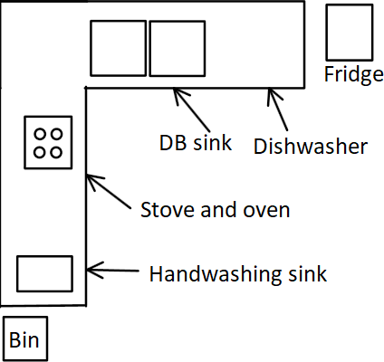

Example list of Finishes/Materials and Equipment:

- Benchtop material – Laminate
- Flooring – Tiles
- Walls – Painted with waterproof paint with glass splashback behind cooking equipment
- Sink – Stainless steel double-bowl sink with 1 mixer tap (depth 480mm, height 156mm, width 1135mm)
- Handwash basin – stainless steel 12.5L basin (depth 300mm, height 255, width 200mm)
- Dishwasher

If you have any photographs of your existing kitchen, you are encouraged to include them with your application.

For further information on Home Based Food businesses, please contact our Environmental Health Department on 9742 0738, mail@wyndham.vic.gov.au or visit
https://www.wyndham.vic.gov.au/services/local-laws-permits/laws-permits-businesses/operating- business/food-businesses-and

