Planning and Environment Act 1987

Wyndham PLANNING SCHEME

AMENDMENT C265wynd

EXPLANATORY REPORT

Who is the planning authority?
This amendment has been prepared by the Wyndham City Council, which is the planning authority for this amendment.
The amendment has been made at the request of Wyndham City Council.

Land affected by the amendment
The land affected by the amendment is within the Tarneit North PSP and within 400 m of future railway station sites and any future Principal Public Transport Network (PPTN).

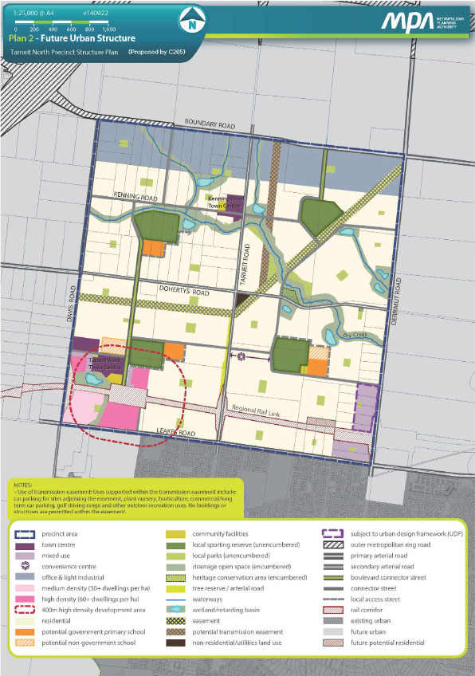
(Figure 1 –Tarneit North PSP – Affected Land)

What the amendment does
The amendment seeks to provide stronger guidance in the Tarneit North PSP to achieve density and housing diversity in the direct surrounds of the Tarneit West Local Town Centre and future Davis Road Railway Station.
Specifically, the amendment proposes to:

- Update Requirement 7 in the Tarneit North PSP.

Requirement 7 currently states:
"Development must appropriately respond to the existing railway station, potential future railway station sites, and future Principal Public Transport Network (PPTN) through the creation of opportunities for high density residential development."

Proposed wording of Requirement 7:
"Development within 400m of the existing railway station, potential future railway station sites, and any future Principal Public Transport Network (PPTN) must provide an appropriate response through the creation of opportunities for high density residential development, particularly stacked housing as defined in Table 1 and as described in the concept plans in Section 3.2.

Table 1 of Section 3.1.2 is reproduced below.
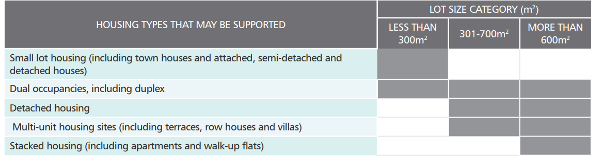

- Update plans 2 and 3 within the Tarneit North PSP
The amendment proposes to replace the existing Future Urban Structure Plan and Image, Character, Heritage, & Housing Plan (i.e. Plan 2 and Plan 3 in the Tarneit North PSP) with updated plans including the changes shown in Figure 2 below:

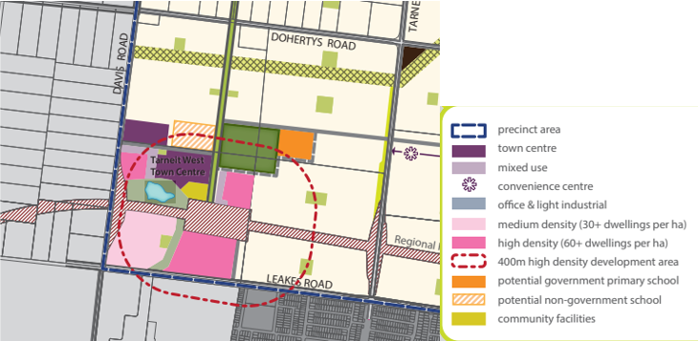
(Figure 2 – Detail of proposed changes to plans 2 & 3 - Tarneit North PSP)

- Amend Schedule 13 to Clause 37.07 (Urban Growth Zone)

The amendment proposes to revise Schedule 13 to the Urban Growth Zone to include an updated Plan 1 showing higher density areas within 400 m of the future Davis Road Railway Station (identical to Figure 2 above).

- Amend the Schedule to Clause 72.04 (Incorporated Documents)
The amendment proposes to introduce a revised schedule to Clause 72.04 to update the document date for the Tarneit North PSP to reflect the date of this amendment.

Strategic assessment of the amendment

Why is the amendment required?
The Tarneit North PSP was Gazetted in September 2014 (C141 Amended December 2014) and is a long-term plan for urban development. It describes how the land is expected to be developed and how and where services are planned to support development. The intent (vision) of the Tarneit North PSP is to retain and enhance the established and already existing attractive elements so that they are able to inform and direct the character and structure of this new and developing area and community. Furthermore, it is intended that “access to wider employment will be improved through additional major infrastructure in this area, including the Regional Rail Link and road improvements.”

The Amendment proposes to update the Tarneit North PSP to reflect an increase in density within 400 metres of the future Davis Road Railway Station. The State Government announced on 2 October 2022 that it will deliver a new Regional Rail Link train station at Tarneit West. This amendment is being sought as the current PSP's provisions on density are unclear and not in accordance with current PSP guidelines on density. Failure to deliver adequate density undermines clear State and local planning objectives to encourage higher density in town centres and railway stations and fails to capitalise on the significant public investment in the Regional Rail Link.

The Victorian Planning Authority (VPA) published a document in October 2021 titled ‘Precinct Structure Planning Guidelines: New Communities in Victoria’. This was an initiative of the Victorian Government aimed at ensuring that plans for places prepared by planning authorities and the VPA empower best practice and liveable new communities. It is noted that the overall “purpose of the Guidelines is to provide the framework for preparing Precinct Structure Plans (PSPs) that guarantee quality outcomes while also being flexible, responsive and supportive of innovation”. Achieving 20-minute neighbourhoods is a principle focus of Plan Melbourne 2017-2050, which promotes local living by facilitating attractive, safe and accessible local communities. The Guidelines draw from this 20-minute neighbourhood principle.

The guidelines specifically detail PSP Targets for viable densities. Target 1 (on page 39) of the Guidelines details that:

The PSP should facilitate increased densities with an average of 30 dwellings or more per Net Developable Hectare (NDHA) within:

- 400 m walkable catchment of an activity centre or train station

- 50 m of open space, (both credited and encumbered open space), boulevards and major public transport routes, including but not limited to the Principal Public Transport Network (PPTN) or similar.

Additionally, Target 3 (on page 39) of the Guidelines details that:

The PSP should facilitate increased housing diversity, with at least three distinct housing typologies to be included in higher density areas (defined by T1).

As the PSP currently stands it has no clear direction on density and does not align with the density or housing diversity requirements detailed in the PSP guidelines.

The proposed update to the PSP will ensure that the density requirements are aligned with the Guidelines and allow Council to require increased density and diversity of development within 400 m of the proposed Davis Road Railway Station.

How does the amendment implement the objectives of planning in Victoria?
The amendment supports the objectives of planning in Victoria and is necessary to implement the following objectives:

- To provide for the fair, orderly, economic and sustainable use, and development of land.

How does the amendment address any environmental, social and economic effects?
The Amendment will have no adverse environmental effects. The subject site is already earmarked for development in the existing PSP. The purpose of this amendment is to increase the density and diversity of development within 400 m of the proposed Davis Road Railway Station.

The proposed Amendment will have a positive effect on the future investment of the Davis Road railway station, provide increased opportunities for housing diversity and help sustain the retail and service role of the Local Town Centre. Furthermore, it will encourage a more walkable neighbourhood and reduce reliance on private motor vehicle use.

Does the amendment address relevant bushfire risk?
No bushfire risk has been identified in relation to the proposed Amendment. Furthermore, the land affected by the Amendment is not located within the Bushfire Management Overlay.

Does the amendment comply with the requirements of any Minister’s Direction applicable to the amendment?
Section 12(2)(a) of the Planning and Environment Act 1987 requires that in preparing a planning scheme amendment, a planning authority must have regard to the Minister’s Directions. The following Minister’s directions are relevant to this amendment:

Ministerial Direction – The Form and Content of Planning Schemes
The amendment is consistent with the Ministerial Direction on the Form and Content of Planning Schemes under section 7(5) of the Planning and Environment Act 1987.

Direction No. 9 Metropolitan Strategy
The amendment is consistent with Ministerial Direction No.9 Metropolitan Strategy which seeks to ensure that planning scheme amendments have regard to the Metropolitan Planning Strategy. Plan Melbourne 2017-2050 seeks to provide a productive City that attracts investment, supports innovation and creates jobs.
The amendment supports the implementation of Plan Melbourne 2017-2050 by supporting the productive use of land and preventing inappropriate density in close proximity to a proposed railway station and future PPTN area.

Direction No. 11 Strategic Assessment of Amendments
The amendment has been prepared having regard to Direction No. 11 Strategic Assessment of Amendments and Planning Practice Note 46: Strategic Assessment Guidelines.

Direction No. 12 Urban Growth Areas

Ministerial Direction 12 is applicable where a planning scheme amendment introduces changes to an incorporated precinct structure plan or introduces or changes a schedule to the Urban Growth Zone. The Direction states that a planning authority must demonstrate and show in the explanatory report that the precinct structure plan or any changes to it are in accordance with any applicable Precinct Structure Plan Guidelines approved by the Minister for Planning. The Precinct Structure Planning Guidelines: New Communities in Victoria published in October 2021 includes guidance that specifically detail PSP Targets for viable densities. Of relevance to this amendment is the guidelines’ direction to facilitate increased densities and housing diversity within 400 m of activity centres and train stations. The proposed update to the PSP will ensure that the density requirements are aligned with the Guidelines and allow Council to require increased density and diversity of development within 400m of the proposed Davis Road Railway Station.

Direction No. 18 Victorian Planning Authority Advice on Planning Scheme Amendments

Consistent with the Direction, the VPA has provided in-principle support for the amendment and encouraged Council to consider the amenity-based density model to promote delivery of affordable and accessible housing choices.

The VPA have formally advised that they had reviewed the draft explanatory report and note that the proposed amendment does not propose to rezone land, and therefore the requirements of Ministerial Direction 18 do not apply.

How does the amendment support or implement the Planning Policy Framework and any adopted State policy?
The amendment complies with the Planning Policy Framework, specifically:

Clause 11.03-1S
The amendment supports the objective of encouraging the concentration of major retail, residential, commercial, administrative, entertainment and cultural developments into activity centres that are highly accessible to the community. The amendment will implement the following strategies:
- Provides different types of housing, including forms of higher density housing
- Is connected by transport
- Encourage a diversity of housing types at higher densities in and around activity centres.
Clause 11.03-2S
The amendment supports the objective to locate urban growth close to transport corridors and services and provide efficient and effective infrastructure to create sustainability benefits while protecting primary production, major sources of raw materials and valued environmental areas. The amendment will implement the following strategies:

- Concentrate urban expansion into growth areas that are served by high-capacity public transport

- Provide a diversity of housing type and distribution.

- Develop precinct structure plans consistent with the Precinct Structure Planning Guidelines (Victorian Planning Authority, 2021) approved by the Minister for Planning

How does the amendment support or implement the Local Planning Policy Framework, and specifically the Municipal Strategic Statement?
The Wyndham planning scheme was translated into the new Planning Policy Framework by amendment C258wynd on 10 February 2022.

Relevant responses to this question have been addressed in the previous and following questions.

How does the amendment support or implement the Municipal Planning Strategy?
This amendment is consistent with the vision and strategic directions at Clause 02 of the Wyndham Planning Scheme, in particular:

Clause 02.02 Vision

The proposed amendment supports Wyndham City Council’s planning vision for a healthy, liveable city that:

- Is future-focused and plans for sustainable development.

- Consists of connected, vibrant neighbourhoods that provide for the cultural, social, economic and recreational needs of the community.

Clause 02.03-1 Settlement

This amendment supports the strategic directions around land use and development in urban growth areas, in particular:

- Align residential growth with key infrastructure and the delivery of economic and employment growth.

- Provide for growth on a scale and form consistent with maintaining the containment, compactness, accessibility and affordability of key growth areas.

This amendment supports the strategic directions around liveability, in particular:

- Plan for liveable, connected and healthy communities in a variety of housing typologies.

Clause 02.03-6 Housing

This amendment supports the strategic directions around increased housing diversity, in particular it will facilitate and support:

- Increase the supply of one to three bedroom dwellings and the diversity of housing.

Does the amendment make proper use of the Victoria Planning Provisions?
Updating the date and amendment number of the Tarneit North PSP incorporated document is the appropriate mechanism to ensure that the correct PSP is referenced and available.

How does the amendment address the views of any relevant agency?
Views of relevant agencies will be sought during the exhibition process. The VPA was consulted prior to preparing this amendment and provided in-principle support to the proposed density increase. The VPA is a key stakeholder being the agency that prepared the original Tarneit North Precinct Structure Plan (2014).

Does the amendment address relevant requirements of the Transport Integration Act 2010?
The Amendment will likely have some minor impact on the transportation system in the local sense as the amendment will increase the density of development within 400m of the proposed Davis Road train station. As a result of this increased density there will be a larger number of dwellings and people within the subject site, the consequence of which can be increased traffic within the area. However, it is not considered that the Amendment will have any significant impact on the transportation system.

Resource and administrative costs

What impact will the new planning provisions have on the resource and administrative costs of the responsible authority?

The proposed Amendment may result in an increase in planning permit applications as a result of the increase in density sought within 400 m of the proposed Davis Road train station. However, it is not anticipated that any additional staff resources will be required because of the implementation of this Amendment.

Where you may inspect this amendment
The amendment can be inspected free of charge at the Wyndham City Council website at [https://www.wyndham.vic.gov.au]

The amendment is available for public inspection, free of charge, during office hours at the following places:
Wyndham City Council
Civic Centre
45 Princes Highway
Werribee VIC 3030

The amendment can also be inspected free of charge at the Department of Environment, Land, Water and Planning website at http://www.planning.vic.gov.au/public-inspection or by contacting the office on 1800 789 386 to arrange a time to view the amendment documentation.

Submissions
Any person who may be affected by the amendment may make a submission to the planning authority. Submissions about the amendment must be received by 31 July 2023.

A submission must be sent to (with reference to Amendment C265):

Wyndham City Council
Civic Centre
45 Princes Highway
Werribee VIC 3030

OR

mail@wyndham.vic.gov.au

Panel hearing dates
In accordance with clause 4(2) of Ministerial Direction No.15 the following panel hearing dates have been set for this amendment:
- directions hearing: 22 October 2023
- panel hearing: 27 November 2023

