Planning and Environment Act 1987

Wyndham PLANNING SCHEME

AMENDMENT C262wynd

EXPLANATORY REPORT

Who is the planning authority?
This amendment has been prepared by the Wyndham City Council, which is the planning authority for this amendment. The amendment has been made at the request of Wyndham City Council.

Land affected by the amendment
The amendment applies to an 8.0 ha portion of land at 418-438 Ballan Road Wyndham Vale being developed as a non-government school (see Figure 1), the Ballan Road Precinct Structure Plan (Ballan Road PSP) and the Wyndham West Development Contributions Plan (Wyndham West DCP).
Figure 1: Non-government school site (orange cross-hatched Potential Non-Govt P-12)
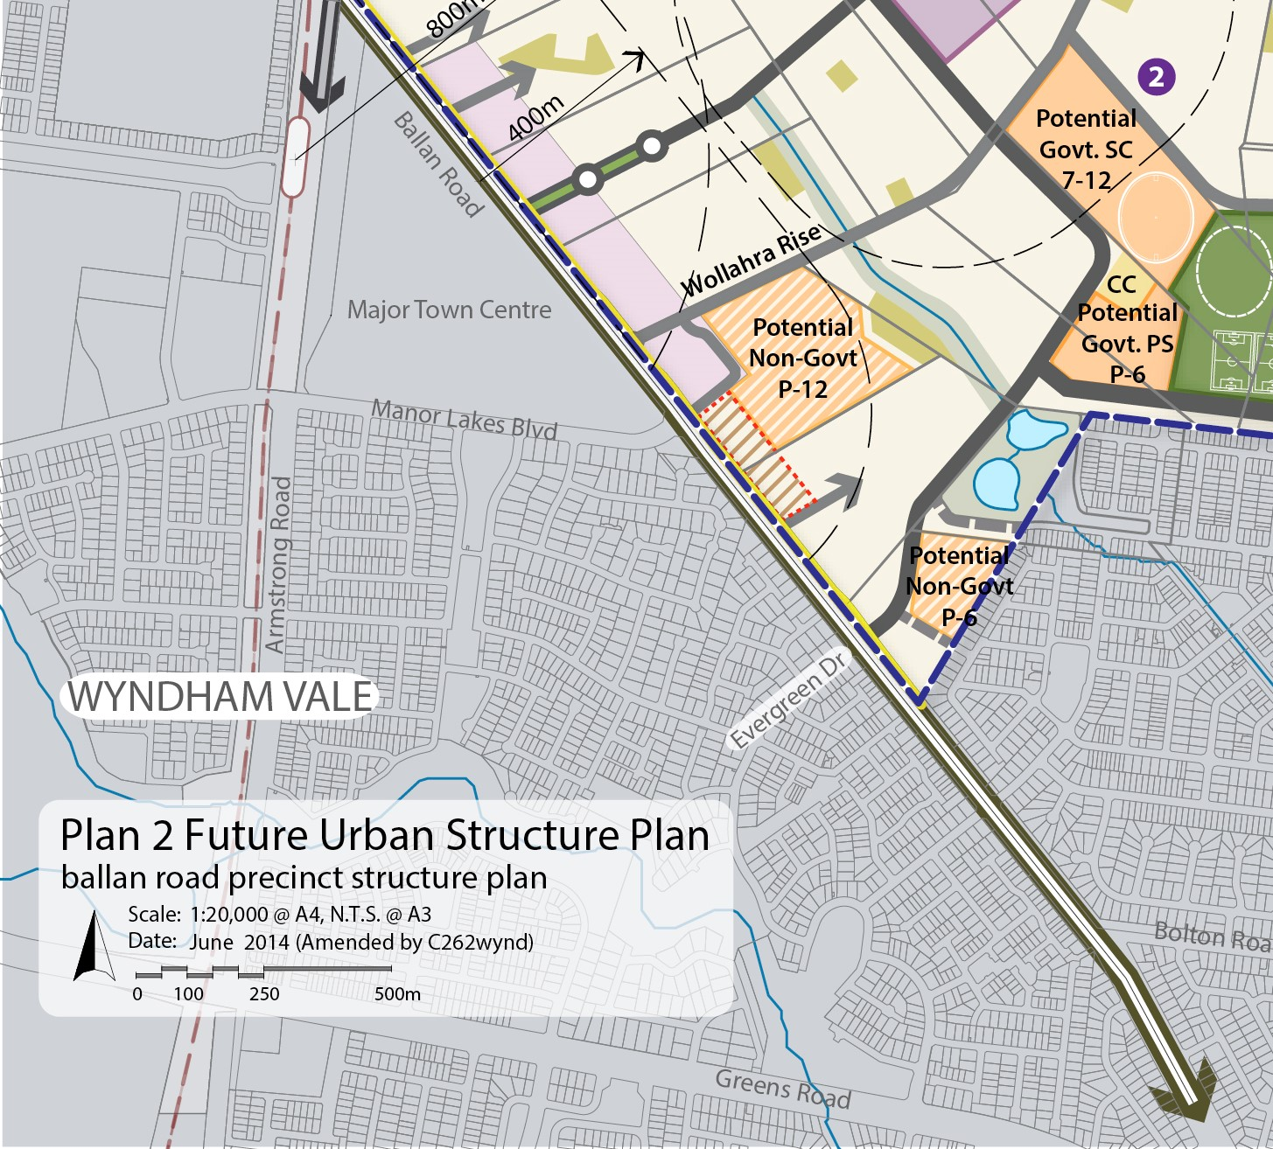

This site was not originally identified in the PSP or DCP as being for a potential non-government school. In the Ballan Road PSP it is identified as residential and included in the Net Developable Area in the land budget of the PSP. As a result of the planning permit being issued for the non-government school and a change in use of the site, the Net Developable Area of the DCP has decreased and created a shortfall of Development Contributions in the order of $3.8 million.

What the amendment does

Amendment C262wynd makes changes to the Future Urban Structure Plan and Land Use Budget in the Ballan Road PSP to show an additional non-government school. The amendment will identify the subject site as a ‘non-government school’ at 418-438 Ballan Road Wyndham Vale with an area of 8.0 ha.

The amendment to the Wyndham West DCP will proportionately decrease the Net Developable Area (NDA) of the DCP as a result of the addition of the non-government school.

This will affect all remaining charge areas of the PSP to adjust for the loss of Development Contributions resulting from the decreased NDA. It will consequently increase the Development Infrastructure Levy (DIL) per hectare rate for all remaining land in the Wyndham West DCP and DCPO Schedule 11.

The DCP has six charge areas. A summary of charges in the unamended document is shown in Table 1 below:

Table 1: Summary of Charges in existing Wyndham West DCP (2014)

The amended summary of charges following an increase in the DIL is shown below as Table 2.

Table 2 :New Summary of Charges table in amended Wyndham West DCP (2023)

All costs in both Table 1 and Table 2 are referenced to the original Wyndham West DCP 2014 for costs (i.e. costs are in dollar amounts used to prepare the Wyndham West DCP 2014). Adjustments are made to these figures in accordance with the DCP each year.

Table 2 shows the decrease in the NDA for Charge Area 4 from 106 hectares (as shown in Table 1) to 98 hectares and a commensurate increase in the DIL for Charge Area 4 and for other Charge Areas 1-3 and 5-6

The DIL for Charge Area 4 impacted by the non-government school is increased from $304,235 to $310,203 per hectare.

In detail, C262wynd:

- Amends the incorporated Ballan Road Precinct Structure Plan (PSP) to identify a non-government school at 418-438 Ballan Road and update accordingly the following sections:
  - Plan 2 - Future Urban Structure Plan (page 6)
  - Section 2.3 - Summary land budget (page 9)
  - Plan 3 - Land use budget (page 10)
  - Table 1 - Summary Land Use Budget (page 11)
  - Plan 4 Image Character and Housing (page 12)
  - Figure 3 - Ballan Road Commercial Area Concept Plan (page 22)
  - Plan 5 Open Space and Community Facilities (page 24)
  - Figure 4 - Southern Community Hub Concept Plan (page 26)
  - Plan 7 Conservation Area Concept Plan (page 34)
  - Plan 8 Public Transport & Trail Network (page 36)
  - Plan 9 Street network & Inter-parcel connections (page 40)
  - Plan 10 Integrated Water Management (page 44)
  - Plan 11 Utilities (page 48)
  - Appendix 4.1 – Table 7 Property Specific Land Budget (page 61)

- Amends the incorporated Wyndham West DCP in the following manner to reflect the increased DIL per hectare rate:

  - Table 1 Summary of Charges (page 5)
  - Section 2.5 The Area to Which the Development Contributions Plan Applies (page 10)
  - Table 2 Charge areas (page 10)
  - Plan 3 Road Projects (page14)
  - Table 3 Road Projects (page 15)
  - Table 4 Intersection Projects (pages 17-19)
  - Table 5 Bridge & Culvert Projects (page 21)
  - Table 6 Recreation Projects (pages 23-25)
  - Table 7 Community Facility Projects (pages 27-28)
  - Table 9a Summary Land Use Budget (page 32)
  - Table 10a Calculation of Costs (Development Infrastructure Levy) (pages 36-38)
  - Table 12 Property Specific Land Budget (pages 52-55)

- Amends Schedule 8 to the Urban Growth Zone (UGZ) by updating Map 1, which is a reproduction of Plan 2 in the updated Precinct Structure Plan (PSP) in order to reflect the addition of the non-government school.

- Amends Schedule 11 to the Development Contributions Plan Overlay (DCPO) to refer to the updated total Proportion of Cost Attributable to Development percentages and amounts, and updates the figure for NDA in Charge Area 4 and the total NDA for all Charge Areas 1-6.

- Amends the schedule to Clause 72.04 to refer to the amended incorporated documents currently titled ‘Ballan Road Precinct Structure Plan, March 2012 (updated April 2016)’ and ‘Wyndham West Development Contributions Plan, March 2012 (updated April 2016)’, and reflect the date that the documents were revised.

Post exhibition changes to Amendment C262
During the exhibition period a mapping error was identified that required the exhibited documents to be updated as follows:
• Replace Map 1 in the exhibited Schedule 8 to the Urban Growth Zone (UGZ) at Clause 37.07 with the corrected Plan 2 in the updated PSP.
• Update the schedule to Clause 72.04 to reflect the March 2023 date that the incorporated documents Ballan Road Precinct Structure Plan, March 2012 (updated April 2016) and Wyndham West Development Contributions Plan, March 2012 (updated April 2016) were revised.

The figure of $4.8million noted in the exhibited version of the explanatory report for this amendment has been revised down due to confirmation of the actual school area of 8ha within a parcel of 10.83 hectares. There has also been an internal road realignment associated with a permit for the school approved by the Minister for Planning. The remaining 2.83 hectares owned by Christian Resource Ministries is still able to be developed for mixed use/commercial or non-residential uses as shown in the PSP.

Strategic assessment of the amendment

Why is the amendment required?
The proposed Amendment is required as a result of a planning permit being issued for an 8ha non-government school not originally identified in the PSP or DCP. The subject site is located at 418-438 Ballan Road Wyndham Vale, being the corner of Ballan Road and Wollahra Rise. Formally, it is identified as Lot 1 on Title Plan PS506355.

In 2018 Wyndham City Council issued a planning permit for Use & Development of an Education Centre (Stage 1A) for the Wyndham Christian College and alteration to a road in a Road Zone (category 1) works on land within a PA02 at 418-438 Ballan Road, Wyndham Vale. Condition 11 (Development Contributions) of the permit issued required the payment of development contributions, and stated “Unless otherwise agreed in writing by the Responsible Authority, prior to the commencement of development, development contributions are to be paid to the Responsible Authority in accordance with the Wyndham West Development Contributions Plan and Schedule 11 to the Development Contributions Plan Overlay”.

In 2022 Council’s Development Contributions Unit reviewed Condition 11 of the permit and determined the condition was included erroneously, and that contributions are not required in respect of this use and development. On 29th April 2022 the planning permit was amended to delete Condition 11. This action is in line with the Ministerial Direction on the Preparation and Content of Development Contributions Plans that states in part (4) that a development contributions plan must not impose a levy in respect of the development of land for a non-government school.

The development of this additional non-government school on the site in the PSP has decreased the NDA of the DCP and created a shortfall of Development Contributions that would otherwise have been collected from a residential development at 418-438 Ballan Road Wyndham Vale.

Subsequently, an increase in the DIL per hectare across the Wyndham West DCP is required to account for the decreased NDA of the DCP. This will result in an equivalent quantum of Development Contributions able to be collected across the DCP, equivalent to the amount anticipated before the non-government school site was removed from the charge area.

The ability to collect the same quantum of DCs as anticipated in the Wyndham West DCP will ensure that there is necessary funding to provide community and transport infrastructure fundamental to the liveability of all PSPs in the DCP area.

The planning scheme (and the DCP as the incorporated document in the Wyndham Planning Scheme) is the only mechanism to set development contributions. The ability to collect sufficient funding for essential local infrastructure through DCs will ensure ongoing community benefits both now and into the future. Council guides its deployment of DCP funds on DCP-cited projects through its Development Contributions Plan Project Implementation Program.(DCP PIP). DCP PIPs have been prepared for both the Wyndham North and Wyndham West DCPs and are reviewed on an annual basis in line with the financial year.

How does the amendment implement the objectives of planning in Victoria?
The amendment facilitates updates to the Ballan Road PSP and Wyndham West DCP to ensure accuracy in the incorporated documents for the delivery of development. It will also ensure that future residents, visitors, and workers in the area can be provided with timely access to local infrastructure and services necessary to support a quality and affordable lifestyle.

The amendment implements a number of the objectives of planning in Victoria under
Section 4 of the Planning and Environment Act 1987 (Act). In particular:

- To provide for the fair, orderly, economic and sustainable use and development of
Land:
The amendment equitably proportions financial levies for development and
community infrastructure to ensure the fair and equitable provision of works, services
and facilities needed by the new community to secure sufficient physical
infrastructure and amenities. It ensures that the cost of providing new infrastructure and services is shared equitably between various development proponents and the wider community.

- To secure a pleasant, efficient and safe working, living and recreational environment
for all Victorians and visitors to Victoria:
The updated DCP will contribute to the costs associated with creation of a pleasant living and recreational environment for the community and its visitors.

- Protect public utilities and other assets and enable the orderly provision and coordination of public utilities and other facilities for the benefit of the community;
The amendment will ensure that the Wyndham West DCP will continue to adequately provide for necessary community infrastructure and upgrades to the existing and future arterial road network to accommodate development within the Ballan Road PSP area.

- To balance the present and future interests of all Victorians:
The DCP ensures that the costs of delivery of land and infrastructure for community use such as open space, community and sports facilities and arterial road upgrades are accounted for at the time that new communities are established, and that future communities are not disadvantaged by insufficient infrastructure.

How does the amendment address any environmental, social and economic effects?
Environmental effects

As the Ballan Road PSP area establishes, maintenance of an appropriate level of DCs will contribute to the development of open space, amenity and increased transport choice. This will subsequently deliver environmental benefits across the PSP and DCP area.

Economic effects

The amendment addresses issues of financial sustainability for Council in delivering infrastructure for growing communities in a cost effective way. The development of additional school sites in the PSP not accounted for in the DCP (and commensurate loss of residential land) has financial implications for the agreed DCP and the availability of funds for delivery of infrastructure.

The amendment ensures that the land budget as shown in the PSP is accurate and that correct costs are set out in the DCP for new infrastructure required to service the developing community. Timely delivery of new essential infrastructure is necessary for local economic development. Such infrastructure maximises opportunities for new residents to safely and efficiently access employment opportunities and everyday services, including shopping, and engage in locally based social activities.

The provision of government schools is not meeting current demand given Wyndham’s rapid growth, and enrolment rates are high for Catholic and independent schools in the municipality. Additional non-government schools may support local economic growth through families being able to access education within Wyndham rather than be forced to leave the municipality.

State government planning policy is supportive of fast track approvals of non-government schools and recognises the importance of the nongovernment school sector in meeting the educational needs of a diverse range of students across the State. In 2019 VC165 introduced new planning scheme provisions to streamline the planning process for non-government schools. The amendment supports the expansion and upgrade of primary and secondary schools that receive funding under the Victorian Government’s Non-Government Schools Capital Fund 2019-20 to 2022-23.

Social Effects

Growth areas are characterised by highly diverse communities. Additional non-government schools in new growth areas delivers greater choice to the emerging local community through an increased diversity and availability of education providers. The amendment adds an additional site for a non-government school within the Ballan Road PSP area, providing greater choice for the diverse community in Wyndham West.

Does the amendment address relevant bushfire risk?

Bushfire risk management is addressed through the Ballan Road PSP, which provides the detailed land use planning for the precinct. The amendment to the incorporated plan does not affect any existing bushfire provisions. The Wyndham Municipal Fire Management Plan is a sub plan of the Wyndham Municipal Emergency Management Plan. Wyndham City's Municipal Emergency Management Plan addresses the prevention of, response to, and recovery from emergencies within Wyndham City.

Does the amendment comply with the requirements of any Minister’s Direction applicable to the amendment?
The proposed amendment has been prepared following Ministerial Direction 15 – the planning scheme amendment process. The amendment complies with the Ministerial Direction on the Form and Content of Planning Schemes under section 7(5) of the Act.

The amendment has been prepared consistent with the Ministerial Direction on the Preparation and Content of Development Contributions Plans that states in part (4) that development contributions plan must not impose a levy in respect of the development of land for a non-government school. The amendment will maintain consistency in the total cost to be recovered for infrastructure as specified in the Wyndham West DCP 2011.The amended DCP will correct the proportion of the cost of the infrastructure being levied from developers throughout the overall Wyndham West DCP area.

In accordance with Ministerial Direction No.18 - Victorian Planning Authority Advice On Planning Scheme Amendments, the amendment was prepared following discussions with the Victorian Planning Authority regarding the intent of the amendment. The site which is the subject of the amendment is identified in the Ballan Road PSP as being for future residential development. The VPA provided advice about the scope of the amendment and assisted with preparation of the updated Ballan Road Precinct Structure Plan (PSP) Incorporated Document and the updated Wyndham West Development Contributions Plan (DCP) Incorporated Document.

The amendment also complies with:

Direction No. 9 - Metropolitan Strategy
The amendment supports the metropolitan strategy Plan Melbourne, in facilitating schools provision in growth areas and specifically Outcome 5 Melbourne is a city of inclusive vibrant and healthy neighbourhoods and Direction 5.3 Deliver social infrastructure to support strong communities.

The amendment will facilitate the development of land within the urban growth boundary of Metropolitan Melbourne, in particular via an updated PSP and DCP supportive of the
equitable and orderly development of the land in an efficient and sustainable manner. The updated documents will ensure that delivery of community and physical infrastructure occurs early in the establishment of the new communities covered by this DCP.

Direction No. 11 - Strategic Assessment of Amendments
This direction seeks to ensure a comprehensive strategic evaluation of a planning scheme amendment. This Explanatory Report addresses the requirements outlined in this direction.

Direction No. 12 - Urban Growth Areas
Ministerial Direction 12 is applicable where a planning scheme amendment introduces changes to an incorporated precinct structure plan or introduces or changes a schedule to the Urban Growth Zone. The Direction states that a planning authority must demonstrate and show in the explanatory report that the precinct structure plan or any changes to it are in accordance with any applicable Precinct Structure Plan Guidelines approved by the Minister for Planning. The Precinct Structure Planning Guidelines: New Communities in Victoria released in November 2021 includes guidance around determining the need for non-government schools in PSP areas and options for associated planning. Of relevance to this amendment, the new ICP Guidelines also confirm that non-government schools are exempt from infrastructure contributions, as specified in the Ministerial Direction on the Preparation and Content of Development Contributions Plans.

How does the amendment support or implement the Planning Policy Framework and any adopted State policy?
The amendment designates a site for a non-government school not previously identified in the PSP, and updates the incorporated documents at Clause 72.04 titled ‘Ballan Road Precinct Structure Plan’ and ‘Wyndham West Development Contributions Plan’.

The amendment gives effect to the following clauses of the PPF:

11.03-2S Growth areas - Deliver timely and adequate provision of public transport and local and regional infrastructure and services, in line with a preferred sequence of land release.

11.02-3S Sequencing of development:
Require new development to make a financial contribution to the provision of infrastructure such as community facilities, public transport and roads

19.02-2L - Support an expansion of the range of educational facilities and services in response to growth and the needs of the community.
19.03-1S Development and infrastructure contributions plans
Clause 37.07 Schedule 8 – the amendment updates Map 1 to show the location of the additional non-government school
Clause 45.06 Schedule 11 - is replaced with a new schedule that increases the Development Infrastructure Levy in the Wyndham West DCP and DCPO Schedule 11
The amendment supports the Victorian Planning Association (VPA) PSP note entitled ‘Non-Government Schools’.

How does the amendment support or implement the Local Planning Policy Framework, and specifically the Municipal Strategic Statement?
The Wyndham planning scheme was translated into the new Planning Policy Framework by amendment C258wynd on 10 February 2022.

Responses to this question have been addressed in the previous and following questions

How does the amendment support or implement the Municipal Planning Strategy?
The amendment gives effect to the following clauses of the MPS:

02.03-8 Transport - Maintain and enhance existing road infrastructure and 02.03-9 Infrastructure ‘Community facilities and development infrastructure’’

Does the amendment make proper use of the Victoria Planning Provisions?
Updating the incorporated documents is the appropriate mechanism to ensure that the community is well serviced with the required level of infrastructure and educational opportunities.

How does the amendment address the views of any relevant agency?

Prior to preparing the amendment Council consulted with the VPA on the amendment scope and proposed changes to the DCP. The VPA is a key stakeholder being the agency that prepared the original Ballan Road Precinct Structure Plan and Wyndham West Development Contributions Plan. VPA officers are supportive of the amendment and its intent. Views of all relevant agencies will be sought during the exhibition process of the amendment.

Does the amendment address relevant requirements of the Transport Integration Act 2010?
There are no specific requirements of the Act that are relevant to the amendment.

Resource and administrative costs

What impact will the new planning provisions have on the resource and administrative costs of the responsible authority?

An updated PSP and DCP is not expected to place additional impost on council’s administrative resources and will ensure Council’s ability to deliver key infrastructure into the future.

Where you may inspect this amendment
The amendment can be inspected free of charge at the Wyndham City Council website at www.wyndham.vic.gov.au
The amendment is available for public inspection, free of charge, during office hours at the following places:
Wyndham City Council Civic Centre
45 Princes Highway, Werribee
The amendment can also be inspected free of charge at the Department of Environment, Land, Water and Planning website at www.planning.vic.gov.au/public-inspection.

