2022
Wyndham Learning
Festival

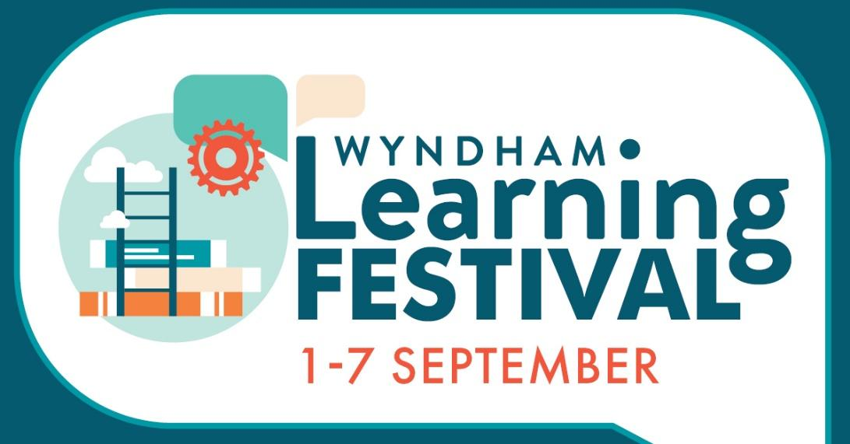
Final Report and Evaluation
Prepared by Sharyn Wheatcroft and Bettina Mitchell with assistance from Diane Tabbagh and Isabelle Incham

Contents
Acknowledgement to Country 2
Executive Summary 4
Key Learnings 4
Why Are Learning Festivals Important? 6
Project Objective 7
Project Collaborations – The Co-Lead Team 7
Project Working Group 8
Marketing 9
Media Coverage 14
Sponsorship 15
Community Engagement 16
Support to Event Providers 17
Events Registered 17
WLF Launch 18
Wyntalk Signature Event 20
Evaluation Framework 21
Most Significant Change Technique 23
Event Participant Feedback 24
Event Provider Feedback 25
Post Festival Reflections Session 26
Next Steps 29
Contact Details 29
Links: 29
Appendix 1: Feedback from Event Provider 30
Appendix 2: Feedback from Event Attendees 33
Appendix 3: 2022 WLF Program 36

Acknowledgement to Country
Wyndham recognises Aboriginal and Torres Strait Islander peoples as the First Custodians of the lands on which Australia was founded. We acknowledge the Bunurong and Wadawurrung people as the Traditional Custodians of the lands on which Wyndham is being built. We pay respect to Ancestors and Elders who always have, and always will, care for Country and community today and for future generations. of the land on which we work and live, and where learning takes place across Australia and globally. We pay respect to their Elders and the diversity of Aboriginal communities past, present and future, and the richness our Aboriginal community members bring to Wyndham and their learning that has been passed across generations for thousands of years.
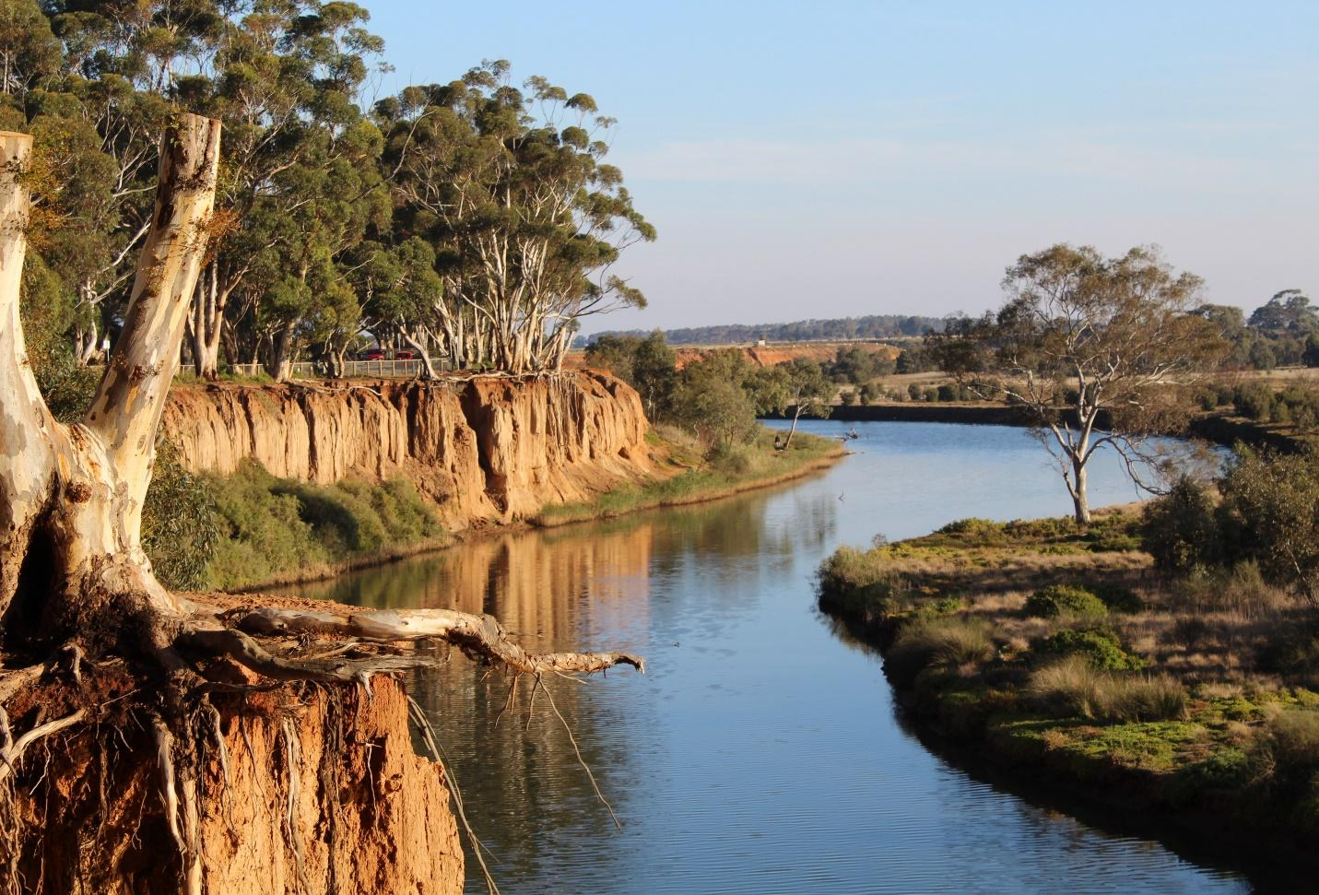
Image: Werribee River, Wyndham Photo by Tarnia Fedele

Executive Summary
The Wyndham Learning Festival (WLF) is Wyndham’s largest annual learning event, focusing
on promoting learning across the lifespan. Following two years of online-only events due to the extended impacts of the Pandemic, the 2022 WLF went ahead with a blended delivery of in- person and online events. With the theme of “Building a Resilient, Sustainable Wyndham”, the free Festival offered something for all ages and interests from 1-7 September and celebrated and encouraged lifelong learning with 70 activities from across the Arts, S.T.E.M, Environment and Sustainability to Health & Wellbeing, Families and Children and more! Events were as varied as a Young Scientist of Wyndham Competition; Thai Cooking; a Photography Workshop; Recycling; a Multicultural Sports Expo; Lawn Bowls; Building Resilience in Children; Gardening; Sustainability; a Farm tour; a Werribee River walk; an author talk with Morris Gleitzman, and many, many more!
As collaborators on the delivery of the Festival, now in its seventh year, the Wyndham Community and Education Centre (Wyndham CEC) and Wyndham City Council (WCC) share a passion for learning and recognise the far-reaching social, economic, environmental and cultural benefits of promoting lifelong learning. This year saw Wyndham CEC purchase and interface an online booking system to the WLF website. This enabled a greater and more timely insight into event data. Previously this data was collected via event feedback surveys, post the events.
- 70 events were registered by a range of organisations
- In person events: 52
- Online/Zoom/Teams:18
- Total registrations 1,288
- WLF website views: 5,891
The attendance vs registration ratios were generally high, reflecting a continuing appetite for new learning activities in the community.

Key Learnings
- Live events enabled people to “meet up” at other events. Builds connections and provides opportunities to chat to people you might not otherwise meet.
- Encouraging awareness of sustainable use of products such as water jugs and glasses or biodegradable cups rather than single use water bottles.
- The high value of using our networks to promote a range of events.
- The expo was a great way to get more than one organisation sharing an event.
- Challenge to engage Indigenous learning events
- Hands on workshops very popular (cooking, art)
- Continued interest from feedback on hands-on learning and urban food farms and environment.
- Update the format of the event day to Day DD:MM:YY start /finish time
- Review events to ensure they are categorised across all age groups.
- Youth services to coordinate with schools focus support network to ID events after school
- A5 flyer with QR code worked best
- Print out an open out brochure with a taste of the WLF events for 2023.
- Messaging for promotions of other events to ensure all event holders have marketing materials.
One objective of the curated program was to enable providers to run smaller, interactive events. The ability to interact with attendees, and to meaningfully field questions from the audience met the needs of both event providers and participants.
Feedback and trends showed on average 60% of those who registered, attended the 70 events that made up the 2022 WLF, with over 1260 people registering across all events.
Learning events were classified into eight categories:
- Environment and Sustainability
- The Arts
- Sports & Recreation
- World of Work & S.T.E.M.
- Health & Wellbeing
- Culture & Diversity
- Food & Cooking
- Families & Children
The working group wholeheartedly thanks the 2022 WLF sponsors for their commitment and involvement in the Festival: VU Polytechnic and Pacific Werribee Shopping Centre. Both were gold sponsors, and their support for the Festival and their commitment to learning in Wyndham was greatly appreciated. VU Polytechnic has been a gold sponsor since the first WLF; whilst special mention can be made of Pacific Werribee Shopping Centre, in its 2nd year of sponsorship – highlighting that we can find lifelong learning in our midst – even in our local shopping centre! The opportunity to be a Festival sponsor provided visibility and cost-effective benefits for the two gold sponsors to support organisations, our community, the sustainability of our Festival and Wyndham’s proud status as an official UNESCO Learning City.
Jennie Barrera, Wyndham CEC, September 2022 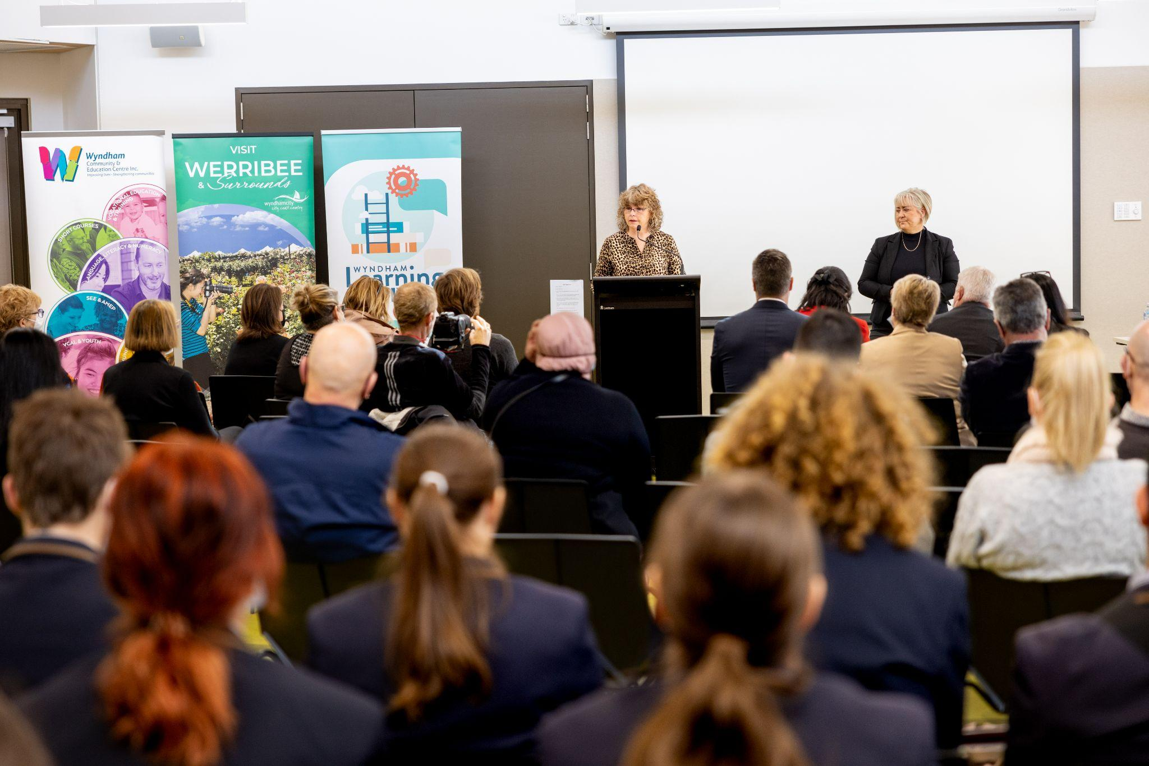

Why Are Learning Festivals Important?

Learning Festivals, such as the WLF, are important because they provide community members with a chance to celebrate learning and engage in learning events to expand their knowledge, skills and interests. Annual learning Festivals such as the WLF, offer an annual series of activities that provide free learning opportunities across local government areas. Festivals often include activities for individuals of all ages and interests, encouraging everyone to learn throughout their lifetime while also welcoming new events, sponsors, and participants to represent the community's diversity and vibrancy. Free learning opportunities such as the WLF are a great way for community members to get involved and learn useful skills by attending sessions of their choice or even socialising with others and making new friends. Learners of all ages are engaged, and many come away with a renewed interest in, and passion for, lifelong learning. Participating in learning activities may enable people to build networks and to positively engage with the community, supporting social inclusion and engagement which in turn supports communities to avoid disharmony, insecurity and even violence. Learning Festivals like the WLF, contribute to making a city more liveable, equitable and cohesive.
Supporting learning Festivals is critical for enhancing learning inclusion, equity and diversity for members of communities. People from all backgrounds regardless of their gender, ethnicity, age, religion and life experiences are supported to participate in learning opportunities offered at Festivals. Learning Festivals not only offer learning opportunities for both participants and event providers, but they also excite people to engage in a celebration of learning both during the Festival and then after the experience. A learning Festival's goal is to bring people together through learning, to encourage people of all ages to try new things and to promote lifelong learning, which encompasses both formal and informal learning. More broadly, learning Festivals provide an opportunity to construct and reflect on a broad and dynamic learning community by adding new events, sponsors, and participants to a city’s learning agenda. It is essential for community members to have access to such opportunities to engage and celebrate learning and incorporating a common theme such as this year’s WLF of ‘Building a Resilient, Sustainable Wyndham’’ can unite a community because that common theme, selected by the community, represents the learning challenges in the community at that specific time. Learning Festivals provide a wide range of options to meet the needs, interests, and aspirations of a community’s residents, enhancing their learning equity and inclusion.

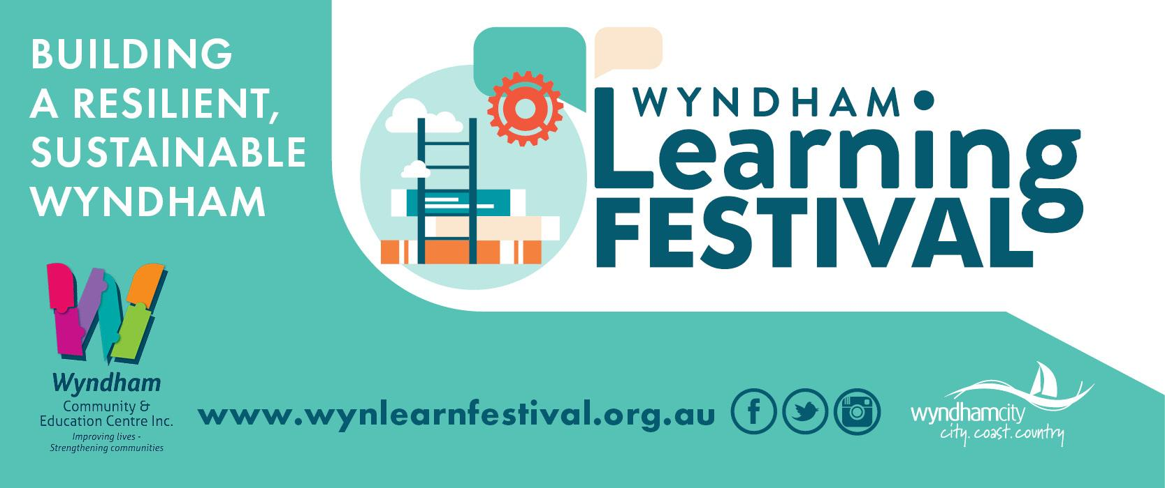

Project Objective
The annual WLF is a whole-of-community event that provides opportunities for FREE learning activities across the City of Wyndham annually. The Festival has activities for all ages and interests, promoting and celebrating lifelong learning for all, showcasing the breadth of learning opportunities across Wyndham and welcoming new events, sponsors and participants to reflect this diverse and dynamic learning community.

Project Collaborations – The Co-Lead Team
The Wyndham Learning Festival is led by Wyndham CEC supported by WCC. From WCC, there were three staff working on this project in various capacities, as well as one intern student undertaking a shared placement with the WCC team and Australian Learning Cities Network (ALCN). From the Wyndham CEC, a dedicated project officer was working on the WLF 3 days per week from April 2022. This increased to 4 days per week in the final six weeks leading up to the Festival itself.
Apart from this, the Wyndham CEC offered support for the working group meetings and also management support where required. Whilst the new website was well received, with a new booking system this year there was a significant amount of support provided to event holders. Despite this, feedback from event holders and participants alike was that the website with the booking functionality was a success:

“ I found it easy to navigate the information I needed”

Additionally, Wyndham CEC and WCC provided substantial support in their shared roles of leading and coordinating the Festival. We received very positive feedback from surveys with comments including:

“The Learning Festival team was great to work with. They were responsive and knowledgeable and made running an event a pleasure. Thank you!”
and
“Big thanks to the working group for making this happen. Wyndham has such an incredible array of learning opportunities, and we are so lucky to have a FREE learning Festival! Yah Wyndham!”

Project Working Group
The WLF Working group met monthly from 8 February 2022 - 9 August 2022. A final reflection and evaluation meeting was held on 11 October 2022. Member representation came from the following organisations:
- Wyndham CEC (4 members)
- WCC Libraries and Learning (2 members)
- WCC Libraries (Programs)
- WCC Sport and Recreation
- WCC Communications Team
- WCC Youth Services Team
- WCC Neighbourhood Hubs Team
- WCC Community Development
- WCC Sustainability Team
- Wyndham Park Community Centre Team
- Velisha Education
- VU Polytechnic

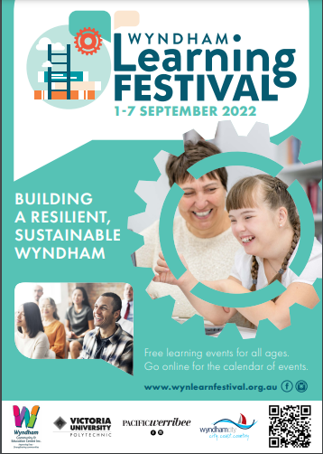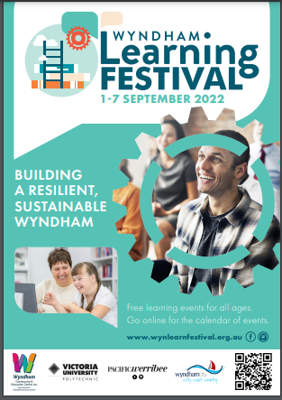
Posters/A5 flyers produced for Festival

Most Significant Change Stories
on Discovering Newfound Interest
Carol Kochy Story - Event Holder
Carol works at her local cultural theatre and has a keen passion to learn new things. She has always been on the lookout for any opportunity to discover new skills and learn new things, and when she saw the Wyndham Learning Festival advertised on her local council’s website, she knew she had to participate. This year, Carol attended events providing lessons on painting, photography, vegetable gardening and Thai cooking.
A significant part of the festival for Carol was discovering new passions and embracing newfound interests. Carol’s two favourite events were the session on photography and learning how to cook Thai cuisine. Especially with photography, she said that it opened up a new perspective where she learnt how to look at things in a different light. From attending these events, Carol says she picked up various skills and even more so, has been inspired to get out in the world to learn more, truly advocating lifelong education

on Getting to Know Nature
Rose Lawson Story - Event Participant
Rose heard of the Wyndham Learning Festival through her daughter, Rebecca, who works as part of the working group coordinating the Festival. She attended the Festival’s signature event ‘Building a Resilient, Sustainable Wyndham: Stories from the Heart of Wyndham’ where she listened to a panel of five residents, sharing their life and educational experiences and insights. Having visited the WynTalk mini sustainable expo of local stall holders sharing ideas and information, she spoke fondly of the different types of groups you can join and the different organisations you are able to be a part of. Rose also attended another event called ‘Getting to Know Your Nature Walk’.
Just like her name, Rose isn’t a stranger to nature as she loves to take her dog on a walk and being surrounded by the flora and fauna. ‘Getting to Know Your Nature Walk’ offered Rose a deeper insight to her surroundings as well as celebrating the local flora and fauna. Prior to the event, Rose recalled that she didn’t know much about the different types of birds and vegetation that reside along the Werribee river but after the event, she found herself being more conscious of her surroundings on her daily walk. It is without doubt that this event made a significant impact on Rose, by which she is able to know and embrace nature on a deeper level.

Marketing

The marketing for the 2022 WLF was split between two key areas: marketing the Festival to potential event providers and marketing the event to potential participants in the Wyndham community.
The WCC Communications Team developed a marketing campaign and a range of marketing assets for digital and print which included: social media tiles, posters, digital screens, online backgrounds for MS Teams meetings and even developed a gif for Wyndham TV (online). Paid, organic, targeted Facebook posts proved the most successful with high engagement, clicks and impressions on these posts (total Facebook reach of 11,000), images below and throughout the report.
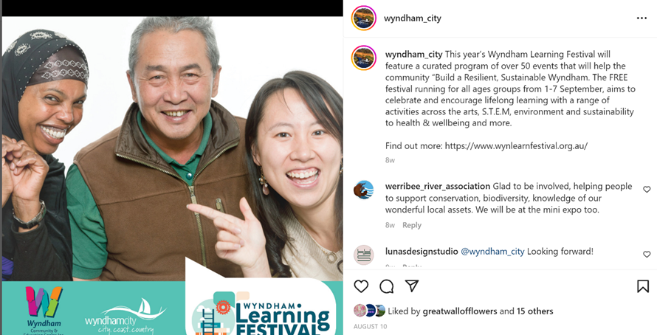
The EOI was announced on 17 May and closed 3 August 2022.
The marketing process began in April 2022 where the Festival was announced to event providers and collaborators. In May 2022, the Festival and its events were then shared with potential participants through numerous channels.
They include:
- the official WLF Facebook page
- local community Facebook pages
- LinkedIn
- Wyndham City What’s On
- the upgraded WLF website
- Mamma Knows West
- Star Weekly news
- Wyndham TV
- WLF database (via mailchimp eNewsletters)
- networks and sharing of emails, social media posts and face to face connections.

2022 Mamma Knows West Facebook Post:
FREE EVENTS - TOP 5 family fun at the Wyndham Learning Festival 2022 (mammaknowswest.com.au)
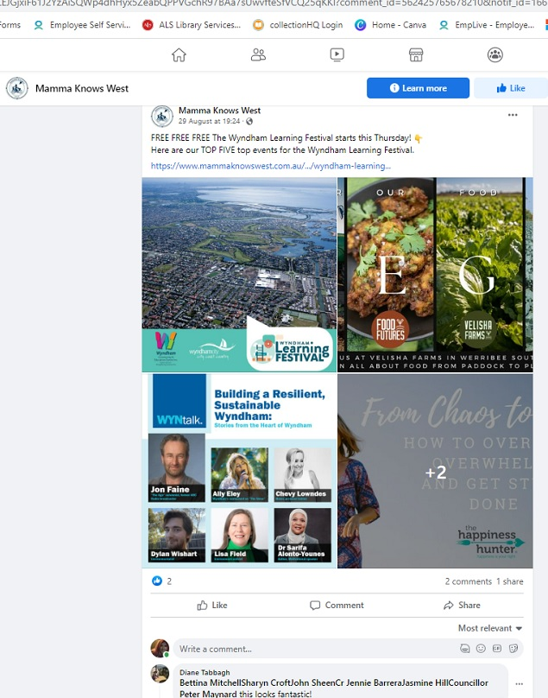

To promote the Festival to providers, regular LinkedIn posts were made to encourage event EOIs and the general promotion of the Festival. Regular mailchimp direct emails were sent to targeted community members and previous event holders.
To promote the Festival to participants, regular posts were made on the official WLF Facebook page from 24 June 2022 until the end of the Festival. These posts were then shared by local community pages. Paid advertisements were also made on Facebook to announce the Sponsors and the 2022 WLF Signature event. Through the marketing on social media platforms, there were almost 6000 views on the WLF website.
This year it was decided not to include Real estate boards in the marketing campaign and instead to plan a suite of direct marketing that would result in a more cost-effective outcome. Marketing channels included Facebook (through regular posts on the WLF FB page, shared to other local community pages); LinkedIn posts; postings on other Council FB pages, including the Libraries FB, listing on the Council What’s On; inclusion in Council e-Newsletters to staff and local schools; articles in the local newspaper; paid advertising on FB; and a feature in the Wyndham Community TV station.

A new WLF website was built in 2021, sponsored by Wyndham CEC. The objective was to produce a fresh and contemporary look, improve functionality, provide a faster download speed and easy to navigate event calendar. The website had two landing pages that can be switched out for the relevant target group commencing with the Event holders. All front-facing information was targeted to support event holders and was switched over on the Festival launch date of 5 August to the event calendar listing all events.

A booking system was included this year, enabling event holders to manage registrations and bookings through the website.

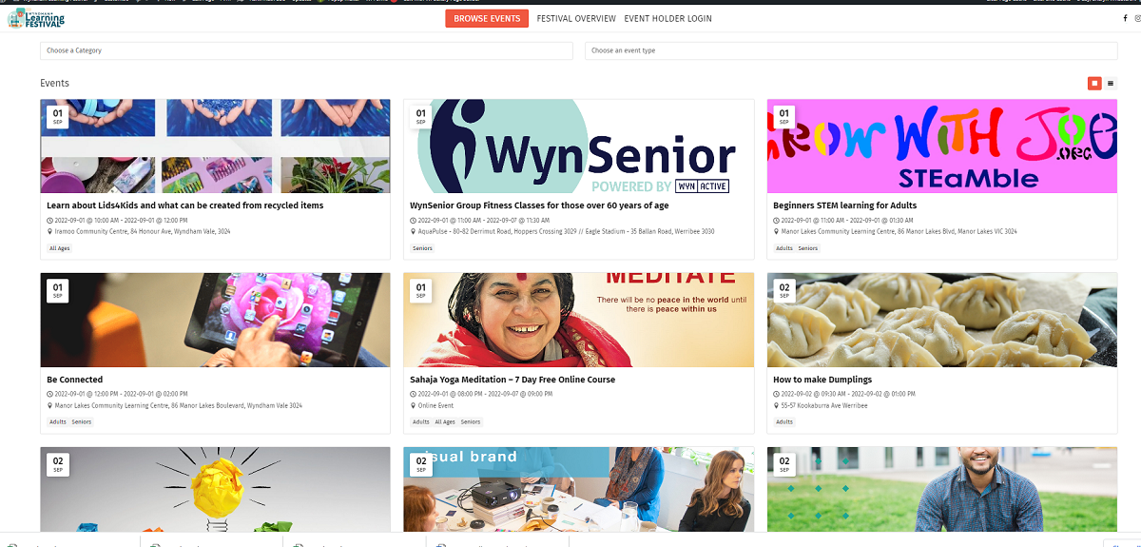

The Buzz Newsletter at Wyndham Community Learning Centres and Hubs
Various articles were submitted to the Buzz Newsletter team, who added this as a stand-alone news piece to ensure wider coverage and many articles were also included in individual community centre newsletters. In addition, community centre staff put posters up around their centres and added the information to their weekly mailouts, which have a wide reach into the community.
Promotional material was also displayed on Wyndham Library branch digital screens and Community Centre screens.
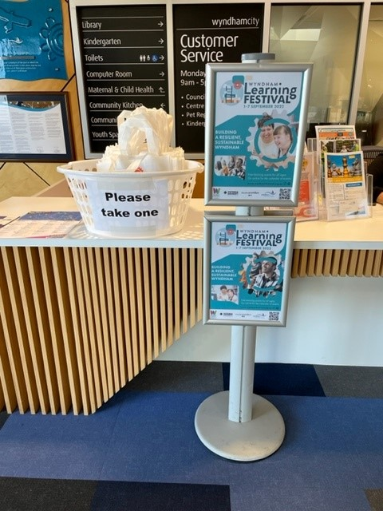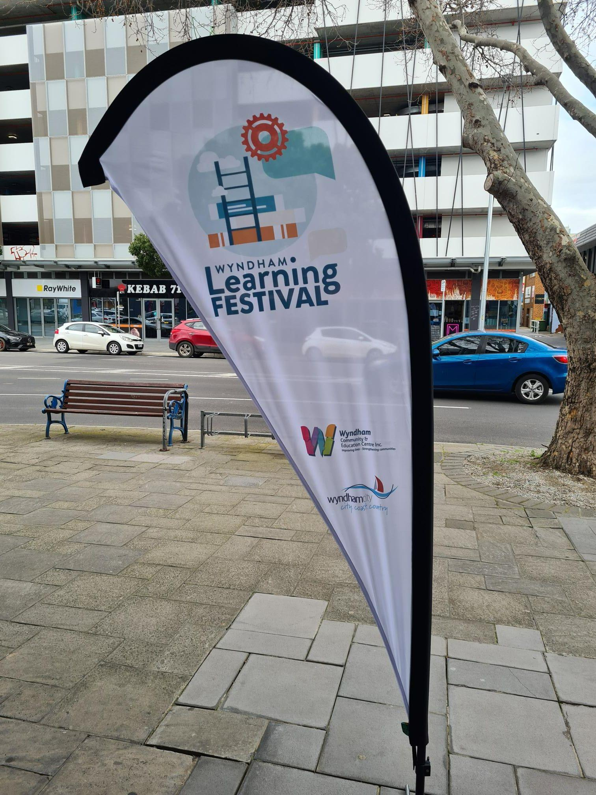
Display at Manor Lakes Community Learning Centre New WLF Teardrop Banner developed by Wyndham CEC
Other Mailouts
Mailouts promoting the Festival, including the community managed inboxes (council managed), were sent every few weeks to give the Festival regular exposure; Wyndham Disability Services Network; Learning Community networks; the Social Support Service Project network; Neighbourhood Hubs mailing list, Libraries eNewsletter, Active Wyndham eNewsletter, WyBayLLEn, Wyndham Best Start eNewsletter, Committee for Wyndham, Wyndham News, The Loop, CEO Monday Memo and Adult Learner Week 2022 website.
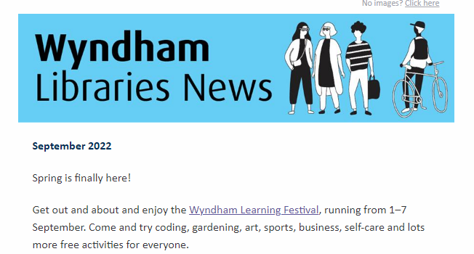https://docs.google.com/document/d/1Q6Nqn1UydVt6yYcT-ctWtVQNm4EaJGxjy4ew8JuIUCY/edit#heading=h.sogqe3e76sjy
WLF Bags as a Marketing Tool
2500 WLF Festival Bags were ordered with images from two local artists that won the WLF bag competition in 2020. The website URL and QR code was added to the bags, making them an attractive and practical promotional item. Bags were distributed through several channels including at the Festival Launch; Wyndham community centres; through library branches, Kinders and local community groups. A total of 3000 bags were printed (1500 of each design).
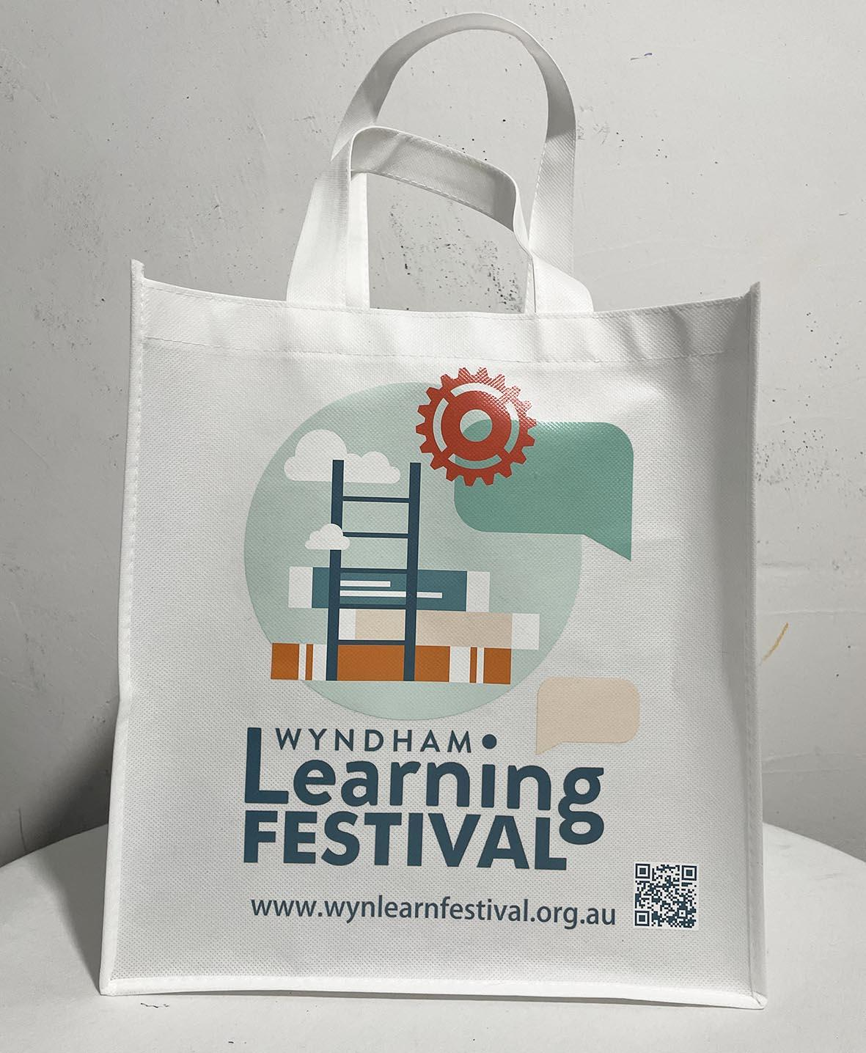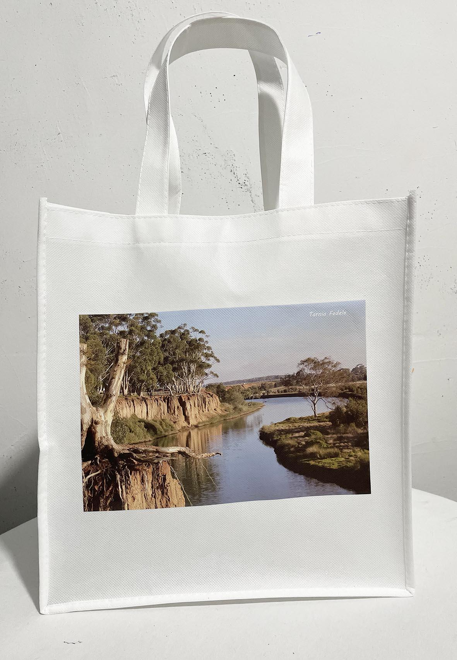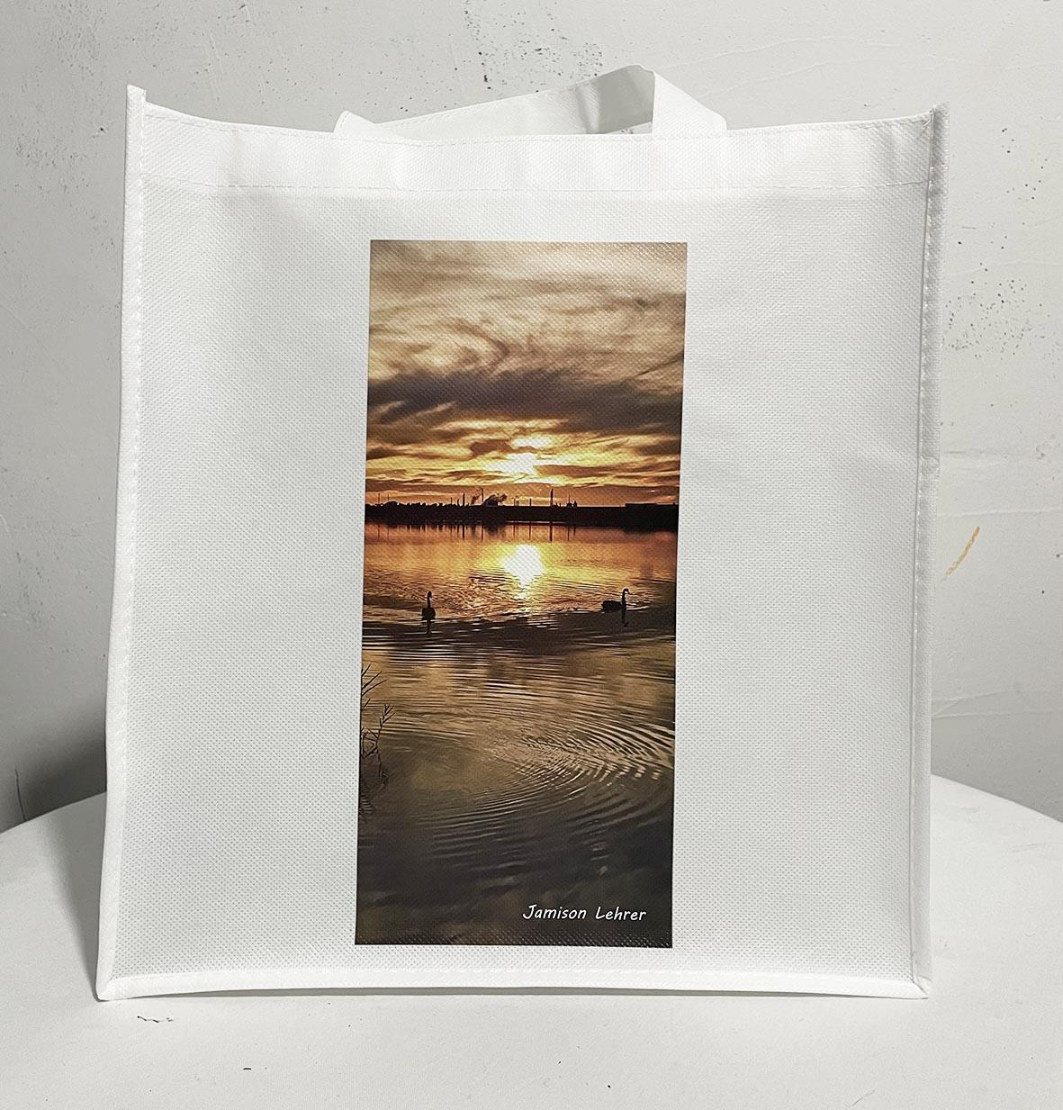
WLF 2022 Bags - artworks by local young people, Tarnia Fedele and Jamison Lehre

Media Coverage

The WCC Communications team developed a marketing campaign with a range of graphically designed artwork for an array of media, including social media, posters and screen signage.
WCC Comms team arranged for an article about the Festival in general as a pre promotion of the Festival and appeared in Star Weekly on 6 July 2022 -
https://issuu.com/starweekly/docs/2022-07-06_wsw_736/2
and another article in the Star Weekly on 31 August 2022
https://wyndham.starweekly.com.au/digital-editions/
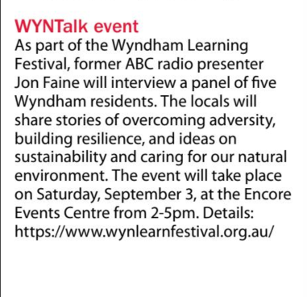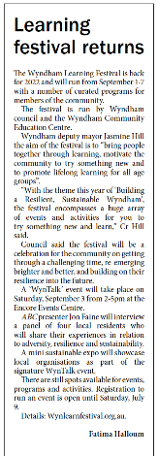

Sponsorship
A targeted Sponsorship Prospectus was developed to support the engagement of sponsors for 2022. Sponsorship packages included:
- Platinum Sponsor: $10,000 (plus GST)
- Gold Sponsor: $5000 (plus GST)
- Silver Sponsor: $2,500 (plus GST)
- Bronze Sponsor: $1000 (plus GST)

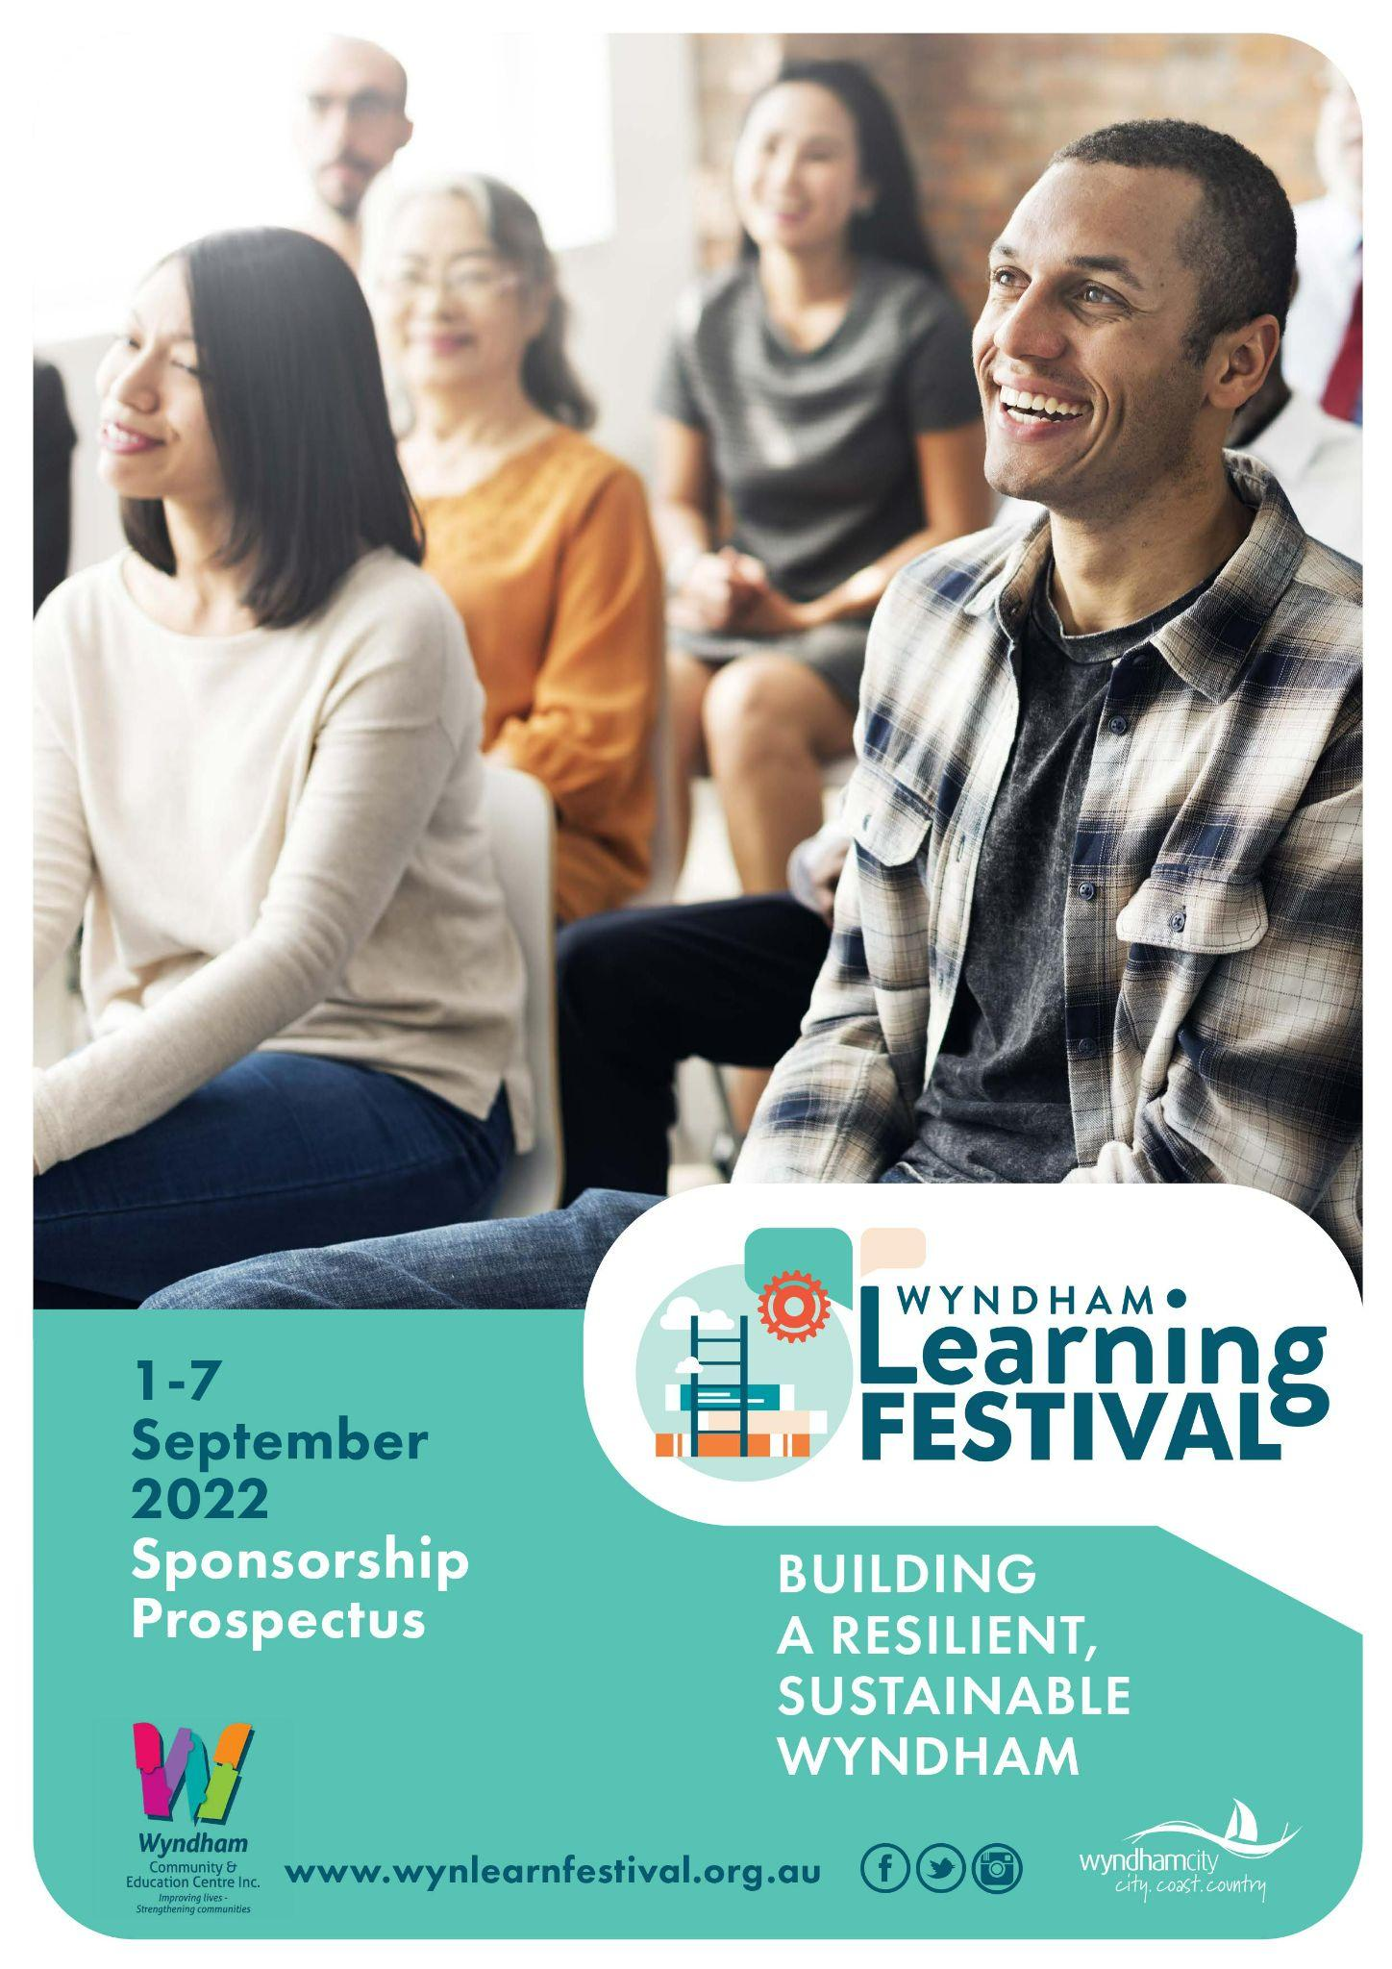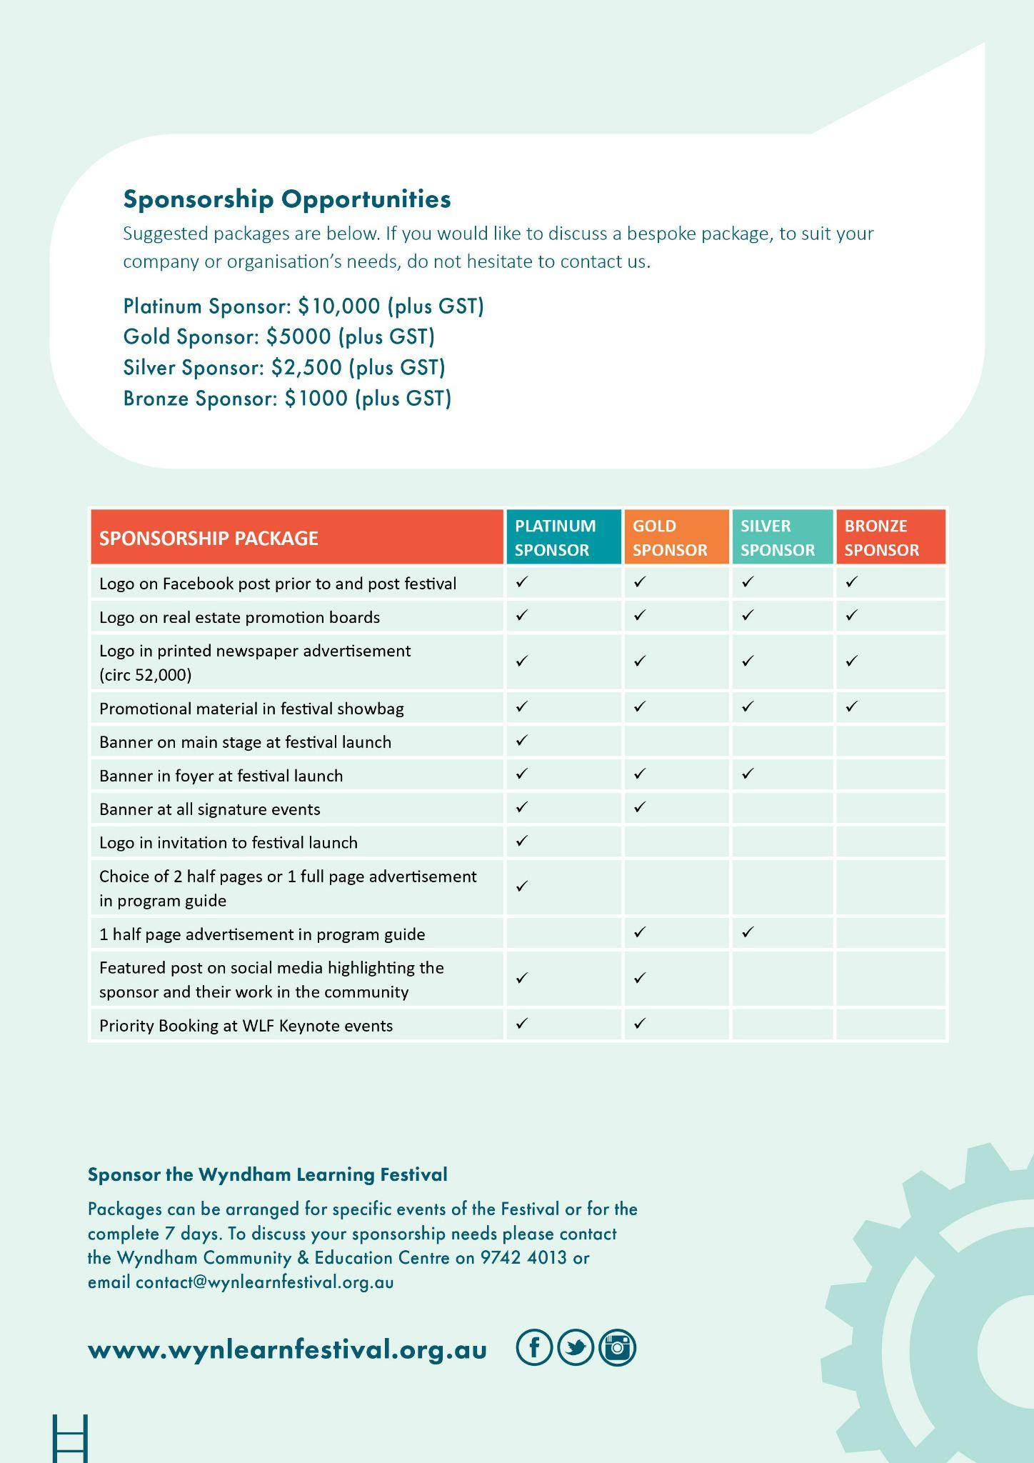

Through the hard work of the organising team, the WLF secured two Gold Sponsors for 2022:
- VU Polytechnic
- Pacific Werribee
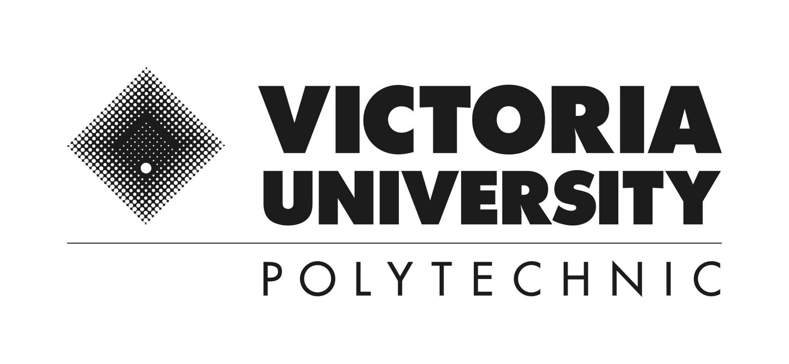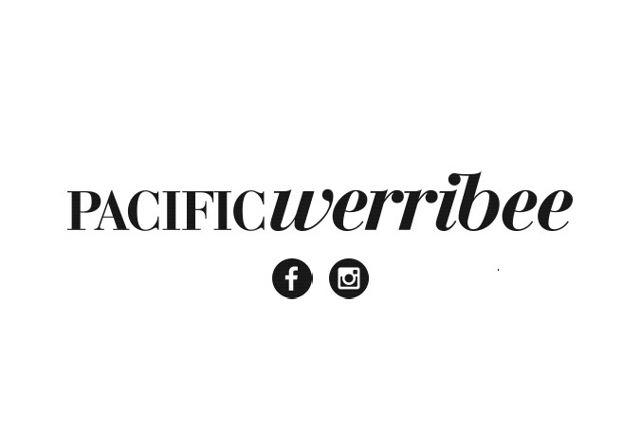

Community Engagement
In the lead up to the Festival, commencing April through to July targeted Electronic Direct Mails (eDMs) were produced and distributed through Mailchimp to over 476 community stakeholders and partners, encouraging groups to get involved through sponsorship, running events and participating in the events. Cut off for registrations was in mid July. Once the events were approved the EDM effort was focussed on education and support to the event holders. Participants were attracted to the events via a range of communication mediums.

Some statistics to note about marketing engagement via EDM

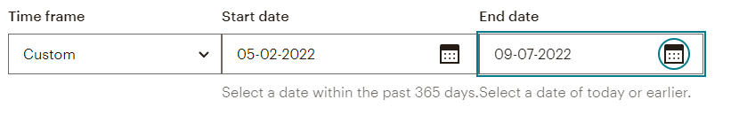
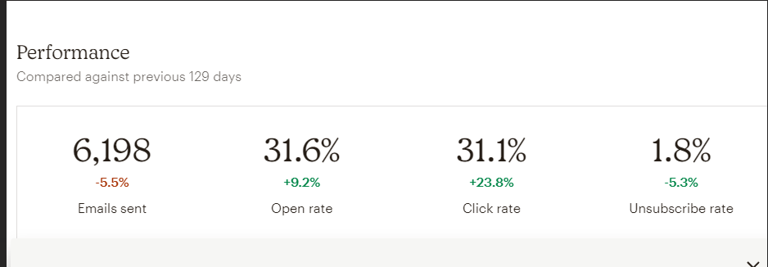
Example of EDM here
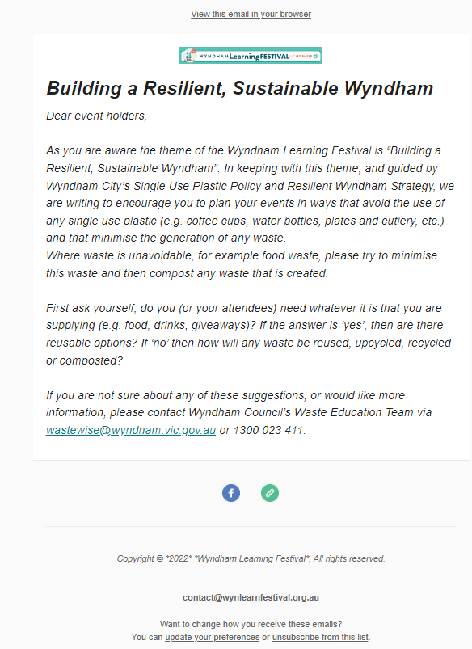

Support to Event Providers
Various communications were distributed to event providers in the lead up to the Festival. On 31 August 2022, the project coordinator emailed all event providers with detailed information on completing feedback surveys, posting to social media and also the event provider toolkit. Various support was offered including attending planning meetings of event providers, assisting with images for their events, detailed support for website issues including an instructional video:
Video on how to register a WLF event

The support to providers also helped increase registrations and participation for many providers, including for an event provider (see comment below) who said the Learning Festival team were great to work with …and made running an event a pleasure!
Survey Feedback from event holders:

Events Registered
Seventy (70) events were registered. Some event topics were held more than once in different locations. The registration numbers reflected are not an exact accurate count of how many people registered or attended. Some event holders ran separate registration platforms (eg. Eventbrite) and therefore registrations/attendances may be higher or lower. Eg Starting a home-based food business - Industry Insights reported to have over 60 participants and one of the Arts events run from Manor Lakes Community Learning Centre has now become a regular permanent event!
See appendix 3 for a table of all WLF events.
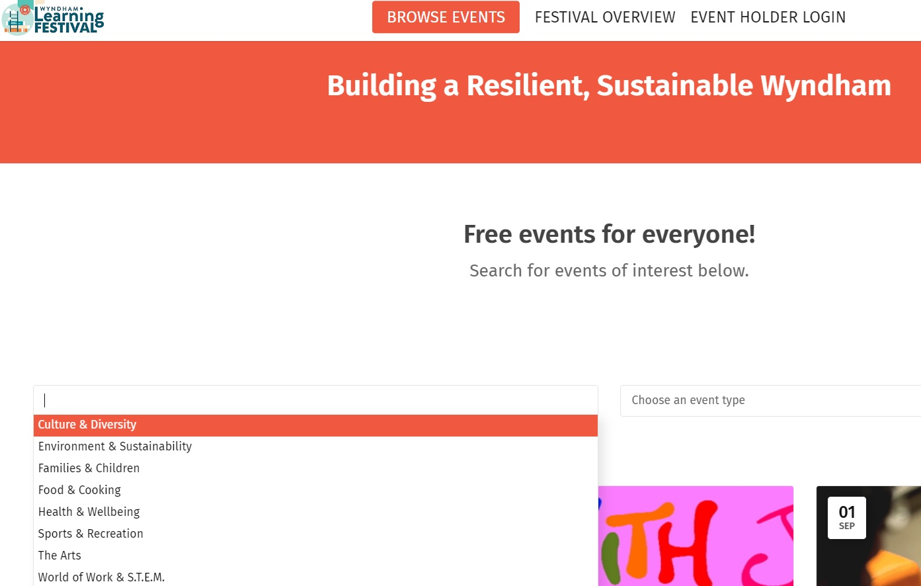

WLF Launch
The launch of the Wyndham Learning Festival was held Friday 5 August at the beautiful Wunggurrwil Dhurrung Centre, in Wyndham Vale.
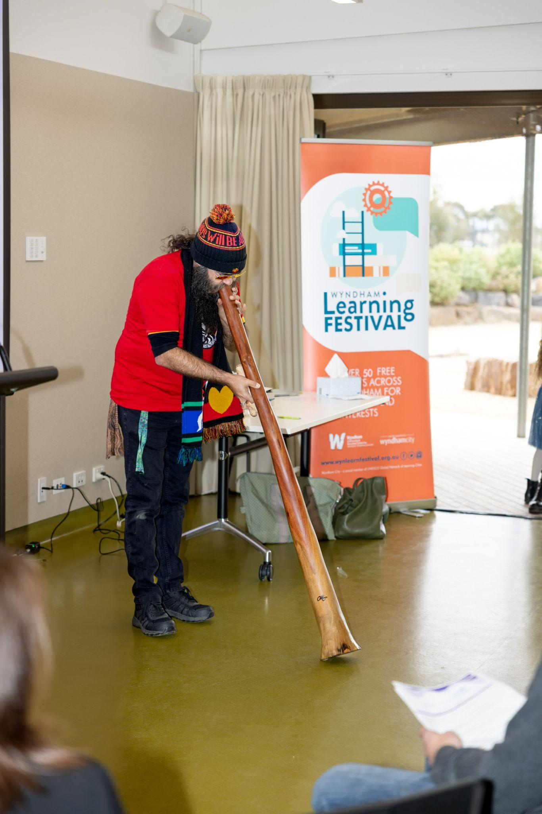 The launch featured a moving Welcome to Country and emotion-filled didgeridoo playing from the Wadawurrung Traditional Owners; and an equally moving Acknowledgement of Country in Aboriginal sign language by the Balim Balim kinder kids. VIPs including Wyndham City Councillors Hill, Ramesh and McIntyre; Stephen Wall, CEO Wyndham City Council; Maria Peters, Chair of Adult, Community and Further Education Board; Jenny Macaffer, CEO, Adult Learning Australia; and Dr Leone Wheeler, Honorary CEO, Australian Learning Communities Network and the 70-strong audience were treated to representatives of the two Gold Festival Sponsors, Victoria University Polytechnic and Pacific Werribee Shopping Centre, sharing their insights into Resilience and Sustainability and Learning in the Community.
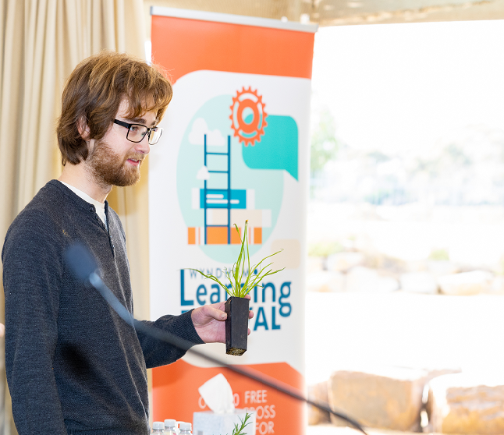Dylan Wishart provided a keynote – speaking from the heart as a proud Aboriginal man, and member of the Wyndham Reconciliation Action Committee, who is studying conservation and ecosystem management at RMIT and is passionate about seeing our urban spaces more biodiverse and more representative of the traditional character of the land we live on.
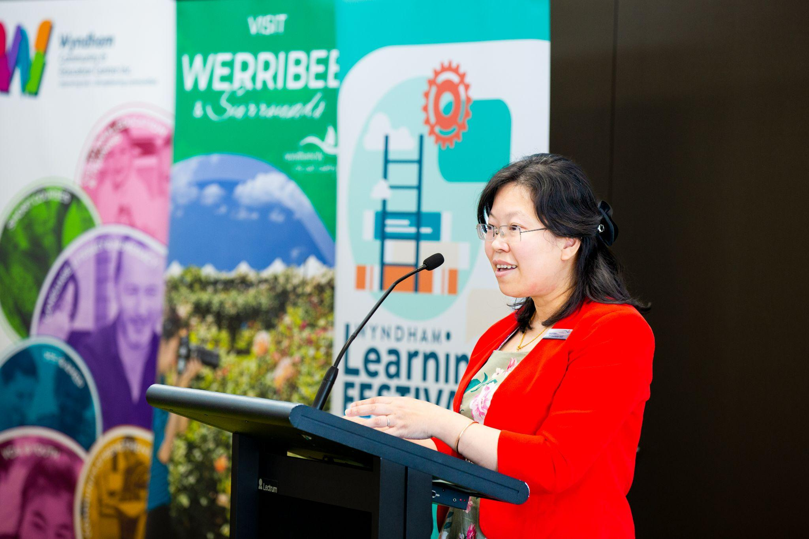 Cr. Jasmine Hill, Deputy Mayor & Learning City Portfolio holder then officially launched the Festival. The audience enjoyed a performance by the Alamanda College Vivace Choir singing a Sea Shanty (with their own sustainability lyrics) and the National Anthem in Dharawal and Dharug (Sydney Aboriginal Languages) and English. Rounding off the incredible talent in Wyndham schools, the Suzanne Cory High School Piano Trio played ambient music for the Launch guests on arrival and over morning tea once proceedings were finished.

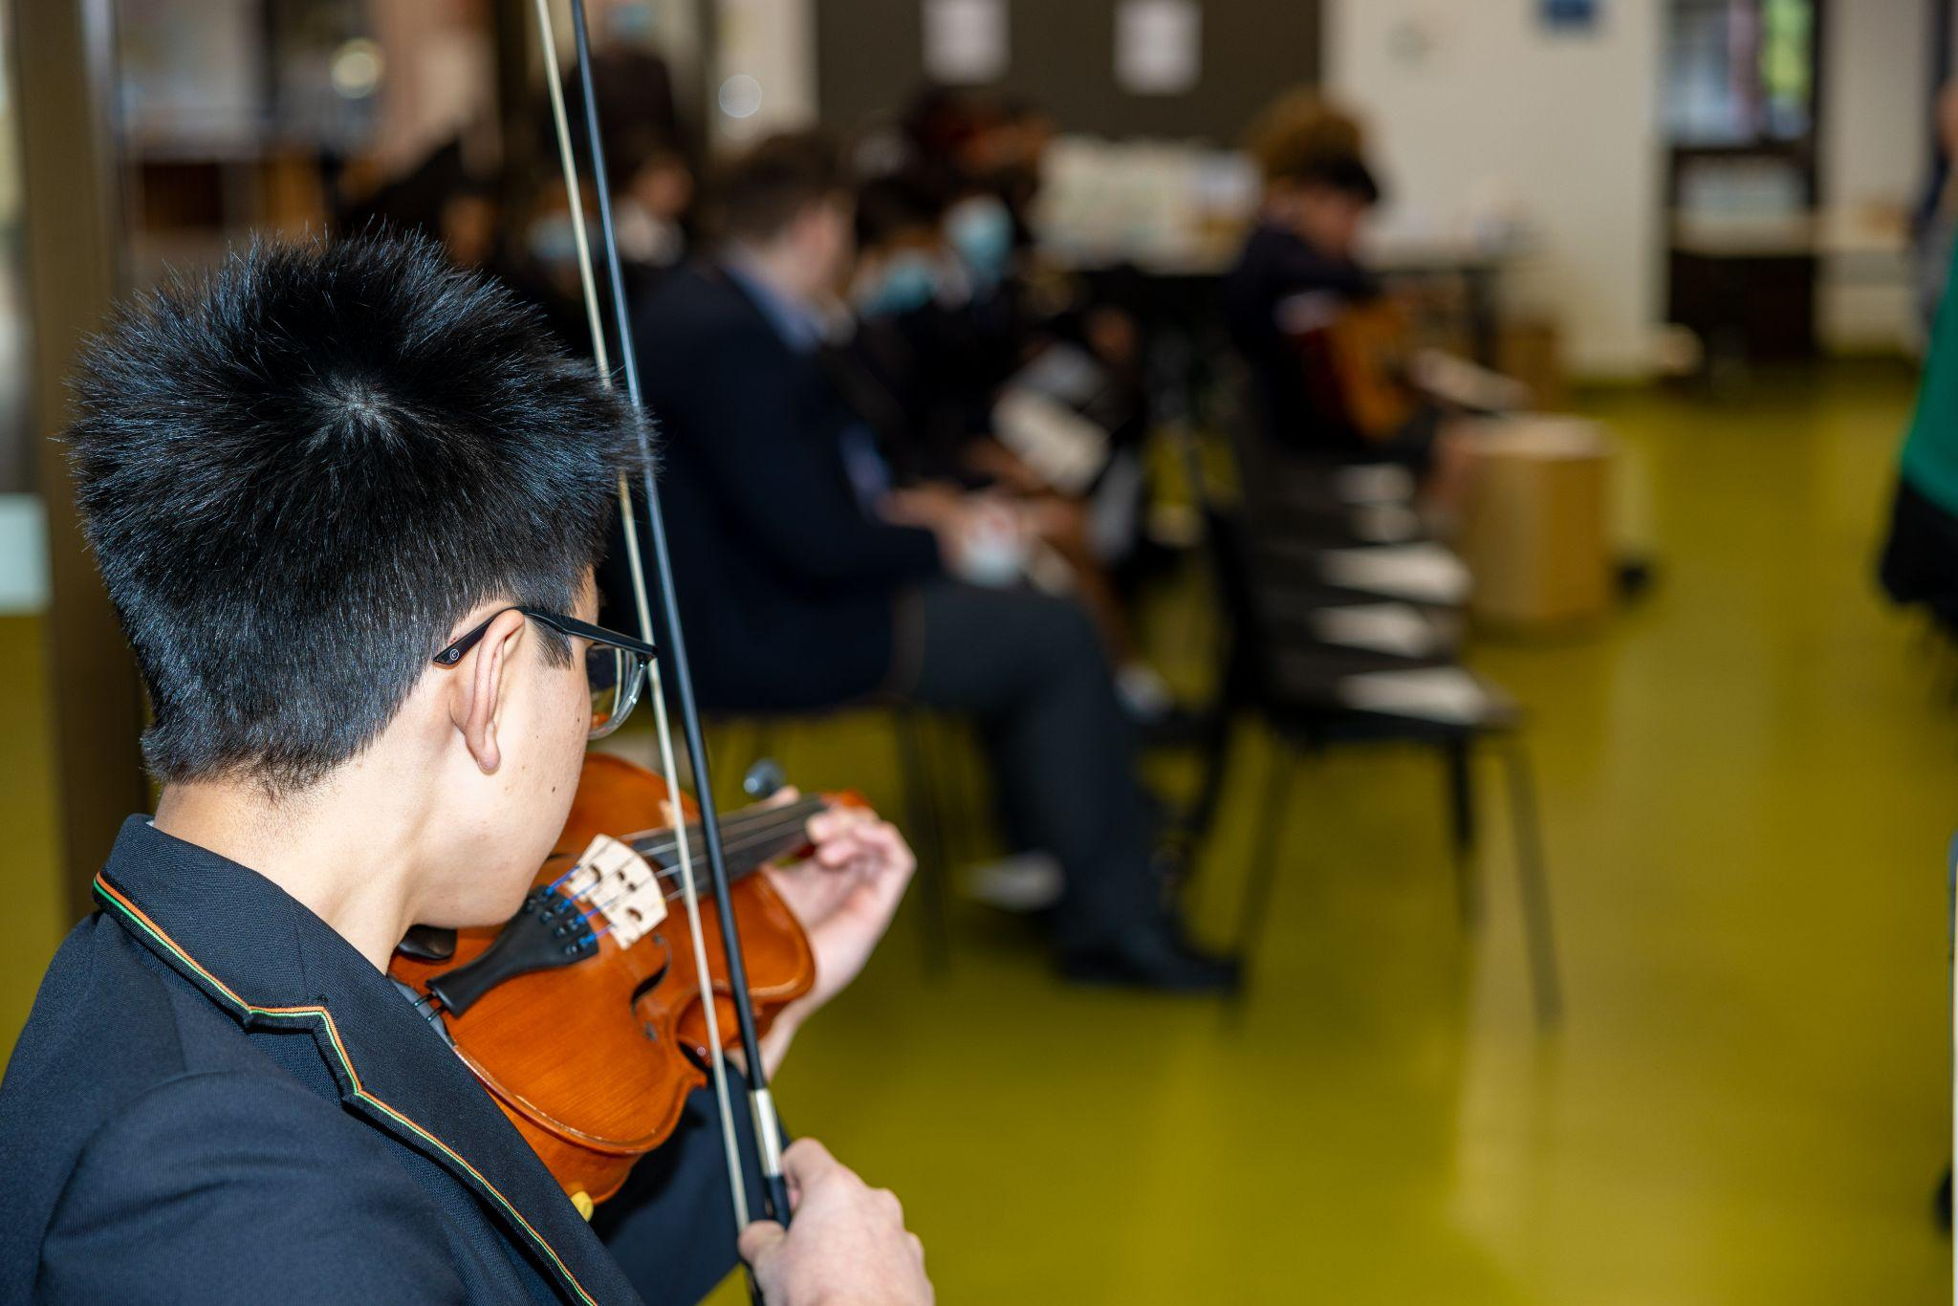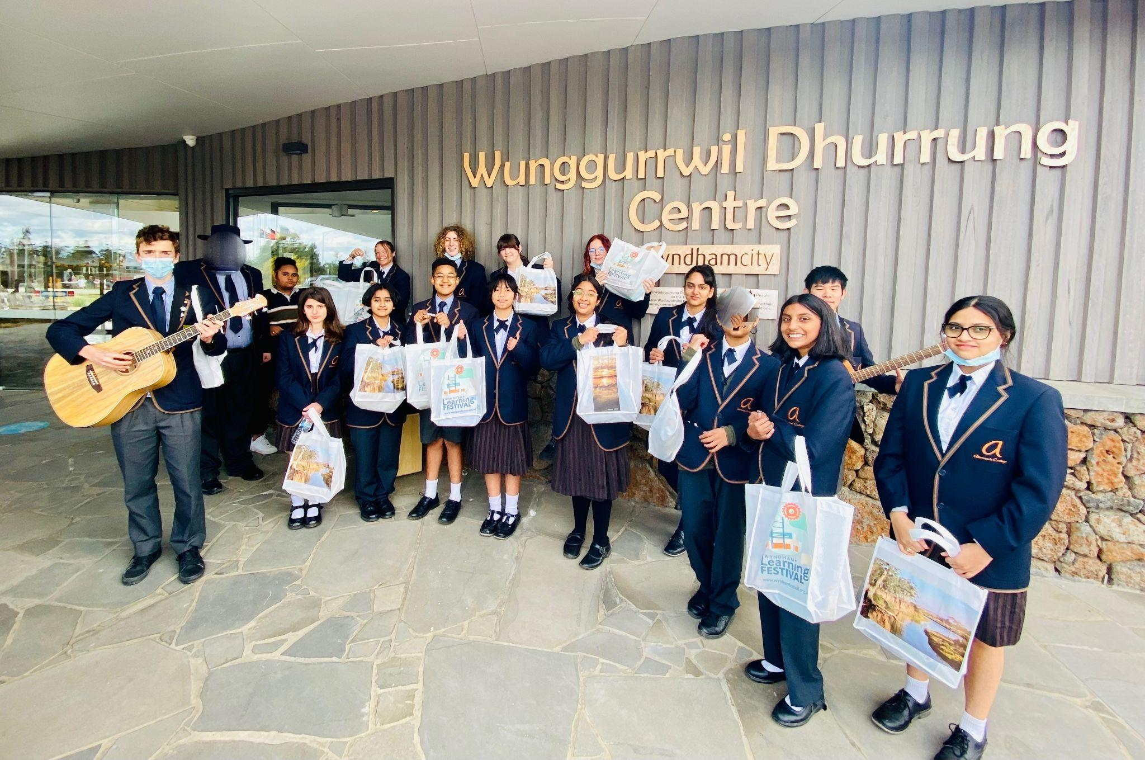

Wyntalk Signature Event
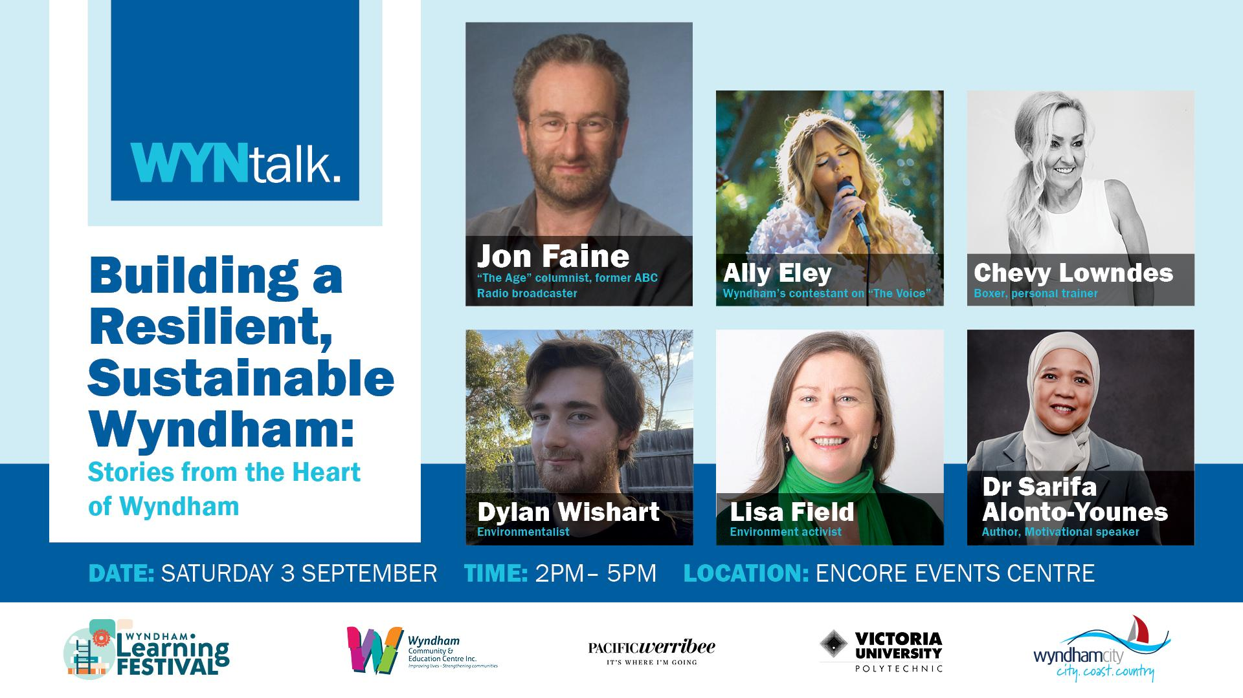
The Wyndham Learning Festival’s signature ‘WynTalk: Building a Resilient, Sustainable Wyndham: Stories from the Heart of Wyndham’ was held on Saturday 3 September at Encore Events Centre, featuring ABC presenter and The Age Journalist Jon Faine and local Wyndham panellists, Ally Eley, Chevy Lowndes, Dylan Wishart, Lisa Field and Dr Sarifa Alonto-Younes.
The panel was insightful, informative, and inspiring. Ally Eley, and her guitarist Steve, gave an entertaining performance featuring some of Ally’s original songs; the mini sustainable expo of local stall holders shared their ideas and information with the attendees; and audience members watched a screening of “Regenerating Australia”, the latest film from Damon Gameau, director of “2040” and “That Sugar Film”.
With 96 registrations, 195 total website views and 98 attendees on the day, the audience were engaged, informed, moved, and showed displays of spontaneous applause throughout the panellists' talk. There were even a few tears amongst the audience.
One audience member mentioned they ‘came away with lots of ideas around resilience and sustainability, especially as to when you are faced with a problem, just deal with it on the spot rather than procrastinate and make that (actually small) problem into something daunting and scary. So, I tried it with something I was stalling on, and the advice worked a treat.’

Other participant survey feedback included:
A Healthy and Sustainable Future – YOU Can Make a Difference! with Linh Do
As Melton’s Lifelong Learning Festival overlapped with the WLF, Wyndham collaborated on an online event called A Healthy and Sustainable Future – YOU Can Make a Difference! that featured in both Festivals.
Social change advocate Linh Do – Director of Leaders for Global Sustainability at the Uni of Melbourne, and advisor to the United Nations Environment Program, led the event connecting local stories of climate and environmental issues around the world.
Linh delivered a keynote setting the global scene – what is climate change, what are the risks and issues? Then the audience heard about the Melton/Wyndham emergency services response plan. Our respective Council Sustainability Officers took questions on disposing of waste, composting, electricity, and recycling. The audience were encouraged to take small and big actions to be part of the solution and influence change. The online event attracted 44 attendees from 96 registrations and the recording of the event was made available to those who registered with 57 views.
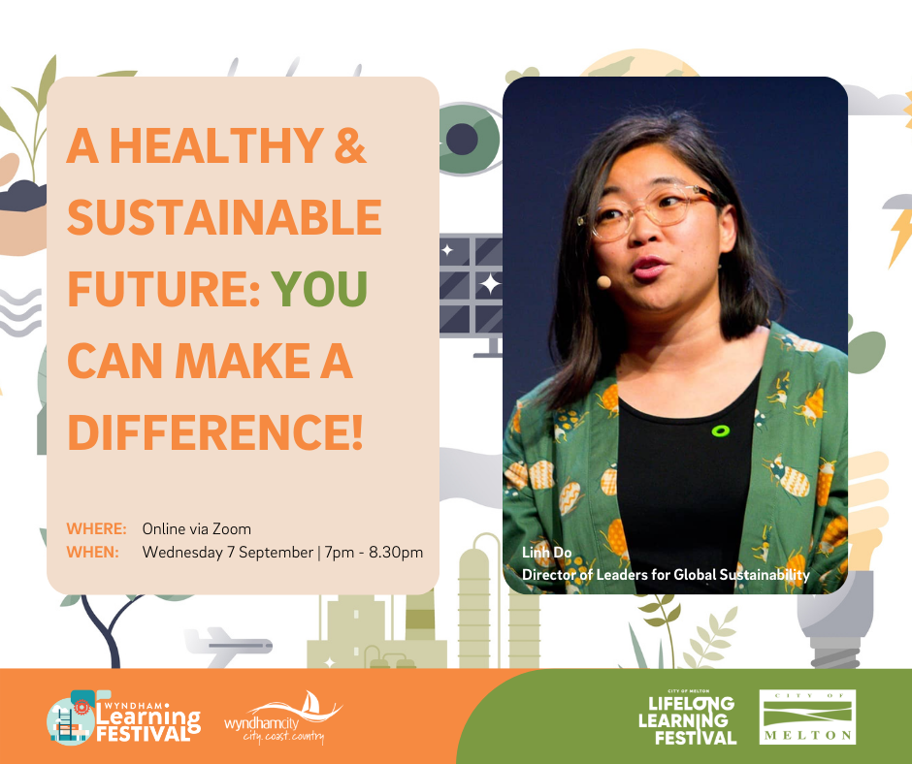
Feedback included:

Evaluation Framework
The Festival took a broad approach to measure the impact of the Festival through the following diverse qualitative and quantitative tools.
Measurement Type | Measurement | Tool
Qualitative | Stories of involvement | Most Significant Change Technique
 | Working group partnerships | MentiMeter
 | Working group feedback | MentiMetre and discussions in final reflection session
 | Event provider surveys | Survey Monkey
 | Participant surveys | Survey Monkey
 | On demand support feedback | Emails and chat function
 | Communications from partners | Emails and chat function (from the online monthly meetings)
Quantitative | Number and diversity of events registered | WLF Website
 | Participant registration numbers | WLF Website
 | Participant attendance numbers | Survey Monkey (event provider survey)
 | Social media engagement | Facebook and LinkedIn  Views, Shares and  Opens/clicks
 | eDM engagement | Mailchimp Views, Shared and Opens/clicks
 | Website views | WordPress

Most Significant Change Technique
The Most Significant Change (MSC) Technique is a qualitative evaluation tool that looks at the impact of the programs and events. This is measured through interviewing individuals who took part in the events. For the Wyndham Learning Festival, four individuals were interviewed. The interview was semi-structured, giving the participants the liberty to share their story and to fully capture the festival’s impact. Short stories were shared with the interviewees in case they had the desire to change or add to their piece.
The stories can be seen below and at the beginning of the report.
Leone Wheeler on Celebrating Inclusivity
Leone is the honorary CEO of the Australian Learning Communities Network (ALCN Inc) and has undertaken research on various learning city projects and most recently wrote about Wyndham’s journey to become a learning city with Diane Tabbagh. Leone has always been keen on what learning festivals offer and this year at the Wyndham Festival, two of the many events she attended were ‘Get Back an Hour Everyday’ which focused on time management and productivity and ‘A Resilient, Healthy, Sustainable Future’ a webinar focused on global sustainability issues and highlighting the need to prepare for emergencies locally. Leone reflected that these events link with part Wyndham’s own Learning Community Strategy: to learn from other international learning cities linking local to global, and to create a more inclusive learning community. A great example was Linh Do, the host for ‘A Resilient, Healthy, Sustainable Future’, who hosted her event all the way from Spain to an audience that participated from across various communities.
The sense of inclusivity was a significant part of Leone’s experience with the Wyndham Learning Festival, particularly attending the launch of the event. She found that the sense of inclusiveness brought joy to the event, especially after the COVID-19 lockdowns that caused a disconnect between individuals. Including a magnificent Welcome to Country at the Wunggurrwil Dhurrung Centre, Wyndham Vale, the event launch captured diversity and inclusivity for Leone as well as encouraging the value of learning. The essence of inclusivity made her experience at the Wyndham Learning Festival very impactful.

Laurie Nowell on Cultural Unity Through Education

Laurie is no stranger to attending the Wyndham Learning Festival as this was his third year attending the Festival. Laurie works with AMES Australia, an organisation that supports migrants, refugees and asylum seekers and also works closely with the Learning Festival. He found that the Festival Learning events share the valuable ability to unite people across cultures and communities through interchanging skills and knowledge.

A significance of the Wyndham Learning Festival for Laurie was seeing people from different cultural backgrounds coming together through education. The act of sharing knowledge to a granular level and displaying practical knowledge not only benefits people as individuals but also tightens communities, promoting cultural unity through education

Event Participant Feedback
A survey was developed in Survey Monkey and asked participants a variety of qualitative questions about their involvement in the Festival and event. There were eighty (80) total responses received from the participants. A summary of the survey results can be accessed from Appendix 2.
In general, the results demonstrate that
- 72% of participants registered attended one learning event, 12% attended two events, with 1% attending 8 events
- 44% of participants were from Werrribee, with 3% from Point Cook and also Hoppers Crossing. Attendees also attended from neighbouring suburbs from Altona, Moonee Ponds, Yarraville and as far as the USA!
- Surprisingly 25% of participants were from a young cohort of 18-24-year age group, followed by 23% from the 45-54 year old cohort
- In comparison, a lesser proportion of young people completed surveys or maybe there were less youngsters participating in the events. This clearly shows that there is a need for additional support and encouragement towards younger people to attend future events.
- 97.5% of participants were very satisfied or satisfied with the events quality - highlighting the WLF events were successful for Wyndham residents.
- 93% of particpants were very satisfied or satisfied with event as a learning experience and benefits stated include:
· Started to be more aware of being more sustainable
· Learned about what it was like to be a writer and writing tips
· Being brave to face my challenged
· Some real gems of wisdom from the panel and Jon Faine wove the stories together to make it very entertaining. You couldn’t hear a pin drop during the panel.
· I learnt more about the Wyndham Community
· Greater knowledge of local area
This shows that the learning outcome of the events may have a positive impact on the participants, thus enhancing participants' knowledge and learning experience.
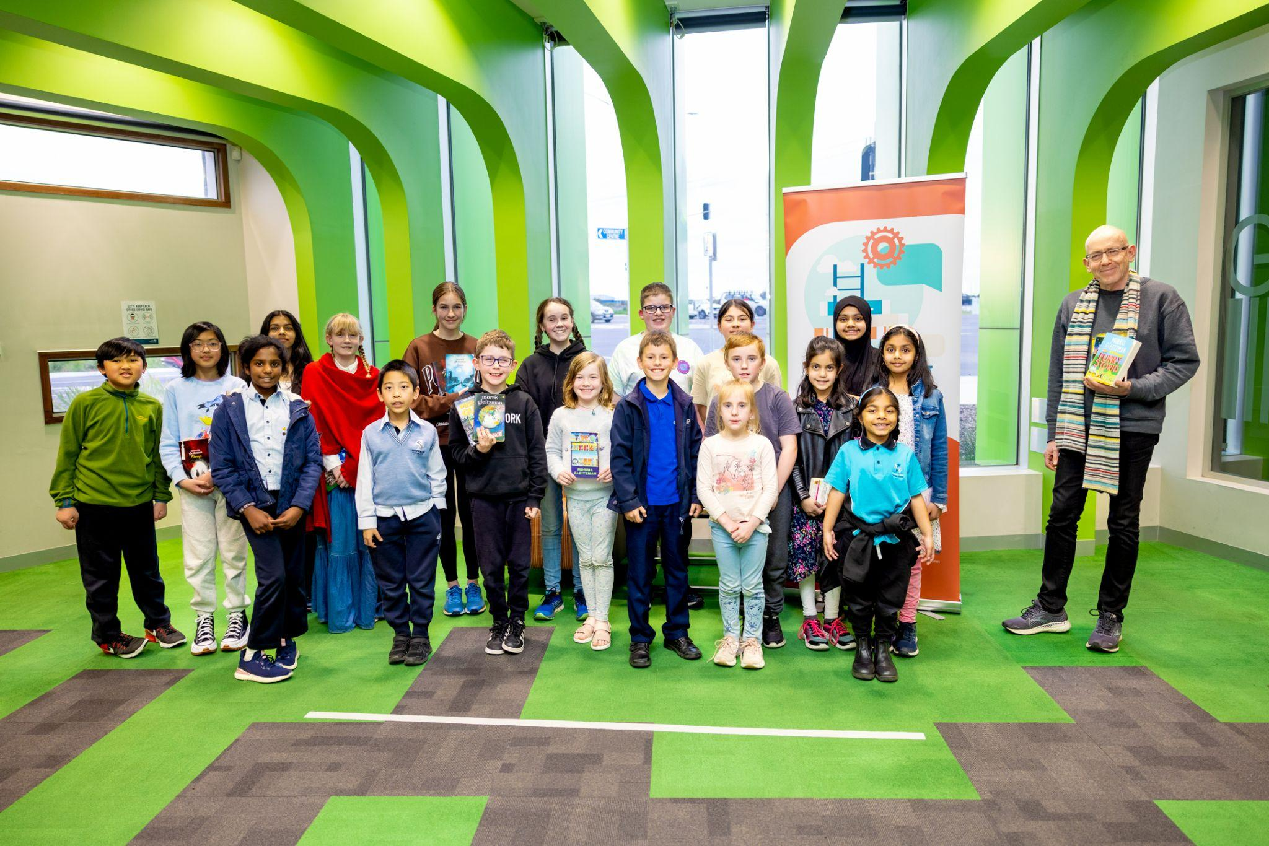

Event Provider Feedback
Eighteen (18) WLF event providers filled out the survey monkey survey. A copy of the data is available in appendix 1, with some notes mentioned below:
Key points of feedback from event holders:
- 74% of Event Holders felt the Festival was well promoted
- 89% of Event Holders says they were very likely or likely to recommend to host an event in the next Festival
- 77% of Event Holders said they would host an event in future Festivals
Perceived Impact on Participants:
- 78% confidence and empowerment
- 89% developing skills and knowledge
- 73% try something new
Do you have any comments?
- Being a part of this learning event was wonderful. It was wonderful to see a number of organizations come together for one cause”
- Well done all concerned. Very well organised. Thank you!
- Amazing experience, highly recommended to business owners to participate
- The Learning Festival team was great to work with. They were responsive and knowledgeable and made running an event a pleasure. Thank you!

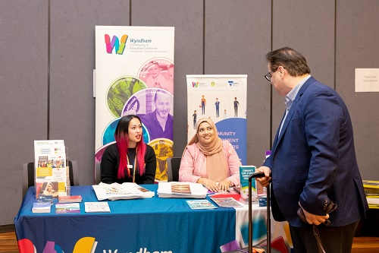

Post Festival Reflections Session
A reflections session was run with the working group on 11 October 2022. The following are a summary of the responses from the session, using the MentiMetre tool.

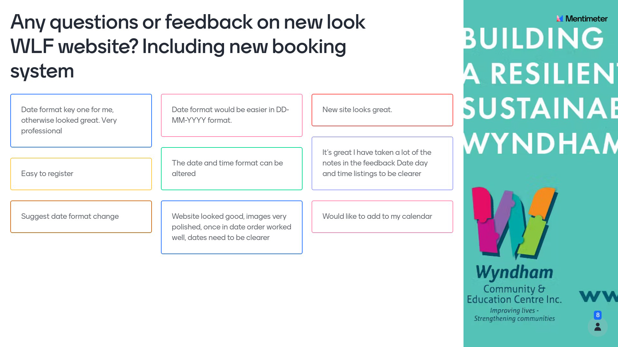
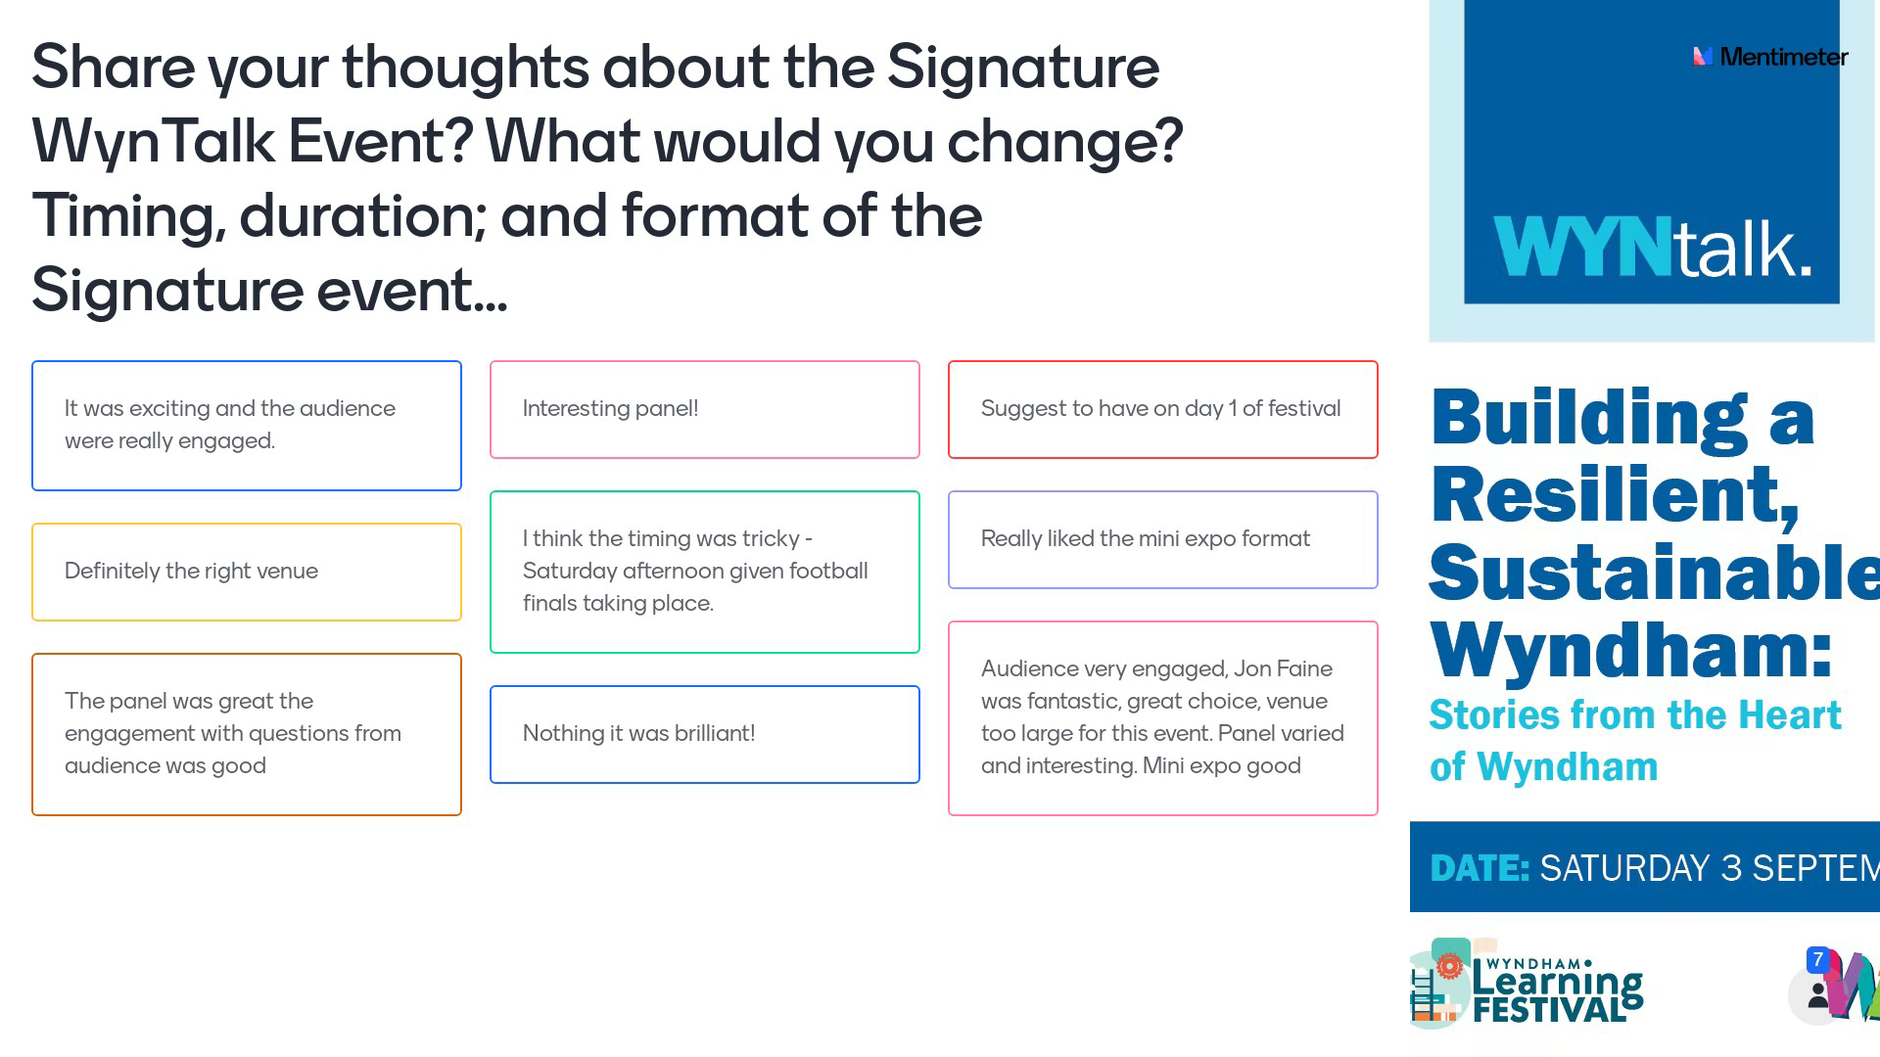

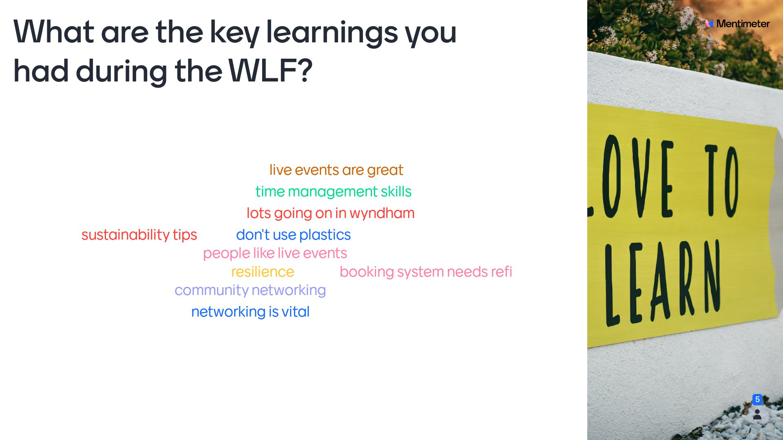
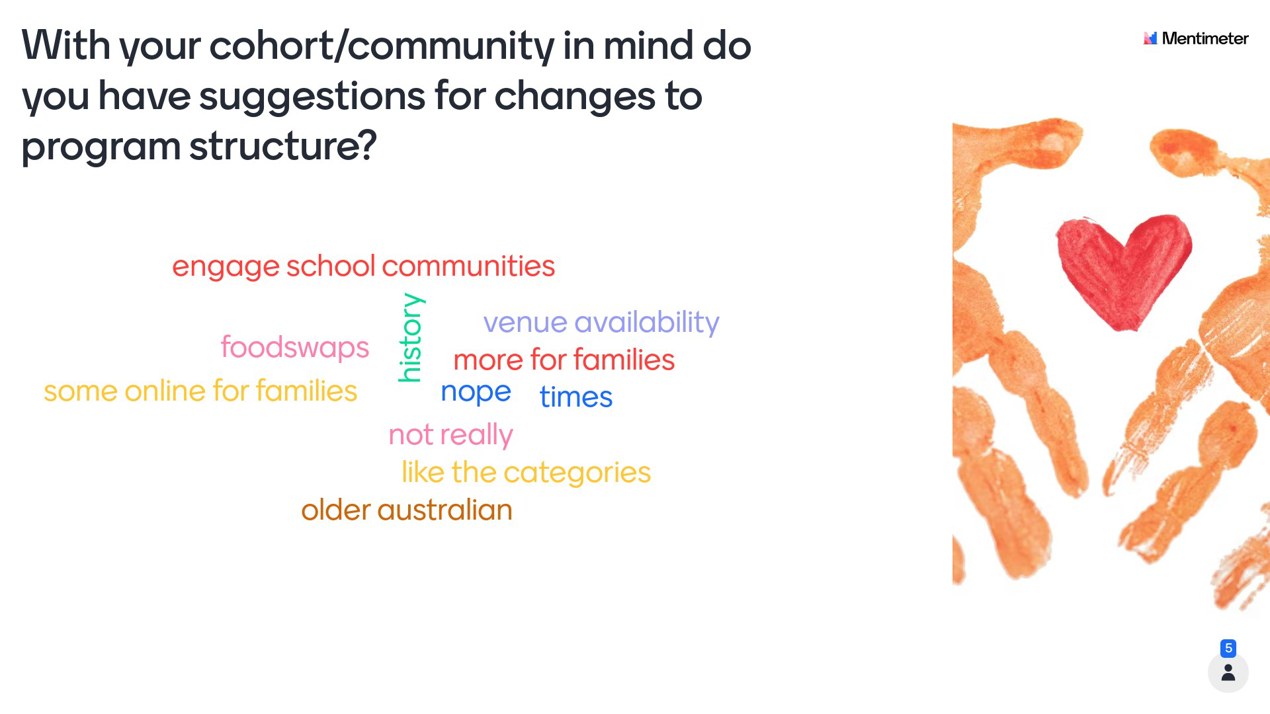
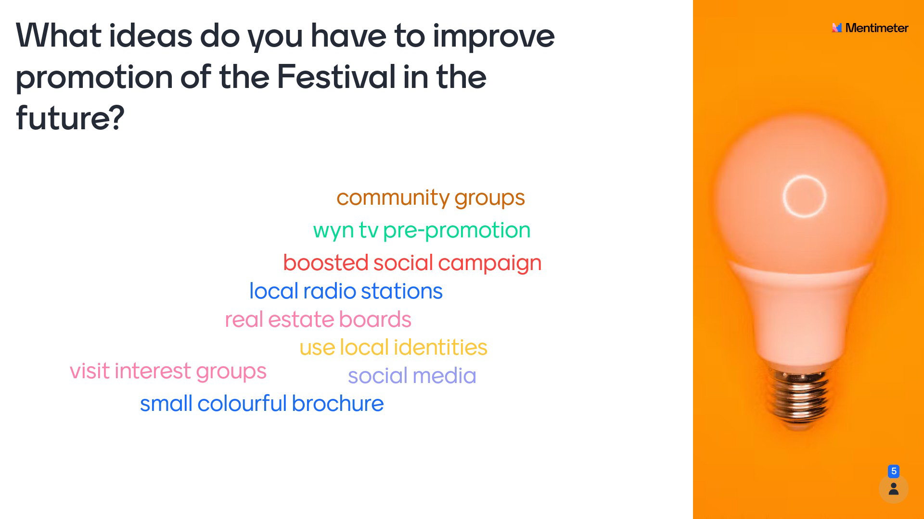
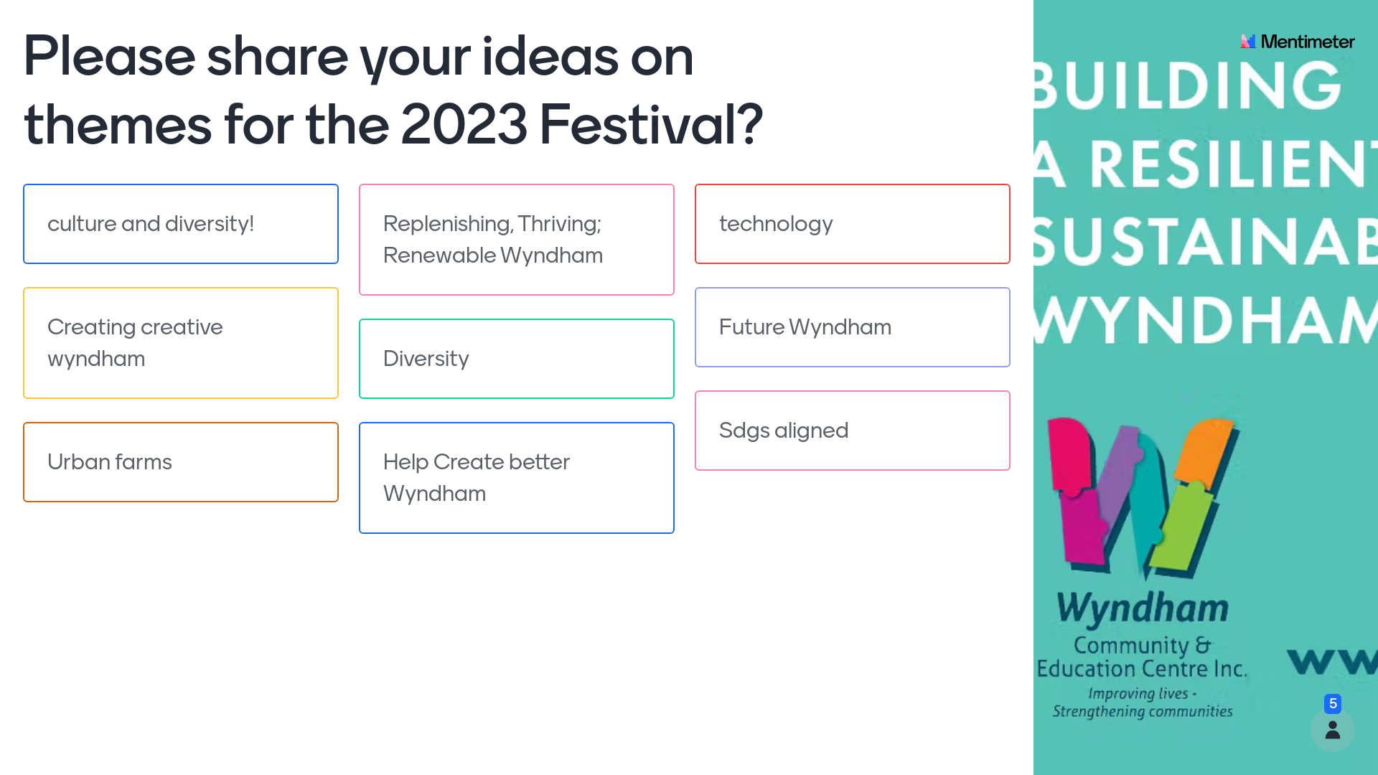

Next Steps
The Festival team will take a break, and then planning will begin for the 2023 Festival. The 2023 Working Group will be established around a new Terms of Reference, and the framework and goals for the 2023 WLF will be designed from February 2023. The Festival is set to run from 1-7 September 2023. The call for event providers to submit their expression of interest to run an event will occur after March 2023.

Contact Details
For more information, www.wynlearnfestival.org.au or email contact@wynlearnfestival.org.au.

Links:
Email
Website
Facebook
Instagram

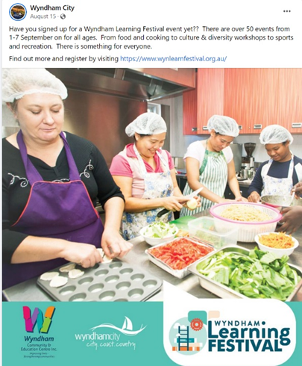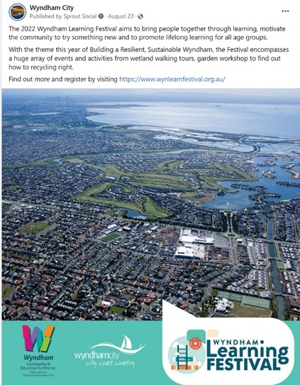

Appendix 1: Feedback from Event Provider

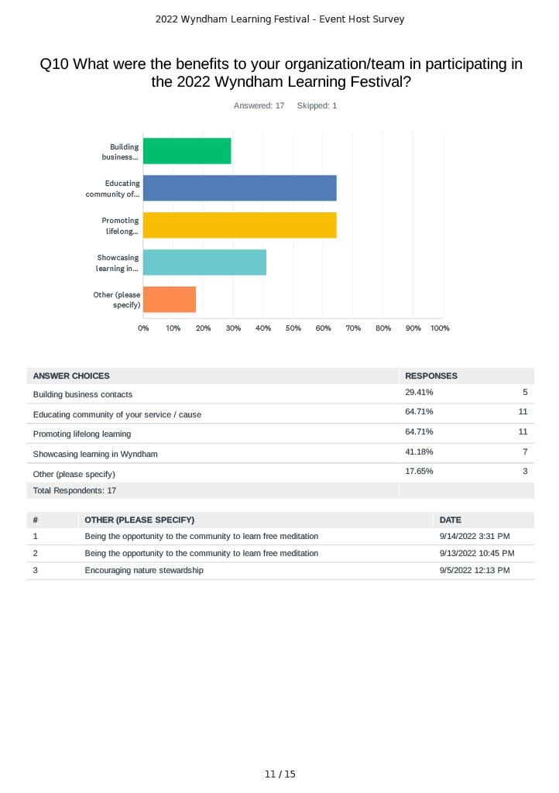

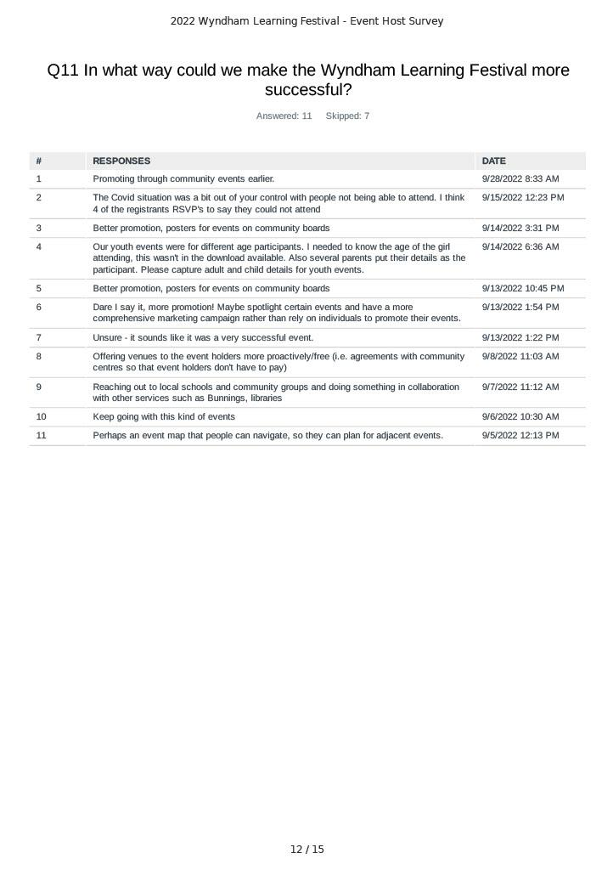

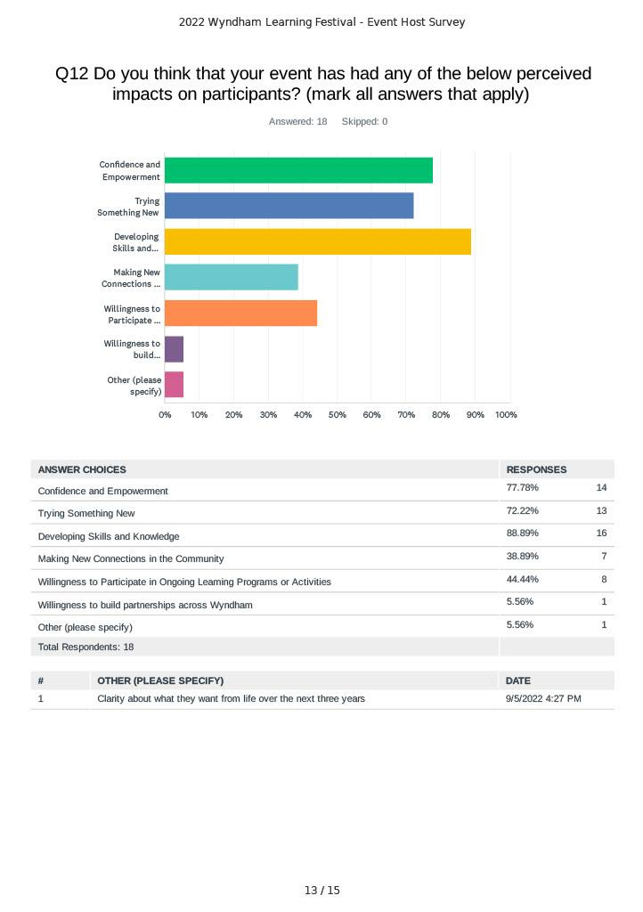

Appendix 2: Feedback from Event Attendees

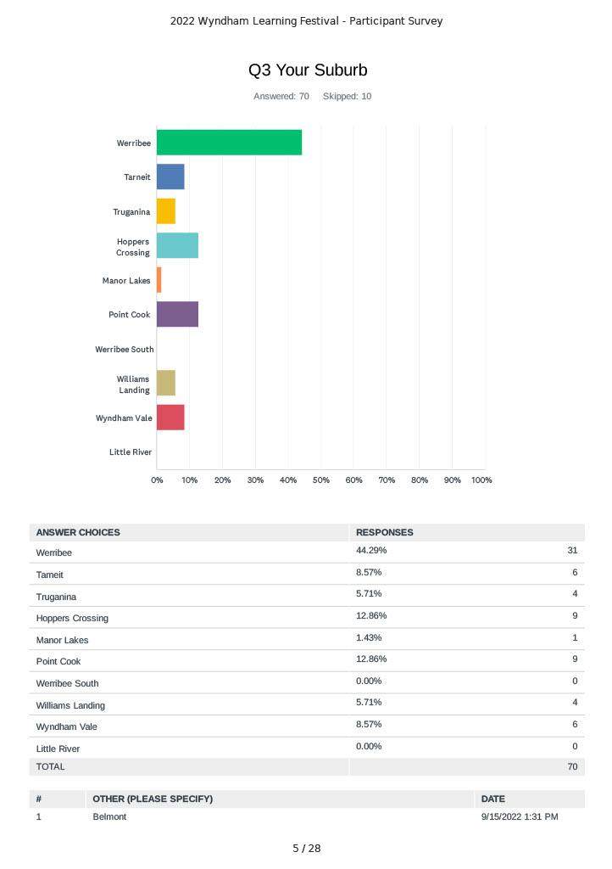
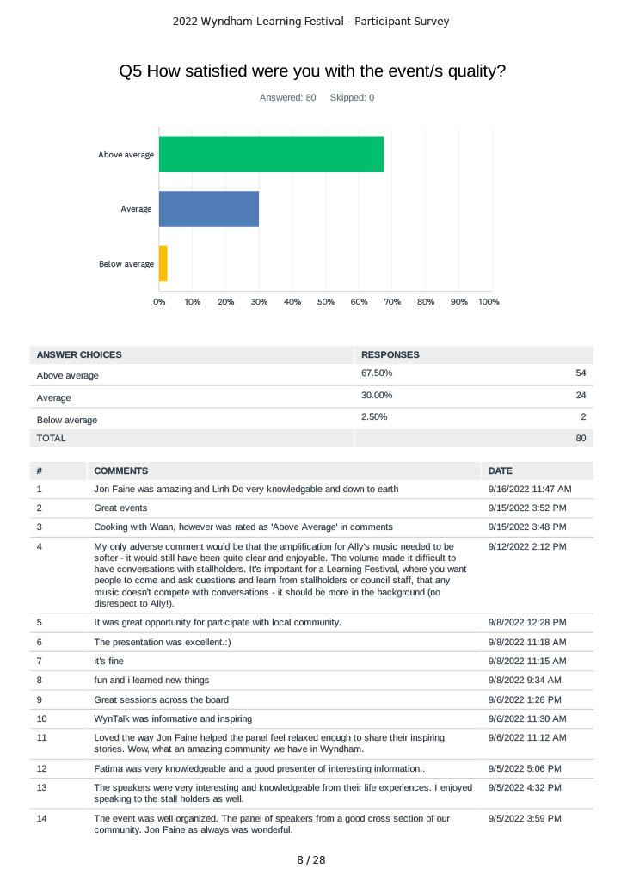

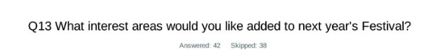

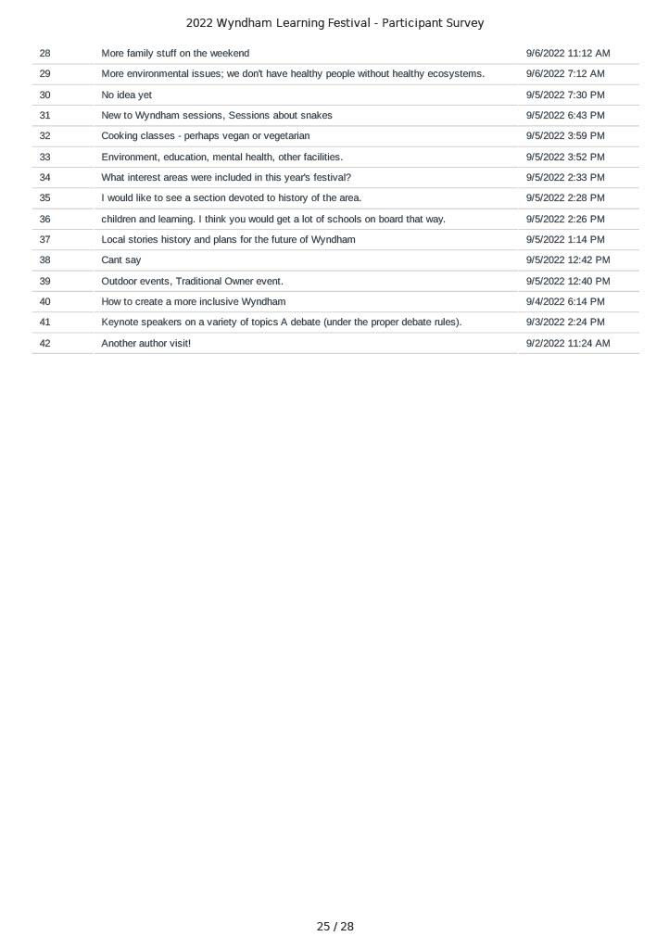

Appendix 3: 2022 WLF Program

Event Title | registrations
KU Food for Life “Video Series” | 12
Ceramics and Pottery Workshop | 8
Working In Wyndham- Manor Lakes Community Learning Centre | 8
Learn about Lids4Kids and what can be created from recycled items | 14
Let's Eat - for carers of fussy eaters | 12
Beginners STEM learning for Adults | 6
WynSenior Group Fitness Classes for those over 60 years of age | 5
Be Connected | 3
Working In Wyndham- Hoppers Crossing Library | 18
Children's Author Talk with Morris Gleitzman | 7
Dealing with Uncertainty: The Power of Your Perspective | 8
From Chaos to Calm: How to Overcome Overwhelm and Get Stuff Done | 25
Sahaja Yoga Meditation - 7 Day Free Online Course | 9
How to make Dumplings | 9
Create Your Vision Board and achieve your dreams | 13
Mental Health &amp; Wellbeing | 64
Elevate your business with a consistent visual brand | 6
Kids Chat | 13
Discover Our Food Future at Velisha Farm | 48
Make The Switch: Reusable Pad Sewing Workshop | 9
Learn to Lawn Bowl @ The Hive | 18
CityMX - Introduction to off road Motorcycles | 8
Wyndham Multicultural Sport Expo | 65
Young Scientist competition of Wyndham | 6
Coding Bootcamp for Kids | 27
Point Cook Wetlands Walk | 8
Full STEM Ahead | 15
WynTalk: Building a Resilient, Sustainable Wyndham: Stories from the Heart of Wyndham | 96
The 3 Secrets from Parents who raise Resilience and Happy Children and Teens | 11
Get to know your Naturehood! | 26
Sahaja Yoga Meditation &amp; Music- Tarneit | 14
Multicultural DV-alert workshop | 11
Working in Wyndham- Point Cook Community and Learning Centre | 15
Assess Your Employability Skills | 33
Youth Cooking Program | 10
NIDA Open Public Speaking Workshop for Teens | 5
Art sessions with Irene for kids | 11
Be A Girl Guide For A Day (Adventure) | 4
The role vegetation plays in cooling our urban environments. | 12
Building Resilience in Children | 21
First Aid &amp; CPR | 45
Scone making with Christine | 8
Smart Cities Simulation Workshop | 20
Be Connected: Can you spot a scam? | 6
Skill Up for the Future with Trailhead | 11
Basic Car Care | 11
Photography For Relaxing | 20
Get Back An Hour In Every Day | 25
Working In Wyndham- Tarneit Community and Learning Centre | 20
Starting a home-based food business - Industry Insights | 15
Be A Girl Guide For A Day (Cool) | 9
Be A Girl Guide For A Day (Wombats) | 2
Safer Homes in Wyndham by Crime Stoppers | 5
Thai cooking with Waan | 8
Disability Confidence Training | 45
Recycling 101 in Wyndham | 16
Introduction to Microsoft Excel | 11
What you need to know to get that job! | 12
Recycling Right Workshop | 40
Working in Wyndham (Youth)- Featherbrook Community Centre | 6
Art Sessions with Irene - Adults | 12
Getting started with Scratch | 2
Cupcake Decorating for kids | 17
South Sudanese Language Cafe | 5
Strategies for Supporting Stressed Out Teens | 5
Building resilience to succeed in an ever-changing world | 29
Safer Homes in Wyndham | 3
Cakes by Design - Adults | 10
My Smart Garden - Growing Salad Greens | 60
A Resilient, Healthy, Sustainable Future: you can make a difference! | 97
TOTAL | 1288

