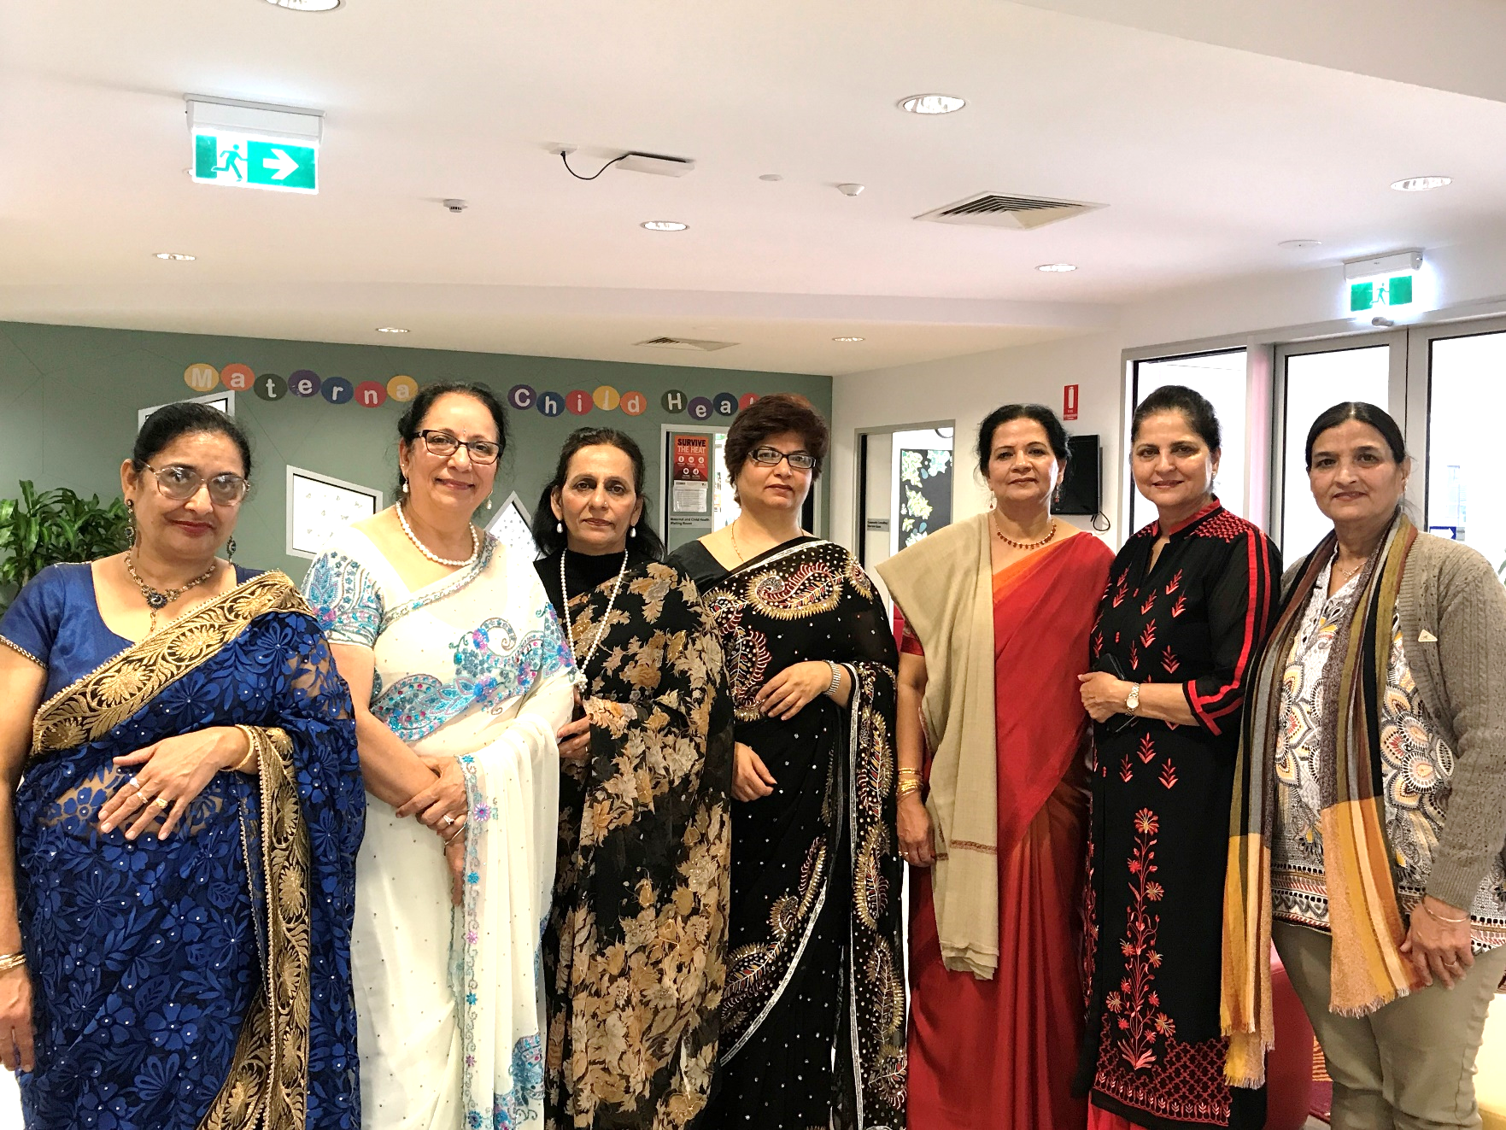

PENROSE PROMENADE

COMMUNITY CENTRE

**Council works to ensure activities in community centres meet local needs and interests. With projected growth in population in the coming years, we are focussed on reaching out to new residents and communities who we haven’t met yet. Priorities for activities have been developed for each community centre based on local demographic data, what residents have told us is important to them along with an assessment of current activities. This fact sheet provides an overview of all this information and the related local priorities.**

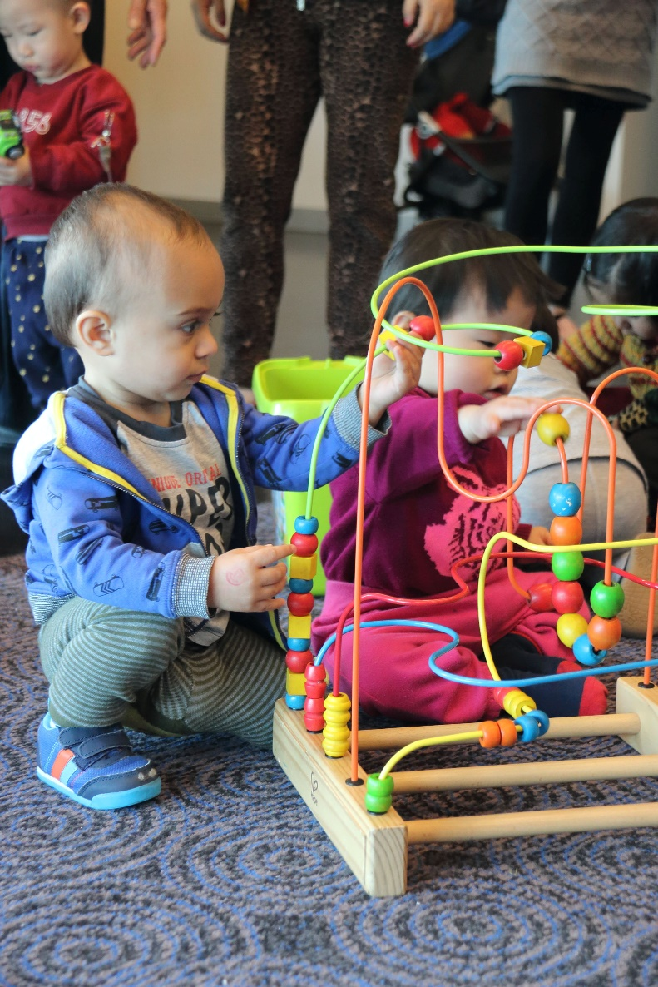

Who lives in and

Around Tarneit?



52% of Tarneit residents were born overseas   
and speak languages other than English at home



Top Countries of Birth

India 11.9% | New Zealand 3.9% |Phillipines 3.2%



59% of the adult population of Wyndham Central are employed

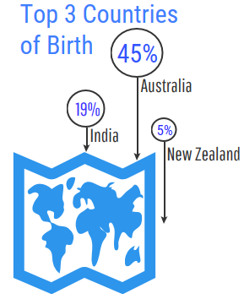

Tarneit Residents Value

**“*Quality Education”***

***“Support Services”***

***“A Place to Bring-up a Family”***

***“Opportunities for community to connect”***

***Wyndham 2040***

What We’re Hearing…

“We’d love to see more opportunities for learning, sports, family activities, health and exercise, and arts and craft!”

“We would love to see natural living knowledge classes and activities, such as gardening”

“We highly value education and opportunities that provide education for our children”

“It would be fantastic to have programs that allow me to express my creativity”

* Opportunities to support learning and express creativity for children, young people and families.
* Activities and programs that bring together and support families from diverse cultural backgrounds.
* Activities that promote sustainability and the environment.
* Activities and programs which promote and encourage positive mental, physical wellbeing and emergency relief and assistance.
* .

**NEIGHBOURHOOD ACTIVITY PRIORITIES FOR 2022**



This information can be translated by contacting Translating and Interpreting Services on 131 450 and asking to be connected to Wyndham City on 1300 023 411