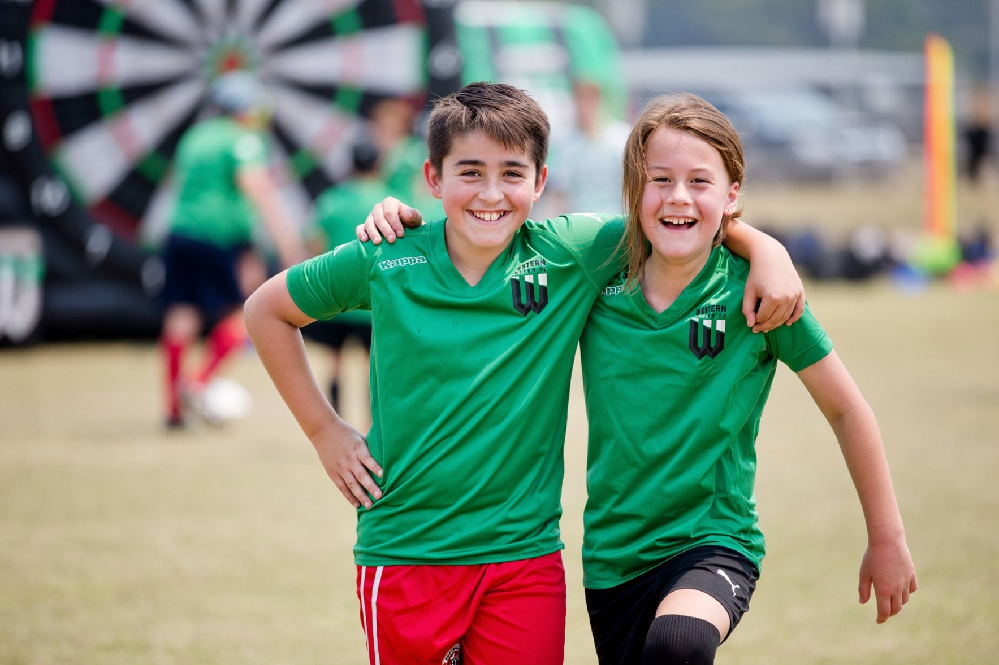

ARNDELL PARK

COMMUNITY CENTRE

**Council works to ensure activities in community centres meet local needs and interests.**

**Priorities for activities have been developed for each community centre based on local**

**demographic data, what residents have told us is important to them along with an assessment**

**of current activities. This fact sheet provides an overview of all this information and the related**

**local priorities.**



Who lives in and

Around Truganina?

45% of households are couples with children

More than half (53%)   
of Wyndham East residents were   
born overseas

65% employed  
in the adult population of Wyndham East

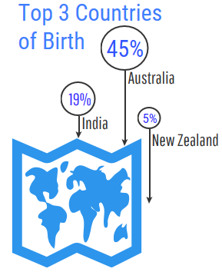





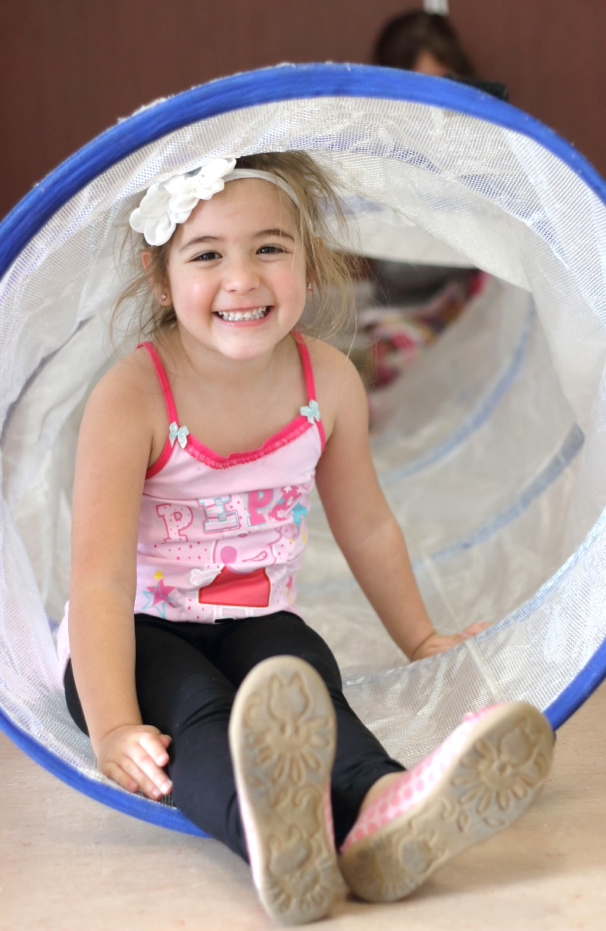

Truganina Residents Value

**“Quality Education”**

**“Local Services”**

**“A Place to Bring-up a Family”**

***Wyndham 2040***

What We’re Hearing…

“We want Halls for Hire for private functions”

“We would like to see more all abilities group activities for families including seniors come together and celebrate”

“We want Multi Cultural Playgroups”

“We would like some training to upskill for Job opportunities and or create a business”

“We’d love to see more opportunities for learning, sports, family activities, health and exercise, and arts and craft!”

“We would like to have school holiday programs”

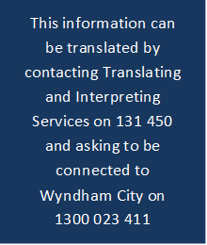

* Creative activities, programs and opportunities that promote the mental and physical wellbeing of all residents in Truganina which could include but not exclusive to music, dance, drama, visual arts, media arts, yoga, walking groups, pram groups, cycling, gardening and all ability activities
* Training, education or service focused on connecting and supporting families with young children and seniors which could include but are not exclusive to early childhood development, leadership skills for emerging leaders and entrepreneurial opportunities
* Projects and social events to build, strengthen and sustain healthy community relationships which celebrate and acknowledge our diverse communities in Truganina.

**NEIGHBOURHOOD ACTIVITY PRIORITIES FOR 2022**