1 ROLE
All Victorian councils are required to establish audit committees under the Victorian Local Government Act. While the Audit & Risk Committee (the Committee) is not a delegated committee of Council, under the act they are subject to the same obligations as a delegated committee in relation to integrity standards and penalties for their breach.
The Committee has no executive role. It is an advisory committee that plays a key role to assist Wyndham City to fulfil its assurance and compliance responsibilities. It is independent of management and reports to the Council, providing recommendations to facilitate decision-making by the Council. The Committee engages with management in a constructive and professional manner in discharging its advisory responsibilities and formulating its advice to Wyndham City.
The Committee has an important independent governance role for the organisation. Wyndham City utilises the ‘Three Lines’ governance model. This is recognised as global best practice in the governance of an organisations risk and control management systems. This model is used to structure the assurance environment and clarify roles and responsibilities.
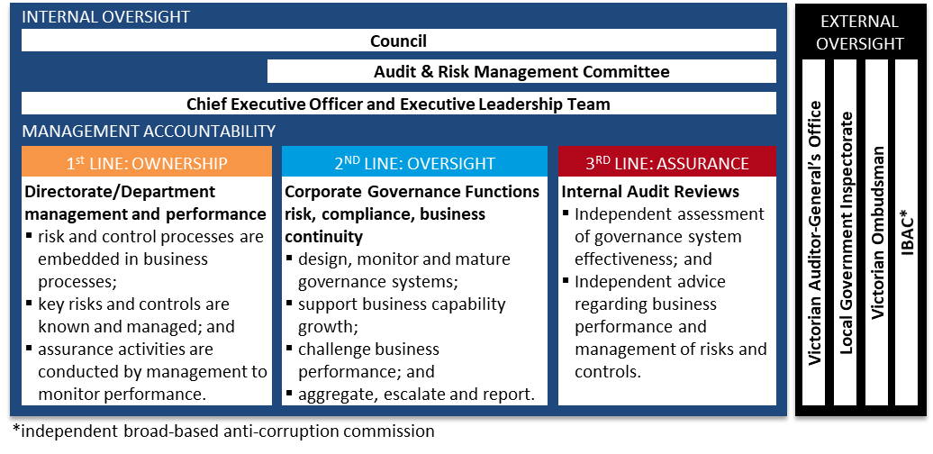

2 DATE OF EFFECT
This charter has effect from 23 May 2023 following its adoption by Council at its Ordinary Meeting on this date.

3 REVIEW FREQUENCY
The Charter will be reviewed annually by the Committee subsequent to its annual assessment and Council approval will be sought for any proposed material amendment.
Note that the Audit and Risk Committee Annual Work Program will be presented as part of Council approval process but is a working document and will be updated as required.

4 OBJECTIVE
The primary objectives of the Committee relate to:
- Governance – ensuring the transparency of Management and Committee performance in meeting the obligations of this Charter; through planning a program of work, provision of necessary information, assessment and reporting of achievement.
- Finance & Performance – enhancing the credibility and objectivity of financial and performance management and reporting, including monitoring and review of financial statements, accounting policy and practice.
- Audit & Risk - reviewing the appropriateness and effectiveness of management’s business systems and processes, through assessment of risk and compliance information to confirm adequacy and effectiveness of the internal control environment.

5 AUTHORITY
The Committee is authorised to:
- Review the internal and external auditor’s annual audit plans and reports of all audits undertaken.
- Seek any information or advice it requires from Councillors, Management or external agencies via the Chief Executive Officer.
- Formally meet with Councillors, management, internal and external auditors as necessary to fulfil its responsibilities.
- Seek resolution on any disagreements between management and the external auditors on financial reporting.
- Request external legal or other professional advice, as considered reasonably necessary to meet its responsibilities, that will be provided at Wyndham City’s expense.
The Chair is authorised to:
- Require the tabling of Committee reports via the CEO to Council at Ordinary Council Meetings.
- Prepare a biannual audit and risk report which describes the activities of the Committee, including finding and recommendations, on behalf of the members; which will be provided to the CEO for tabling at Council.

6 MEMBERSHIP
The Committee will comprise seven members, the majority of whom must be independent:
- one (1) independent Chair (must not be a Councillor of Wyndham City);
- three (3) independent members with backgrounds in finance, risk management and have experience in public sector management; and
- three (3) Councillors (including the Mayor).
The Committee must collectively have expertise in financial management and risk; and experience in public sector management. The Committee must not include any person who is a member of Wyndham City staff.
Committee members must hold in strict confidence all information acquired through the Council. They must not intentionally or recklessly disclose information that the person knows, or should reasonably know, is confidential information; unless authorised by Wyndham City or for approved specified legal or regulatory purposes. They must not intentionally misuse their position to attempt or gain, directly or indirectly, an advantage for themselves or another; or to attempt or cause detriment to Wyndham City.

6.1 Independent Committee Members
Council will appoint the independent members, including the Chair.
The independent member appointments, including the Chair, are for one term of three years. They are eligible for re-appointment for a second three-year term. Reappointment should consider the avoidance of more than one member retiring at the same time. To enable orderly rotation of membership, a shorter-term reappointment may be considered, to remain within the six-year term. Previously appointed independent members are welcome to apply for advertised roles on the Committee. Should a retiring member apply for the pending vacancy, and be successful, that person will be eligible for a third and final term. This would allow for a maximum continuous term of nine years, with market recruitment process required for the third term appointment.
The independent members of the Committee will receive an honorarium for their attendance at meetings and the work undertaken between meetings. The level of the honorarium will be agreed by Council as part of the appointment process and paid quarterly.

6.2 Councillor Committee Members
The Mayor – ex officio, is appointed to the Committee annually.
Two additional Councillors, preferably with a background in finance and/or risk management or are open to participate in professional development to better equip them for the role.
Councillors will be appointed to the Committee by the Council for one term of four years. Their eligibility for continuous re-appointment is at the discretion of the Council.
Where a serving Councillor is elected as the Mayor, during their term as a member of the Committee, the subsequent vacancy may be filled at the discretion of Council.

7 quorum
The Committee quorum shall be three members, comprising two independent members and one councillor member.

8 meetings

8.1 Meeting Attendance

All Committee members are expected to attend each meeting in person. However, teleconference or videoconference facilities will be made available if required.

In addition to the Committee Members, the following persons have a standing invitation to attend relevant sections of the Committee meetings:
- Wyndham City Executive and Management as directed by the Chief Executive Officer;
- Wyndham City internal auditors; and
- Wyndham City secretariat support.
Other Council employees may be invited at the discretion of the Chair or a standing invitee.

Representatives of the external auditor will attend meetings relevant to the preparation and presentation of the annual financial report and results of the external audit. The external auditor may be invited to attend other meetings as required.
Standing invitees are expected to attend when an agenda item related to their portfolio is presented.

8.2 Meeting Conduct
The Committee will meet at least four times a year, with authority to convene additional meetings, as circumstances require.
The Chair of the Committee is authorised to appoint an Acting Chair when required.

The Committee may, if required, agree to conduct business by circular resolution with approval of the Chair.
Committee members must declare any conflicts of interest at the commencement of each meeting or before discussion of the relevant agenda item or topic. Details of any conflicts of interest will be appropriately minuted.
Where members or invitees at Committee meetings are deemed to have a real, potential or perceived conflict of interest, it may be appropriate that they be excused from Committee deliberations on the issue pertaining to that conflict.

The Committee, without management present, will have opportunity to meet separately with the internal auditor and the external auditor, at least annually, to discuss issues of relevant interest.

8.3 Meeting Facilitation

The Chief Executive Officer must facilitate the meetings of the Committee, maintain appropriate records and provide secretariat support to the Committee, such that:
- Meeting agendas together with appropriate briefing material are prepared and provided in advance of the meeting date to members, generally seven calendar days.
- Internal audit scopes may be issued for quorum approval via circular resolution.
- Minutes are prepared and distributed for approval after the meeting and then ratified at the following meeting.
- An opportunity must be provided for the auditors to meet with the Committee to discuss any matters that the Committee, internal auditor or external auditor believes should be discussed privately.
- Receipt of biannual written declarations of Committee members by the CEO is confirmed. These declarations will state whether members have any pecuniary or other interests of a personal nature, that create a real or potential conflict of interest; that would preclude them from performing their duties as a member of the Committee.

9 responsibiliities

9.1 Governance
- Receive an update from the CEO on significant achievements and strategic matters which increase Committee understanding of the organisational context and enable the effective performance of their role.
- Receive updates, and reports as required, from Directors on key operational matters relevant to Committee performance. Undertake an annual self-assessment of Committee performance to confirm the responsibilities of this charter have been met and provide to the CEO for tabling at the next Council Meeting.
- Maintain the Committee Charter and meeting schedule that includes a standing agenda and work plan, to assure coverage of charter responsibilities.
- Produce a biannual audit and risk report which describes the activities of the Committee, including findings and recommendations, for presentation at a Council Meeting by the CEO.

9.2 Finance & Performance
- Review with management and the external auditor the strategy, progress and results of the financial audit. Recommend the adoption of Annual Financial and Performance Statements to Council.
- Monitor the annual financial and performance reporting of Wyndham City, and consider whether it is complete, consistent with information known to the Committee, and reflects appropriate accounting principles and policy.
- Review the process for the consolidation of financial information of any Wyndham City related entities into the annual financial report.
- Review significant accounting and reporting issues, including complex or unusual transactions and highly judgemental areas, and recent accounting, professional and regulatory pronouncements and legislative changes, and understand their effect on financial policy management and reporting.
- Monitor Councillor expenses, to ensure they are in line with policy and are an appropriate use of public funds.
- Monitor Chief Executive Officer credit card expenses, to ensure they are in line with policy and are an appropriate use of public funds.

9.3 Audit & Risk
- Review with management and the internal auditor the performance of the internal audit function, ensuring the charter, activities, staffing, and structure are appropriate to enable their independent review.
- Review and approve the annual audit plan and all major changes to the plan, including coverage of material business risks.
- Monitor the execution of the internal audit plan, by approving internal audit scopes, accepting internal audit reports and reviewing managements completion of agreed actions.
- Monitor the publications of national integrity agencies reports and guidance relevant to Wyndham City Council.
- Monitor and advise on the implementation of the risk and compliance frameworks, considering the effectiveness of the key control environment and reliability of assurance activities; particularly:
  - strategic risk management, through review of strategic risk assurance activity and implementation of the enterprise risk management system;
  - compliance risk management, through compliance program assurance activity and oversight of the enterprise compliance management system implementation.
  - service disruption risk management, through review of the business continuity management system implementation and other activity undertaken to build organisational resilience;
  - conduct risk management, through review of the fraud management system implementation and monitoring application and reporting of integrity policies covering gifts, benefits & hospitality and conflicts of interest.
  - financial risk management through review of the insurance coverage and claims management relied on as a key mitigator of financial risk exposure;
- Receive and review management assurances and relevant supporting evidence in relation to the systems and processes in place to monitor the effectiveness of compliance with legislation and regulations.

‘Council’ for the purpose of this document refers to the group of democratically elected councillors of a municipal council.
‘Wyndham City’ for the purpose of this document refers to the municipal council as an organisation.
Any content deemed confidential will be reported to a Confidential Council meeting, if required.

