Wyndham Workers
with Young People Network

Minutes
Thursday 2 September 2021 - 9.30am-11.00am

Welcome and Introductions
Josie Piazzese, Acting Senior Youth Support Officer – Wyndham City Council Youth Services

Acknowledgement of the Kulin Nation
“I wish to acknowledge the peoples of the Kulin Nation as the Traditional Owners of the land on which we are gathered and pay respect to their elders, past and present. I also wish to pay respect to any Elders from other communities and acknowledge any future young leaders who are here”

Presentation – Trans and Gender Diverse Training
Sally Goldner AM (she/her) – Educator and Finance Manager, Transgender Victoria
Web: http://tgv.org.au

Training Slides | Alliance Health Information Sheet Inclusive Language Guide on Intersex, Trans and Gender Diversity | Some Resources for LGBTI - All Ages | First Nations and LGBTIQA+ Key Dates 2020

Information Sharing:
Name: Monica Reina
Agency & Position: Whitelion
Email: ailsa.gibson-sheridan@whitelion.asn.au Ph: 0421 711 765

We are now accepting referrals for young people aged 16-25 who are facing barriers to employment. The Breakthrough Mentoring program matches young people which trained volunteer mentors for one on one mentoring support for one hour a week over 18 weeks and will focus on the strengths, skills and goals of the young person.

For more info please contact Ailsa on ailsa.gibson-sheridan@whitelion.asn.au or 0421 711 765 😊

Information Sharing Continued:

Name: Tome Dimov
Agency & Position: Djerriwarrh Health Services – ParentsNext Program
Email: ParentsNext@djerriwarrh.org Ph: 0403 240 036

Our ParentsNext program has been revamped. From 1 July 2021 participants have access to the Participation Fund, Wage Subsidies and Relocation Assistance.

In the last financial year the ParentsNext program helped 446 participant to find employment, 92 participant achieved their education goals and 100 ESL (Early School Leavers) participant were placed in education.

The most exciting change now is that the ParentsNext program is also open for direct registrations without a referral from Centrelink required.

Our ParentsNext team provides tailored support and complete wrap around service to all participants.

If you have a participant(s) who is a parent with youngest child over 9 months and under 5 ½ years, we can directly register them and begin supporting them in their journey to education & employment.

Please feel free to email your referral to ParentsNext@djerriwarrh.org or contact me directly on my mobile (0403 240 036) if you require further information.

Name: Rosie Barbara
Agency & Position: Wyndham City Youth Services – Youth Counsellor
Email: counselling@wyndham.vic.gov.au Ph: 8734 1355

Here is the information regarding upcoming family information sessions and counselling services offered by Wyndham, please with your contacts/parents/carers.

Andrew Fuller – Building mentally healthy kids
Date and Time: Thursday October 21 – 6:30pm – 8pm
Location: Youth Resource Centre and Online
Organiser: Youth Services – Counselling Team
Cost: Free
Website: https://www.wyndham.vic.gov.au/whats-on/andrew-fuller
Facebook Event: https://www.facebook.com/events/201342315353707
Bookings: https://www.trybooking.com/BTBKR

The Sleep Foundation – ‘Supporting your teen to get quality sleep’ - Online Webinar
Thursday 18 November – 6:30pm – 7:30pm
Website: https://www.wyndham.vic.gov.au/whats-on/quality-sleep
Facebook Event: https://www.facebook.com/events/388628786028099
Registrations: https://www.trybooking.com/BTBUL

Youth Services – Counselling Team
Youth and Children’s counselling service – referral link - currently a 15 week wait https://www.wyndham.vic.gov.au/counselling-referral-form

Information Sharing Continued:

Name: Natasha Quinn
Agency & Position: Wyndham City Council, Youth Services, Street Surfer Bus
Email: natasha.quinn@wyndham.vic.gov.au M: 0437 878 620

Booking system is live – https://www.wyndham.vic.gov.au/services/youth-services/services-programs/wyndham-street-surfer-bus

Can be booked via the link if you would like the ssb team to attend any events / programs your running.

Name: Brett Bowen
Agency & Position: Wyndham City Youth Services – Youth Development Officer
Email: ParentsNext@djerriwarrh.org Ph: 0403 240 036

Q Program
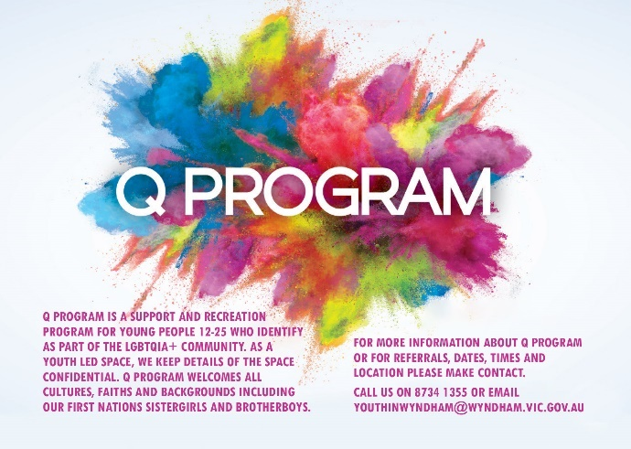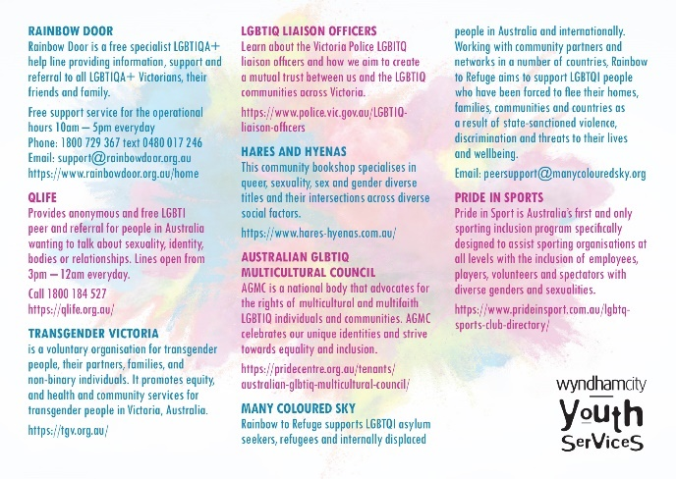

Q Program is a support and recreation program for young people 12-25 who identify as part of the LGBTQIA+ community. As a youth led space, we keep details of the space confidential.

For more information about Q Program or for referrals, dates, times and location please make contact. Call us on 8734 1355 or email youthinwyndham@wyndham.vic.gov.au

Information Sharing Continued:

Name: Rikki Green
Agency & Position: Better Place Australia Email: rikki.green@betterplace.com.au
Web: https://www.betterplaceaustralia.com.au/better-place-for-kids/
https://www.betterplaceaustralia.com.au/personal-development/

Better Place Australia seeing children and adolescents ages 5 to 18 under our Supporting Children After Separation Program (SCASP), Ages 10+ Family and Relationship Counselling (FARs) and have some limited spaces for children and adolescents through private counselling (mental health care plans).

Our fees work on a sliding scale starting at $35 for concession.
Better Place Australia also runs group programs to support parents such as Parenting After Separation and we are hoping to run regular Tuning into kids and teens.

You can email me on rikki.green@betterplace.com.au

Name: Danielle Diez
Agency & Position: Wyndham City Council, Youth Services, Youth Development Officer
Email: danielle.diez@wyndham.vic.gov.au

The following workshop will open for attendance August 20th through Try Booking-
September 22nd Wednesday - Speaking Skilfully to gain Employment 10am-4pm
@ Point Cook Community Learning Centre 1-21 Cheetham Street, Point Cook 3030 – if restrictions are still in place, this event will be held online.
(Opens-August 20th – closes September 20th)- Please contact Danielle. Due to COVID- space capacity is limited. (25 pax)

Come to this free and fun one day workshop, which will give you the tips and tricks to get the job you want. Speaking skilfully to gain employment is an employability skills workshop, which focuses on verbal communication while looking for employment.

Young people of Wyndham 15-25 years come and participate in the free CREATE Program where you’ll gain skills and knowledge in job readiness, employment pathways and goal setting in a fun and

interactive learning environment. This Includes resume workshops, interview scenarios, public speaking and effective communication skills. Be creative, innovative and job ready!
Proudly supported by WCIG Employment Services and Wyndham City Youth Services.

Website - https://www.wyndham.vic.gov.au/whats-on/create-speaking
Registrations: - https://www.trybooking.com/BTCDI

Information Sharing Continued:

Name: Ingrid and Brittany
Agency & Position: Uniting Vic Tas – Footscray – Jobs Victoria Advocates
Ingrid Fitzgerald  T: 0481 454 699  E: Ingrid.Fitzgerald@vt.uniting.org  Direct: 1300 122 917 | Brittany Purcell  M: 0479 175 812  E: Brittany.Purcell@vt.uniting.org
Hi Everyone,
We are working as Jobs Victoria Advocates based at Uniting Vic Tas in Footscray. We will be working across the Maribyrnong, Hobsons Bay and Wyndham LGAs. We are currently delivering the program in a virtual capacity whilst restrictions are in place.

If you are aware of any young people that are school leavers that may need some extra support at this time in terms of employment, education, welfare and connection to community please refer them on to the program, it is a free service to all Victorians.

Please reach out if you need any further information, my colleague Ingrid and myself would be pleased to chat with you further. Our direct number for clients to contact us is 1300 122 917 and our client enquiry email is jobadvocatesmetrowest@vt.uniting.org

You can read more about the Jobs Advocate Program on the below link.
https://jobs.vic.gov.au/about-jobs-victoria/our-programs/advocates

Jobs Victoria Advocates
Advocates meet with jobseekers in their local communities. They link people looking for work with the information, support and training that’s right for them. www.jobs.vic.gov.au

Name: Asha Reech
Agency & Position: Western BACE
Email: asha@westernbace.com Ph: 03 8560 4761

STEM Careers Taster Program October Intake 2
We are now accepting referral for 10 -young people in Melbourne’s West aged 17-25, who are interested in technology and or looking to pursue a career in the STEM field.

Participants are taken through five STEM career taster challenge weeks (1 day onsite per week with additional self-paced learning challenges at home) consisting of hands-on-learning with some of the latest technologies, industry mentors and visits.

The Program is designed to put STEM in a real-world context and expose participants to the breadth of opportunity STEM careers offer and the variety of pathways into STEM industries

Information Sharing Continued:

Name: Sahrish Adnan
Agency & Position: TMG College Australia
Email: sahrisha@tmg.edu.au

Hi, my name is Sahrish . At TMG College Australia, we work collaboratively to offer some great industry relevant training opportunities to the community members to enhance their personal and professional development. I would be very happy to offer my services to the organisations and job providers to help the community by giving them appropriate career advising , course offerings and work placements.

Name: Cara Tizon
Agency & Position: Red Cross
Email: ctizon@redcross.org.au

Red Cross WorkREDi provides employment support for young people 16-25yo in contact with the law, providing employment and skill development pathways, volunteer opportunities and minimal funding support for training and work readiness.
0403 992 189 or email vicworkredi@redcross.org.au for referrals.

Youth Justice Advisory Group is a lived experience group for young people 16-25yo in contact with the law, also open to their close contacts (family and friends). Members are paid for their participation.

For those experiencing extreme hardship, there's COVID emergency relief: https://www.redcross.org.au/get-help/help-for-migrants-in-transition/help-for-migrants-in-transition/vic-relief.
Applications can be done online directly without a referral. Contact: Cara Tizon ctizon@redcross.org.au or 0403992189

Extreme Hardship Support Program – Victoria
Financial relief including Extreme Hardship Support Program to meet urgent needs during the COVID-19 pandemic. www.redcross.org.au

Name: Khushi Ashraf
Agency & Position: Wyndham City Council - Social & Economic Inclusion
Email: Khushi.ashraf@wyndham.vic.gov.au

Hi Everyone,
We have an exciting new program called the Young Innovators Program. The program brings together 12 local young people (aged 18-35) who have an idea, vision or innovation project they would like to implement or have started implementing that will make a positive impact in the local community.

Over 6 months, the innovators will be given access to workshops and masterclasses delivered by corporate and community partners as well as mentors from Wyndham City Council to help the innovators refine their projects and a pool of $5,000 in seed funding to help successful innovators get started.

For more info, check out the website at: https://lnkd.in/gh7P5Suq
Applications close Sunday, 12th September 2021

Newsletter

To submit your information for sharing with the Network please complete the
ONLINE FORM

To subscribe to the Network: SUBSCRIBE HERE

To request to present at a meeting email: WyndhamYouthNetwork@wyndham.vic.gov.au

For previous Network Minutes and meeting dates visit: Wyndham Workers with Young People Network Website

Any enquires regarding the Youth Resource Centre or Wyndham City Youth Services please contact reception on 8734 1355 or email: youthinwyndham@wyndham.vic.gov.au

Join the next meeting:

To join this meeting – click on the link at the scheduled meeting time:
Join Microsoft Teams Meeting
Learn more about Teams | Meeting options

2021 Meeting Dates

Thursdays – 9:30am – 11am via MS Teams – until further notice

14 October
25 November

