Wyndham Workers
with Young People Network

Minutes
Thursday 29 April 2021 - 9.30am-11.00am

Welcome and Introductions
Elise Staron, Senior Youth Support Officer – Wyndham City Council Youth Services

Acknowledgement of the Kulin Nation
“I wish to acknowledge the peoples of the Kulin Nation as the Traditional Owners of the land on which we are gathered and pay respect to their elders, past and present. I also wish to pay respect to any Elders from other communities and acknowledge any future young leaders who are here”

Presentation: Natalie CB, Women’s Health West- Team Leader
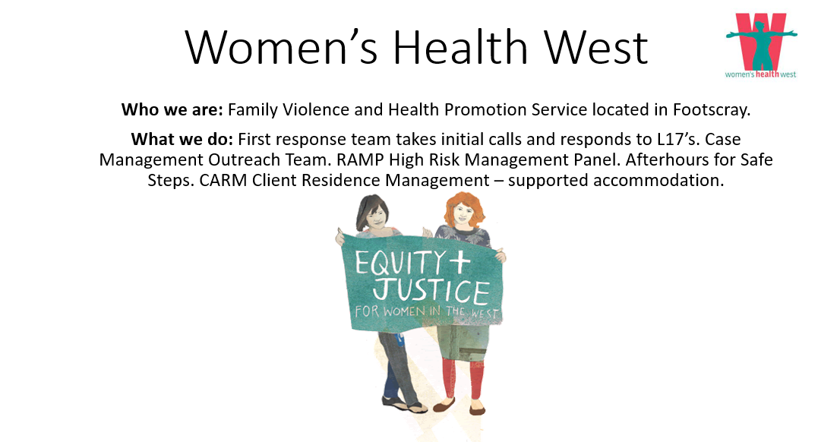
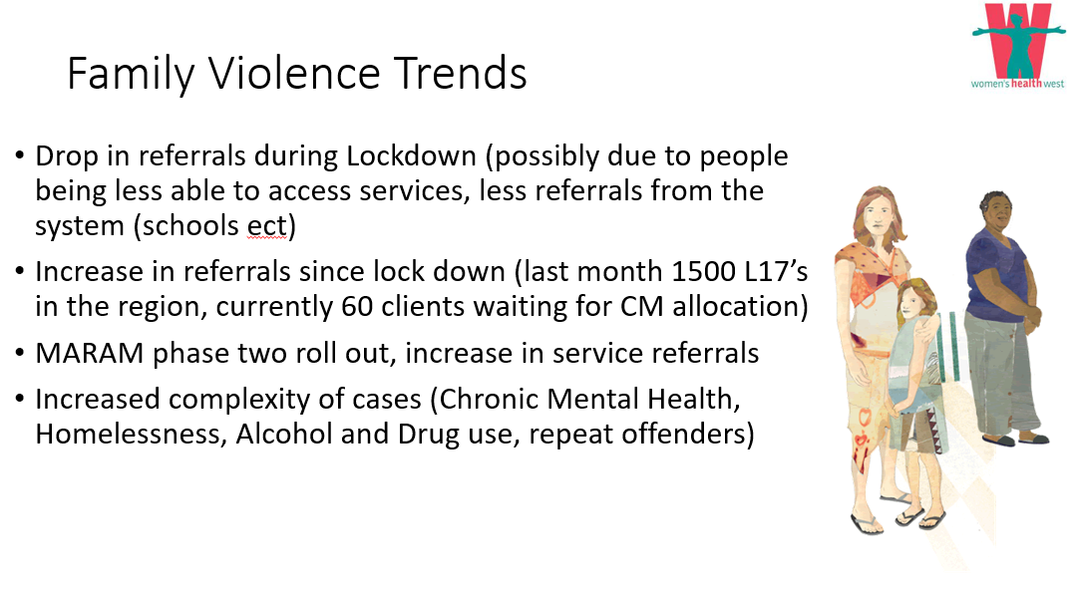

Presentation Continued:
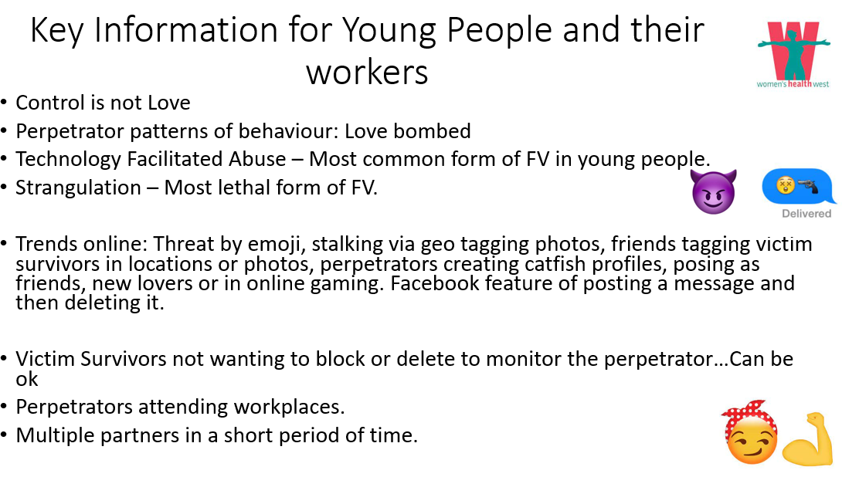
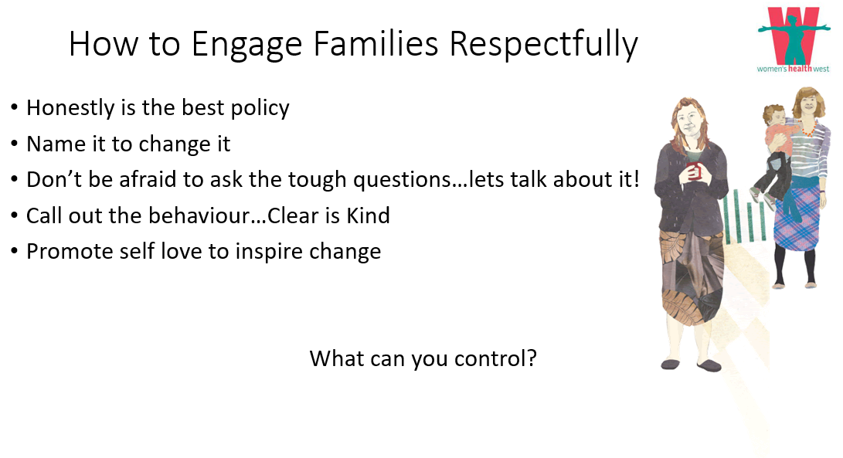
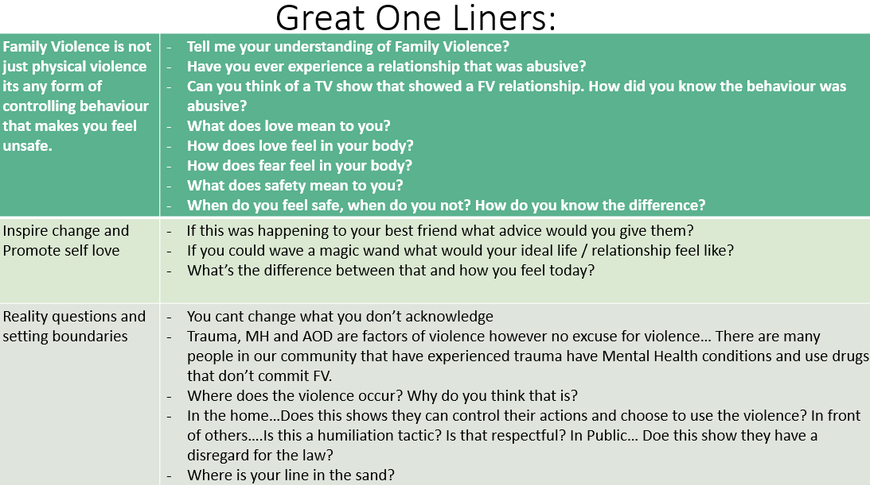

Presentation Continued:
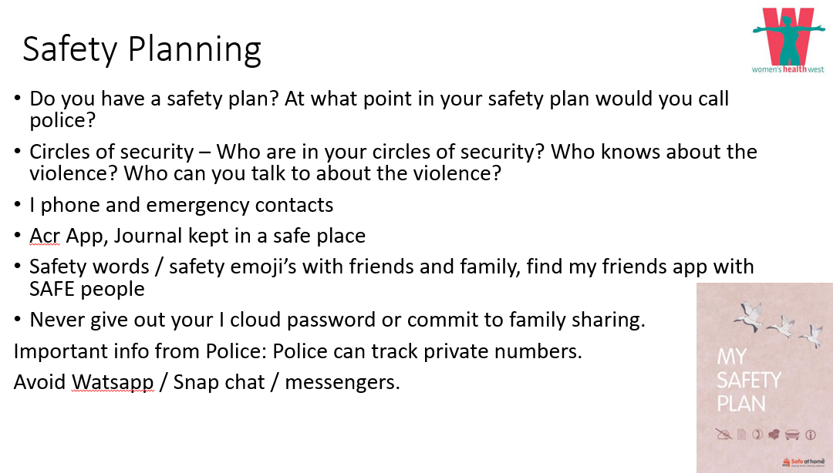
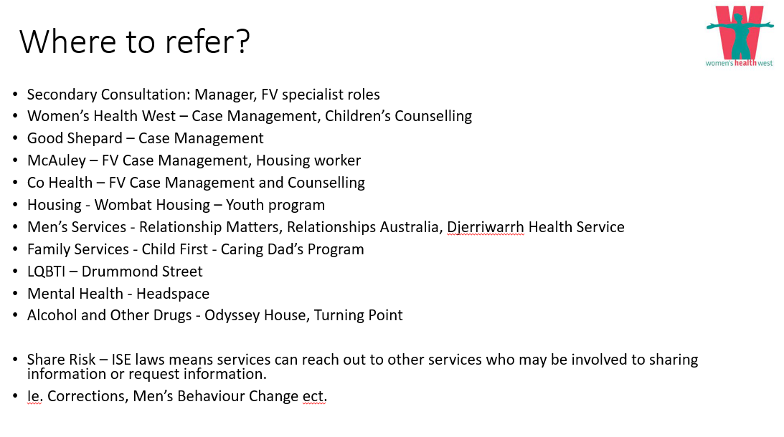
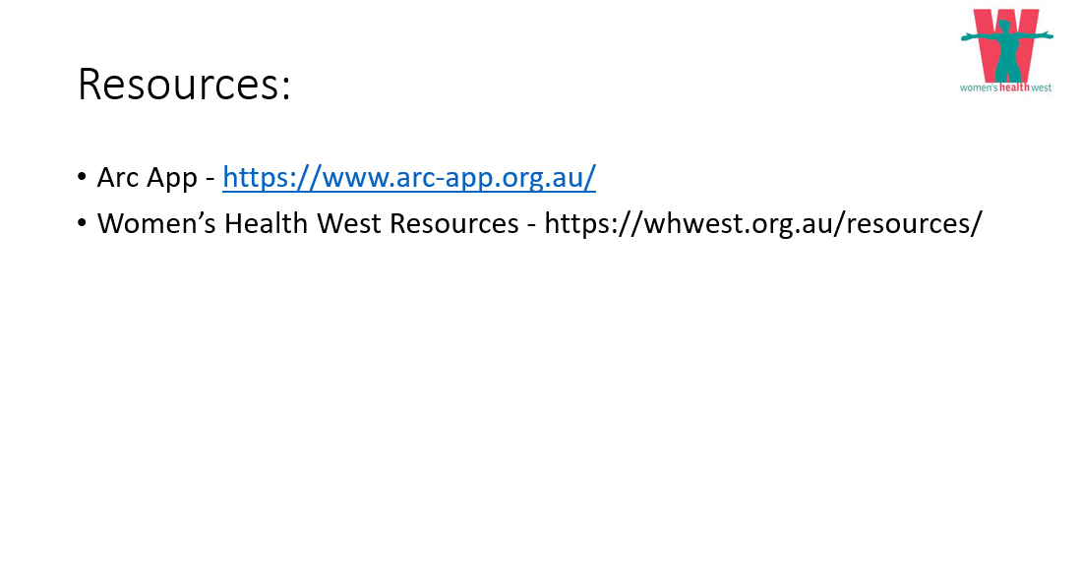
Name: Natalie CB
Agency & Position: Women’s Health West – Team Leader
Email: nataliecb@whwest.org.au Ph: 9689 9588

Information Sharing:
Name: Andrew Dodds
Agency & Position: Anglicare Victoria
Email: andrew.dodds@anglicarevic.org.au
Looking after young people in Out of Home Care. Thanks for this networking opportunity and the ability to hear of the programs in this area.

Name: Paul Cabrera
Agency & Position: University Polytechnic, Community Services Department
Email: paul.cabrera@vu.edu.au - Victoria

Name: Michelle Fry
Agency & Position: Victoria University Community Services, Youth Work and Mental Health Department
Email: michelle.fry@vu.edu.au

Name: Keren Leizerovitz
Agency & Position: Youthlaw (specialist legal service for young people)
Email: keren@youthlaw.asn.au
Youth FV worker within our integrated legal program for adolescents using violence in the home (Wyndham/Brimbank/Melbourne region)

Name: Natasha Quinn
Agency & Position: Senior Youth Worker on the Street Surfer Bus team in Wyndham City Council's Youth Services.
Email: Natasha.quinn@wyndham.vic.gov.au
The Street Surfer Bus is a state-of-the-art mobile youth information centre. We are a Wyndham wide tool that partnerships and collaborates with internal council departments and external agencies to provide a safe space for young people in Wyndham.

Name: Ailsa Gibson-Sheridan
Agency & Position: White Lion, Breakthrough Youth Mentor Coordinator
Email: ailsa.gibson-sheridan@whitelion.asn.au M: 0421 711 765I started with Whitelion in Hoppers Crossing this week working on the Breakthrough Mentoring program. We’re currently looking for mentors to work without young people, so feel free to get in contact with me 😊

Name: Veronica Red
Agency & Position:
Email: veronica@edgecs.com.au
Centre Based programs for NDIS participants at Werribee/Melton/Geelong - Short Term Accommodation stays (Farm Stay) - Driving Programs (Learners) and Allied Health

Information Sharing Continued:

Name: Michelle Lamblin
Agency & Position: Orygen
Email: mapssproject@orygen.org.au
Michelle Lamblin and Sam McKay here from Orygen's Suicide Prevention Unit. We wanted to share with the group some info about two key programs of ours running in schools in partnership with Victorian DET across Wyndham and the north west region:

- Multimodal Approach to Preventing Suicide in Schools (MAPSS) project – targeted at year 10 students and offering universal suicide prevention training (safeTALK) alongside screening and specialised follow up for students experiencing suicide risk. We have a number of schools enrolled in the program and are currently recruiting new schools. Schools can also access free 2-day ASIST training for staff.

- PERSYST Program – aimed at parents of young people aged 12-25 across Victoria. The program offers free online suicide prevention training via Livingworks Start. Parents will receive a $25 Coles gift card for completing a series of online surveys before and after the training. I can email some flyers around but for any further info please get in touch with me.

Name: Adrian Scerri
Agency & Position: School Focused Youth Services - Hobsons Bay & Wyndham
Email: ascerri@hobsonsbay.vic.gov.au
Supporting students who are at a risk of disengagement.

Name: Maddy Ware
Agency & Position: The Huddle, Careers Coordinator
Email: maddy.ware@nmfc.com.au
Careers Coordinator at The Huddle and I manage our Game Changers Program which aims to support young people into employment. maddy.ware@nmfc.com.au

Name: Rosie Barbara
Agency & Position: Wyndham Youth Services, Youth Counsellor
Email: rosie.barbara@wyndham.vic.gov.au
Are you a Counsellor looking for some peer support? Join the Western Region Counsellor's Peer Support Network, a place to connect with other Counsellors, discuss themes and take part in case consultations offered by Hobsons bay, Wyndham and Orygen. Email your interest.

Name: Keren
Agency & Position: Youth Practitioner (Family Violence Program)
Email: keren@youthlaw.asn.au
Ph: 0448 431 274 or 03 9113 9500
Feel free to get in touch with any questions!

Information Sharing Continued:

Name: James Lawther
Agency & Position: TRY Mentoring
Email: james.lawther@try.org.au Ph: 0409 982 275

TRY has been operating a volunteer based 1:1 mentoring program in Wyndham and surrounds for quite a while. Mentors are matched with young people known to child protection, and they catch up regularly for one year to provide friendship and a positive role model.

We are springing back into action and are looking for volunteers to meet the need across the West. We are especially interested in any staff from your organisations who may wish to volunteer as workers in this field make such great mentors! Participants catch up with young people in their local area every week or fortnight and a free to do so whenever suits them, as well as being free to do whatever activities they like. It is very flexible and a
rewarding one-on-one role, so please feel free to share within your organisation and get in touch if you are interested.

More information can be found here https://trymentoring.org.au/. Please feel free to get in touch if you have any questions.

Name: Rachel
Agency & Position: FLIP - Flexible Learning Intervention Pathways
Email: rachel.f@flip.vic.edu.au
FLIP is a reengagement program working with students in Wyndham and Hobsons Bay who are not attending their enrolled school for a range of reasons. We aim to reengage students with their education, transition them into an alternative pathway or into education. Contact details for enquiries: Jodie Peterson (Program Manager) jodie.p@flip.vic.edu.au 0498 028 848 and/or, rachel.f@flip.vic.edu.au

Name: Cara Tizon
Agency & Position: Red Cross Youth Justice program
Email: ctizon@redcross.org.au
- WorkREDi - employment support for young people who are at risk/in contact with the criminal justice system
- Youth Justice Advisory Group - lived experience group of young people in contact with the criminal justice system to share their stories, expertise and experience, members are paid for their time and contribution

Please feel free to contact myself for any referrals/queries etc. Thank you!

Name: Chloe Drieberg
Agency & Position: Wyndham Youth Services, Youth Development Officer
Email: danielle.diez@wyndham.vic.gov.au
Homework support program and create program or call Point Cook Youth Services 8375 2346.
Information Sharing Continued:

Name: Sandra Milunovic
Agency & Position: Children and Parenting support service (CaPSS)
Email: sandra.milunovic@salvationarmy.org.au Ph: 0429 984 478
We are an early intervention service aiming to strengthen families and improve outcomes for children across Melton, Melton south/west, Werribee, Wyndham Vale, Laverton and Hoppers Crossing North and South. We provide Parent training, various support groups and 1:1 parenting support. If you would like to know more feel free to contact me.

Name: Laura Notman
Agency & Position: Infoxchange
Email: Lnotman@infoxchange.org Ph: 0417592313
Infoxchange is a not for profit social enterprise delivering technology for social justice.

Ask Izzy is a free website that can help anyone find essential services in their local area such as housing, food, health care and counselling. https://askizzy.org.au/

We are always trying to improve Ask Izzy and are currently working on making Ask Izzy better for people with a disability, their family and carers, we would love to hear from you if you work in the Disability sector and are interested in giving us feedback on Ask Izzy.
Ask Izzy is a mobile website that connects people in need with housing, a meal, money help, health and wellbeing services, family violence support, counselling and much more.

Name: Noushin Barghi Jahromi (pronunciation: n uu sh ee n)
Agency & Position: Wyndham City, Social and Economic Inclusion
Email: noushin.barghi@wyndham.vic.gov.au

Hi all, from Social and Economic Inclusion Department at Wyndham City, any questions please reach out to me.

Stress Management in Tough Times Workshop (15-25)
We face them in professional and our personal lives. They come in many different forms some planned, some unwanted and some totally unavoidable. With tough times comes a great deal of stress...

Join this session to build understanding and equip yourself with the skills in stress recognition and management.

📅Wednesday 12 May 2021
🕟 5.30PM - 7:30PM
📍Encore Events Centre
https://managestressintoughtimes.eventbrite.com.au

Information Sharing Continued:

Learn how to reply to: "What can you bring to our team?" Workshop (15-25)
How much do we really know ourselves? Knowing your own strengths, areas of improvement and challenges means that you can bring your full self to work.

This workshop will explore activities that help us understand our own strengths and how to be more self-aware. It’s all about develop the abilities and strengths that we already possess and how to deepen our career potentials.

📅Wednesday 26 May 2021
🕟 5.30PM - 7:30PM
📍Encore Events Centre
https://selfawarenessandactualization.eventbrite.com.au

Make it Wyndham - Gala Pitch Night – Public (All ages)
Two rounds of Make it Wyndham workshop has been delivered by Wyndham City and illuminate Future in 2020 & 2021. Workshops provided a positive opportunity to grow the confidence and skills of the young entrepreneurs in Wyndham in starting their own business.

Now it’s time for a Gala Pitch Night to recognise their completion of the program and give them a platform to pitch their business ideas.
📅Wednesday 2 June 2021
🕟 6:30 PM – 9:00 PM
📍Encore Events Centre
https://events.humanitix.com/make-it-wyndham-gala-pitch-night-public

Starting a business is something worth celebrating and on the gala night participants will have a chance to jump up on stage and present their incredible idea to others.

We are opening limited free tickets to the Wyndham community and businesses to join us﻿ and get behind new businesses in our city and inspire more local entrepreneurs to start their business journey.

Wyndham Young professionals Meetup- Tradeswomen Australia (All Ages)
Australia is experiencing skill shortages in 62 trade areas, with the right support from key support networks and industry, these positions could be filled by skilled, strong and capable Tradeswomen.

Join our next Wyndham Young Professionals Meetup to hear from women in Trades and find out how you can follow your trade career dreams or empower girls and women around you to access, participate and succeed in trades.
📅Wednesday 19 May 2021
🕟 6:00 PM- 7:30 PM
📍Online
https://events.humanitix.com/wyndham-young-professionals-meetup
Information Sharing Continued:

Link to subscribe to Employment Pathways eNewsletter:
https://www.wyndham.vic.gov.au/careers/industry-insights/employment-pathways-enewsletter

Wyndham Young professionals Meetup- Tradeswomen Australia, Hosted online, 19th of May | Humanitix

Australia is experiencing skill shortages in 62 trade areas, with the right support from key support networks and industry, these positions could be filled by skilled, strong and capable Tradeswomen.

Name: Jamaica Barrientos
Agency & Position: Wyndham Youth Services, Youth Development Officer
Email: Jamaica.barrientos@wyndham.vic.gov.au

Wyndham Youth Services Team Baby, Bump & Beyond Program (BBB) Program has now started and is being delivered every Wednesday 11am – 1pm @Youth Resource Centre (86 Derrimut Rd, Hoppers Crossing).
BBB will run between April – June 2021 (Term 2). Children are also welcome to attend.

Program Eligibility Criteria
- Pregnant and/or young female parents
- Aged 12 – 25 years
- Live, work, study or recreate in Wyndham

What can the program offer?
- To have the opportunity to interact, socialise and meet another young mother’s
- To participate in a safe, supportive and non-judgement child friendly space
- To have direct access to information and support specialist services (including our Maternal Child Health Nursing Team)
- To attend educational workshops aimed at enhancing personal development, parenting, life skills & promote positive well-being
- To have a greater sense of connectedness, reduce isolation and belonging in the community
- To attend FREE and/or low-cost fun excursions both within Wyndham and/or across Melbourne

If you know if any young females interested advise them to fill out the registration form here https://www.wyndham.vic.gov.au/form/online-youth-program-enrolment

Name: Gabi Orosz
Agency & Position: CMY Envision Program for newly arrived youth
Email: gorosz@cmy.net.au
Goal setting, employment support, youth activities and more!

Newsletter

To submit your information for sharing with the Network please complete the
ONLINE FORM

To subscribe to the Network: SUBSCRIBE HERE

To request to present at a meeting email: WyndhamYouthNetwork@wyndham.vic.gov.au

For previous Network Minutes and meeting dates visit: Wyndham Workers with Young People Network Website

Any enquires regarding the Youth Resource Centre or Wyndham City Youth Services please contact reception on 8734 1355 or email: youthinwyndham@wyndham.vic.gov.au

Join the next meeting:

To join this meeting – click on the link at the scheduled meeting time:
Join Microsoft Teams Meeting
Learn more about Teams | Meeting options

2021 Meeting Dates

Thursdays – 9:30am – 11:30am via MS Teams – until further notice

10 June
22 July
2 September
14 October
25 November

