Wyndham Workers
with Young People Network

Minutes

Thursday 18 March 2021 - 9.30am-11.00am

Welcome and Introductions
Elise Staron, Senior Youth Support Officer – Wyndham City Council Youth Services

Acknowledgement of the Kulin Nation
“I wish to acknowledge the peoples of the Kulin Nation as the Traditional Owners of the land on which we are gathered and pay respect to their elders, past and present. I also wish to pay respect to any Elders from other communities and acknowledge any future young leaders who are here”

Sophie Campbell, Program Coordinator West Metro, Specialist Family Violence Crisis Outreach Service - The Salvation Army Australia Territory
Contact details:
sophie.campbell@salvationarmy.org.au
pegah.aliSinaeePoor@salvationarmy.org.au

Please click on the document to view the Safety Plan

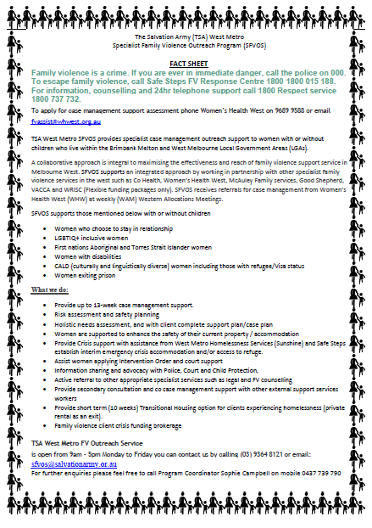
Information Sharing:

Name: Ebony Barker
Agency & Position: Wyndham Youth Services, Youth Worker – Street Surfer Bus
Email: ebony.barker@wyndham.vic.gov.au

https://www.wyndham.vic.gov.au/services/youth-services/services-programs/wyndham-street-surfer-bus

Name: Laura Notman
Agency & Position: Community Engagement Lead
Email: Lnotman@infoxchange.org Ph: 9418 7454 M: 0417 592 313

Ask Izzy is a free website that can help anyone find essential services in their local area such as housing, food, money help, family violence support and counselling.
As mentioned, we would love the expertise of people in this network group to give us feedback on Ask Izzy Beta. We are working on making it more helpful for those experiencing disadvantage or vulnerability due to the COVID-19 pandemic. If you have a couple of minutes to check out Ask Izzy Beta and provide feedback to us, (negative feedback welcomed) that would be much appreciated. Provide feedback by emailing me directly at Lnotman@infoxchange.org or the feedback link at the top of the Ask Izzy web page. Or we can have a quick chat on the phone about it!

Name: Ebony Raby
Agency & Position: Encompass Community Services, Business Development & Events Officer
Email: ebonyr@encompass-cs.org.au Ph: 5222 3377, 0414 744 612
79 Gheringhap Street
Geelong Victoria, Australia 3220
www.encompass-cs.org.au
Name: Malia Seumalu
Agency & Position: Breakthrough Mentoring Worker, Whitelion
Email: malia.seumalu@whitelion.asn.au
Whitelion currently recruiting mentors who are able to dedicate their time to match up with our young people at risk

Information Sharing Continued:

Name: Mike Gregory
Agency & Position:
Email: mike.gregory@comfortcarefoundationinc.org

Name: Scott Krakouer
Agency & Position: YSS West Metro Region, Youth & Family Worker
Email: SKrakouer@ysas.org.au Ph: 8080 8040
I'm the new Wyndham youth and family worker for YSAS. My program works with 10-17 year olds who have had contact with Police, and either are or could potentially offend. We work with YP and their family to divert them from a youth justice pathway.

Name: Adrian Gonnella
Agency & Position: Wyndham Youth Services, Youth Development Officer
Email: adrian.gonnella@wyndham.vic.gov.au
Happy to chat or discuss ideas at any time! Taking over Guys Night and Holiday Action programs at Youth Services! Got some exciting plans coming and would love to be able to promote through our strong networks. Look forward to being able to get to schools in term 2!

Name: Maree Recupero
Agency & Position: Wyndham Youth Services, Youth Counselling and Support – Social Work Role
Email: maree.recupero@wyndham.vic.gov.au
Youth Counselling and Support referral form:
https://www.wyndham.vic.gov.au/youthandfamilycounsellingsupport

Information Sharing Continued:
Name: Mike Gregory
Agency & Position: Project Coordinator, Comfort Care Foundation
Email: admin@comfortcarefoundationinc.org Ph: 1300 225 884

Comfort Care is a not for profit organisation and our vision and mission is to bring comfort, hope and benevolent relief to disadvantaged groups, including young people, women, children, people with disabilities, domestic violence victims and the homeless. We also provide an NDIS service and run two cafes, in our Point Cook office and in Footscray.
We are based in Point Cook with branches in South Australia and New South Wales.
General Website www.comfortcarefoundation1.com/
NDIS website www.cfcconnected.org

eNewsletter

To submit your information for sharing with the Network please complete the
ONLINE FORM

To subscribe to the Network: SUBSCRIBE HERE

To request to present at a meeting email: WyndhamYouthNetwork@wyndham.vic.gov.au

For previous Network Minutes and meeting dates visit: Wyndham Workers with Young People Network Website

Any enquires regarding the Youth Resource Centre or Wyndham City Youth Services please contact reception on 8734 1355 or email: youthinwyndham@wyndham.vic.gov.au

Join the next meeting:
Microsoft Teams meeting
Join on your computer or mobile app
Click here to join the meeting
NOTE: Please ensure your microphone is muted before joining the meeting

2021 Meeting Dates

Thursdays – 9:30am – 11:30am via MS Teams – until further notice

29 April
10 June
22 July
2 September
14 October
25 November

