Wyndham Outdoor Dining and Trading
Public Health and Food Safety Guide

Public Health Guide
This guide is based on the Victorian Government’s CovidSafe Settings and includes key resources, FAQs and tips for businesses planning to re-open with outdoor trading or dining areas. All operating businesses:

- Must have a completed and implemented CovidSafe Plan
- Must comply with all current Victorian State COVID19 infection control measures required for their industry
(refer to Victorian Government Business Support & Hospitality Restart Guidelines for more information)

  - Density limits (indoor/outdoor)
  - Distance requirements between groups (indoor/outdoor)

- Operate using COVIDSafe principles
(refer to Hospitality Restart Guidelines and Cleaning Guidelines for more information)
  - ensure physical distancing in line with DHHS requirements
  - wear a mask
  - practice good hygiene
  - keep good records and act quickly if staff become unwell
  - avoid interactions in close spaces
  - create workforce bubbles.

- Staff should complete Free infection control training online

Food Safety Guidelines - Restricted Level

- Fixed Food Premises
  - Food preparation and food storage is not permitted to occur outside the food premises without a temporary food permit (https://streatrader.health.vic.gov.au/). This also includes preparation of drinks such as coffee.
  - Food vending machines, food preparation equipment, and other equipment such as refrigerators, coffee machines and utensils are not permitted to be stored outside the food premises.
  - Tables and chairs should be adequately cleaned and sanitised after each use
(refer to your Food Safety Program – Support Program – Cleaning and Sanitising for more information).
  - If serving food to an outdoor dining area more than 10 metres from the food premises, the food is to be adequately covered until it is served to the customer.

Tobacco Guidelines - Restricted Level
(refer to the Department of Health & Human Services Smoke Free Dining guide for more information)

- Customers are not permitted to smoke in any outdoor dining area.
- Converted outdoor smoking areas into outdoor dining areas will no longer allow customers to smoke in that area.
- If a dining area is adjacent to a designated smoking area, it must meet 1 of the following
  - 4 metre buffer zone
  - Wall erected at least 2.1m high
- Differences between Outdoor Dining and Outdoor Drinking:
  - Outdoor dining - Smoke-free
    - Food is eaten, or is available to be eaten, in the area
    - Drinks (alcoholic and non-alcoholic) are consumed
  - Outdoor drinking - Smoking restrictions apply under certain conditions
    - No food (other than snacks) is eaten, or is available to be eaten, in the area
    - Drinks (alcoholic and non-alcoholic) are consumed, e.g. coffee and tea

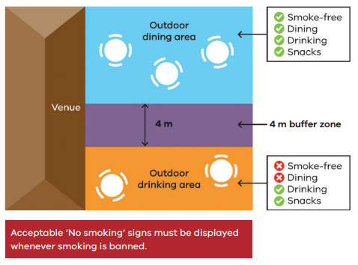
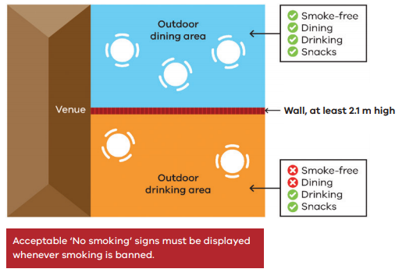

Liquor Licences
Businesses will need to apply for a liquor licence for their new outdoor trading area or apply to vary an existing licence for extended areas.

The Victorian Commission for Gambling and Liquor Regulation have created a free, streamlined process to help existing licensees temporarily use public outdoor areas to supply liquor, with further detail at www.vcglr.vic.gov.au/covid-19.

