Wyndham Workers
with Young People Network

Minutes
Thursday 4 February 2021 - 9.30am-11.00am

Welcome and Introductions
Elise Staron & Marie Pewhairangi, Senior Youth Support Officer – Wyndham City Council Youth Services

Acknowledgement of the Kulin Nation
“I wish to acknowledge the peoples of the Kulin Nation as the Traditional Owners of the land on which we are gathered and pay respect to their elders, past and present. I also wish to pay respect to any Elders from other communities and acknowledge any future young leaders who are here”

Jake Todaro, Youth and Family Counsellor, Youth Services:

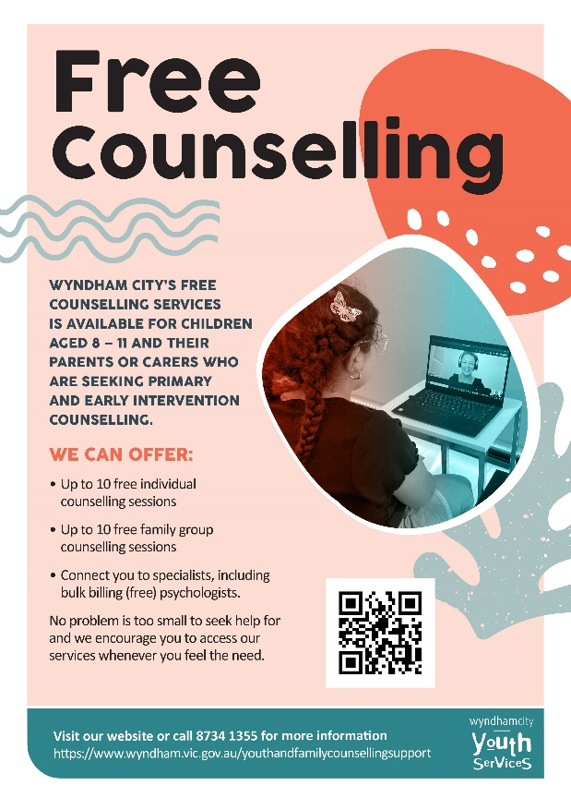
Middle Years Counselling Presentation:
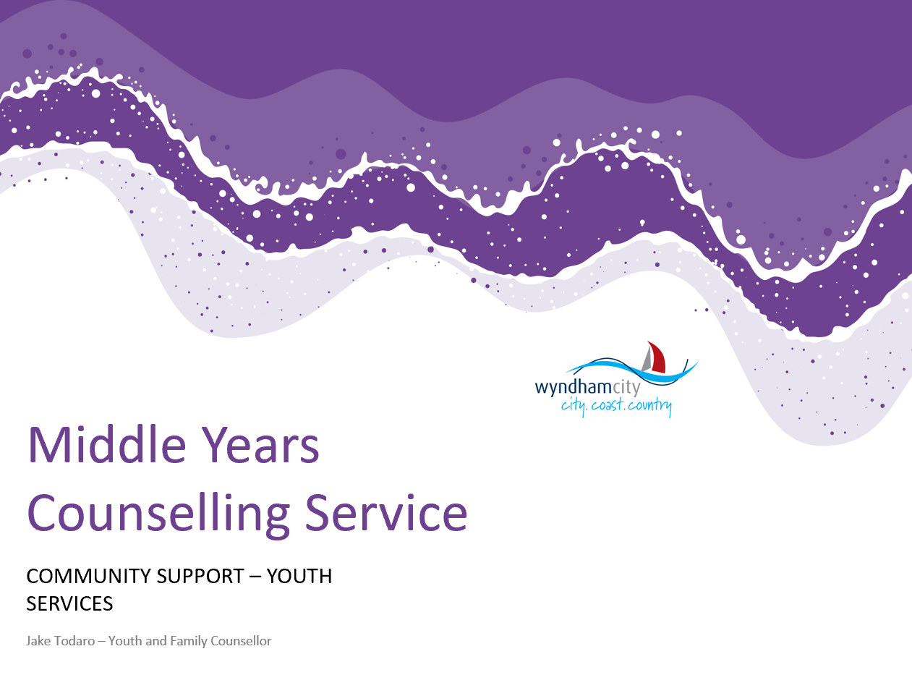 | 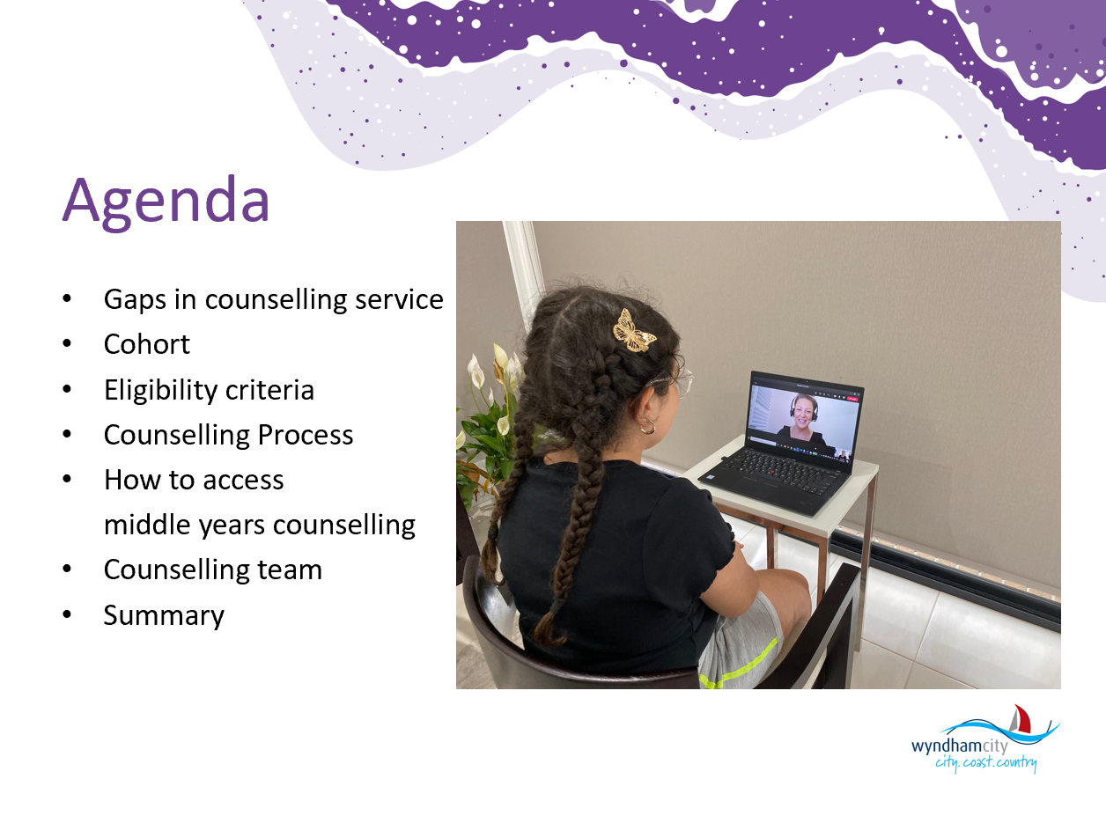
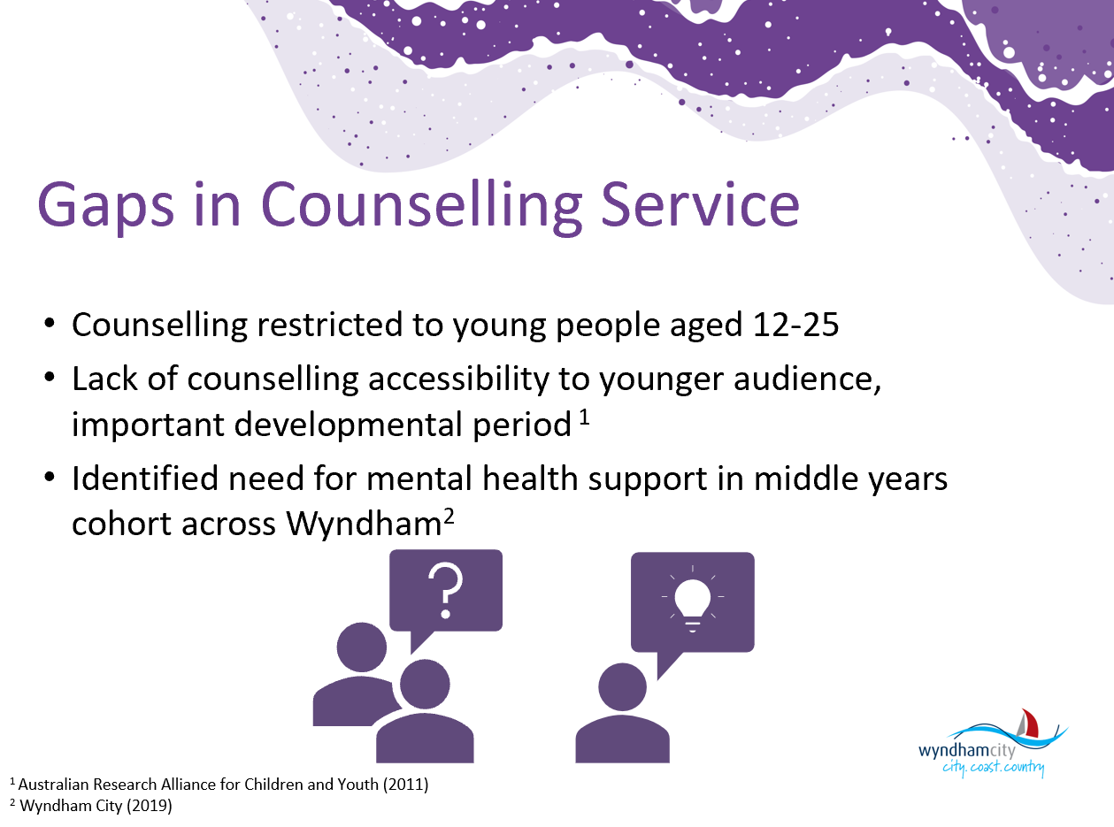 | 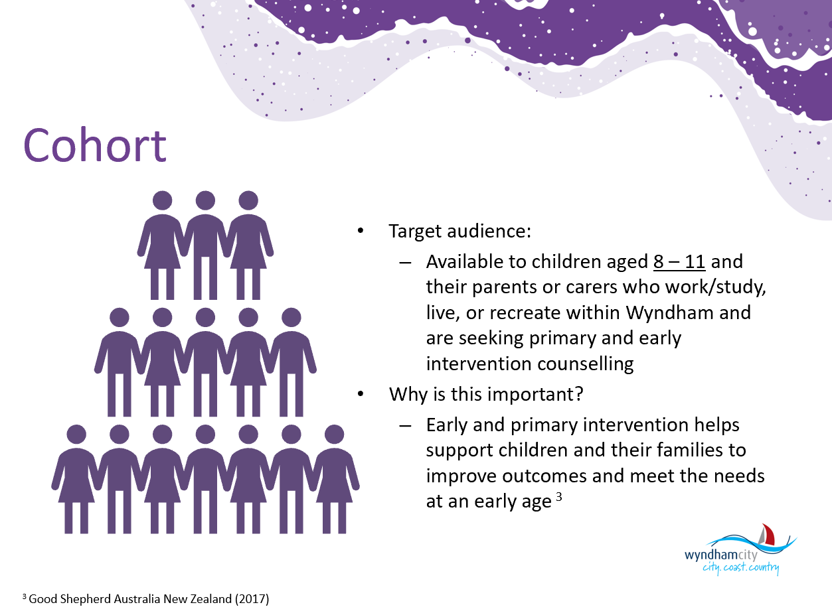
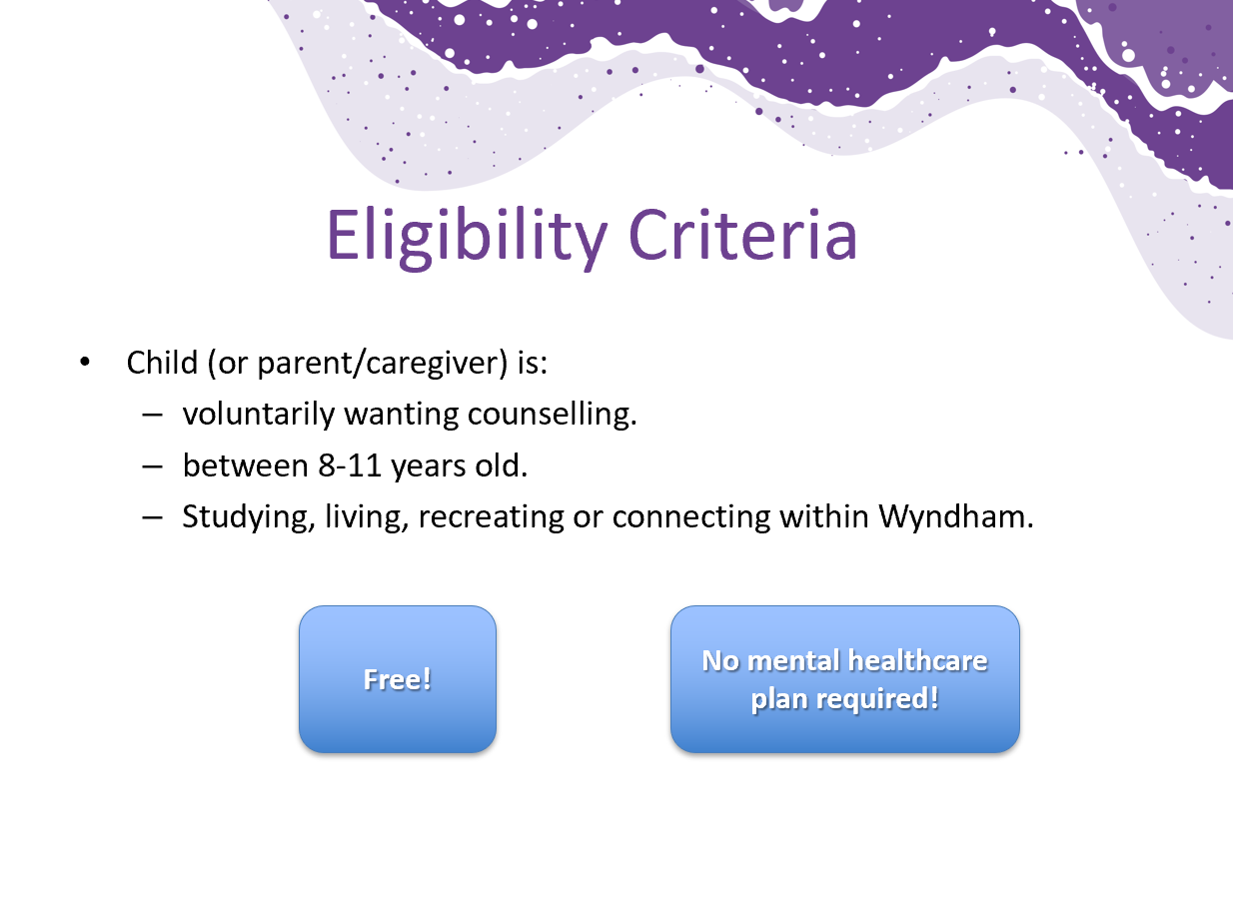 | 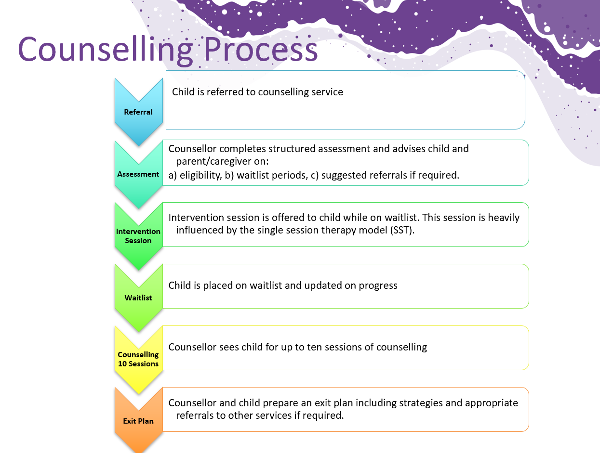
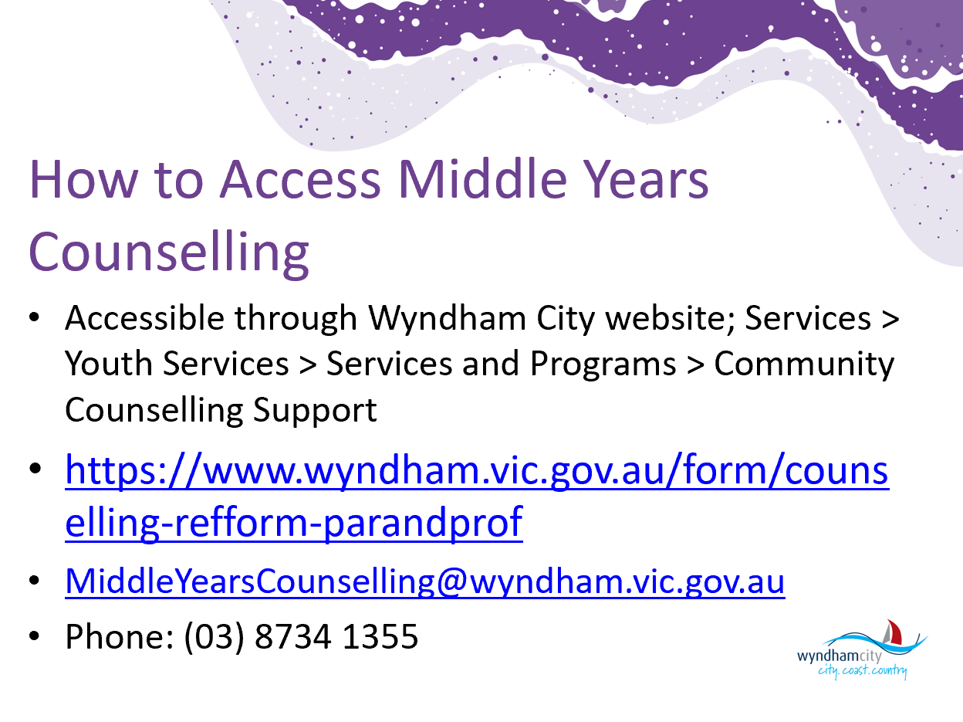 | 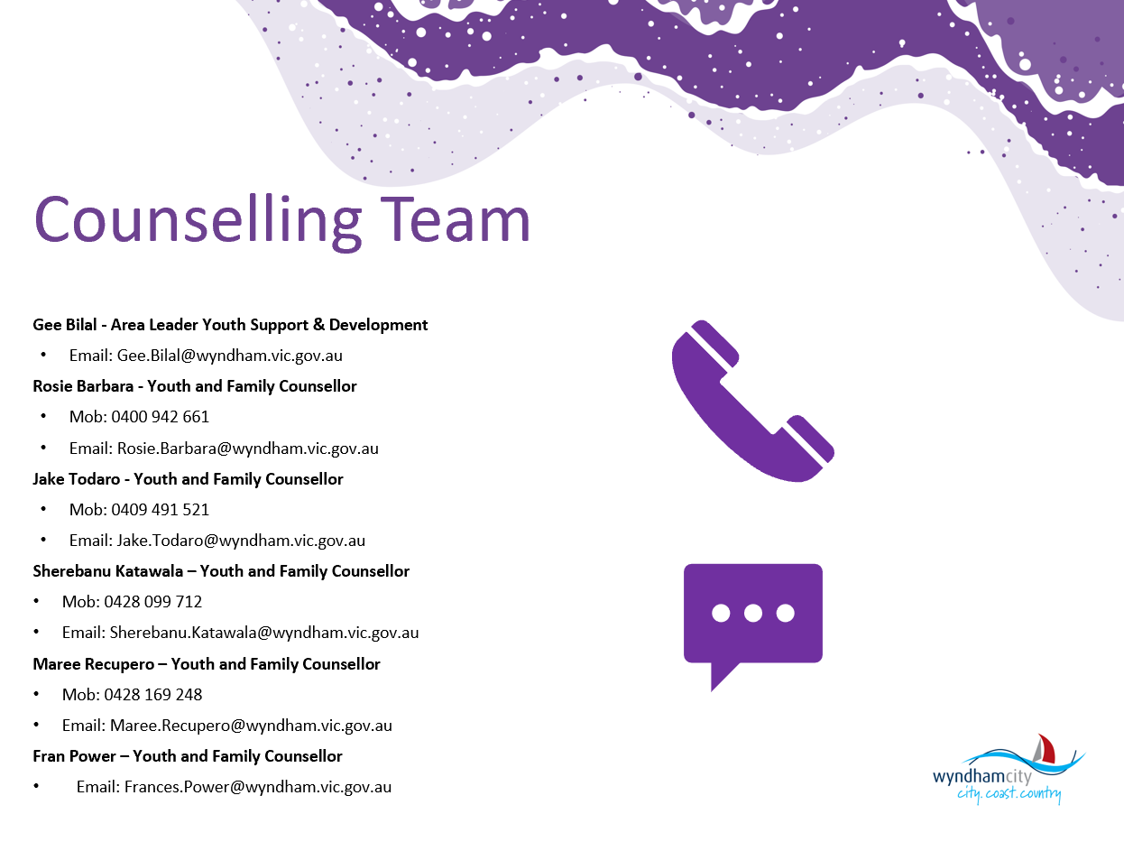
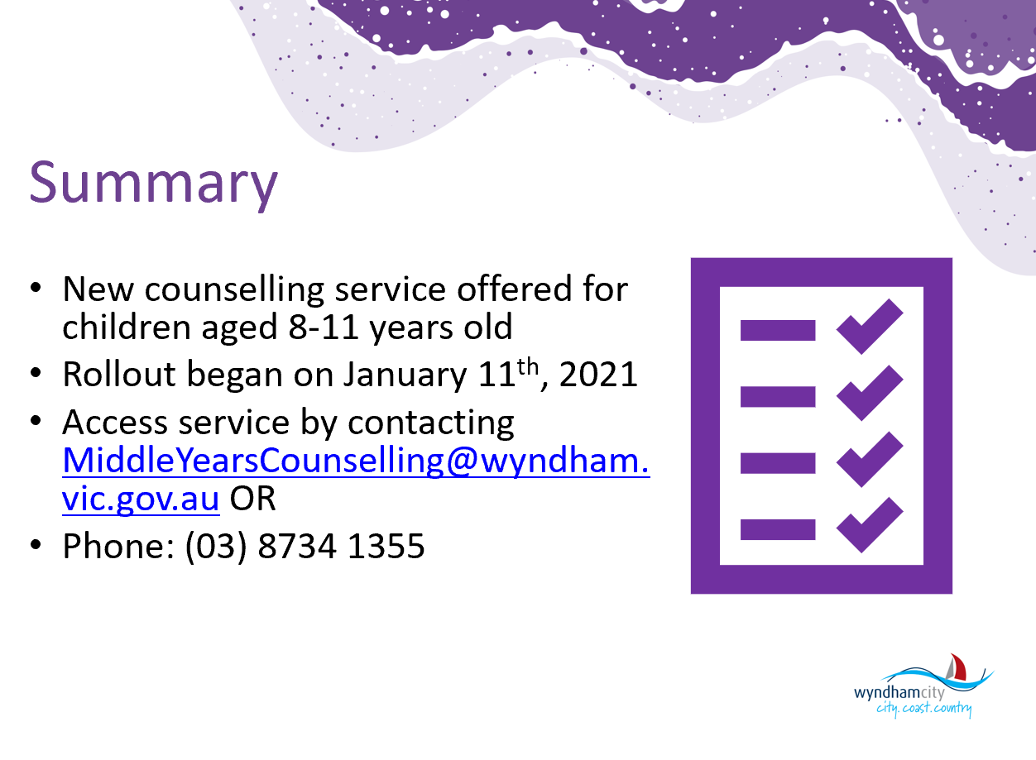

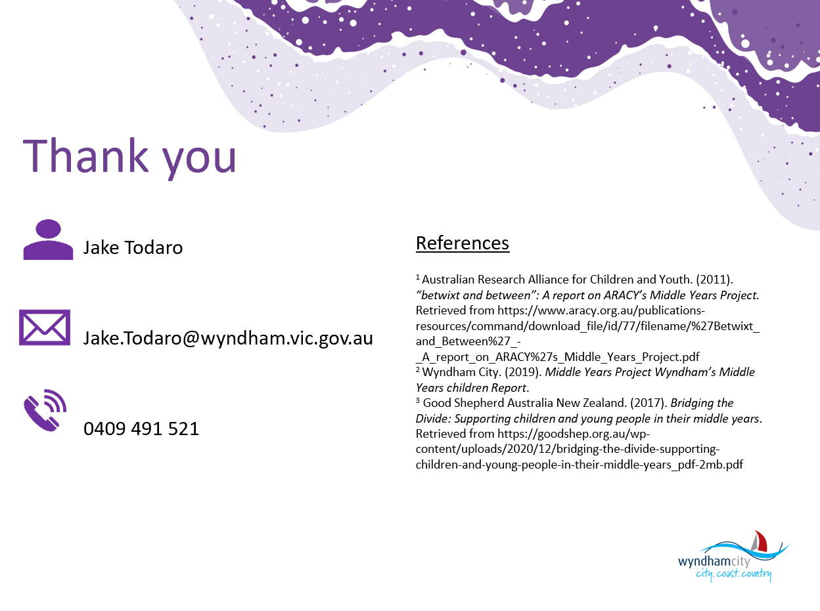
Information Sharing:

Name: Bevan Studd
Agency & Position: Multi Skills Training, Client relationship manager
Email: Bevan@multiskills.com.au and Ph: 0499 456 451

Hello Everyone , Just wanted to introduce myself my name is Bevan Studd. New to this group. Client relationship manager - Multi Skills training - Werribee & Geelong - Just wanted to share some information regarding new Job Trainer Funding - Ages 17 to 24 are eligible for Funded Cert III Civil Construction and Cert III in Scaffolding - if you would like any more information please feel free to contact me.

Name: Julie Babiano
Agency & Position: CMY, Reconnect Program
Email: jbabiano@cmy.net.au Ph: 0436 617 954
Hello everyone! The Reconnect program will support vulnerable groups to support education and employment pathways.
Young People Aged between 17- 19 years: not engaged in education or training for six months or more (less than 8 hours per week).
Mature Participants: Aged between 20-64 years: Unemployed for six months or more (less than 8 hours per week) and not engaged in education or training for six months or more (less than 8 hours per week).
Young people (17 to 24 years of age) who have been, or are currently on, Youth Justice Orders
Asylum Seekers: Young people (17 to 24 years of age) who have been, or are currently on, Youth Justice Orders Email: jbabiano@cmy.net.au

Name: Noushin Barghi Jahromi
Agency & Position: Social and Economic Inclusion, Wyndham City Council
Email: noushin.barghi@wyndham.vic.gov.au
Good morning all from Kulin nation land, I’m Noushin from Social and Economic Inclusion at Wyndham city.
Here are some of our current programs:
- How to Adult series: Series of emotional intelligence and soft skills workshop for young people: Feb-June 2021
https://www.wyndhamtogether.com.au/event/how-to-adult-workshops-2021/
Information Sharing - continued
- Young Professionals meetup- Draw your Career Map / 10 Feb :
https://www.wyndhamtogether.com.au/event/wyndham-young-professionals-meet-up/
- Make it Wyndham: Series of entrepreneurial skills workshop for young people/ Feb- March 2021
https://www.wyndhamtogether.com.au/event/make-it-wyndham-2021/
- Industry Insights into Horticulture and Land Management/ 16 Feb
https://www.wyndhamtogether.com.au/event/industry-insights-into-horticulture-and-land-management/
- Link to subscribe to Employment Pathways newsletter:
https://ecommunications.wyndham.vic.gov.au/h/d/FECED08AF0F84656
any questions, please email
Wyndham Young Professionals Meet up - Wyndham Together
To get you started in 2021, join us to discuss how you can draw Your Career Map!
https://www.wyndhamtogether.com.au/event/wyndham-young-professionals-meet-up/

Name: Rhonda Velkovski
Agency & Position: EdConnect Australia
Email: rhonda.velkovski@edconnect.org.au Ph: 0477 090 027
We recruit, screen, train and support volunteers and place them in schools, where schools need help. We run a learning support program and a mentoring program to support students in school hours and on school grounds. Our focus is to support at-risk students and those who would benefit from additional support. For more information. Please contact me or visit www.edconnectaustralia.org.au
Flyer https://www.edconnectaustralia.org.au/schools
Name: Moses Ronyi
Agency & Position: Junubi Wyndham Youth Work, Wyndham community education Centre
Email: moses.ronyi@wyndhamcec.org.au Ph: 0431 126 762

Information Sharing - continued

Name: Ian Ferretter & Sarah-Jane
Agency & Position: IPC Health
Email: Ian.Ferretter@ipchealth.com.au or Sarah-Jane.Blunt@ipchealth.com.au

We provide education to school aged children year 7-12 on gaming to gambling, gambling harm, and financial wellbeing. Please contact us if you would like a session for young people.

Name: Rikki Green
Agency & Position: Better Place Australia, Child Counsellor
Email: rikki.green@betterplace.com.au
Good morning all. I am a Child Counsellor at Better Place Australia. We see clients 5 to 18 years under our supporting children after separation program.
https://www.betterplaceaustralia.com.au/counselling-and-psychology/supporting-children-through-separation/#:~:text=Aiding%20children%20through%20separation%20%7C%20Services%20%7C%20Better%20Place%20Australia&text=In%20this%20time%20of%20heightened,the%20make%20an%20online%20enquiry.
As well as clients 10 and up under our family and relationship and private counselling programs.
https://www.betterplaceaustralia.com.au/counselling-and-psychology/counselling-for-individuals/
Aiding children through separation | Services | Better Place Australia
Supporting children to build resilience and develop healthy coping strategies through challenging periods of parental separation and family conflict.
www.betterplaceaustralia.com.au

Information Sharing - continued
Name: Heather Bunting
Agency & Position: Joseph’s Corner
E: contact@josephscorner.org.au or heatherjbunting@gmail.com Ph: 9315 2580 or 0421 908 424
From 17th February we will be offering a 6-week course on Supporting Healthy Relationships During and After COVID times. The course is for adults but looking at relationships of parents and children, grandparents and children, as well as relationships of all combinations!! Love to see anyone there - it will be on zoom.

Name: Emily
Agency & Position: Headspace Werribee, Community Awareness Officer
Email: emily.tester@orygen.org.au or you can call the centre on 8001 2366.

Headspace Werribee social groups - all on Zoom currently: - Skillspace every Wednesday, 4-5pm from 24 Feb – 31 March, Year 7 & 8 students, manage difficult experiences and stress, feel good about yourself, develop healthy habits - ninjaArt - art group - every Thursday, 4-5pm from 4 Feb – 1 April 12-25 year olds

Our parents and carers webinar (focused on supporting carers to support their young people) is tonight @ 7PM - register here: https://www.eventbrite.com.au/e/werribee-covid-19-parent-and-carer-webinar-supporting-young-people-registration-
133186220571?fbclid=IwAR23Fztn99Ht4BaOIHPbKKZ1BKcwrDFjW-ib9dbsJELNVjQSNczwu1Cf9Y8

headspace Werribee school workshops (generally high school aged, some capacity for Grade 6) - get in touch at emily.tester@orygen.org.au if you would like us out at your school!

Name: Marita Hagel
Agency & Position: Melbourne City Mission, Detour Program
Ph: 1800 338 687 Email: mhagel@mcm.org.au
Hi everyone, Marita from Detour program Melbourne City Mission in Western region providing early intervention support for young people 12-24 at risk of homelessness. We are open for referrals call 1800 338 687. Email to talk to Detour about early intervention support for young people at risk of homelessness in Western metro region.

Information Sharing - continued
Name: Linda Kelly
Agency & Position: The Gordon Tafe Werribee
Email: lkelly@gordontafe.edu.au

The Gordon Tafe Werribee. We have students studying in the cert IV Disability Sector and Diploma in Community Services requiring student placement. These students will have completed their learning's and looking to gain placement and potentially employment post placement. Disability are based from the 14th of June for 80 hrs and Diploma in Community Services commence from the 6th of September for 200 hrs. If you feel you can assist we would greatly appreciate the support for these students to grow within their next journey. There is no cost to placement. I can always come and meet with you. Kind Regards Linda Kelly

Name: Shannon Bell
Agency & Position: YSAS
Email: sbell@ysas.org.au

Name: Gabi Orosz
Agency & Position: Centre for Multicultural Youth
Email: gorosz@cmy.net.au
Centre for Multicultural Youth ENVISION program (settlement program for newly arrived youth aged 15-25.

Name: Jackie
Agency & Position: Salvation Army Employment Plus
Email: jackie.cassar@salvationarmy.org.au Ph: 0438 817 864
I am part of the Transition to work program in Melbourne West, We assist disengaged youth (15-24 years old) with employment and training. We support youth with interview clothing, financial assistance with training, support youth towards getting their driver’s license, upskilling and provide support with barriers that restrict young people from engaging in employment or education. Youth consultants assist with preparing youth for work and reverse marketing to employers. The program runs for 18 months. If you would like any further information please feel free to contact me.

Name: Kristina Beyit
Agency & Position:
Email: kristina.beyit@ds.org.au

Nice to meet everyone. If you would like to consult around any cases prior to referral you can contact me by emailing me.
Information Sharing - continued
Name: Rosie Barbara
Agency & Position: Youth Services, Youth and Family Counsellor
Email: rosie.barbara@wyndham.vic.gov.au
Counselling enquiry form:
https://www.wyndham.vic.gov.au/community-counselling-enquiry-form
Consent link:
https://www.wyndham.vic.gov.au/form/counselling-consent-form

Name: Danielle Diez
Agency & Position: Youth Development Officer, Youth Services
Email: danielle.diez@wyndham.vic.gov.au

Youth Engagement activation on Saturday 13th of February- Soccer in the Summertime- join Youth Services staff in a fun 2 hour drill session- light drills and meet new friends. 1pm-3pm Featherbrook Community Learning Centre. FREE.

eNewsletter

To submit your information for sharing with the Network please complete the
ONLINE FORM

To subscribe to the Network: SUBSCRIBE HERE

To request to present at a meeting email: WyndhamYouthNetwork@wyndham.vic.gov.au

For previous Network Minutes and meeting dates visit: Wyndham Workers with Young People Network Website

Any enquires regarding the Youth Resource Centre or Wyndham City Youth Services please contact reception on 8734 1355 or email: youthinwyndham@wyndham.vic.gov.au

Join the next meeting:

To join this meeting – click on the link at the scheduled meeting time:
Join Microsoft Teams Meeting
Learn more about Teams | Meeting options

2021 Meeting Dates

Thursdays – 9:30am – 11:30am via MS Teams – until further notice

18 March
29 April
10 June
22 July
2 September
14 October
25 November

