Wyndham Outdoor Dining and Trading
Public Health and Food Safety Guide

Public Health Guide: Restricted Level
This guide is based on the CovidSafe Summer step of the Victorian Government’s Metro Melbourne Roadmap and includes key resources, FAQs and tips for businesses planning to re-open with outdoor trading or dining areas. As part of the Victorian Government’s Metro Melbourne Roadmap, all operating businesses:

- Must have a completed and implemented CovidSafe Plan
- Must comply with all current Victorian State COVID19 infection control measures required for their industry
(refer to Victorian Government Business Support & Hospitality Restart Guidelines for more information)

  - Density limits (indoor/outdoor)
  - Distance requirements between groups (indoor/outdoor)

- Operate using COVIDSafe principles
(refer to Hospitality Restart Guidelines and Cleaning Guidelines for more information)
  - ensure physical distancing in line with DHHS requirements
  - wear a mask
  - practice good hygiene
  - keep good records and act quickly if staff become unwell
  - avoid interactions in close spaces
  - create workforce bubbles.

- Staff should complete Free infection control training online

Outdoor & Indoor Seating Restrictions – As of 11:59PM 6 December 2020
Patron limits for OUTDOOR & INDOOR spaces | - Must adhere to density limit of 1 patron per 2m² for venues that can accommodate for more than 25 patrons.  - No density limits if there are less than 25 patrons (applies to small operations/venues).  - Density quotient of 1 patron per 4m² on a dancefloor up to a maximum of 50 people.  - No requirement for seated service  - No other patron group/venue limits
Electronic Record Keeping | - All venues are required to use electronic record keeping (QR Code) when applying the density quotient of 1 patron per 2m²  - In venues not using electronic record (pen & paper) a density quotient of 1 patron per 4m² applies
Indoor and Outdoor Food Courts | - Indoor and outdoor food courts open with a density quotient of 1 patron per 2m². No patron cap for indoor food courts.
Table Spacing | - Tables spaced at least 1.5m apart.

Food Safety Guidelines - Restricted Level

- Fixed Food Premises
  - Food preparation and food storage is not permitted to occur outside the food premises without a temporary food permit (https://streatrader.health.vic.gov.au/). This also includes preparation of drinks such as coffee.
  - Food vending machines, food preparation equipment, and other equipment such as refrigerators, coffee machines and utensils are not permitted to be stored outside the food premises.
  - Tables and chairs should be adequately cleaned and sanitised after each use
  - (refer to your Food Safety Program – Support Program – Cleaning and Sanitising for more information).
  - If serving food to an outdoor dining area more than 10 metres from the food premises, the food is to be adequately covered until it is served to the customer.

Tobacco Guidelines - Restricted Level
(refer to the Department of Health & Human Services Smoke Free Dining guide for more information)

- Customers are not permitted to smoke in any outdoor dining area.
- Converted outdoor smoking areas into outdoor dining areas will no longer allow customers to smoke in that area.
- If a dining area is adjacent to a designated smoking area, it must meet 1 of the following
  - 4 metre buffer zone
  - Wall erected at least 2.1m high
- Differences between Outdoor Dining and Outdoor Drinking:
  - Outdoor dining - Smoke-free
    - Food is eaten, or is available to be eaten, in the area
    - Drinks (alcoholic and non-alcoholic) are consumed
  - Outdoor drinking - Smoking restrictions apply under certain conditions
    - No food (other than snacks) is eaten, or is available to be eaten, in the area
    - Drinks (alcoholic and non-alcoholic) are consumed, e.g. coffee and tea

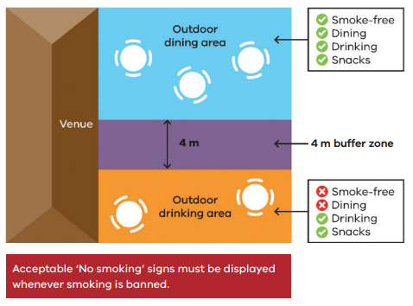
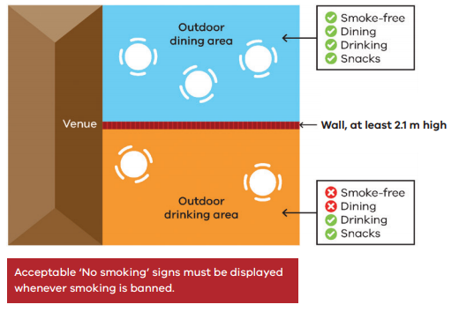

Liquor Licences
Businesses will need to apply for a liquor licence for their new outdoor trading area or apply to vary an existing licence for extended areas.

The Victorian Commission for Gambling and Liquor Regulation have created a free, streamlined process to help existing licensees temporarily use public outdoor areas to supply liquor, with further detail at www.vcglr.vic.gov.au/covid-19.

