Wyndham Outdoor Dining and Trading
Public Health and Food Safety Guide

Public Health Guide: Restricted Level
This guide is based on the Third Step of the Victorian Government’s Metro Melbourne Roadmap and includes key resources, FAQs and tips for businesses planning to re-open with outdoor trading or dining areas. As part of the Victorian Government’s Metro Melbourne Roadmap, all operating businesses:
- Must have a completed and implemented CovidSafe Plan
- Must comply with all current Victorian State COVID19 infection control measures required for their industry
(refer to Department of Health & Human Services & Business Victoria Hospitality Guidelines for more information)
  - Max seating limits (indoor/outdoor)
  - Distance requirements between groups (indoor/outdoor)
  - Density limits (indoor/outdoor)
- Operate using COVIDSafe principles
(refer to Business Victoria Hospitality Guidelines for more information)
  - ensure physical distancing in line with DHHS requirements
  - wear a mask
  - practice good hygiene
  - keep good records and act quickly if staff become unwell
  - avoid interactions in close spaces
  - create workforce bubbles.
- Staff should complete Free infection control training online

Outdoor Seating Restrictions
Patron limits per outdoor space | - Open for seated service only  - Maximum number of patrons is the number permitted by the density quotient (one patron per two square metres) or 50, whichever is the lesser. Cap of 50 patrons outdoors per venue.
Patron limits per indoor space | - Open for seated service only  - Maximum number of patrons is the number permitted by the density quotient (one patron per four square metres) or 10 people per space, whichever is the lesser. Cap of 20 patrons indoors per venue, with a maximum of two separate spaces.  - For takeaway, members of the public limited to the number permitted by the density quotient of 1 customer per 4 square metres  - Density quotient does not apply to toilets and where used as a thoroughfare to outdoor space (e.g. foyer, reception area)
Table/booking limit | - No more than 10 patrons per booking
Table spacing | - Patrons must be seated so they are 1.5m away from any patron from an adjacent group

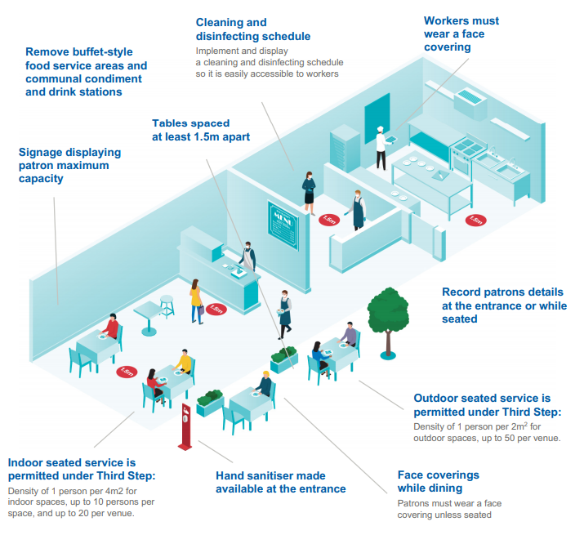

Food Safety Guidelines - Restricted Level

- Fixed Food Premises
  - Food preparation and food storage is not permitted to occur outside the food premises without a temporary food permit (https://streatrader.health.vic.gov.au/). This also includes preparation of drinks such as coffee.
  - Food vending machines, food preparation equipment, and other equipment such as refrigerators, coffee machines and utensils are not permitted to be stored outside the food premises.
  - Tables and chairs should be adequately cleaned and sanitised after each use
  - (refer to your Food Safety Program – Support Program – Cleaning and Sanitising for more information).
  - If serving food to an outdoor dining area more than 10 metres from the food premises, the food is to be adequately covered until it is served to the customer.

Tobacco Guidelines - Restricted Level
(refer to the Department of Health & Human Services Smoke Free Dining guide for more information)

- Customers are not permitted to smoke in any outdoor dining area.
- Converted outdoor smoking areas into outdoor dining areas will no longer allow customers to smoke in that area.
- If a dining area is adjacent to a designated smoking area, it must meet 1 of the following
  - 4 metre buffer zone
  - Wall erected at least 2.1m high
- Differences between Outdoor Dining and Outdoor Drinking:
  - Outdoor dining - Smoke-free
    - Food is eaten, or is available to be eaten, in the area
    - Drinks (alcoholic and non-alcoholic) are consumed
  - Outdoor drinking - Smoking restrictions apply under certain conditions
    - No food (other than snacks) is eaten, or is available to be eaten, in the area
    - Drinks (alcoholic and non-alcoholic) are consumed, e.g. coffee and tea

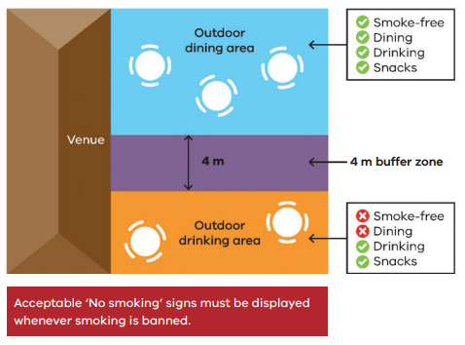
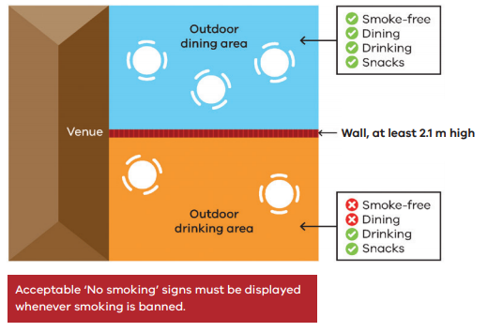

Liquor Licences
Businesses will need to apply for a liquor licence for their new outdoor trading area or apply to vary an existing licence for extended areas.

The Victorian Commission for Gambling and Liquor Regulation have created a free, streamlined process to help existing licensees temporarily use public outdoor areas to supply liquor, with further detail at www.vcglr.vic.gov.au/covid-19.

