Wyndham Workers
with Young People Network

Minutes
Thursday 27 August 2020 - 9.30am-11.30am

The next Wyndham Workers with Young People Network meeting is scheduled for Thursday 8 October
Welcome and Introductions
Paula Hearnden, Senior Youth Support Officer – Wyndham City Council Youth Services

Acknowledgement of the Kulin Nation
“I wish to acknowledge the peoples of the Kulin Nation as the Traditional Owners of the land on which we are gathered and pay respect to their elders, past and present. I also wish to pay respect to any Elders from other communities and acknowledge any future young leaders who are here”

Presentation: Gabi Orosz – Project Officer -
Centre for Multicultural Youth
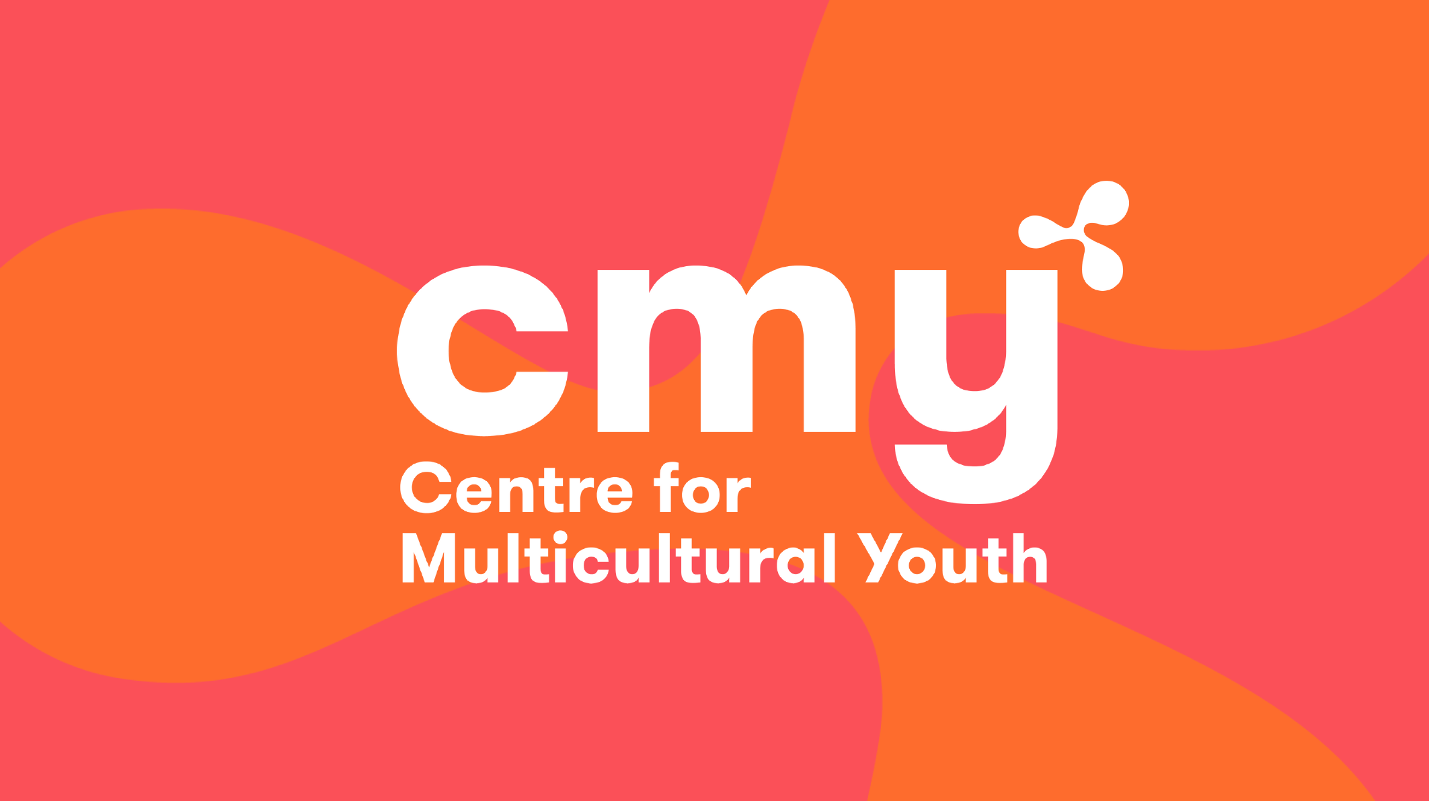 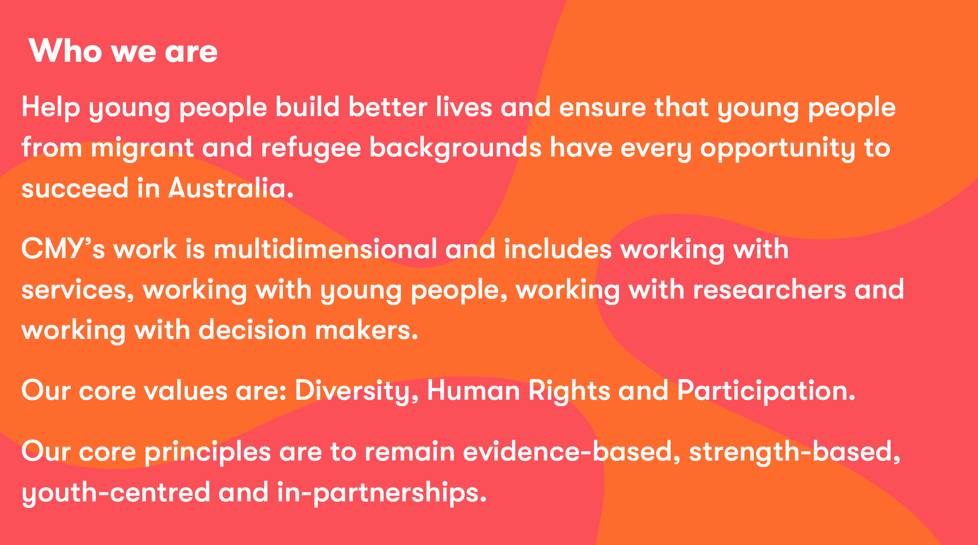
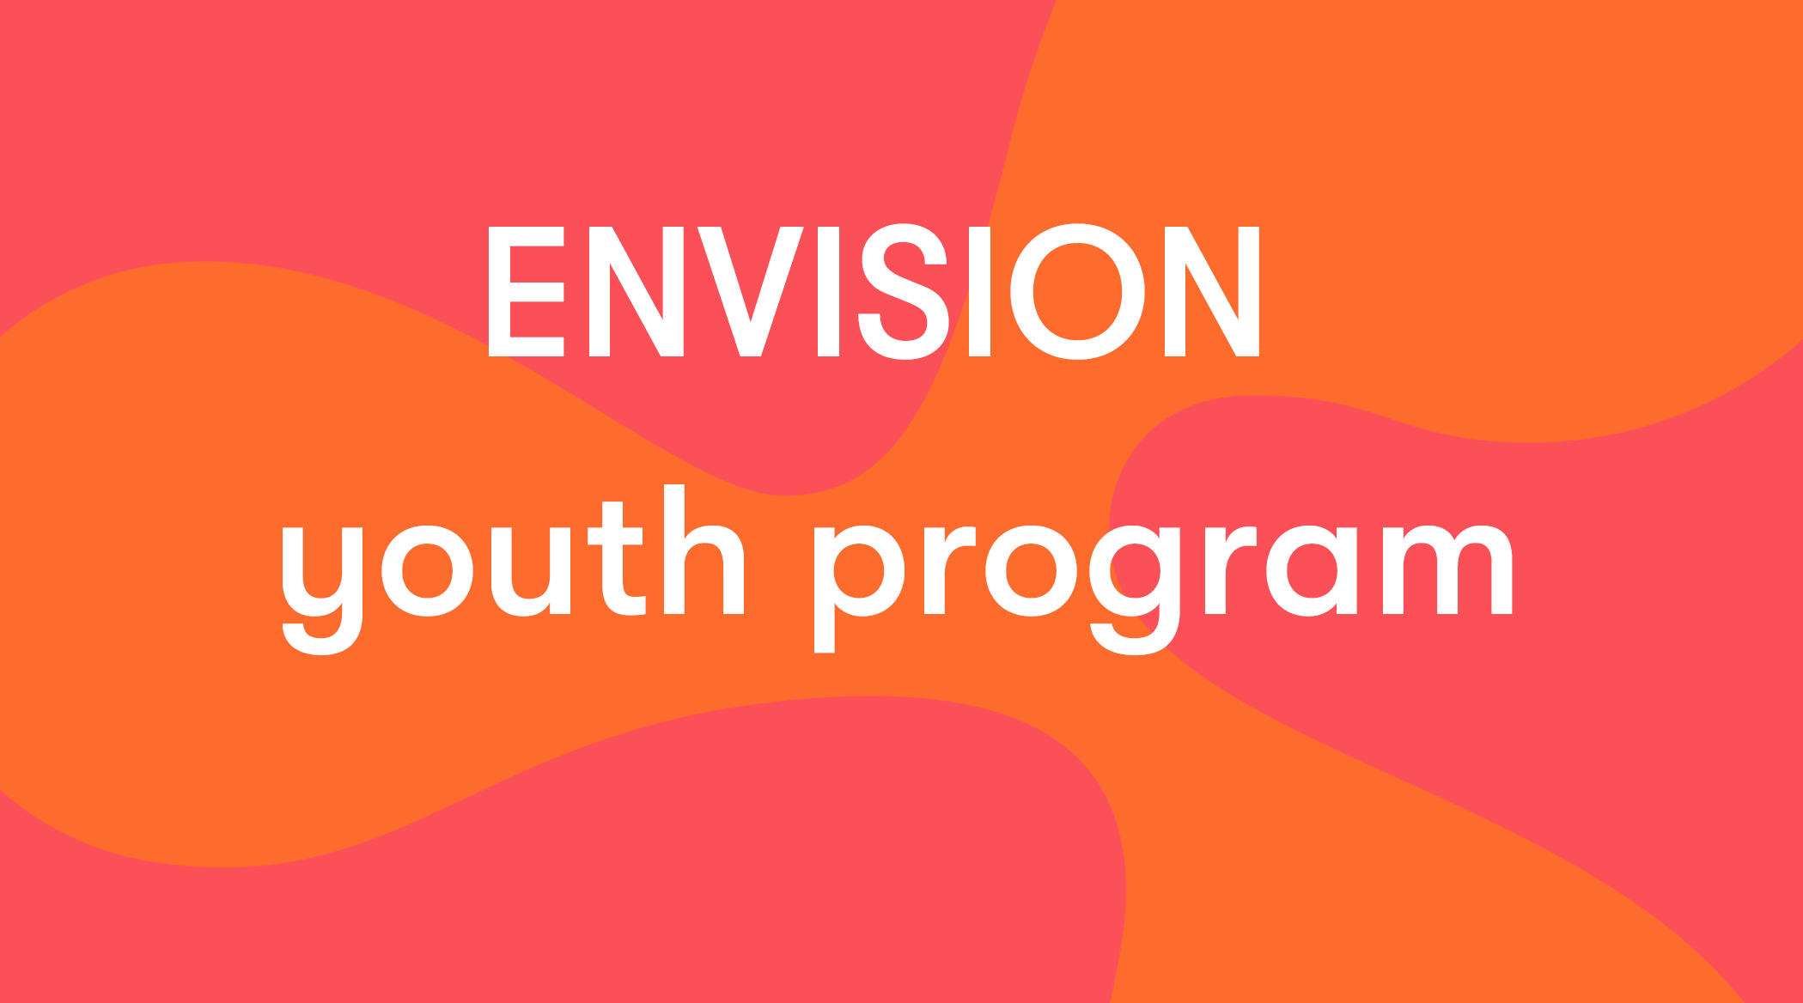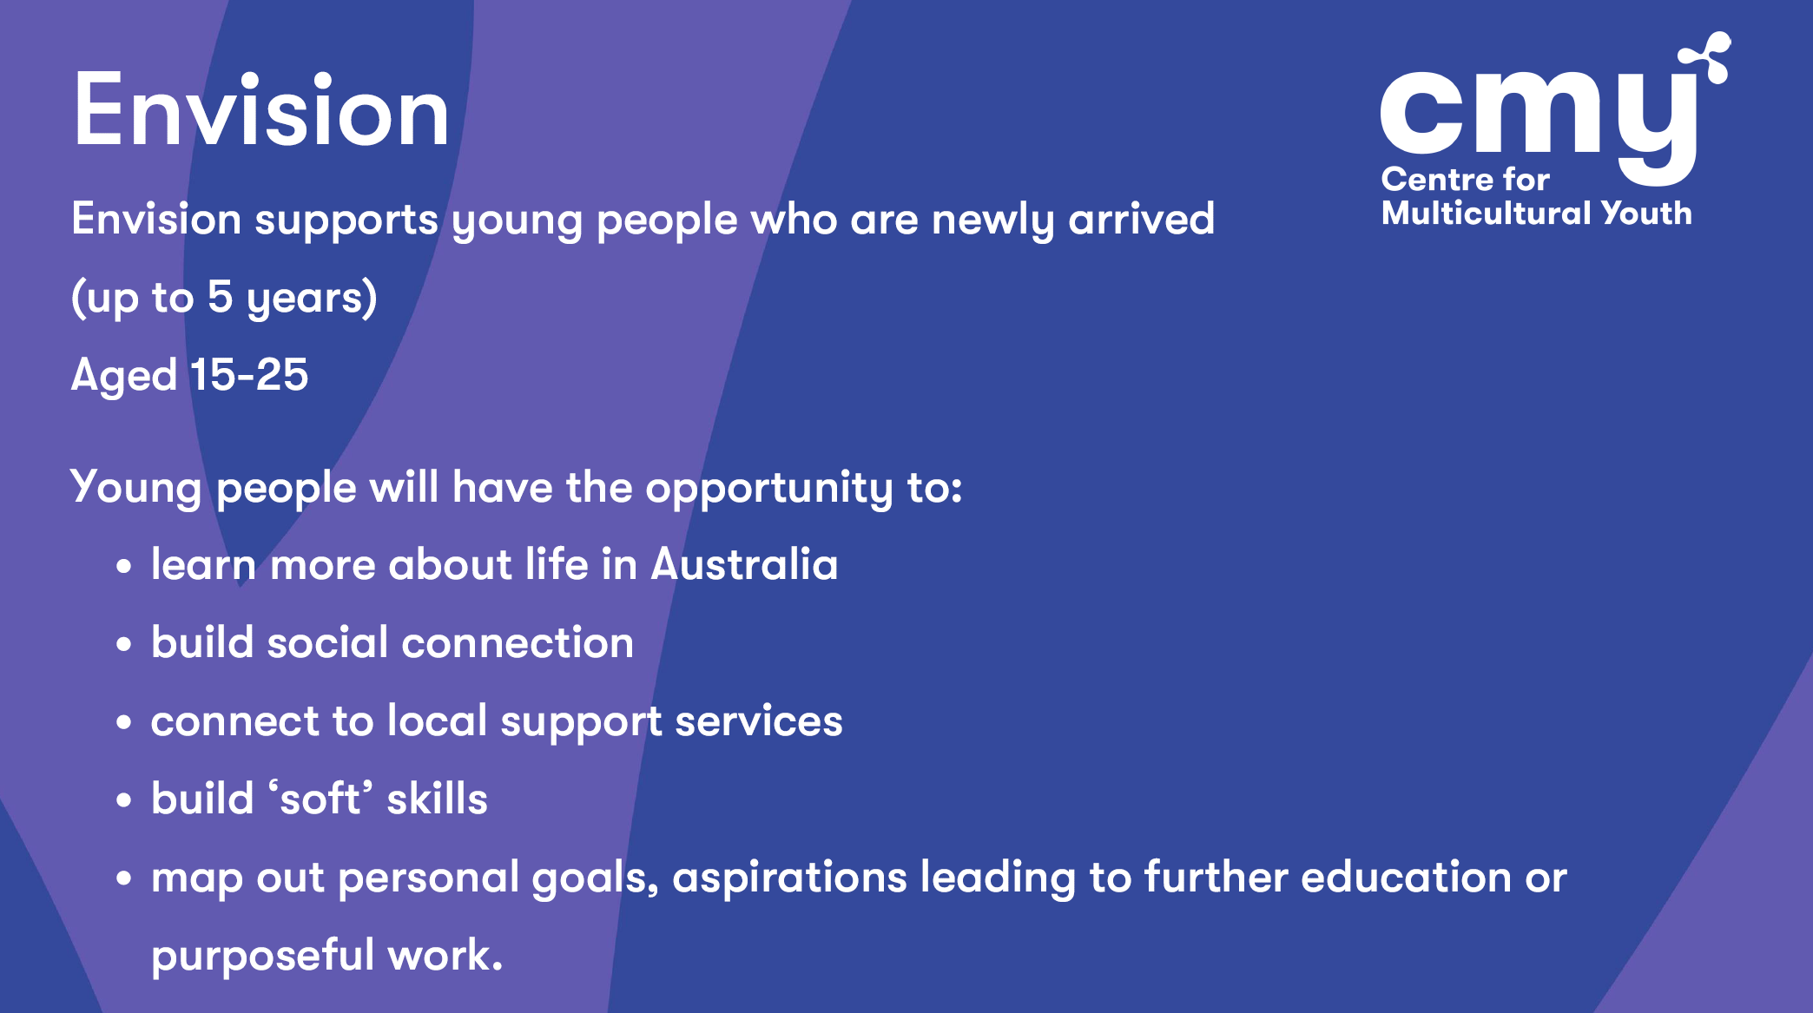
Presentation continued:
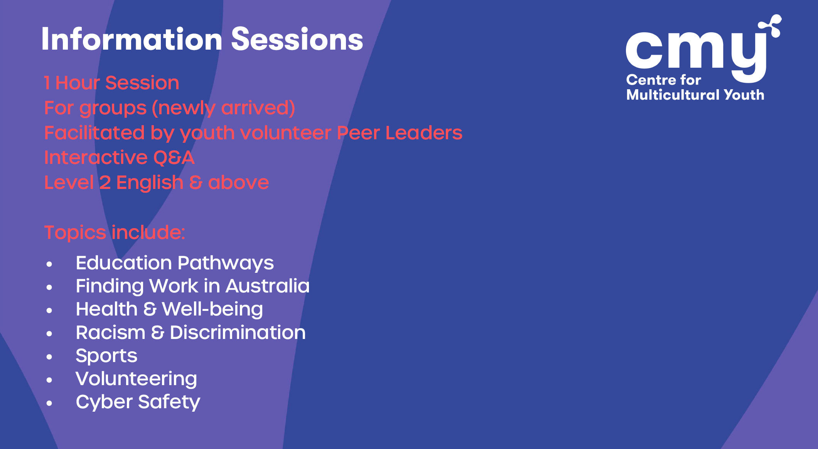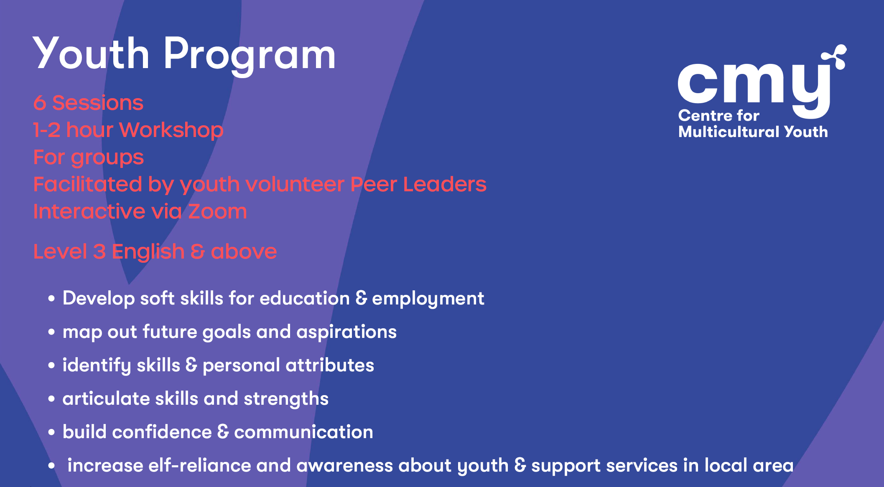

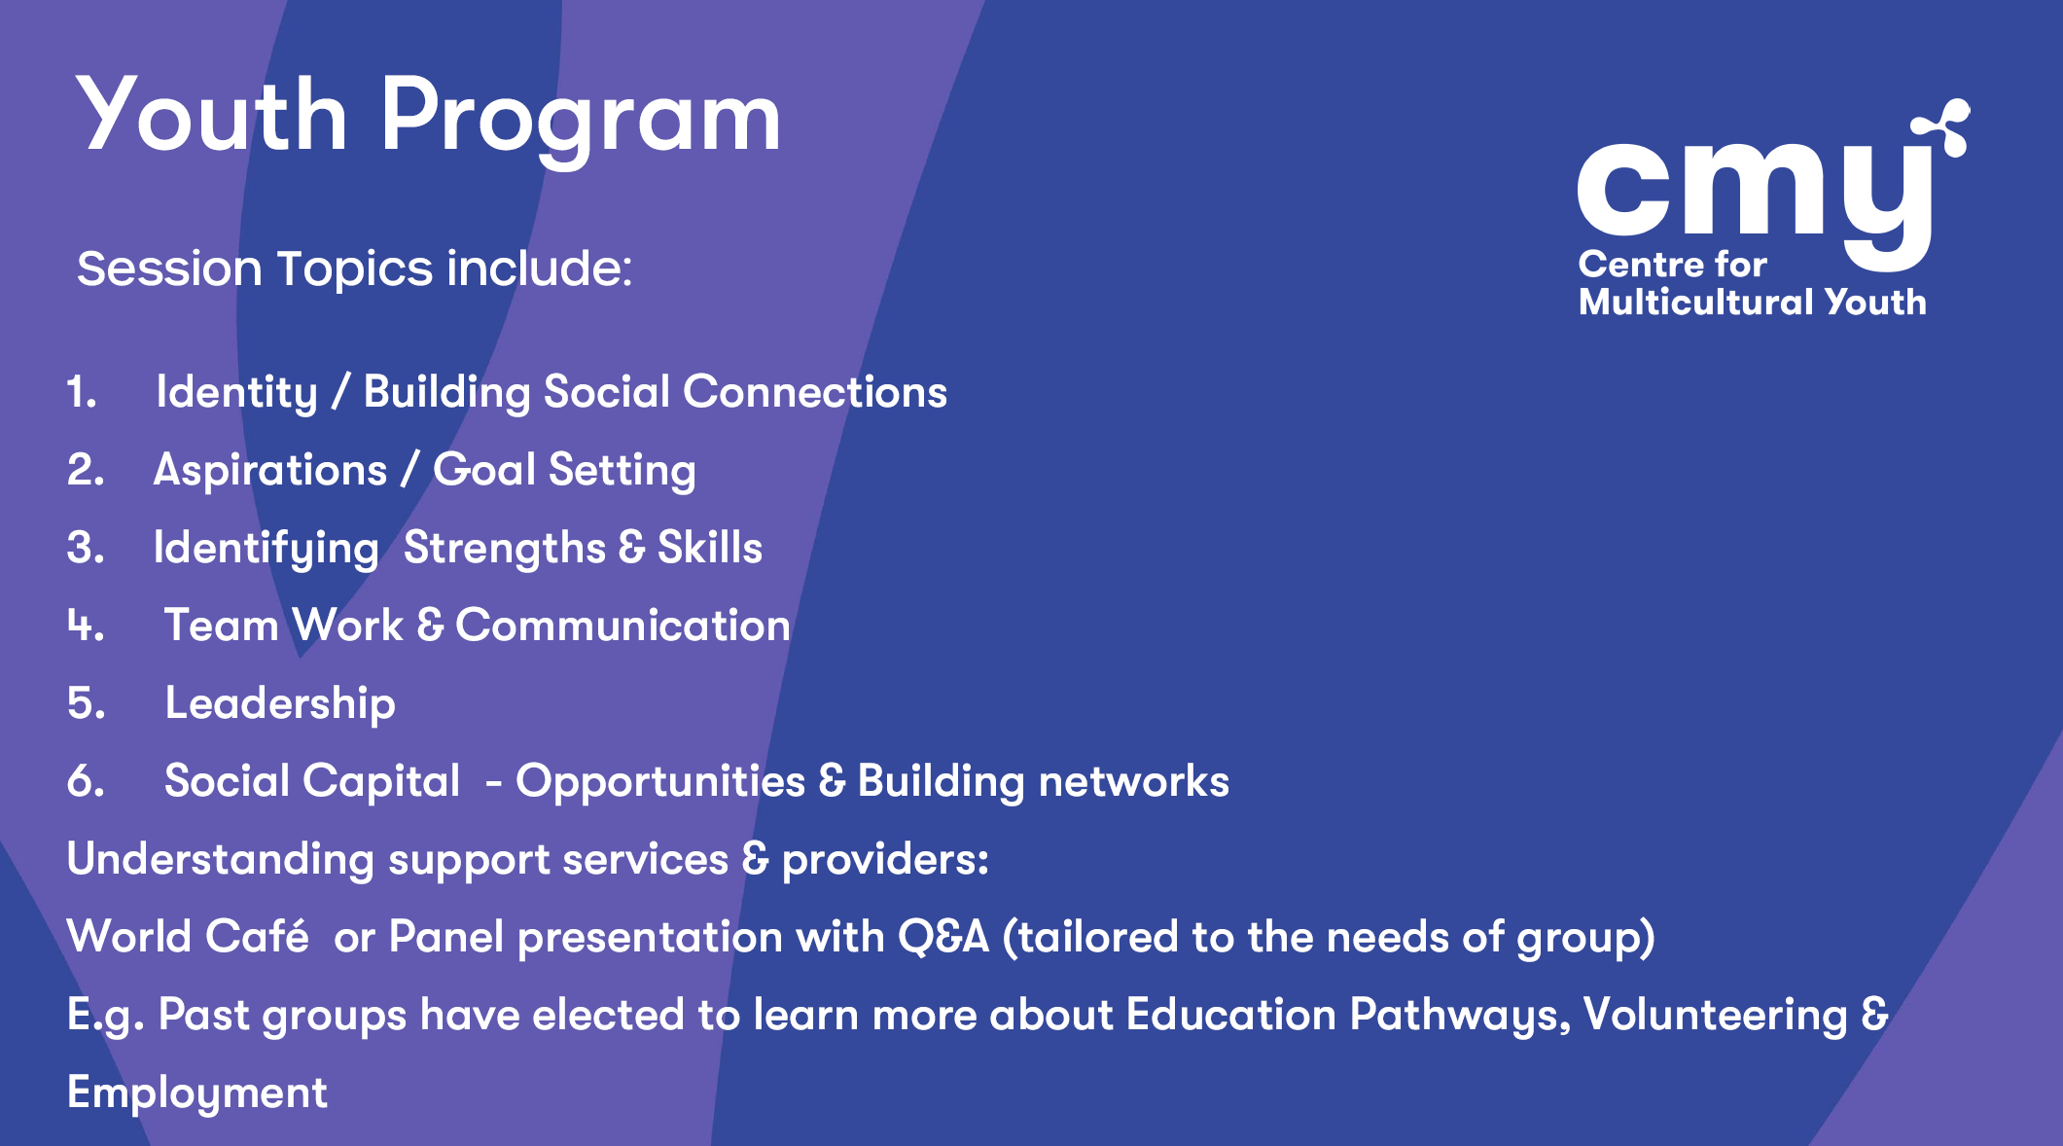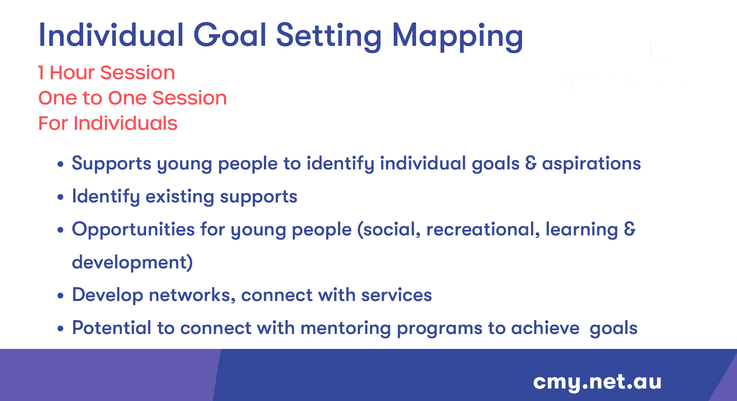
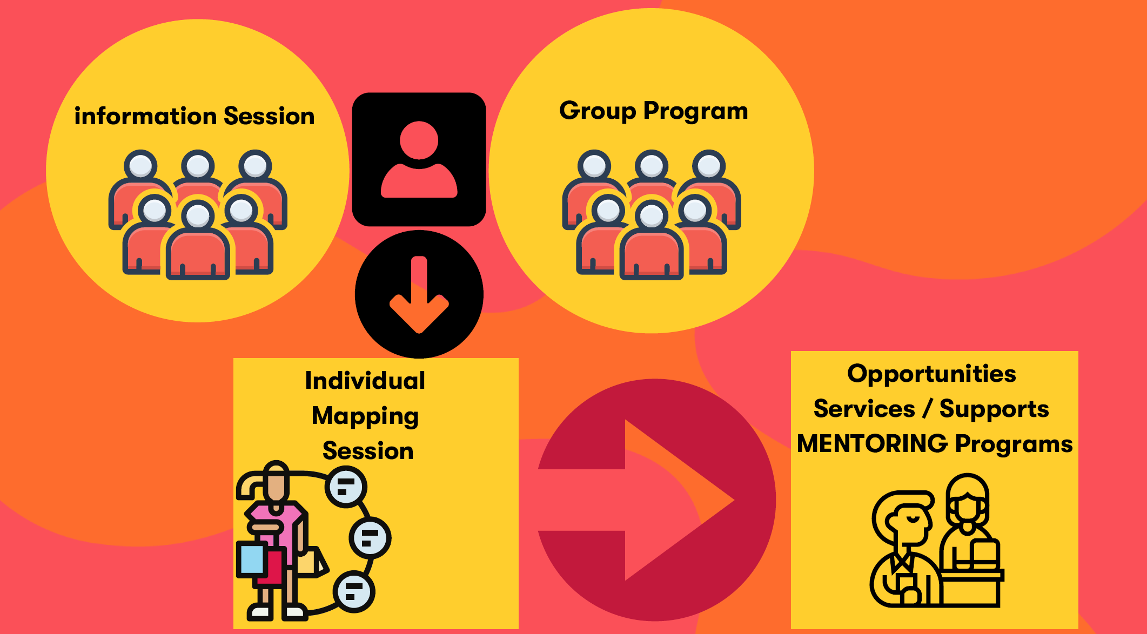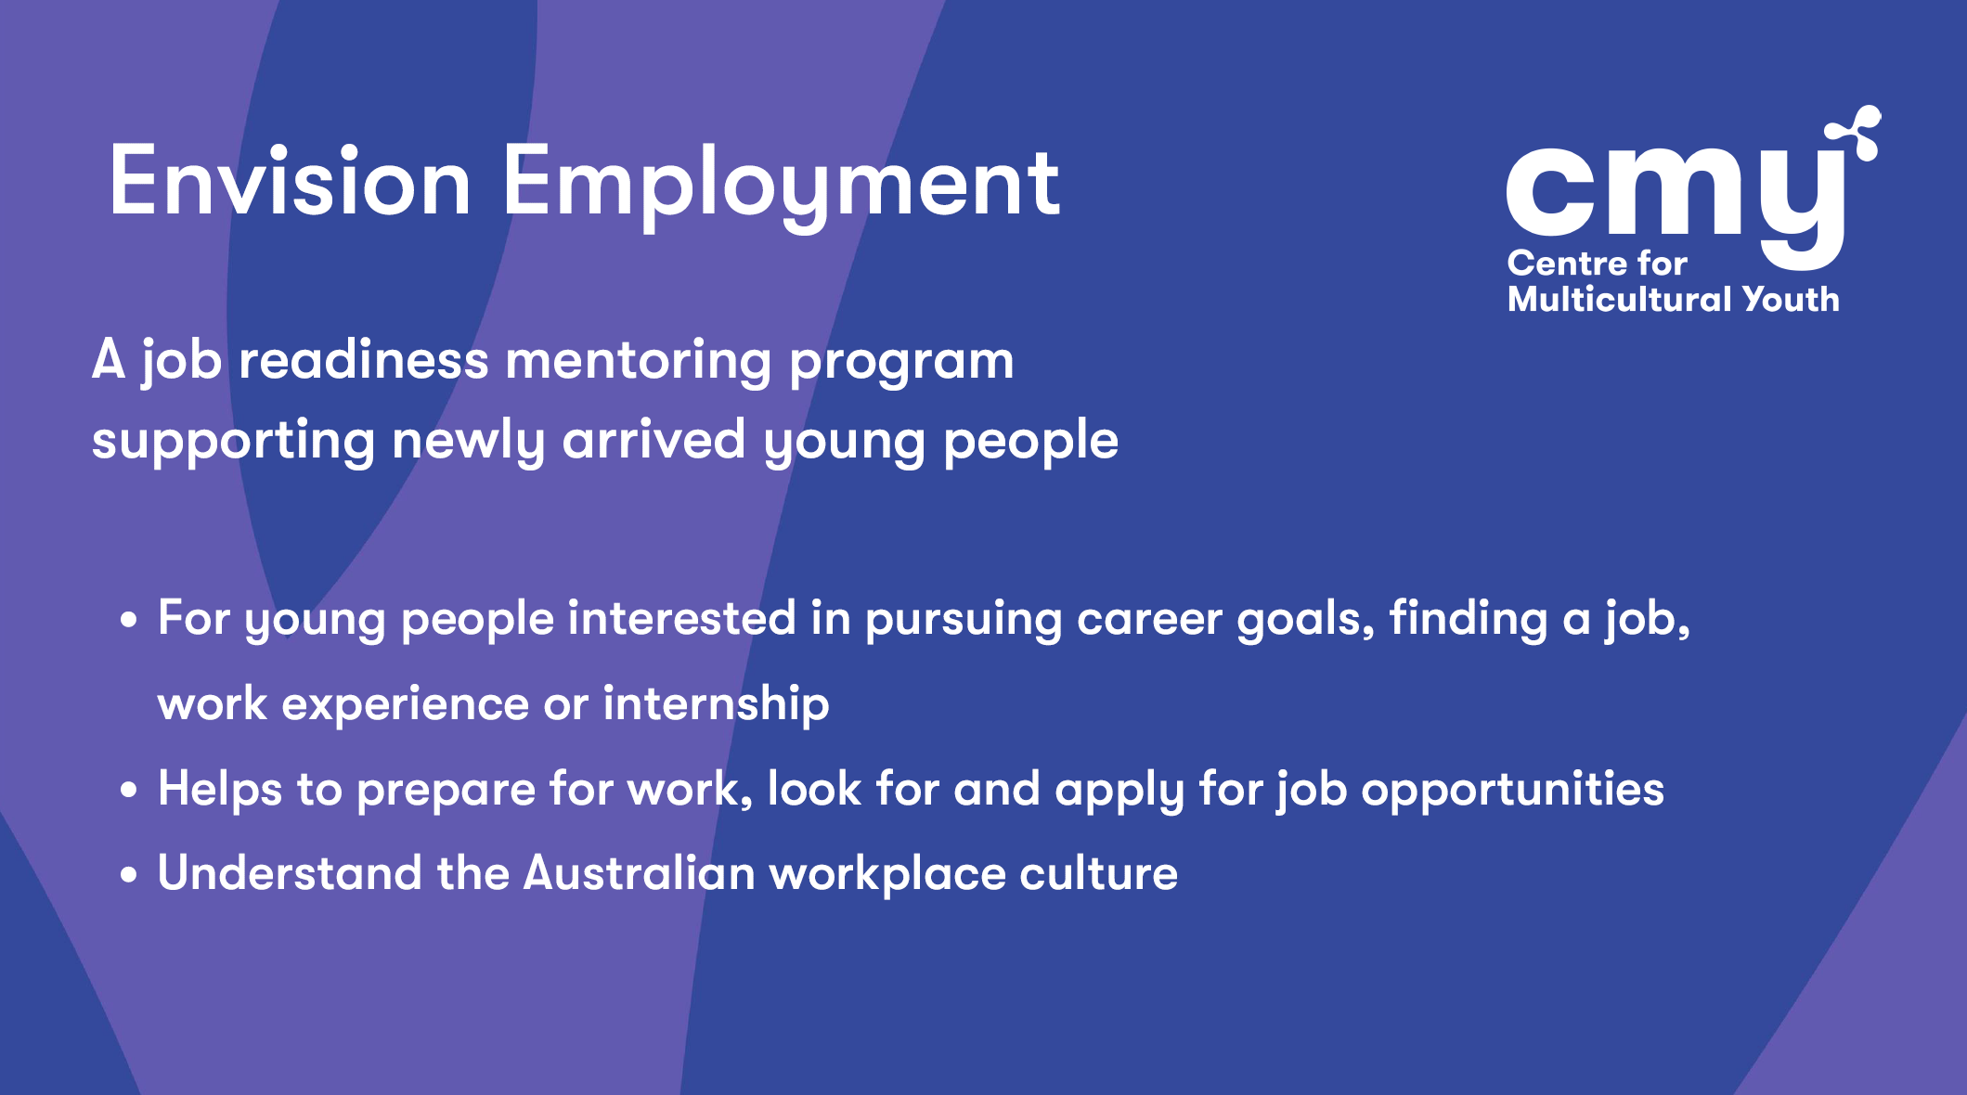

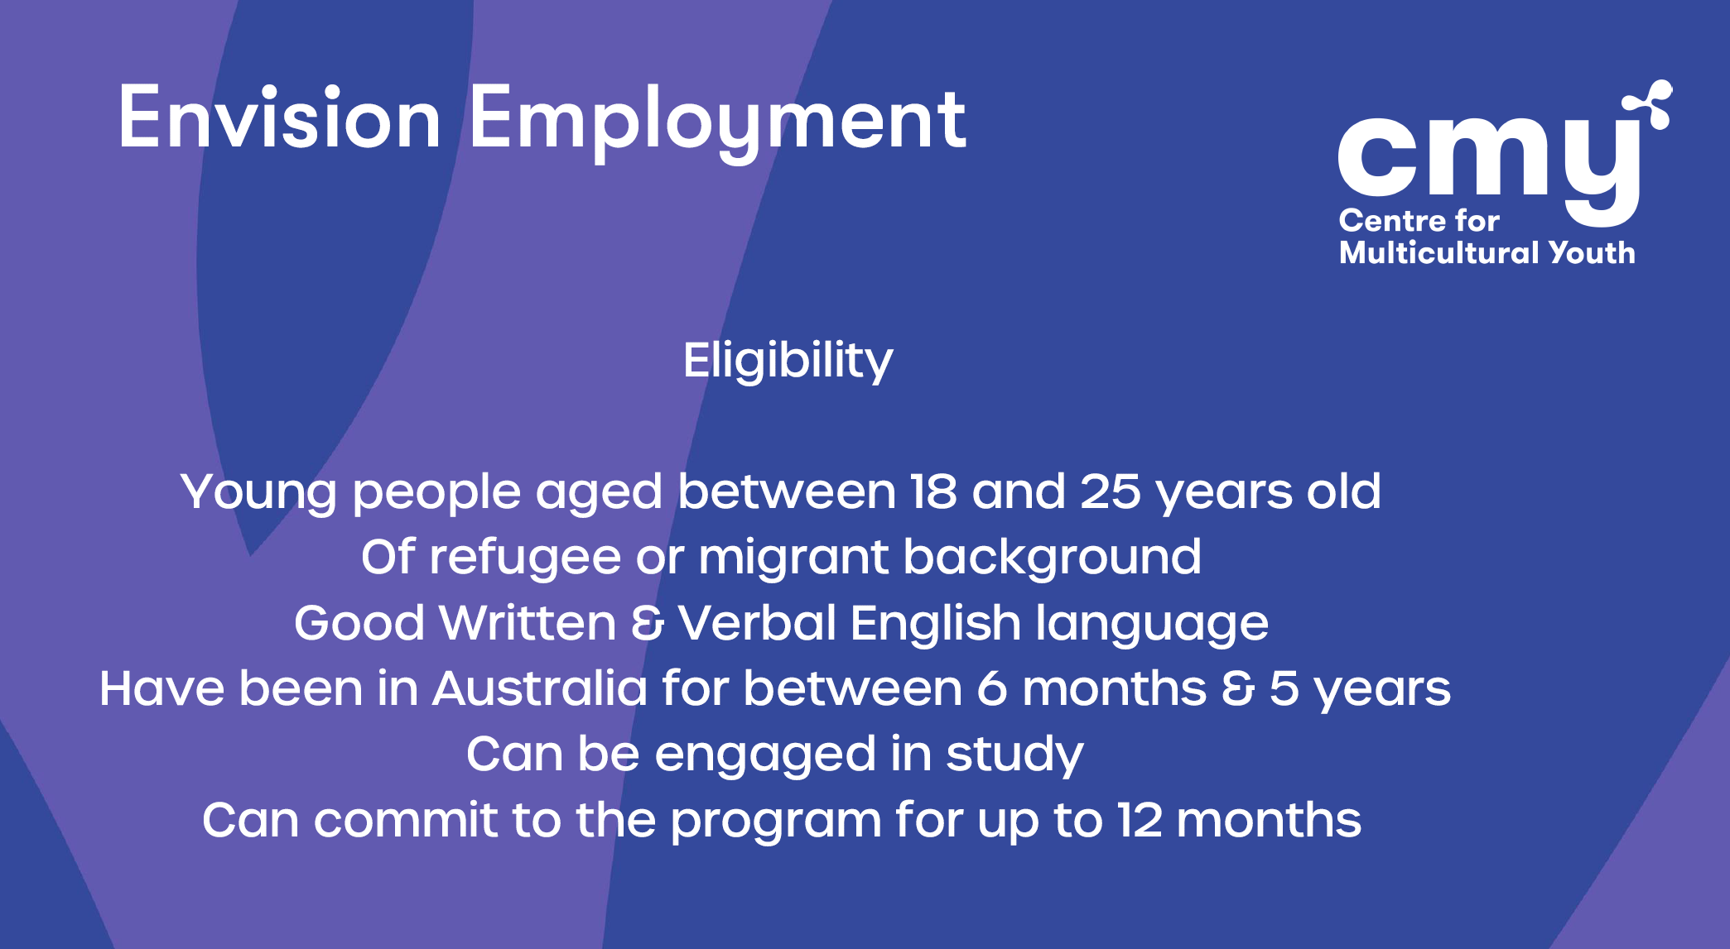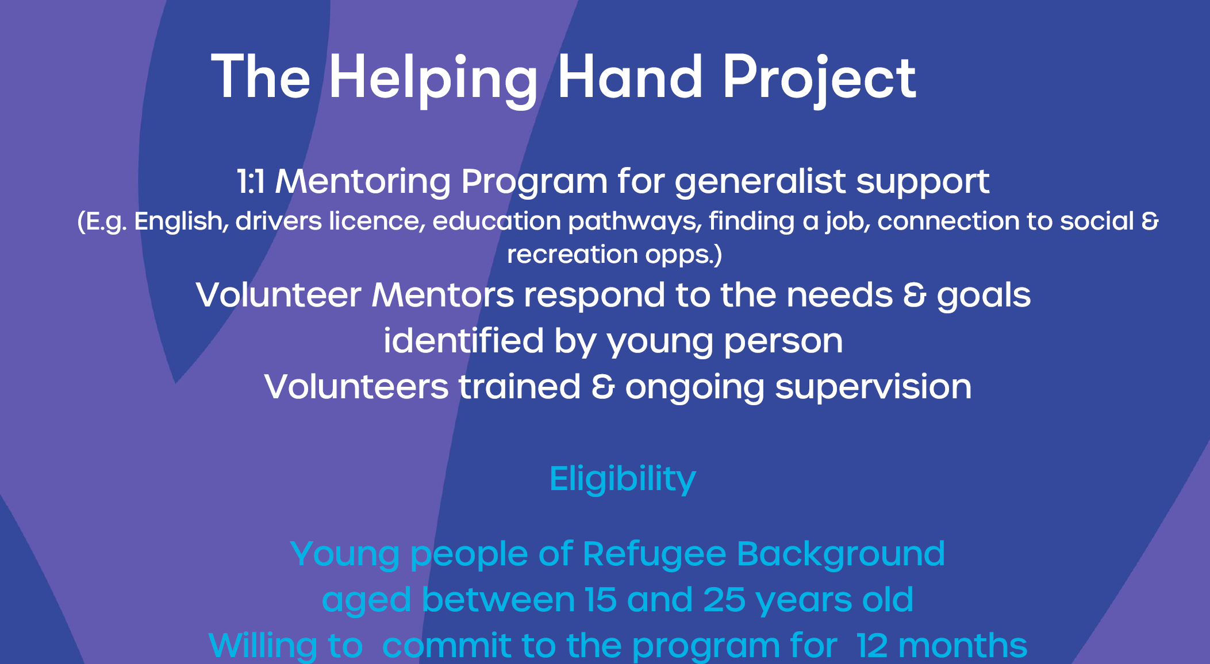
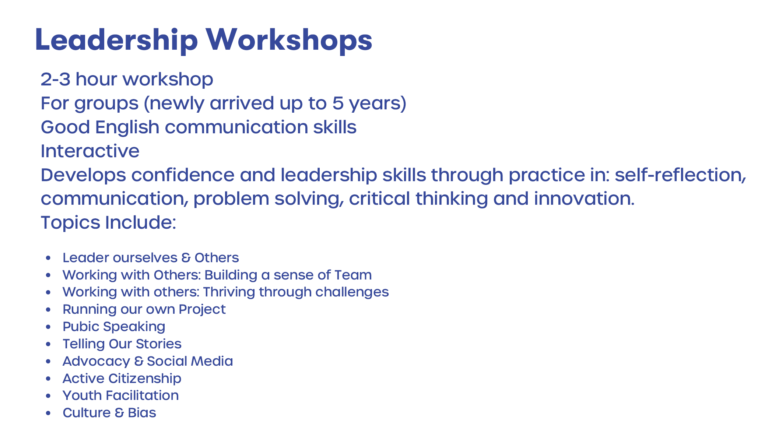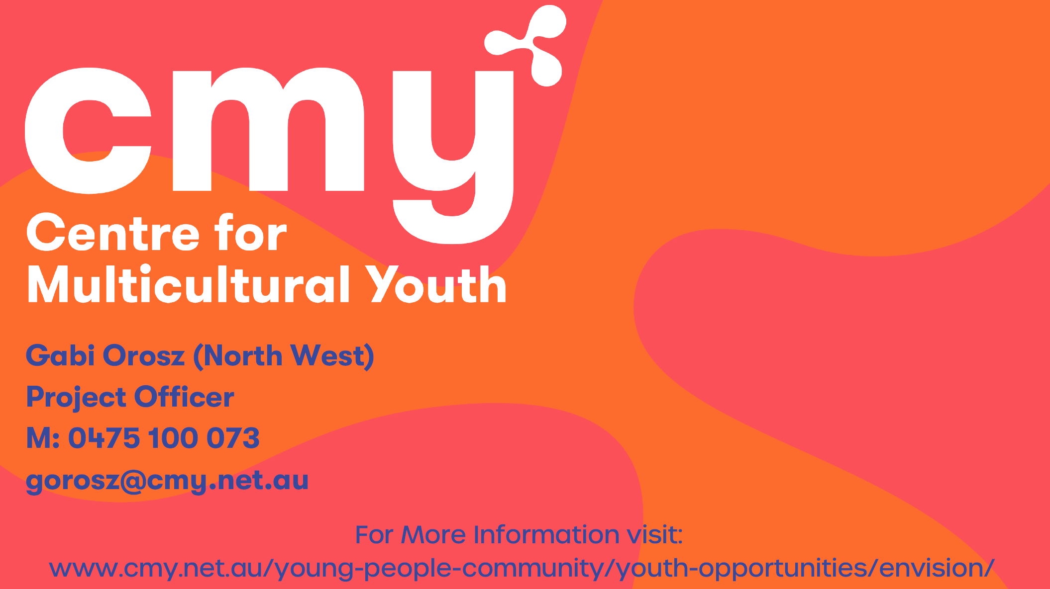

Presentation: Anthony Hurst – Youth Counsellor - Wyndham City Council Youth Services

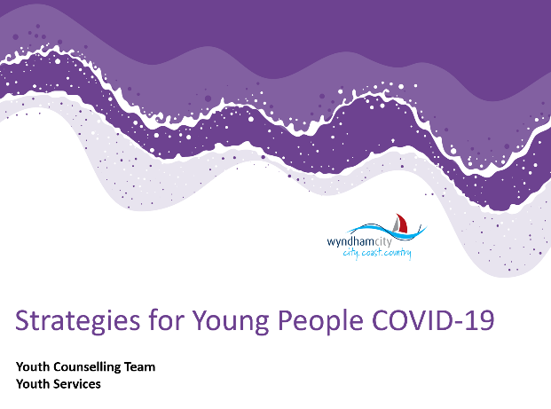
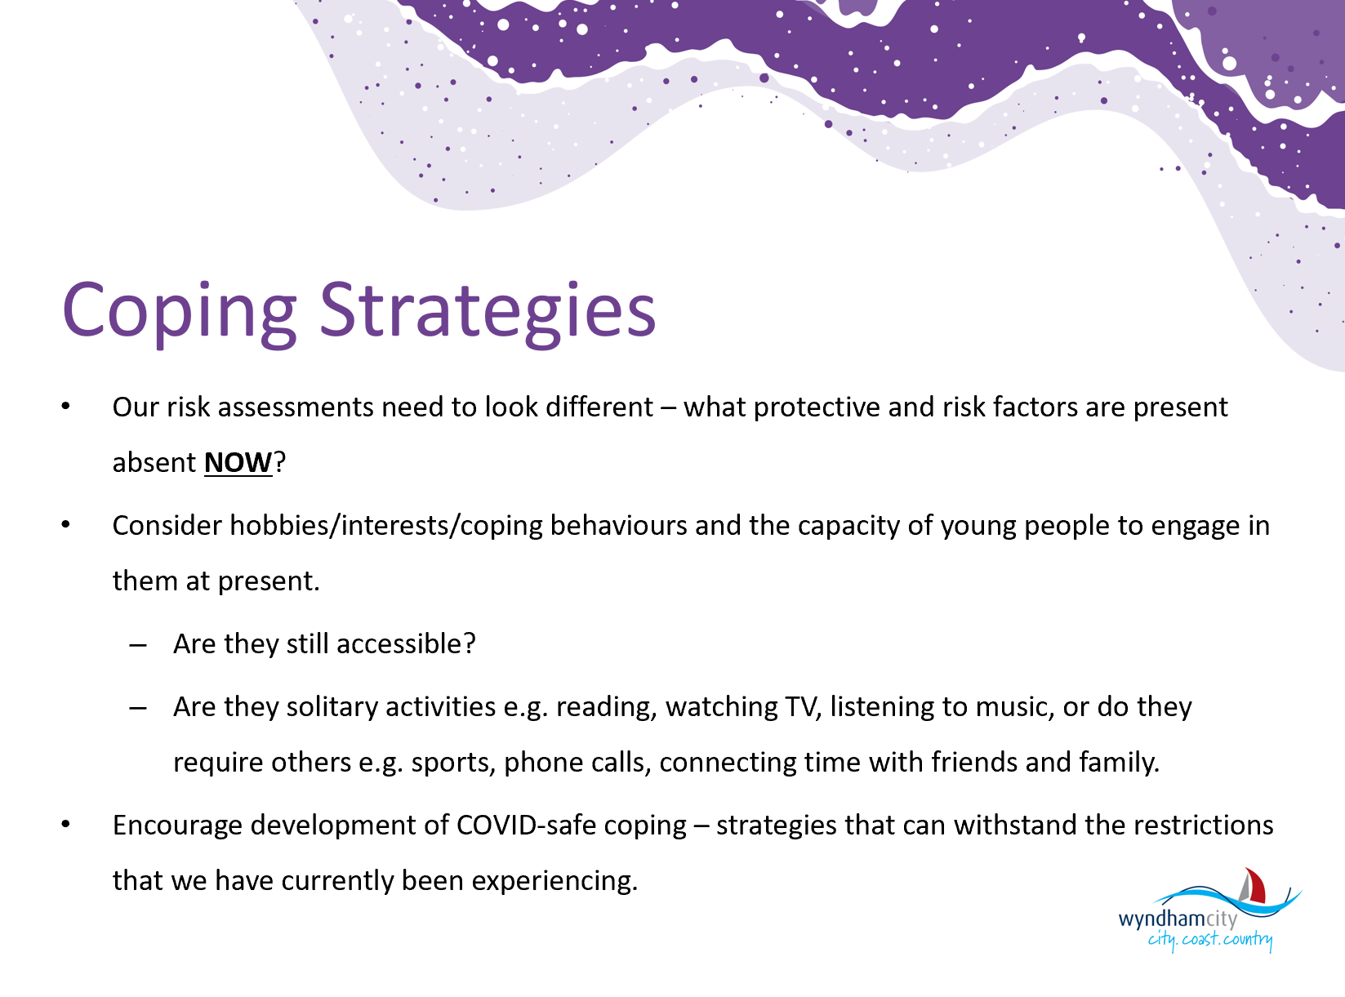
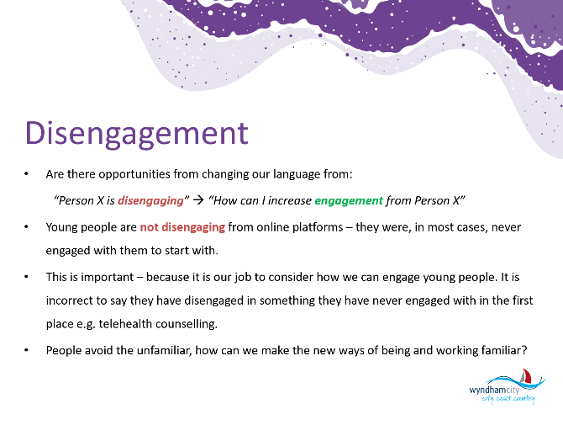
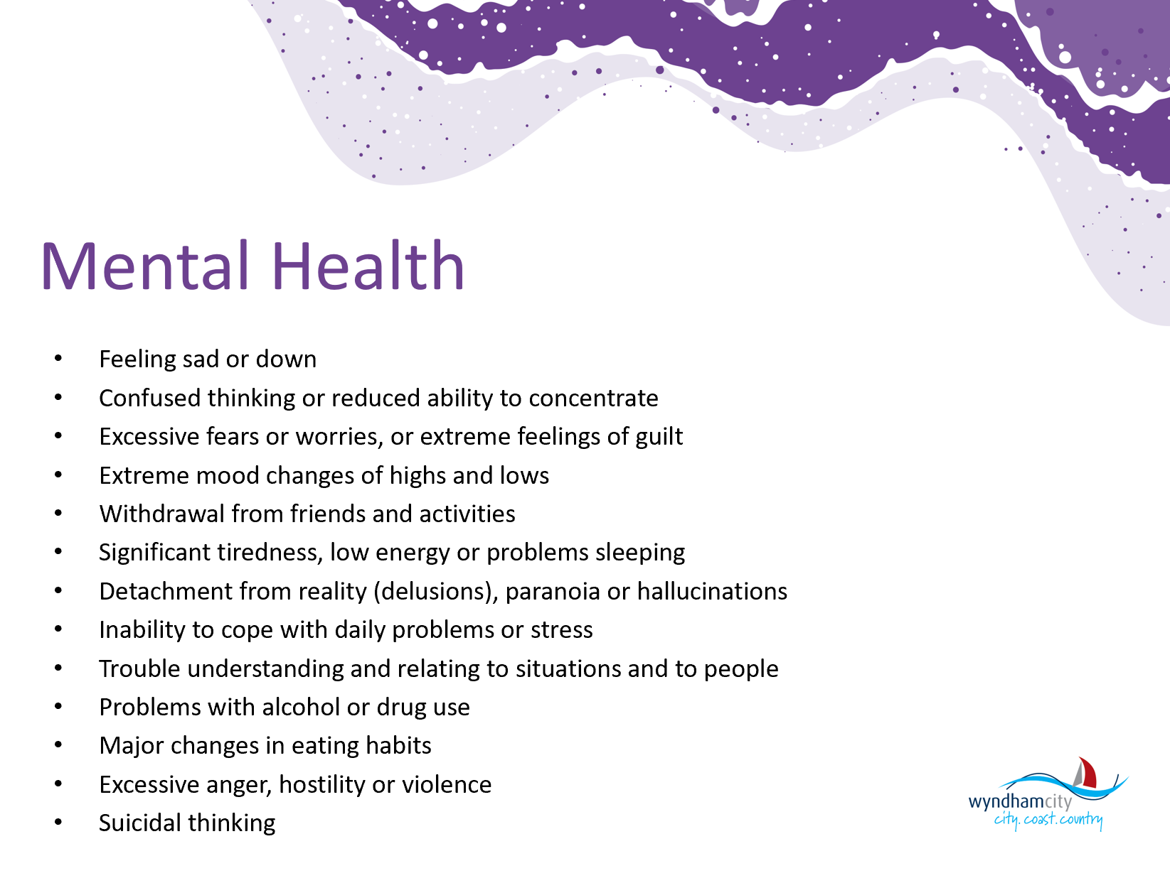
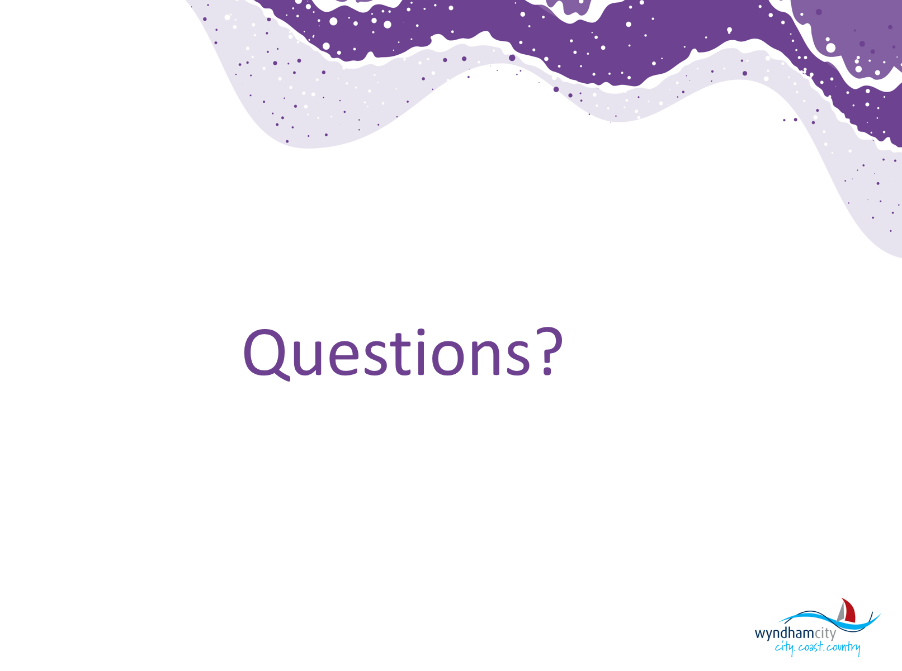

Information Sharing:
Name: Jackie Cassar
Agency: The Salvation Army Employment Plus
Position: Senior Recruiter
Contact: 0438 817 864 E: jackie.cassar@salvationarmy.org.au

The Transition to work program assists youth, 15-24 years old with pre employment barriers, training options and sourcing and maintaining employment.

Name: Tharindu Jayadeva (TJ)
Agency: Headspace Werribee
Position: Community Awareness Officer
Contact: tharindu.jayadeva@orygen.org.au Ph: 8001 2366

Hello Wyndham!

At headspace, we know that last few weeks and months may have been pretty challenging, so we just wanted to share a reminder that headspace Werribee is still open every weekday (working offsite every day except Tuesdays for now) and providing support via telehealth and phone services.

We also have eheadspace, our national online and phone support service which is open from 9am-1am every day, including public holidays. Details for eheadspace can be found here: https://headspace.org.au/eheadspace/

Most days of the week, there are also online group chats for young people (with specific ones for families and friends) to connect with one another in a safe and moderated space. Details for our group chats can be found here: https://headspace.org.au/eheadspace/group-chat/

Our Work and Study service is also running, aiming to support young people with navigating the work and study space at the moment, and how they may be able to work towards their goals in a supported way. Details on our Work and Study program can be found here: https://headspace.org.au/young-people/digital-work-and-study-program/

The next Wyndham Workers with Young People Network meeting is scheduled for
Thursday 8 October on Microsoft Teams

2020 Meeting Dates

All future meetings for 2020 will be going ahead, to be delivered online via Microsoft Teams.
The meeting link will be sent out with the Agenda, prior to the meeting.
8 October
19 November

To submit your information for sharing with the Network:
https://youthwyndham.org/wyndham_youth_network_news

To subscribe to the Network:
https://youthwyndham.org/wyndham_network_subscribe

To request to present at a meeting email:
wyndhamyouthnetwork@wyndham.vic.gov.au

Website: Wyndham Workers with Young People Network – click here

To contact the Wyndham Workers with Young People Network email:
wyndhamyouthnetwork@wyndham.vic.gov.au

