Instructions
joining LIVE EVENTS using teams

STEP 1
To join the meeting click on the link sent in your reminder.

STEP 2
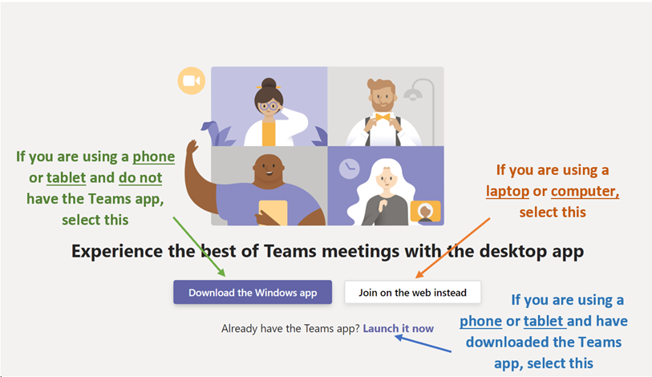
After clicking on the link, you will then be asked how you want to enter Microsoft Teams. Follow the instructions on your screen. See the guide below to help you join the event:

STEP 3
If you are using a desktop/laptop, a screen like this will appear:
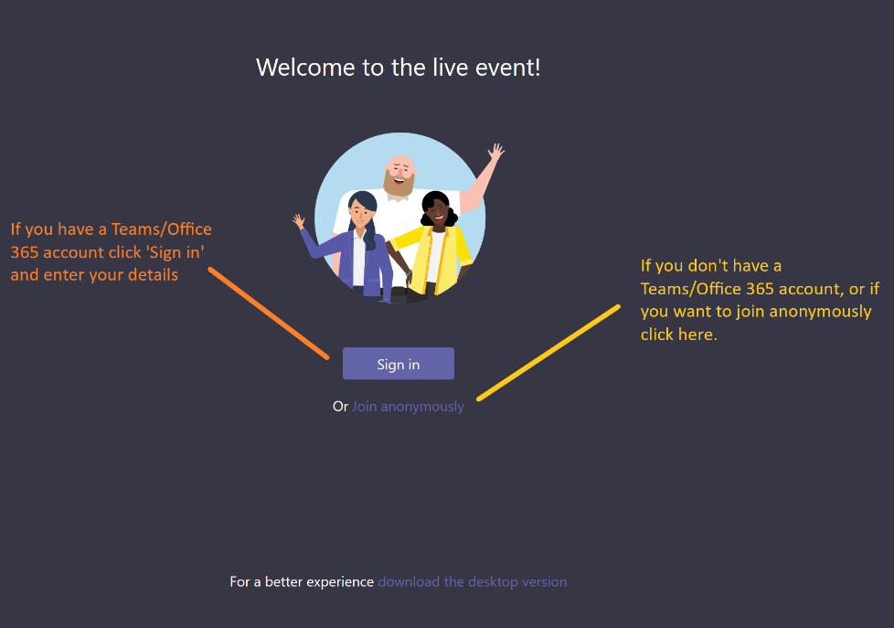

If you are using a tablet or phone a screen like this will appear. Please type in your name:

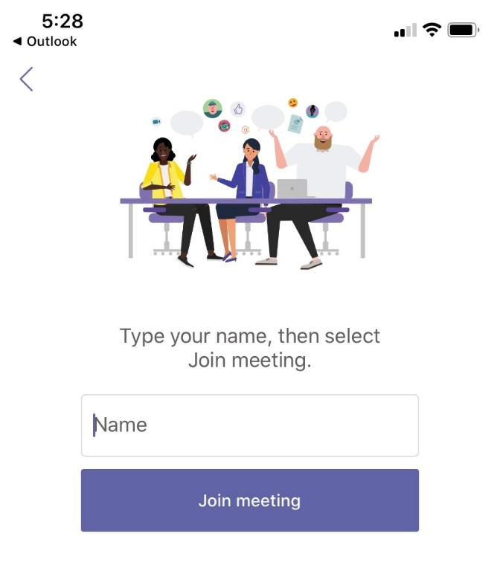

STEP 4
Once you’ve signed in you will see a screen like the one pictured here. See the guide below to help you navigate the screen:
