Wyndham Workers
with Young People Network

Minutes
Thursday 4 June 2020 - 9.30am-11.30am
@ Youth Resource Centre

The next Wyndham Workers with Young People Network meeting is scheduled for Thursday 16 July

Welcome & Introductions
Tanya Whitmore, Senior Youth Support Officer – Wyndham City Council Youth Services

Acknowledgement of the Kulin Nation
“I wish to acknowledge the peoples of the Kulin Nation as the Traditional Owners of the land on which we are gathered and pay respect to their elders, past and present. I also wish to pay respect to any Elders from other communities and acknowledge any future young leaders who are here”

Presentation:
Gee Bilal, Area Leader Youth Support and Development (East District) – Wyndham City Council Youth Services

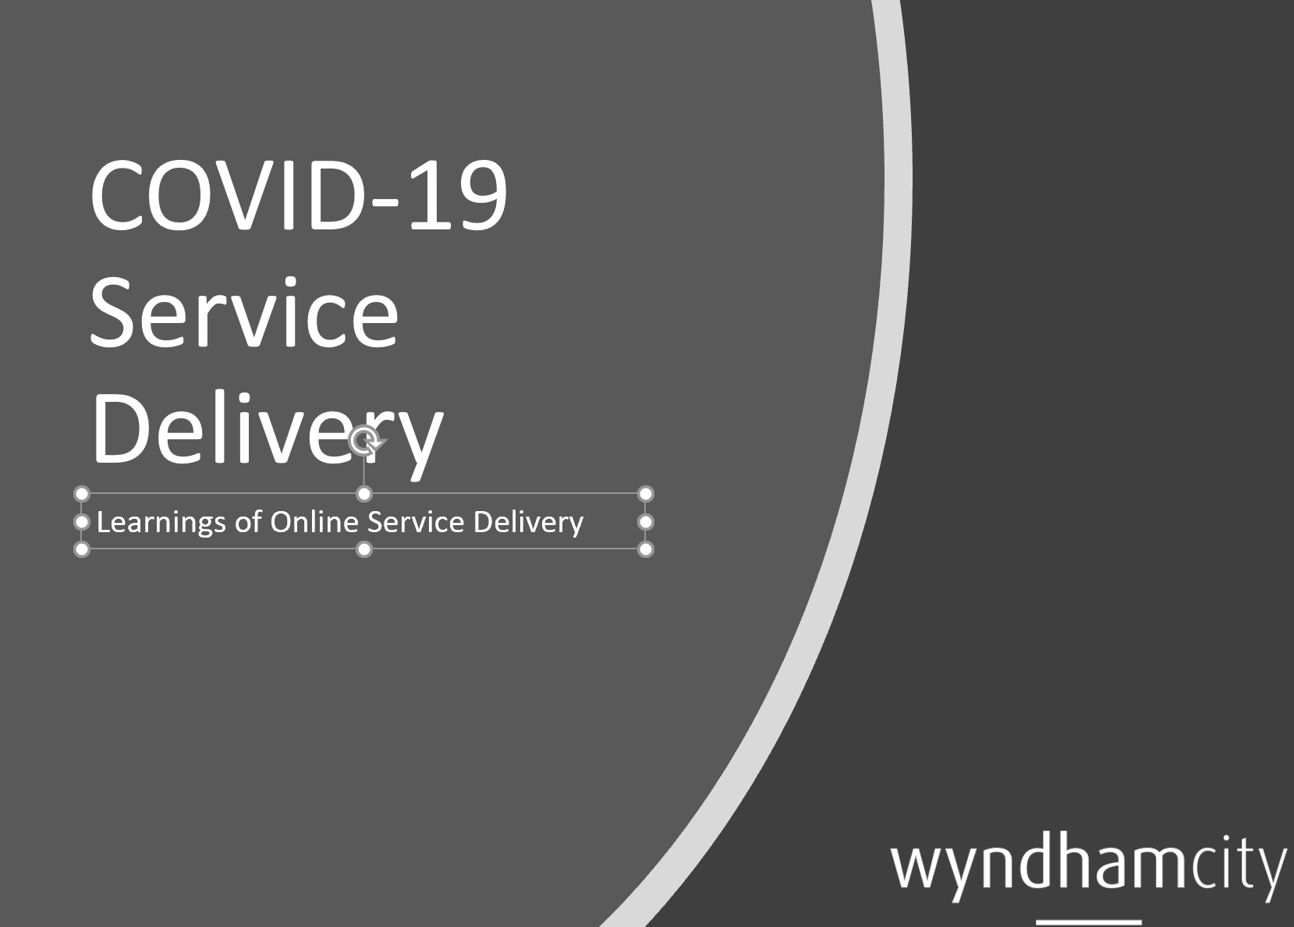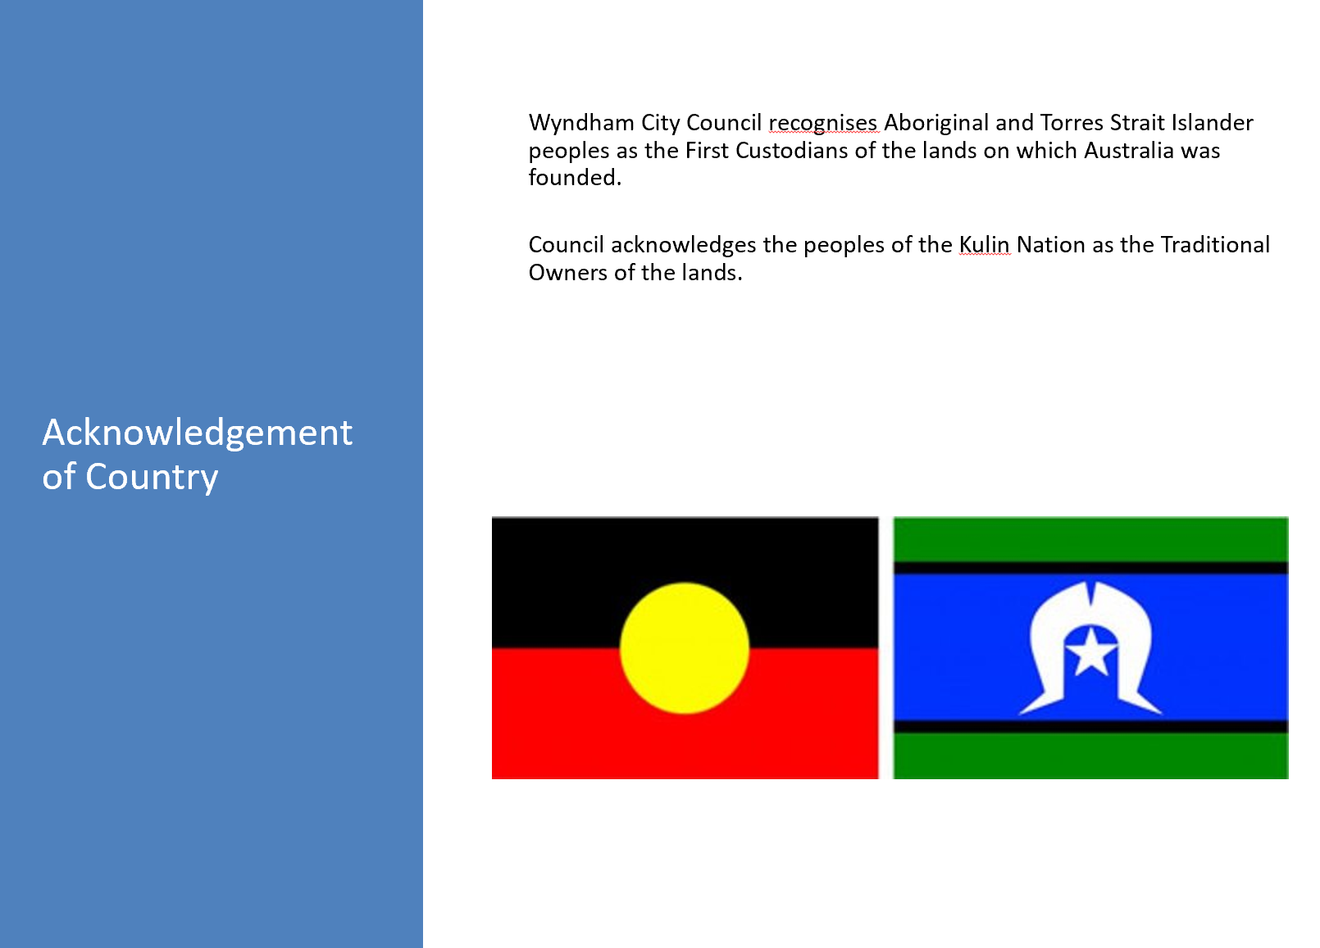
Presentation continued:

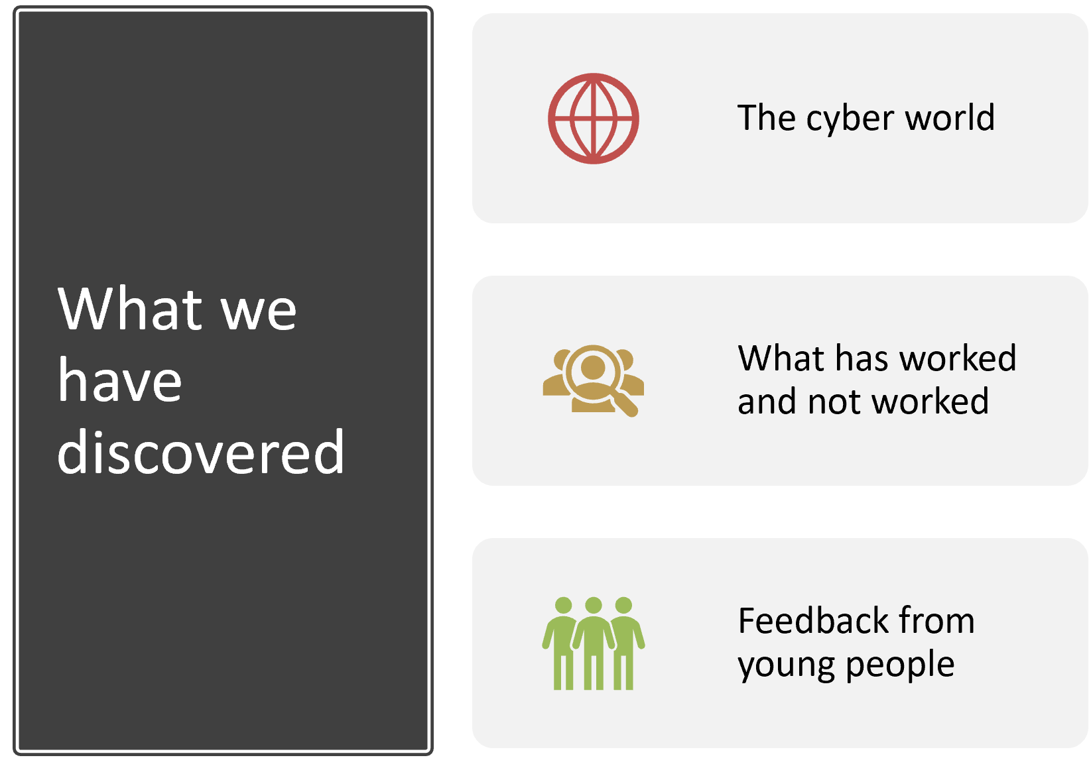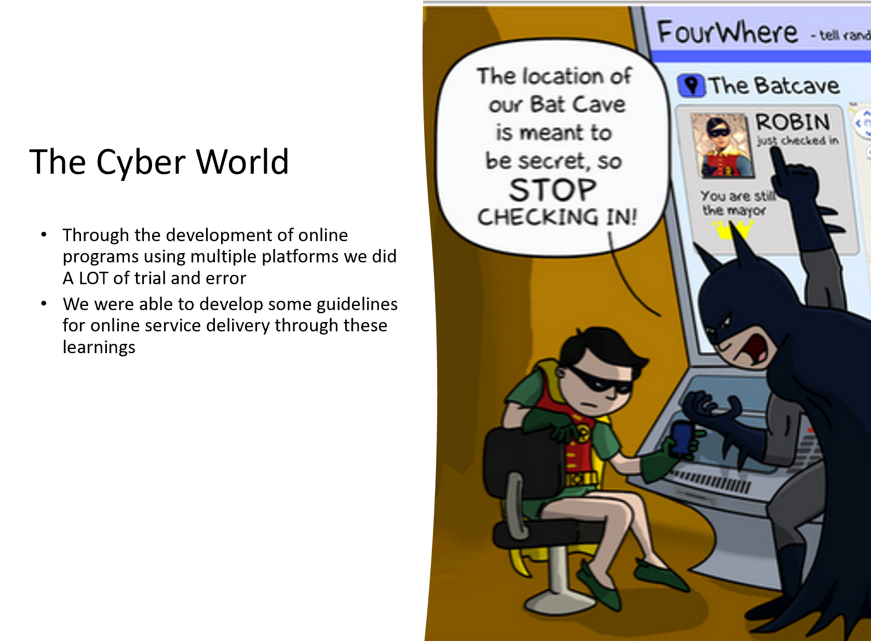
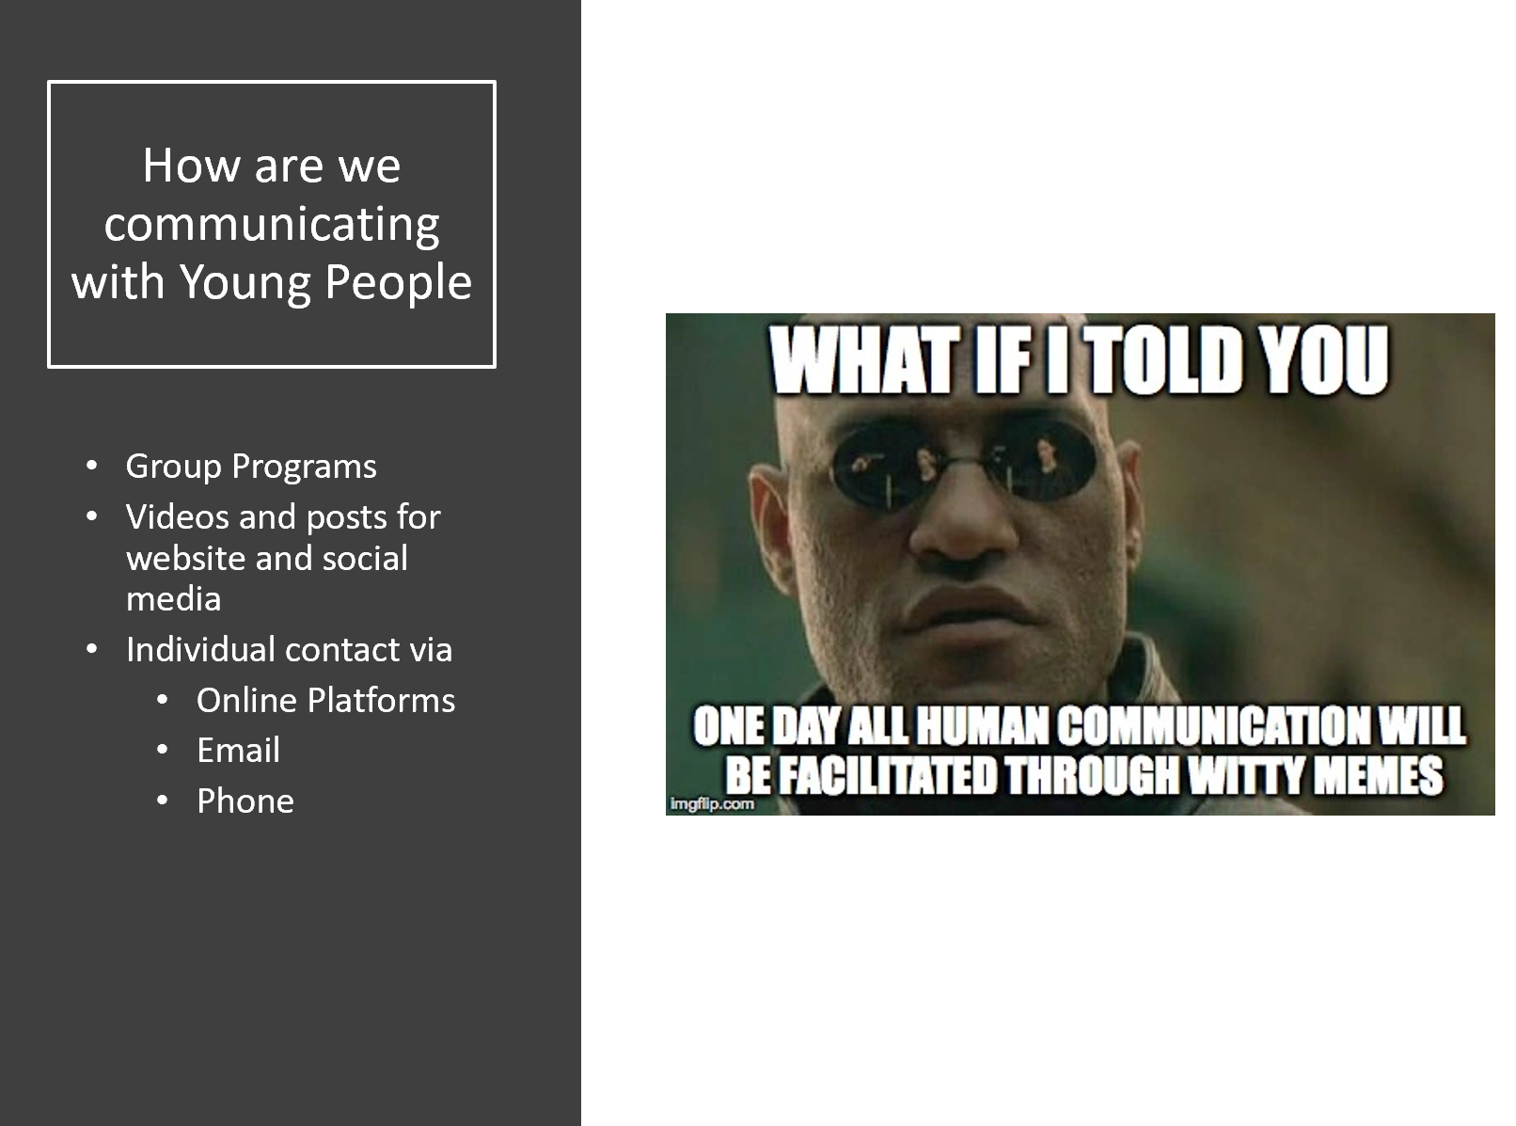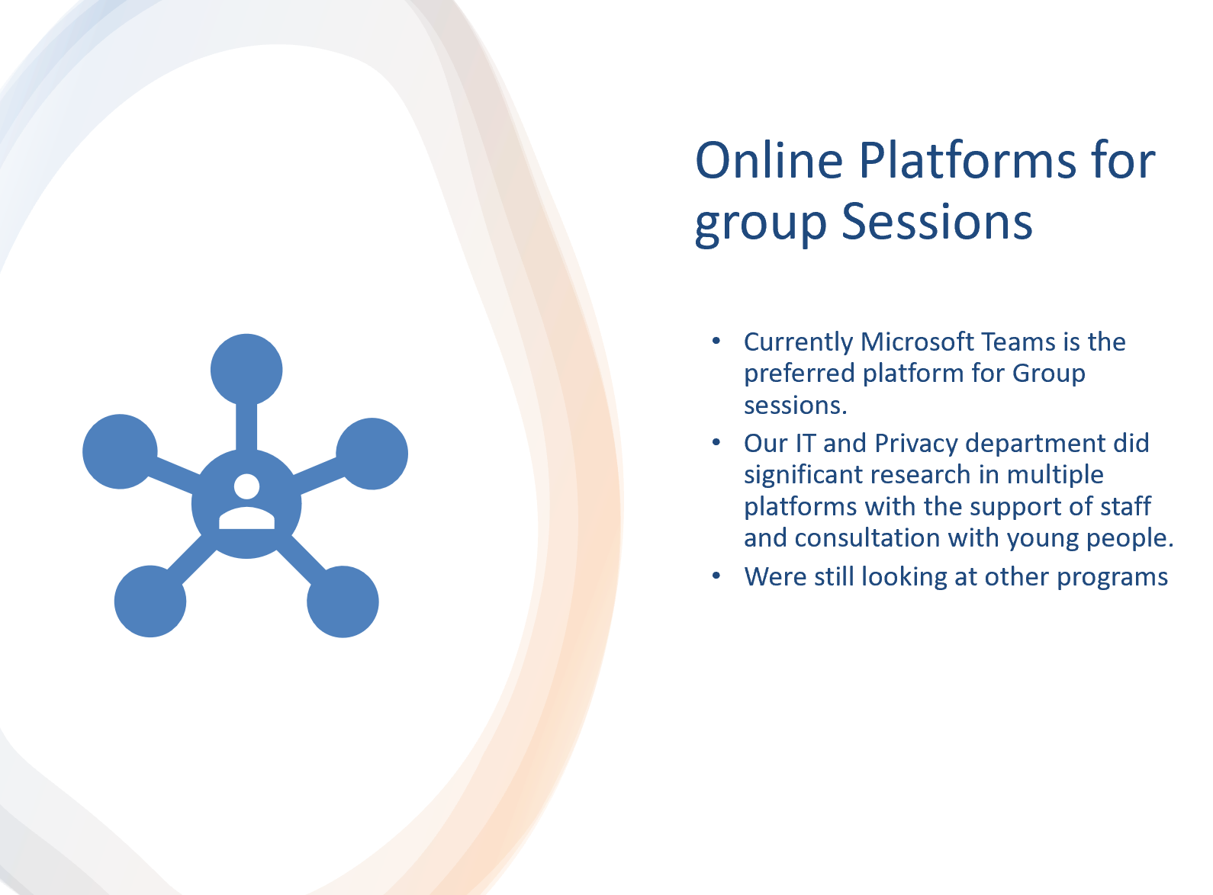

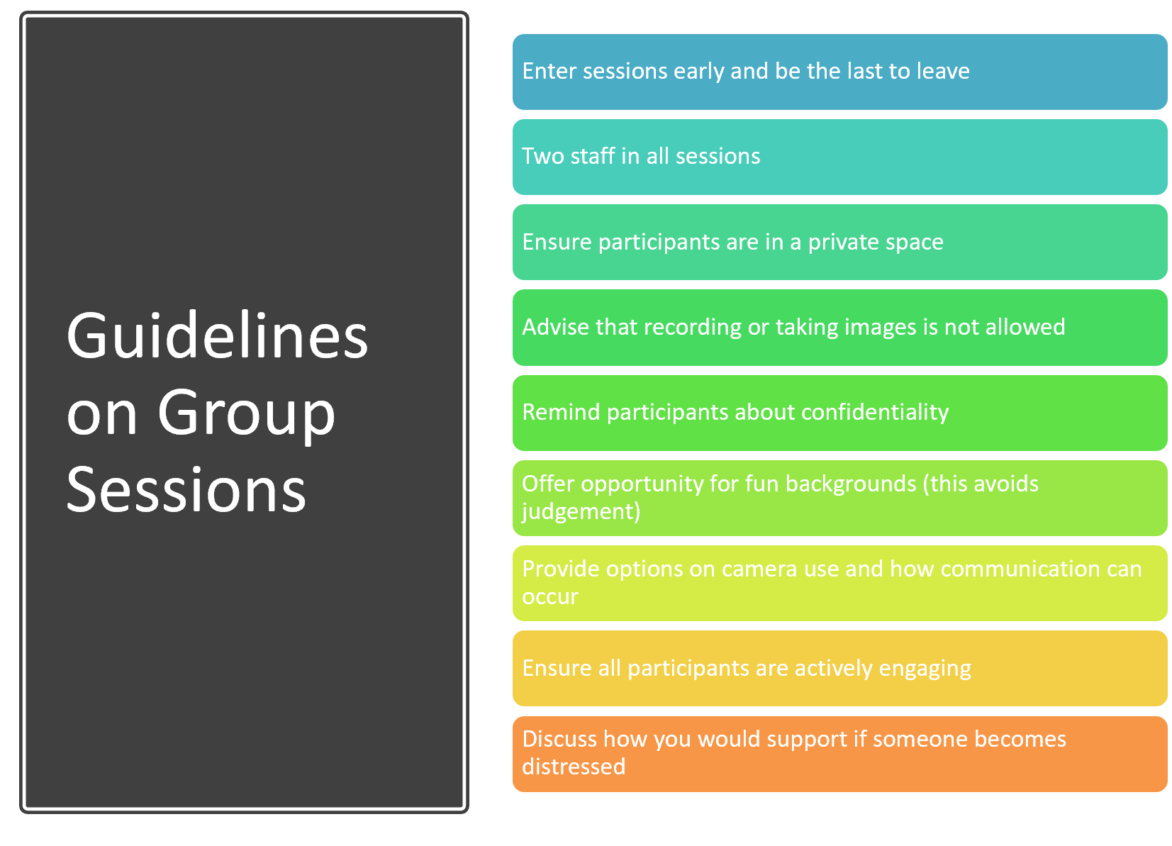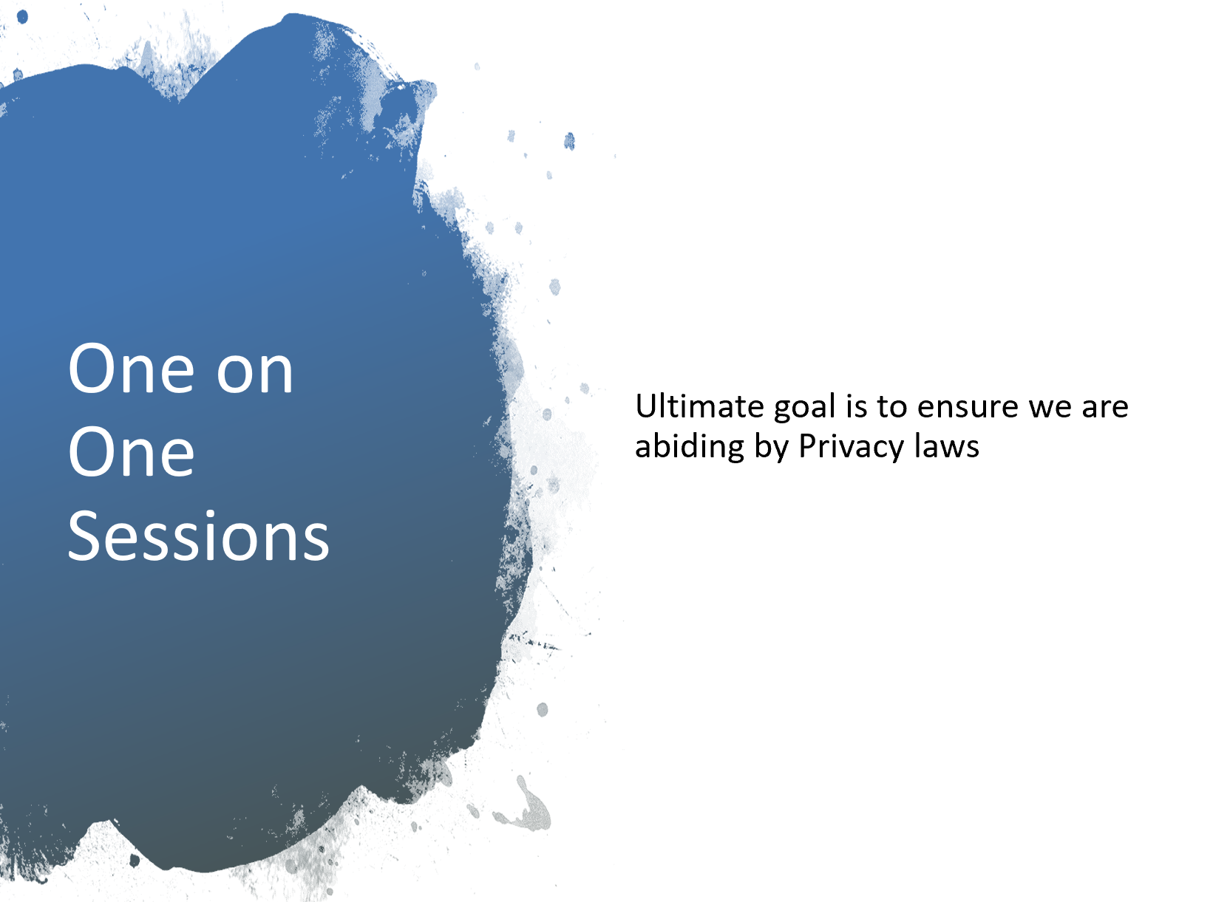
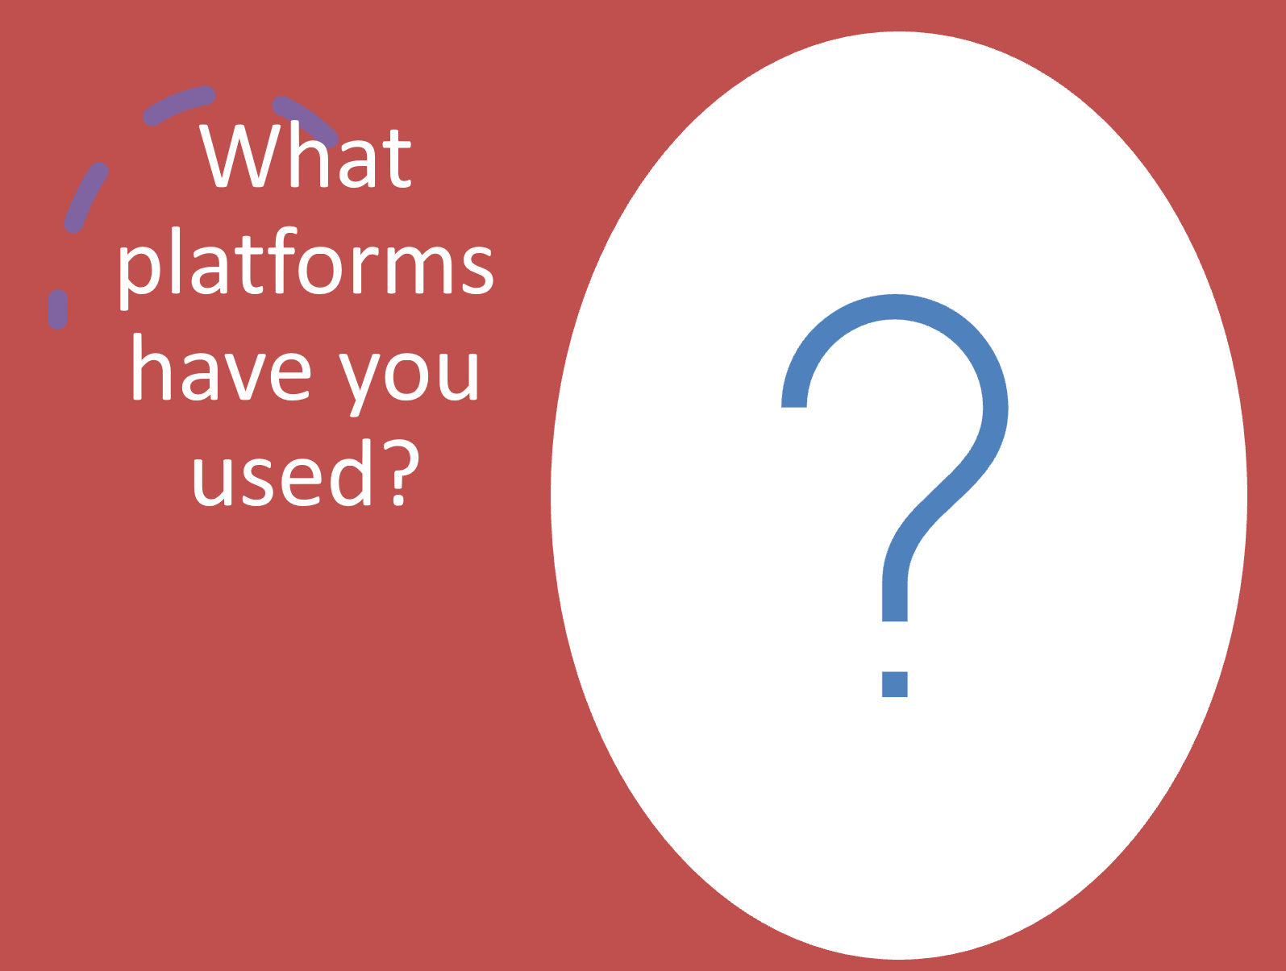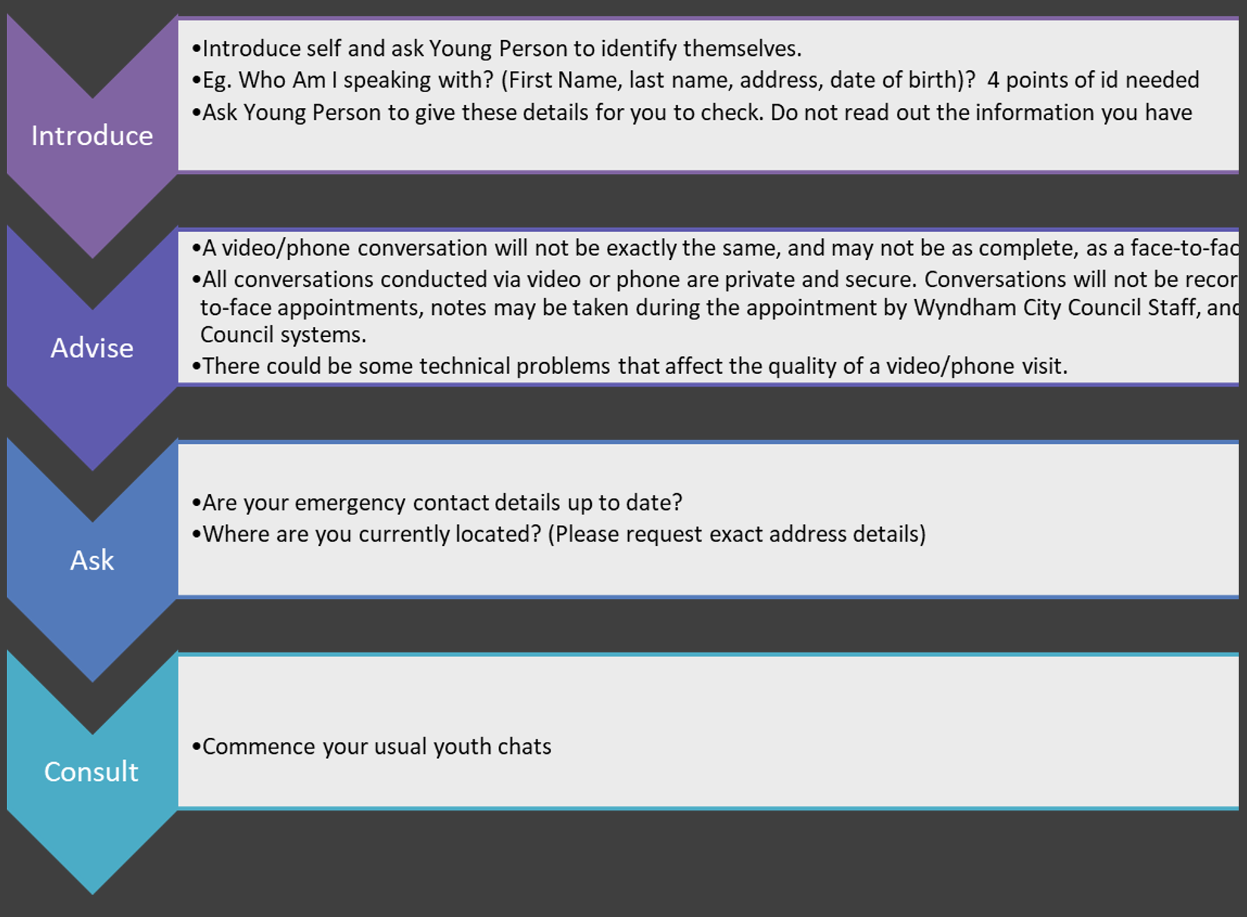
Presentation continued:
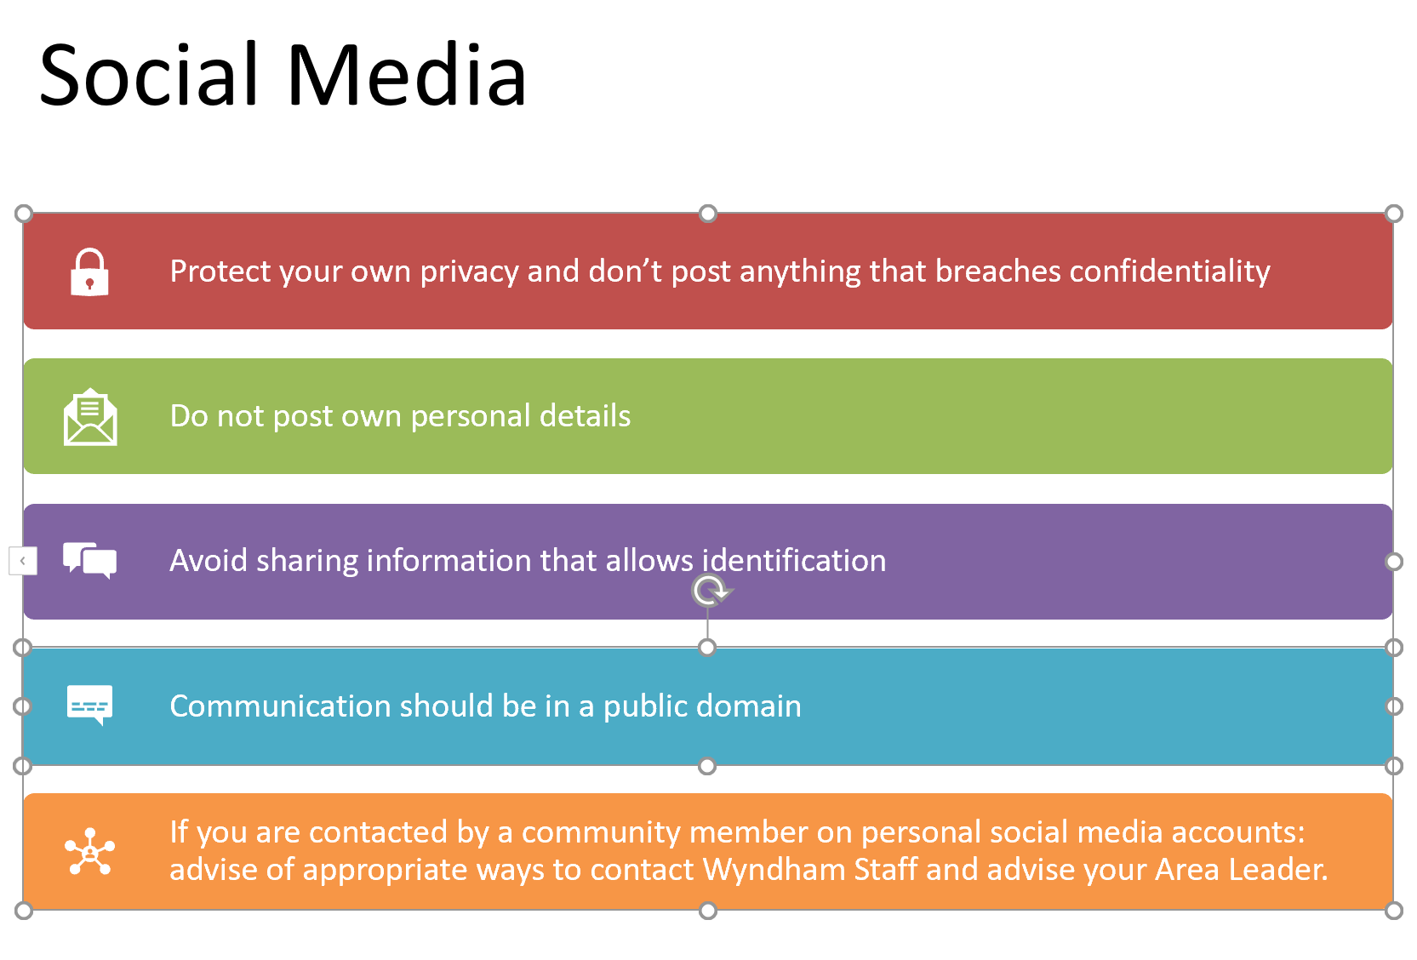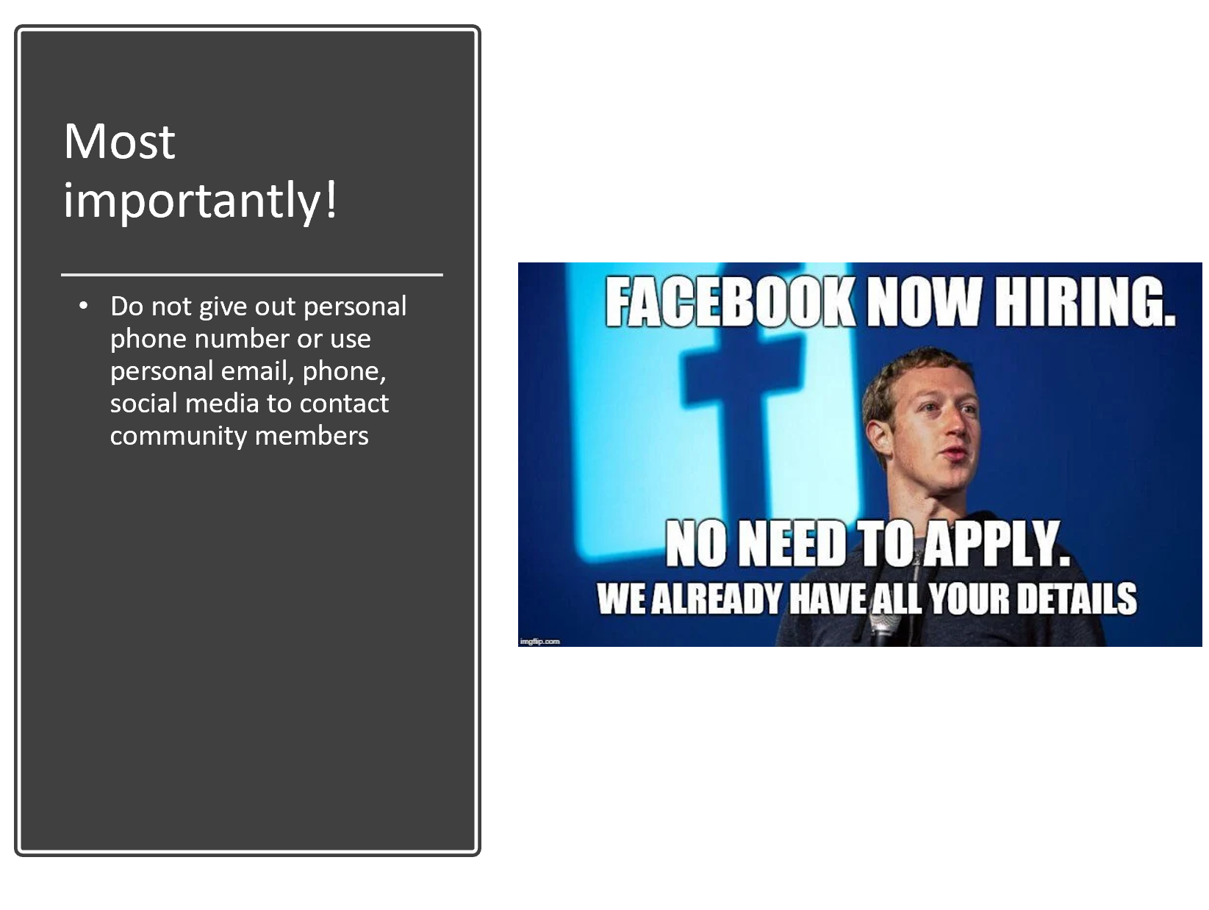
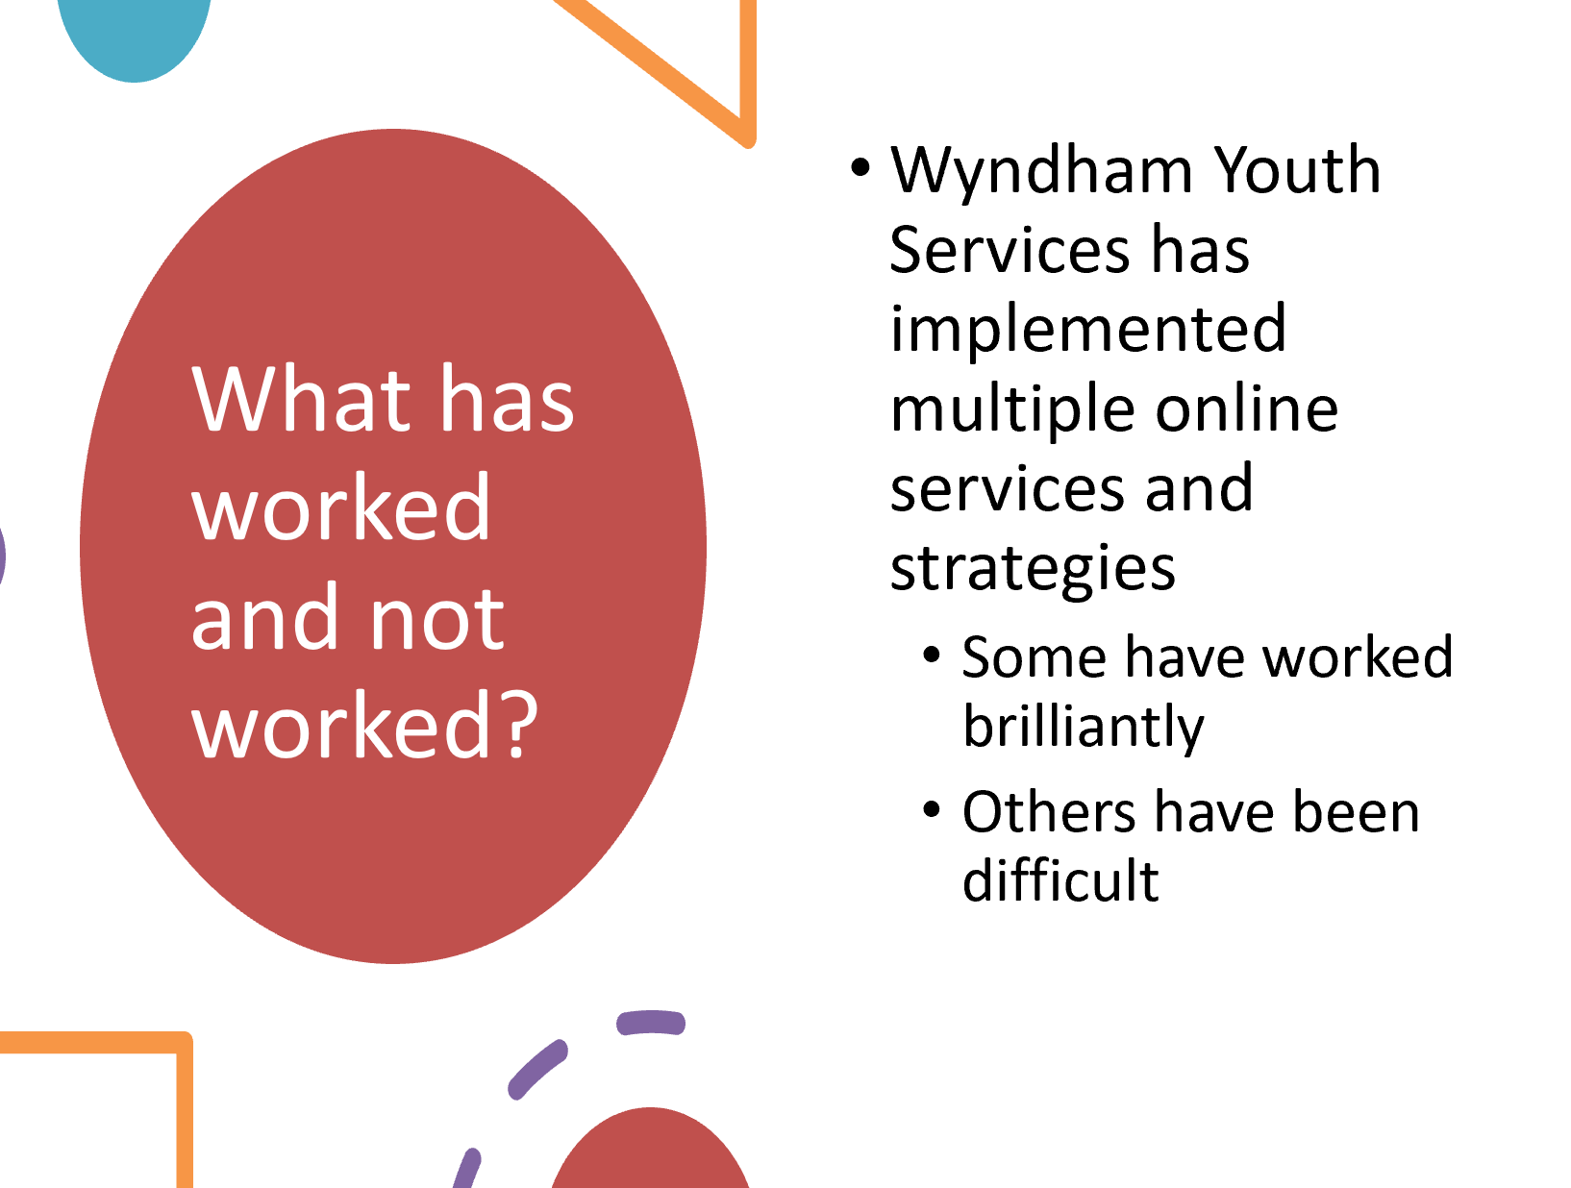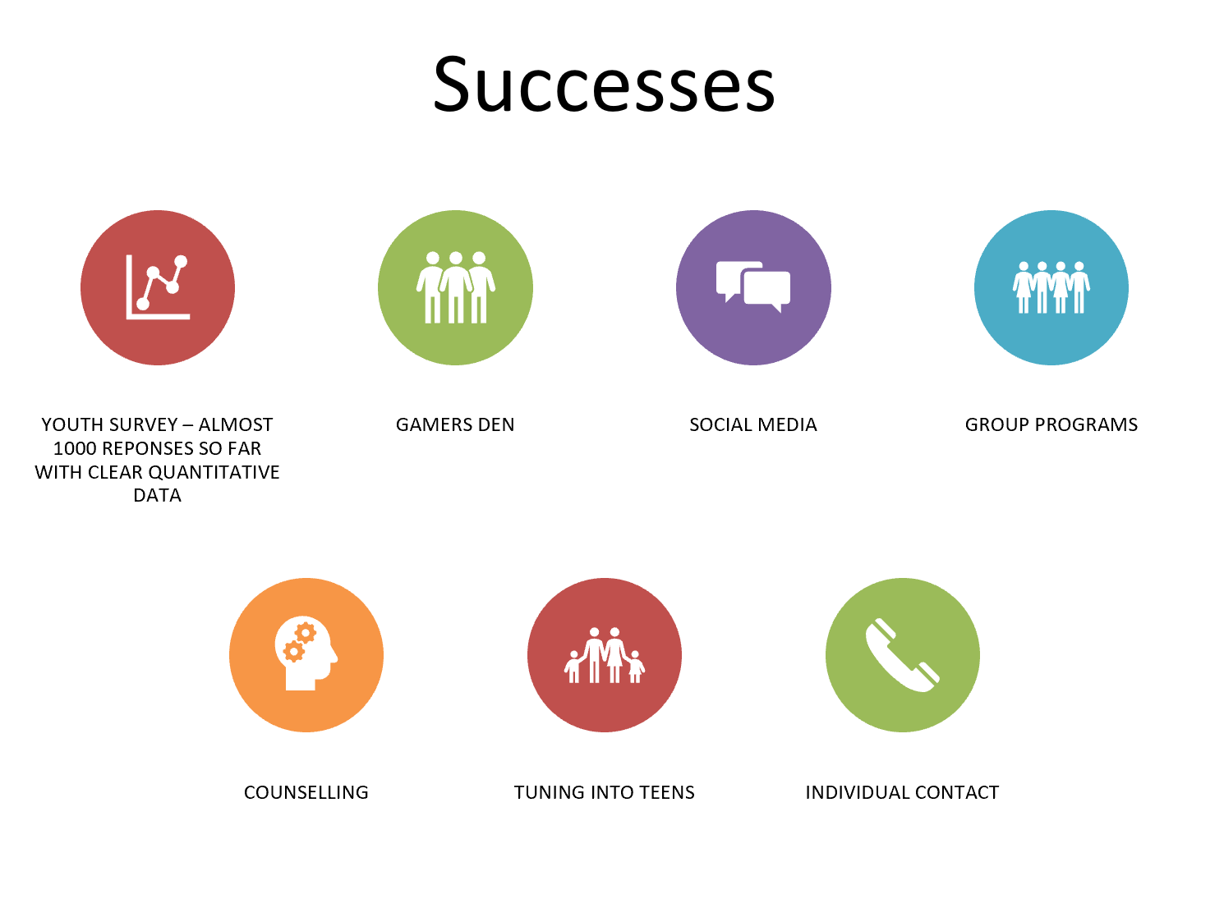
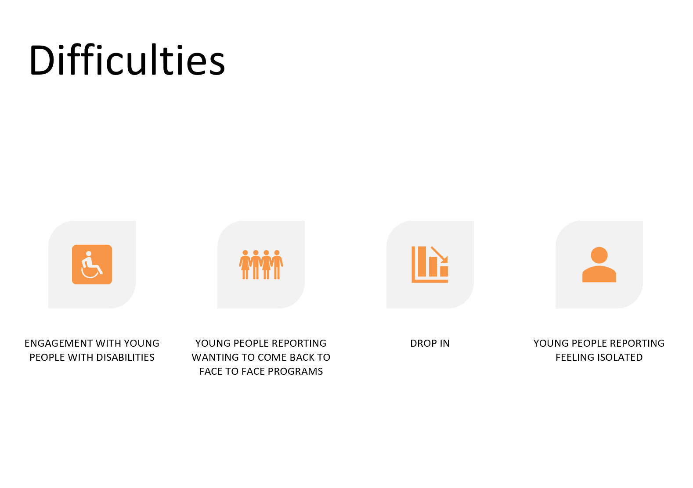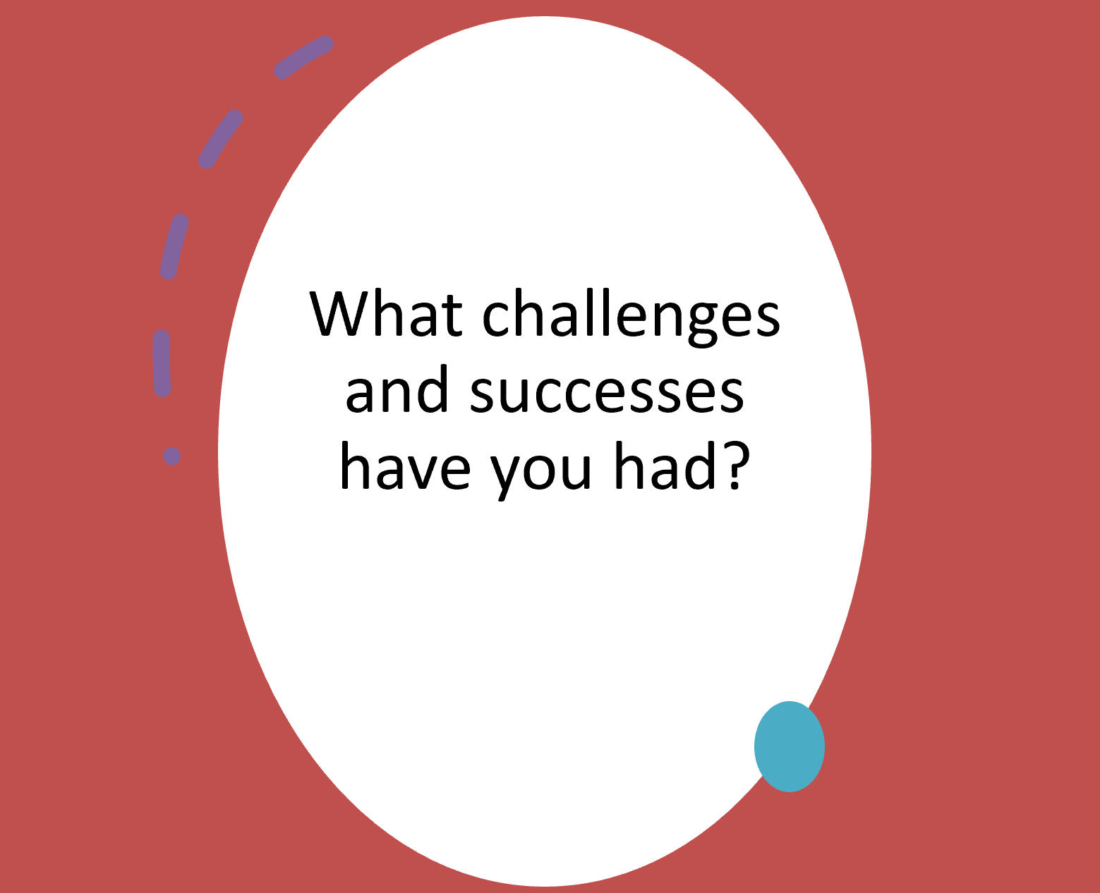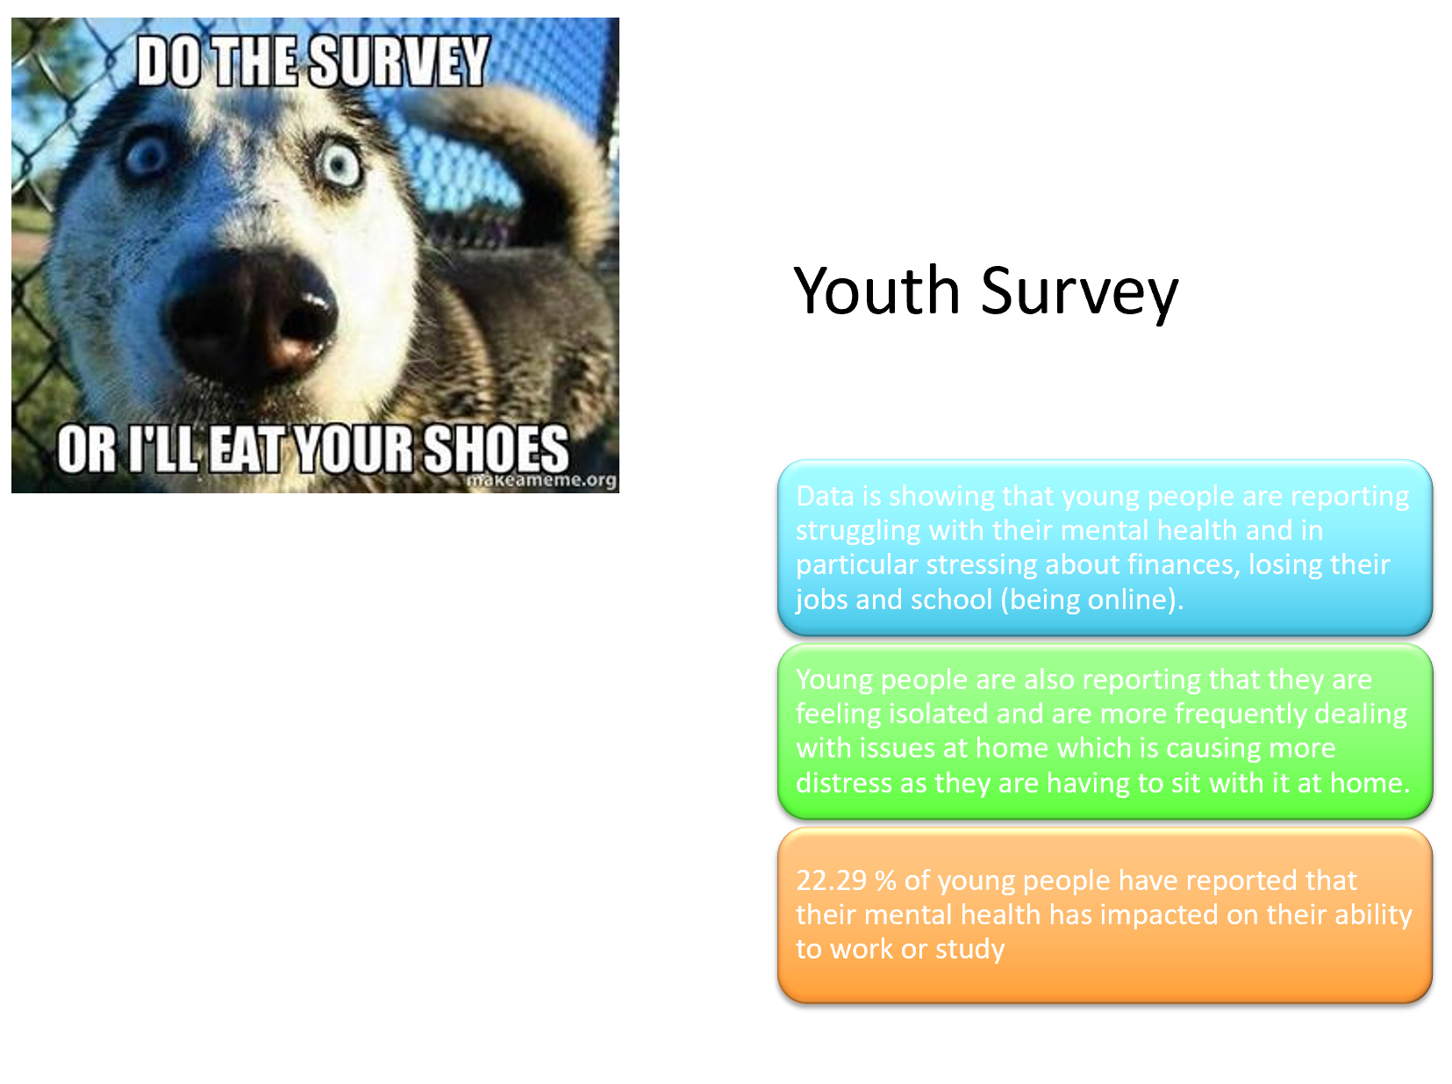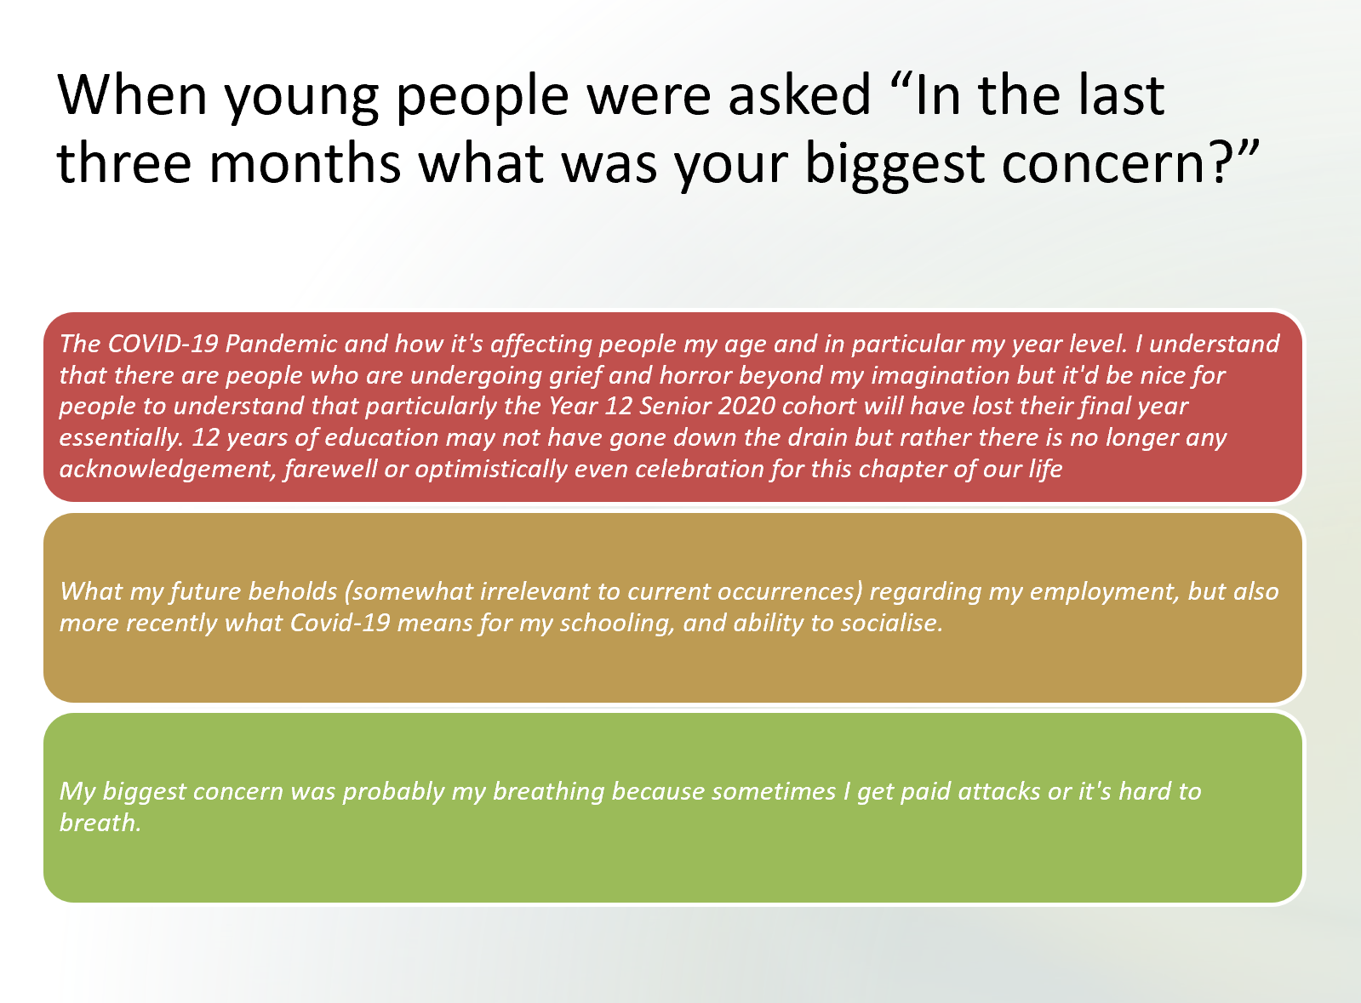
Presentation continued:

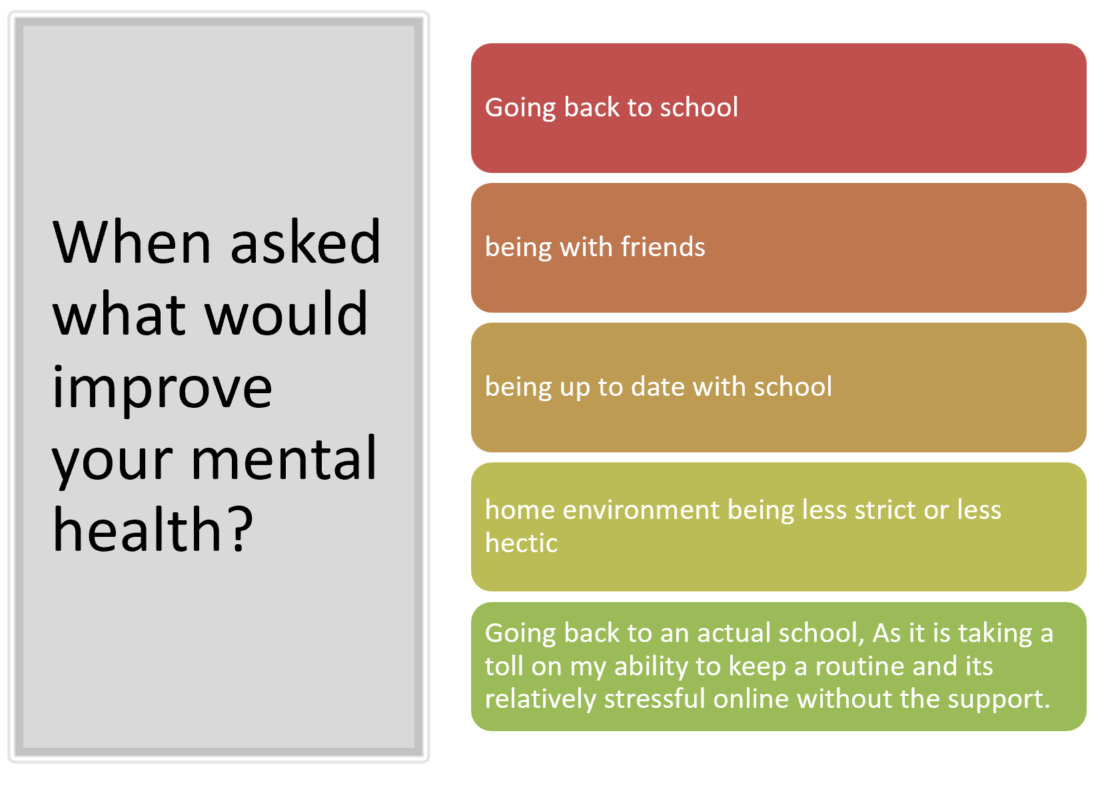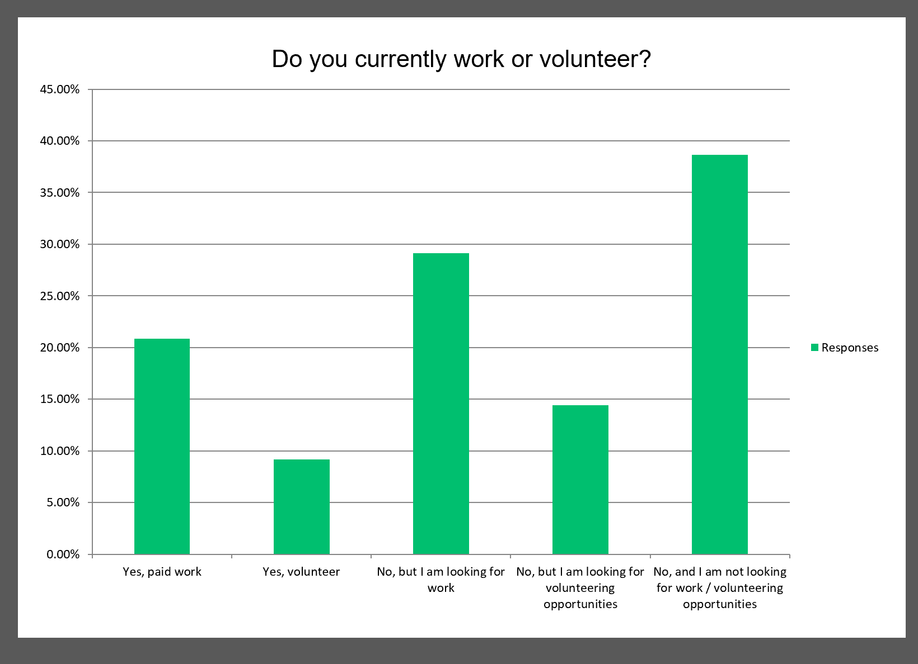

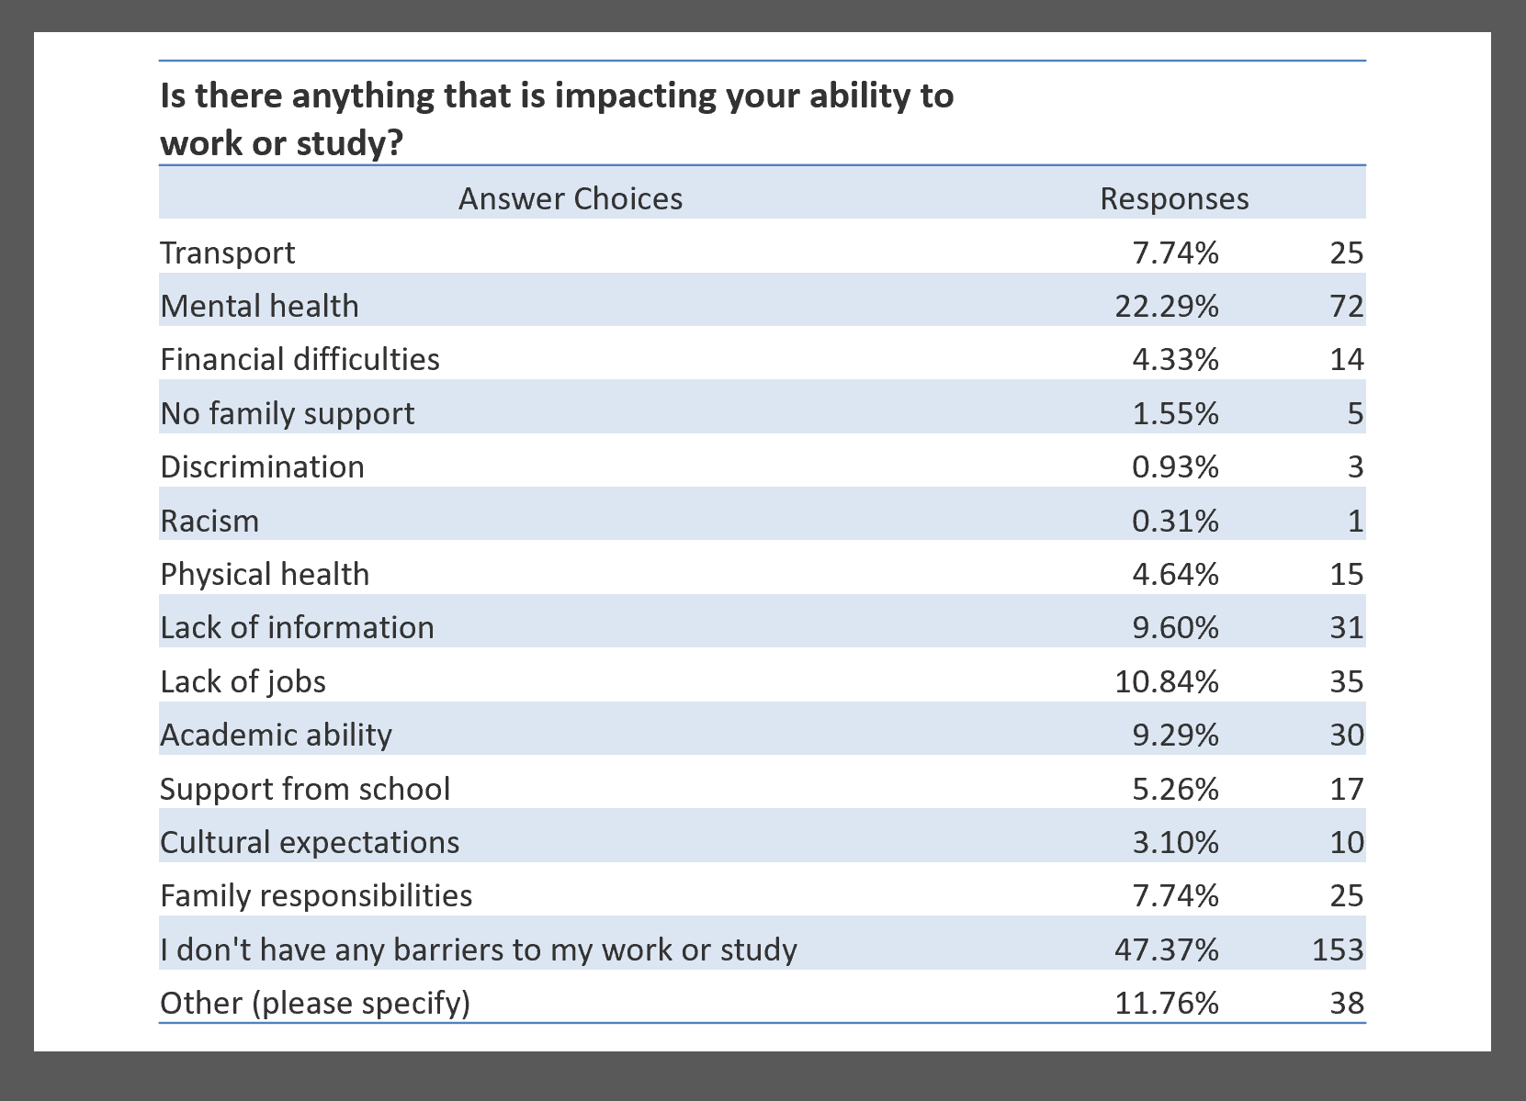

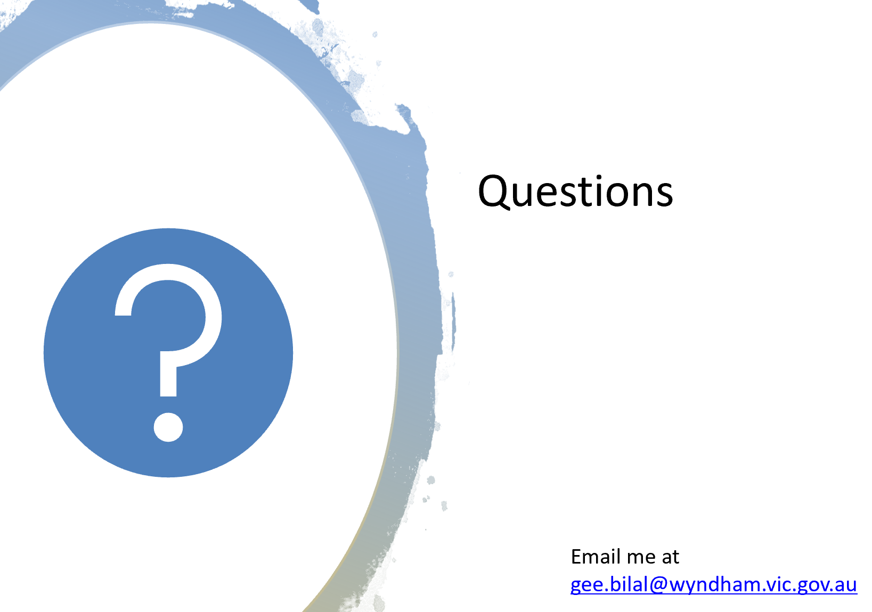

Information Sharing:

Name: Samantha Boden
Agency: Djerriwarrh Community & Education Services
Position: Pathways Coordinator
Email: samb@djerriwarrh.org

- Samantha looks after the Pathways Department at Djerriwarrh servicing the Better Futures, Skills First Reconnect and Jobs Victoria Employment Network programs. Based in Melton and Brimbank.

- Our Skills Frist Reconnect and JVEN programs are currently at capacity and no longer taking referrals. If we receive referrals via our website we will review and forward to other relevant service providers that may be able to assist.

- Better Futures aims is to engage earlier with care leavers, supporting them to have an active voice in their transition planning, and providing individualized supports both in-care and post-care across a range of life areas including housing, health and wellbeing, education, employment, and community and cultural connections.
- Better Futures referrals are made via westernbetterfutures@wcig.org.au
- Please see Better Futures referral form attached for Post Care referrals (over 18). If the referral is under 18 they need to be referred by DHHS or case contracted manager via CRIS.

Name: Sandra Milunovic
Agency: The Salvation Army – Children and Parent Support Services (CaPSS)
Position: Parenting Support Practitioner
Contact: 0429 984 478 E: Sandra.Milunovic@salvationarmy.org.au

- Tech Savvy Online - Parents/Carers can learn some Tips and tricks for keeping young people safe while using technology and social media. Three sessions coming up. Please refer to flyer for more information and how to register.

- 123 Magic Parent Training – Evidenced based training for parents/ Carers who are keen to learn how to discipline their children without arguing, yelling or smacking. Course Commences online Wednesday 10th June 2020 6pm-7pm. For more information or to register by Friday 5th June please contact Greg Bracey Lead Practitioner on 0409 608 551 or greg.bracey@aus.salvationarmy.org

Information Sharing Continued:
Name: Tharindu Jayadeva (TJ)
Agency: Headspace Werribee
Position: Community Awareness Officer
Contact: 8001 2366 E: tharindu.jayadeva@orygen.org.au

Headspace Werribee is still here, supporting young people (12-25yo) in Wyndham with their mental health and wellbeing. We’re currently offering counselling services via telehealth, however, should a young person require support in-person, we’ll chat through these options on a case-by-case basis.

COVID-19 RESOURCES:
- COVID-19 support resources website: https://headspace.org.au/covid-19/

GROUP PROGRAMS:
We have just started a new short-term online group program, called Mindfulness Mondays. Facilitated by two clinicians, it’s an opportunity for young people (12-25yo) to connect and destress using breathing, crafts and yoga activities.
A link to more details here: https://headspace.org.au/headspace-centres/werribee/

HEADSPACE DIGITAL SERVICES:
headspace Digital Services is our online youth engagement tool, which consists of five main aspects which can be found on the headspace website:
- Website content
- Decks: Throughout the headspace website (like on this page: https://headspace.org.au/covid-19/) there’s a tool called ‘decks’. These are bite-sized modules of interactive and dynamic content embedded throughout the headspace website, and are designed to increase the digital support options available for young people (they can be used on any device).
- Spaces: This is an online platform for users to create an account and gather, organise and share tailored information and resources about their mental health and wellbeing. There are two types of spaces for young people to interact with: personal and community (found here: https://headspace.org.au/eheadspace/spaces/personal/setup).
- Group chats: Most weeknights there are moderated group chats on the below topics on the Spaces section of the website:
- Monday: Navigating Relationships
- Tuesday: qheadspace (LGBTIQA+ online support group)
- Wednesday: General Coping
- Thursday: yarnspace (for Aboriginal and Torres Strait Islander young people), fortnightly
- Thursday: Supporting Others (for adults supporting young people), fortnightly
- eheadspace: Our online counselling service, open from 9am-1am every day, including public holidays. Young people can engage 1-on-1 with a clinician via online chat or email (there is no phone service for eheadspace at the moment).

Information Sharing Continued:
HEALTH PROMOTION:
We’re still working with schools and community groups to organise health promotion/mental health literacy workshops with young people. Although at this stage we can’t deliver these activities in-person, we’d still love to hear from you if you’d like to organise an online workshop (or forward-plan for an in-person program later in the year).

Name: Daisy Tanielu – Savavau
Agency: IPC Health
Position: Family Services Practitioner
Contact: 0421 543 764 E: Daisy.Tanielu-Savavau@ipchealth.com.au
IPC Health Family Services – we continue to work with our families over the Wyndham and Brimbank Catchment – but are working remotely – via face time with them and professionals via Zoom etc.
For Family Services – there is a process in regards to each of the services in IPC Health in returning to work – but for Family Services – it could be a while before we return to the office – so we continue to work remotely, work collaboratively with external services and professionals and visit families who are at immanent risk as we have COVID 19 protocols to adhere to when visiting families.

Name: Kerryn Williams
Agency: Department of Education and Training
Position: DET Navigator Coordinator – Western Melbourne
Contact: 7005 1830/0436 802 442 E: Williams.Kerryn.L@edumail.vic.gov.au

- The Navigator program is for disengaged students aged 12-17 years, providing individual outreach support to assist young people to return to education. More information on the webpage.

- Make referrals via the Navigator online referral form or call Kerryn on 7005 1830 to discuss potential referrals.

- Contact the Navigator team via Sandra Inserra, Anglicare Navigator Team Leader, on 9713 2500 or at Sandra.Inserra@anglicarevic.org.au.

Name: Kelly Ardonis
Agency: Uniting Employment Services
Position: Service Leader
Contact: (03) 9749 0489 M: 0438 866 822

Refer to the accompanying flyers
Information Sharing Continued:
Name: Alison Duffin
Agency: Family Planning Victoria
Position: Community Outreach Coordinator
Contact: 0459162085 E: alduffin@fpv.org.au clinicaleducation@fpv.org.au

Our Community Outreach Program is now pleased to offer free online sessions to both individual youth and community workers and organisations working with young people aged 12-25, who are at risk or outside mainstream school settings. These FREE eLearning and Zoom classroom personal/professional development sessions are available to book via our website now.

For individual workers there is “Sex in the City: working with young people” which is a full day course equivalent.
For organisations wishing to offer their staff professional learning there is a half day or full day equivalent course available for your staff, “Young people’s sexual health”.

For information about all our online learning courses for the Youth and Community sector please see our link on Family Planning’s Website “Community Outreach Sessions”

https://www.fpv.org.au/communities/services/community-outreach-sessions

We also have a 2 hour free stand-alone online learning module (which is included in all the full and half day training sessions) that people are able to complete, should they be unable to attend a half or full days training. Click here for more info:

https://www.fpv.org.au/courses/working-with-young-people-a-guide-to-accessing-sexual-health-services?section=communities

The next Wyndham Workers with Young People Network meeting is scheduled for Thursday 16 July at the Youth Resource Centre – 9:30am – 11:30am.

Please contact the Wyndham Youth Network for further information regarding this network or to present: wyndhamyouthnetwork@wyndham.vic.gov.au or 8734 1355

For information sharing please email: wyndhamyouthnetwork@wyndham.vic.gov.au
Website: Wyndham Workers with Young People Network – click here

2020 Meeting Dates

All future meetings for 2020 will be going ahead, most likely to be delivered online.
The dates are as follows:

16th July
27th August
8th October
19th November

