Wyndham Workers
with Young People Network

Minutes
Thursday 12 March 2020 - 9.30am-11.30am
@ Youth Resource Centre
86 Derrimut Rd, Hoppers Crossing

Note: The meeting scheduled for 23 April has been Cancelled. The next Wyndham Workers with Young People Network meeting is scheduled for Thursday 4 June at the Youth Resource Centre – 9:30am – 11:30am.

Welcome & Introductions
Tanya Whitmore, Senior Youth Support Officer – Wyndham City Council Youth Services

Acknowledgement of the Kulin Nation
“I wish to acknowledge the peoples of the Kulin Nation as the Traditional Owners of the land on which we are gathered and pay respect to their elders, past and present. I also wish to pay respect to any Elders from other communities and acknowledge any future young leaders who are here”

Presentation
Cath Guerrieri - Uniting Reconnect West Program – Youth & Family Mediator
Michael Culliver & Caitlyn – Melbourne Athletic
- Uniting is running a fitness and wellbeing program with Melbourne Athletics
- The program will be free and it will run for 6 weeks, including various introductions to different aspects to gym life. Classes will include some strength based exercises boxing, nutrition, and I’ll be doing mindfulness.
- There will be two different groups running at the same time, 10 kids in each class, 12-14years and 15 -18 years of age.
- All highly qualified trainers!
- Term 2: 21st April - 26th May, one hour session per week from 4:30pm -5:30pm

Presentation – Shannon Bell – YSAS
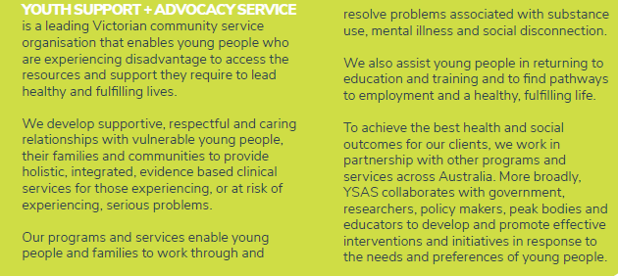

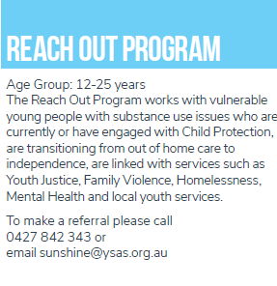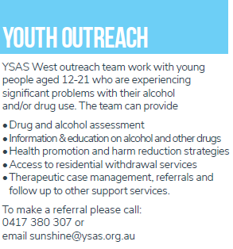

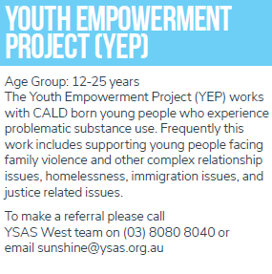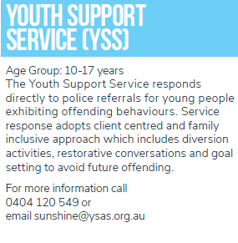
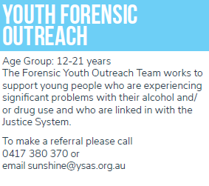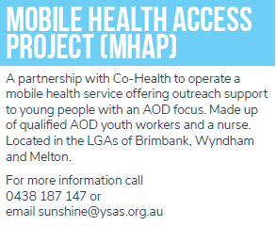

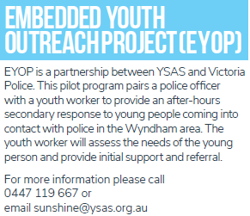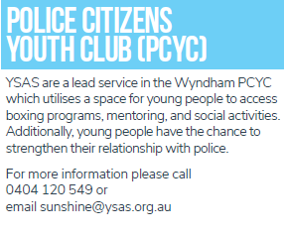

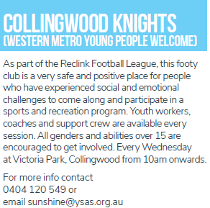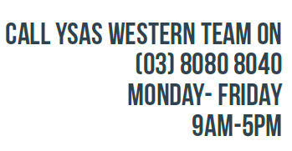

Information Sharing:
Name: Philippe Aslanis
Agency: Kookaburra Kids
Contact: 0431 411 971 E: philippeaslanis@kookaburrakids.org.au
- Referrals open
- Referrals through website
- No formal diagnosis of MI needed
- Q2 dates released for activity days 3rd April, 2nd May, 25th June
- November & October camp confirmed.

Name: Michael Culliver
Agency: Melbourne Athletic
Contact: 0400 056 106
Melbourne Athletic Performance Rehabilitation
- Youth Athletic Development
- Sports Rehabilitation
- High performance training
- Injury prevention
- Consulting

Name: Dennis Johnson
Agency: Drummond Street Services
Email: dennis.johnsson@ds.org.au
- Family mental health support services (FMHSS)
- Targeted psychological services (TPS)
- Family Foundation – Parent coaching for new parents

Name: Danlie Wv & Emily Drewitt
Agency: Anglicare
Email: danlie.wv@anglicarevic.org.au P: 9731 2500

- Reach out is now accepting new referrals for young people who have issues with substance use. Young people ages 12-25 who live, study or work in the city of Wyndham. They provide assessments, counselling, casework and linkage to other support the young person needs.

- WOW program is a women’s only program based therapeutic group service. Women 18 years and older have the opportunity to engage with other women to develop healthy social support as part of AOD relapse prevention treatment. This program runs on Wednesdays for 7 weeks, activities focus on self-care and healthy and positive physical activities to promote health & fun with rewarding experiences.
Information Sharing continued:

Name: Michelle Chahine
Agency: AMES Australia – Youth Services
Email: chahinem@ames.net.au M: 0427 210 798
- Currently accepting referrals for young people aged 17-25 who require support with education and employment pathways.
- We are taking expressions of interest for young people interested in studying certificate 1 in general education for adults. Starting on 14th April 2020.

Name: Cath Guerrieri
Agency: Uniting Reconnect West Program
Contact: 9051 2000 M: 0426 820 283

Program round two. 12-18 years of age.
6-week sport health program.
Qualified trainers from Melbourne Athletics Performance & Rehabilitation.
Tuesday 21st April – 26th May 2020 - 4:30-5:30pm

Classes include:
- Boxing
- Nutrition
- Weight training introduction
- Mindfulness

Two groups of 10, 12-14 – 1st group- 15-18- second group.
Program run at Vic Uni – Werribee.

Note: The meeting scheduled for 23 April has been Cancelled. The next Wyndham Workers with Young People Network meeting is scheduled for Thursday 4 June at the Youth Resource Centre – 9:30am – 11:30am.

Please contact the Wyndham Youth Network for further information regarding this network or to present: wyndhamyouthnetwork@wyndham.vic.gov.au or 8734 1355

For information sharing please email: wyndhamyouthnetwork@wyndham.vic.gov.au
Website: Wyndham Workers with Young People Network – click here

2020 Meeting Dates

All meetings are 9.30am-11.30am unless otherwise stated on the Agenda
@ Wyndham Youth Resource Centre - 86 Derrimut Road, Hoppers Crossing

23 April - Cancelled
28 May
25 June
23 July
27 August
15 October
19 November
17 December

