Manor Lakes Community Learning Centre
BUZZ Newsletter Term 1 2020

86 Manor Lakes Blvd, Manor Lakes 3024
Phone: 8734 8934
Email: manorlakesclc@wyndham.vic.gov.au

Wyndham Council acknowledges the Wadawurrung peoples of the Kulin Nation as the Traditional Owners of the land & on which Manor Lakes Community Learning Centre is built. In all our activities in this place, may we pay respect to Elders of all Aboriginal communities, past, present and future.

WELCOME TO OUR TERM-1 2020 NEWSLETTER

An exciting place making collaboration with the Vibrant City Centres department and Manor Lakes Youth Support team will see an outdoor activation space created at Manor Lakes Community Centre from February 3 till April 14, 2020.

Following the completion of the Werribee City Centre Pop Up Park, part of the park set up will be shifted across to Manor Lakes to create a trial outdoor space. The departments are currently looking to co-program the space with activities to cater for all ages hosted by Libraries, Early Years and Youth Services.

The area will be monitored, and users surveyed for the 10-week activation period to see how the community is engaging with the space for future planning.

UPCOMING HOLIDAY PROGRAMS:
Come and join our craft workshop this school holidays. This holiday workshop is ideal for kids between 8-12 years of age.
The course includes cost of the materials as well.
Date: 06 April, Monday
Time: From 10am—11.15 pm
Cost: $12.00
Bookings via Event brite only.
For enquiries call centre on 8734 8934 or email at manorlakesclc@wyndham.vic.gov.au

Come and enjoy our holiday Easter cooking workshop and learn to make Easter cupcakes and decorate Easter biscuits. This workshop is ideal for kids between 6-12 years of age.

The workshop includes cost of the materials.

Date: 7 April, Tuesday
Time: From 3.30pm—4.30pm
Cost: $12.00
Bookings via Event brite only.
For enquiries call centre on 8734 8934 or email at manorlakesclc@wyndham.vic.gov.au

Come along with your family for a movie afternoon at the Manor Lakes Community Learning Centre. Bring along your own pillow and blankie. Popcorn will be provided. Film to be screened will be announced closer to the date.

Date: 8 April, Wednesday
Time: From 12:30 pm
FREE event
Bookings via Event brite only.

For enquiries call centre on 8734 8934 or email at manorlakesclc@wyndham.vic.gov.au

SOUTH SUDANESE HOMEWORK CLUB @ MANOR LAKES

Do you need help with your homework? This homework club will be supporting children of South Sudanese background that are attending primary school between grade 3 to grade 6.

Where: Manor Lakes Community Learning Centre
When: Thursdays
Time: 3pm—5pm
Cost: FREE
Age group: Grade 3 - Grade 6

Contact: Poly
Phone: 0434 178 753
Email: poly.kiyaga@wyndhamcec.org.au
Website: www.wyndhamcec.org.au

HOSPITALITY TRAINING

Back of house and Front of House is a practical 10-week hospitality course which is run through the operations of Genevieve's Community Kitchen. A great way to learn hospitality skills whilst gaining confidence and practical workplace experience.

BACK OF HOUSE
19 February—22 April
Wednesdays 10am - 3pm
Cost: $40/ $25 on concession (Payment by card only)
Learn the fundamentals of Back of House Hospitality operations including food handling, food safety program, food preparation, cooking, menu planning, basic Barista training.

FRONT OF HOUSE
20 February—23 April
Day and time: Thursdays 10am - 3pm
Cost: $40/ $25 on concession (Payment by card only)
Learn the fundamentals of Front of House Hospitality operations including food handling, food safety program, customer service, setup/clean-up of restaurant and basic Barista training.

We recommend registering for both courses to gain the maximum benefit of the full hospitality training experience. To register please contact the centre.

Where: Manor Lakes Community Learning Centre
86 Manor Lakes Blvd Manor Lakes - 3024
Contact: 8734 8934
Email: manorlakesclc@wyndham.vic.gov.au

ENJOY BREAKFAST AT OUR CAFÉ
The breakfast café at the Manor Lakes Community Learning Centre is now open on the below days and times.
Tuesdays & Wednesdays: 8am - 11am
Thursdays: 8am - 10am

Come along and catch up with friends and family and relax over a cup of coffee and enjoy breakfast.
On Tuesday’s we have specials - Pancakes!!

No bookings required

SETTLEMENT SERVICES AT MANOR LAKES
Eh Su from Wyndham Community and Education Centre is now seeing clients who have arrived in Australia in the past five years, as refugees, at Manor Lakes Community Learning Centre.

Clients seek support for all manner of things, including Centrelink payments, housing issues, family support, fines, family violence, insurance, utility issues and much more.
No appointment required, just turn up

Where: Manor Lakes Community Learning Centre
When: Mondays
Time: 9am—1pm

YOUR COUNCIL CLOSE TO HOME

Did you know a range of council transactions are available @ Manor Lakes Community Learning Centre? You can now make

- Council payments
- Kinder enquiries
- Pet registrations
- Town Planning enquiries
- Building Services enquiries
- Economic growth queries

Ceramic Classes with Melissa

Come and join us in an exciting class that explores the various skills and techniques involved in ceramics & pottery at the Manor Lakes Community Learning Centre. The ceramics classes provide an exciting learning environment for children to develop a number of key skills like increases creative thinking, enhances motor skills and expands problem solving skills.
To make a booking please contact: Melissa at melissa.cermics@outlook.com

Ceramics regular classes

When: Saturdays 1st Feb - 7th March or Mondays 3rd Feb - 9th March
Time: 9:30am - 11:30am (Saturdays) or 6:45pm - 8:45pm (Mondays)
Cost: $160 for 6 weeks (2-hour sessions)
Includes introductory clay and materials, any extra materials and kiln firing of work to be purchased during classes.
Ceramics for Kids
The ceramics classes provide an exciting learning environment for children to develop a number of key skills like increases creative thinking, enhances motor skills and expands problem solving skills.
When: Saturdays 14th March - 21st March or Mondays 16th March - 23rd March
Time: 6:45pm - 8:15pm on Mondays and 9:30am - 11:00am on Saturdays
Cost: $40 (2 X 1.5-hour sessions)
Ages: 6 - 16 years

UPCOMING SHORT BUSINESS TRAINING SESSIONS

A range of free and low-cost short business training sessions are available. More sessions will be added later in the year.

Starting a Business — Thursday 13 February - 6.00pm - 8.00pm
Tax Essentials for Small Business - Friday 28 February - 9.30am - 11.30am
Digital Marketing Essentials— Wednesday 25 March 6.00pm - 8.00pm

Where: Wyndham Civic Centre 45 Princess Highway Werribee

Starting a Business for new migrants & asylum seekers
Monday 23 March—1.00pm - 4.30pm

Where: Point Cook Community Learning Centre

For more information and to register:
Book Online: http://www.wyndham.vic.gov.au/businesstraining
Contact: Economic Growth Unit at Wyndham Council
Phone: 9742 0788
Web: www.wyndham.vic.gov.au/businesstraining
Email: business@wyndham.vic.gov.au

COUNCIL SERVICES | DAY & TIME | INFORMATION | COST

Town Planning - Give advice & information  The planning permit process, liquor licence queries, when a planning permit is required, viewing advertising plans online, relevant Wyndham Planning Scheme queries. | Tuesday  8am—12pm | Manor Lakes Community Learning Centre  : 8734 8934  : manorlakesclc@wyndham.vic.gov.au | Free
Building Approvals - Give advice & information  The building permit process, when a building permit is required, relevant building codes, standards, forms and agencies. | Tuesday  8am—12pm
Economic Growth  Provide information about services and assistance provided by Wyndham City for businesses, as well as other government support for new businesses. | Tuesday  8am—12pm | To book an app  : 9742 0788 or  : business@wyndham.vic.gov.au

EARLY YEARS | DAY & TIME | INFORMATION | COST
Wyndham City Council Maternal & Child Health  Offer professional nursing support & advice for parents with children from birth to school age. | By Appointment Only | Contact: Maternal & Child Health  : 9742 8148  Website: www.wyndham.vic.gov.au select Maternal & Child Health Services | No cost
Wyndham City Council Immunisation  Free childhood immunisations.  No appointments necessary | Fridays  1pm – 2pm  14 February  13 March  17 April | Contact: Environmental Health  : 9742 0736 | No cost
Wyndham City Council First Time Parents Group  The Maternal & Child Health Parenting Group is aimed at new parents, facilitated by qualified MCH staff, covering topics relevant to early parenting. | Tuesdays  10am-12pm | Contact: Maternal & Child Health  : 9742 8148  Website: www.wyndham.vic.gov.au select Maternal & Child Health Services | No Cost
Wyndham City Council - Kindergarten  3 & 4-Year-Old Kindergarten Services | Weekly sessions | Kindergarten Enrolment Officer  : 9742 8147 | Fees  Apply
Multicultural Playgroup (5 years and under)  This structured playgroup will give you and your child (0-4 yrs.) the opportunity to actively participate in a stimulating variety of activities. All backgrounds warmly welcomed. | Thursdays  12.30pm-2pm | Manor Lakes Community Learning Centre  : 8734 8934  : manorlakesclc@wyndham.vic.gov.au  During school terms only | $45 per term
Grasshoppers Playgroup  Playgroup is an experience where babies, toddlers, pre-school children and their parents (or carers) meet together on a regular basis to play, learn, develop skills and socialise.  $50 per term for one session per week  $ 85 per term for both sessions per week | Mondays Thursdays  9.30am—11.15am | Contact: Sonia Caruana  : 0438 585 087  : grasshoppers@  grasshoppersplaygroup.com.au  Web: www.grasshoppersplaygroup.com.au  During school terms only | Fees Apply
Small Talk - FREE  Playgroup Facilitated by Wyndham City Council. Please call to find out about the selection process | Wednesdays  9.30am – 12.30pm | Contact: Leonie O’Malley  : 8734 5478 | No Cost
Tweddle-My Time  Peer Support group for families who have children with a disability. | Tuesdays  9.30am—12pm | Contact: Tweedle  : 9689 1577  : kylee.brealey@tweddle.org.au  During school terms only | No Cost

EARLY YEARS | DAY & TIME | INFORMATION | COST
Rhyme Time  Active sing-along songs and nursery rhymes,  Suitable for ages 1—5 years. | Tuesdays  Thursdays  10.30am | Contact: Manor Lakes Library  : 8734 8930  During school terms only | No Cost
Baby Time  Gentle sing-along songs, nursery rhymes & baby bounces  Ages 0 - 1 year & their parents. | Wednesdays  10.30am  Fridays  2pm
Story Time  Stories, songs and craft activities  Ages 3 - 5 years | Fridays  10.30am
Bilingual Story time (English/Karen) | 3rd Monday of the month - 10:30am  17 February  16 March  20 April
Lego Club  Come along to your library every week to design, build and imagine with Lego. Hang out with other kids who enjoy Lego & check out our Lego books!  Ages 3 + | Mondays 3.30pm—4.30pm
Homework Help  Would you like help with your homework? Homework Help aims to give one-on-one assistance with curriculum-based homework and studies as well as access to the library’s Study Assist collection.  Ages 9+ | Tuesdays  4-5pm
All Ages Chess  Come along to this all ages chess program where you can learn to play or improve your skills. Pop-in at any time while the program is running. | Mondays  3:30pm - 5pm  No bookings required
LAN Gaming  Join in PC multiplayer gaming in the Learning Room. Learn to play new games and hang out with your friends.  Ages 10+ | Wednesdays  3.30pm - 4.30pm
STEAM Lab  Experiment with circuits, robots, coding and lots more at the library’s STEAM Lab! Participants must be able to attend all weekly sessions which run during the school term.  Ages 9-13 | Thursdays  4pm - 5pm

CLUB 60 CELEBERATING GURU NANAK 550TH BIRTHDAY

Victoria is home to Australia’s largest Sikh Community. Each year Sikh communities right across the world celebrate
Guru Nanak—the first Guru and Founder of Sikhism. Our Club 60 Wyndham vale Seniors men’s group celebrated the event with enthusiasm on the 16 October 2019. With more than 200 people turning up for event celebrations, the community greeted and prayed on this happy occasion. Various members spoke about the glories of the spiritual leader. They sang songs and prayed for the wellbeing for everyone. The event was a grand success and was witnessed by Councillor Heather Marcus as well.

Upcoming Events—CLEAN UP AUSTRALIA DAY @ MANOR LAKES

“On October 13, a clean-up day of the Manor Lakes Linear Park took place, this was an initiative of local resident and student Sasha who partnered with Nature West. The Clean Up day was a great success with around five large bags of rubbish collected which included glass and plastic bottles, lots of plastic and wrappers, soft drink cans and general household material. The Manor Lakes Linear Park hasn’t looked so good with many thanks to the members of the community for their help and a very big thank you to Sasha for being passionate about the environment and her community and putting into action her ideas and plans. Another thanks to Bruce and the team at Nature West for your support and for supplying the equipment and the best way to finish up - the post clean up BBQ. Please find details about our next clean-up day.
Date: March 1, Sunday
Where: Manor Lakes Community Learning Centre
Time: 10:30am Clean up
12:30opm Lunch
To bring: Sturdy Shoes, Suitable Clothing, hat and Sunscreen
It’s a family friendly activity. All are welcome.

NEW MULTI CULTURAL PLAY GROUP AT MANOR LAKES - JOIN NOW!

This playgroup will be facilitated by a qualified experiences facilitator with creative art and craft. The group will be regularly connecting with services like Kindergarten, Centre Link, Family Services and Maternal and Child Health.

Please note that spots are limited. To make a booking or for more information please contact the centre on the number provided.

WHEN: Tuesday’s starting in Term 1
on 4 February 2020
WHERE: Manor Lakes Community Learning Centre
TIME: 12.30pm - 2.30pm
COST: $45 per term
(payment by card only)
CONTACT: 8734 8934
manorlakesclc@wyndham.vic.gov.au

YOUTH | DAY & TIME | INFORMATION | COST
Urban Vibes  Connecting young people of all backgrounds through arts, dance, music and food!  Ages: 12 – 17 | Mondays  3:30pm – 5pm | Youth Resource Centre  : 8734 1355 | No Cost
Girls Night  Enjoy some fun activities and workshops for girls only!  Ages: 12 – 17 | Wednesdays  3:30pm – 5pm
Gamers Den  Hang out and learn new board games, play console games, group games, card games, role playing games and snacks of course  Ages: 12 – 17 | Thursdays  3:30pm – 5pm
Kick back Fridays  Enjoy a safe space to chill and hang out to end your week!  Ages: 12 – 18 | Fridays  3:30pm – 5pm
Wyndham West Youth Committee  Young people meet fortnightly to discuss  various issues and concerns, help run  activities and events for the community and learn valuable leadership skills. | Every 2nd  Monday of the month  3.30pm—4.30pm
Melbourne Victory Soccer Program  Free soccer program for boys facilitated by Melbourne Victory trainer every Wednesday at Manor Lakes Community Learning Centre.  Ages: Year 10 – 12 or 15 year —20-year old’s | Wednesdays  3:30pm—5:30pm | Contact: Gulcan Koca  : 8656 0766  :GKoca@mvfc.com.au
Game On!  Like gaming? Drop in after school and show off your skills on Nintendo Switch and PlayStation 4.  Beginner to advanced players welcome.  Ages 12-19 | 4th Tuesday of the month | Contact: Manor Lakes Library  : 8734 8930  During school terms only
YA Book to Movie Club  Come along to our just for teens Book to Movie Club. See all your favourite YA titles on the big screen and discover movies that you never knew began their lives as books.  Ages 12 + | 2nd Tuesday of the month
Youth resume help  Free help for individuals or small groups on resume writing and interview questions.  Ages 15-25 | Wednesdays  4pm—5pm  Bookings essential
RECREATION & LEISURE | DAY & TIME | INFORMATION | COST
TEKIDS  Teach kids to build robots and how  to do coding. | Saturdays  4:15 - 5pm | Contact: Shilpi  : 0435 023 078  : Tekidsaustralia@gmail.com | Fees apply
Natyanjali (School of Dance)  Bharatnatyam dance classes. | Mondays  4pm—5pm | Contact: Anitha Perumal  : 0470 177 937 | Fees apply
Sahaja Yoga  Mental and physical health and fitness for the community via meditation sessions. | Fridays  7pm – 8pm | : 0434 237 989  : tonysahaj@gmail.com | Free

RECREATION & LEISURE | DAY & TIME | INFORMATION | COST
Flash Taekwondo  Taekwondo training helps you gain self-confidence, balance, self-defence, physical skills, social development and co-ordination. | Mondays  Wednesdays  4pm—9pm | Contact: Nenad  : 0412 536 552  : flashtaekwondo@hotmail.com | Fees Apply
Zumba Classes  Forget about the workout! Just lose yourself in the music and find yourself in shape at the ultimate dance-fitness party. | Thursdays  7pm—8pm | Contact: Angela Shegog  : 0422 570 010 (after4pm)  : angelashegog.zumba@gmail.com  Web: angelashegog.zumba.com | Fees Apply
Ceramics Classes  Suitable for all levels of experience.  Adults - 5 weeks  Kids - 2 weeks | Saturdays  9am - 12pm  Mondays - New  6:45pm—8:45pm | Contact: Melissa  : melissa.ceramics@outlook.com | Fees apply
Bollywood Dance School Australia  Bollywood, Jazz Contemporary & Hip-Hop dance for kids, teens & adults. | Tuesdays  5:45pm - 7:45pm | Contact: Lata  :0499 888 115  : admin@bollywooddanceschool.com.au  Website: www.bollywooddanceschool.com.au | Fees apply
ABCD Bollywood Dance  Bollywood dance classes  Ages 3+ | Sundays  11am—1pm | Contact: Shweta  : 0433 346 672  : shwetayana13@gmail.com | Fees apply
Club 60 Wyndham Vale  Group for Indian seniors who are involved in the welfare of society by helping isolated seniors to participate in activities. | Monday & Fridays 12.30pm—3pm | : happytwofaces@hotmail.com | No cost
Movie Club  Do you enjoy watching movies and discussing them with others? Then come along to the Manor Lakes library movie club. Doors open at 6pm for a 6:30pm start.  Ages Adults only | 3rd Tuesday of the month 6:30pm onwards  From 18 February | Contact: Manor Lakes Library  : 8734 8930 | No cost
Wyndham Patchworkers  It’s time to sew and chat, make friends, learn, swap ideas and indulge your passion for quilting and patchwork. | 2nd & 4th Saturday of the month  9:30am – 4pm | Contact: Monica Parnis  : 0417 058 590  :wyndhampatchworkersinc@hotmail.com | Fees apply
Women's Friendship Group  Join the Women's Friendship Group. | Tuesdays Fortnightly  12.30pm – 2.30pm | Contact: Manor Lakes Community Learning Centre  : 8734 8934  : manorlakesclc@wyndham.vic.gov.au | No Cost
Craft Group  Bring along a craft project you are working on or try something new. | Mondays  10am - 12pm |  | No Cost
The Needlecases  If you enjoy knitting, patchwork, crocheting, embroidery and other forms of needlework, this is the group for you. | Fridays  9am – 12pm |  | No Cost
Hercules Fitness for Seniors  Come and try a gentle exercise program, that provides a fun, social & safe way to be active. | Wednesdays  9am—10am |  | $6 per session
Zumba for mums and bubs- Reclink Australia  Mum and bubs Zumba classes | Wednesday  10.30am –11.30am |  | Fees Apply

EDUCATION & TRAINING | DAY & TIME | INFORMATION | COST
UExL Academy  UExL Academy provides high-quality and affordable STEM (Science, Technology, Engineering and Math) based learning program for children aged 5 to 12 Year (Prep to Grade 6). We offer Maths and Science Tutoring as well as Robotics and DIY Science learning program. | Saturdays  10am - 12pm | Contact: Sonal  : 0434 527 207  : sonals@uexlacademy.com  Web: https://www.uexlacademy.com | Fees apply
Kids Concepts  Offers unique skill development courses for children aged between 4-16 years, that can help improve child’s learning ability, memory, calculation speed and cognitive skills. | Fridays  5pm – 7pm | Contact: Keerti Hosur  : 0413 949 831  : info@kidsconceptsaus.com  Web: www.kidsconceptsaus.com | Fees Apply
Lynn’s Learning  Maths and English Tuition developed by Australian Teachers (Kinder to Year 10) covering:  Classwork and Homework  Individualised extension and remedial skills  Problem solving and mathematical skills  Creative writing techniques  Scholarship preparation  NAPLAN and ICAS preparation  Kids with learning difficulties including disadvantaged kids | Saturdays  1pm –6pm | Contact: Bhumika  : 0434 190 266  : wyndhamvale@lynnslearning.com  Web: : www.lynnslearning.com.au | Fees Apply

FAITH & CULTURAL GROUPS | DAY & TIME | INFORMATION | COST
Worship Centre  Samoan worship group. | Sundays  1.30pm—6.00pm | Contact: Ken Tueipi  : 0498 552 722  : kentueipi@yahoo.com.au | No cost
Newstart Church  Church worship service and Sunday school. | Sundays  10am - 12:00pm | Contact: Neil  : 0422 381 514  : office@newstart.org.au  Website: www.newstart.church
Oasis Ministries International  We meet regularly to provide meaningful connections and groups for people within the community and all walks of life. We have life groups for men, women, youth and kids in a safe space for their growth and development | Sundays  3.30pm –5.30pm | Contact: Eddie  : 0421 691 599  : contact@omint.com.au  Website: www.oasisministriesinternational.com.au

SUPPORT | DAY & TIME | INFORMATION | COST
Food Bank Manor Lakes  Providing food items to people in need. | Wednesdays  10.30am—12pm | Contact: Manor Lakes Community Learning Centre  : 8734 8934  : lukas@newstart.org.au | No cost
Youth Counselling  Free, confidential counselling for young people.  Ages: 12-25 years | By appointment only | Contact: Wyndham Youth Services  : 8734 1355  :youthinwyndham@wyndham.vic.gov.au | No cost
VicSeg - New Futures  This group is for South Sudanese mothers and children with the opportunity to talk & support one another in the local community. | Wednesdays  12pm—3pm | Contact: VicSeg  : 8754 0500  : kdiacono@vicsegnewfutures.org.au | No Cost
Wyndham Deaf Association  Social Club for the Deaf Community in Wyndham to get together for social activities. | 4th Friday of the month  7pm – 11pm | Contact: Di  : d_drousch@bigpond.com | $5 session
United Minds Community Services  Counselling services | Tuesdays 9am - 7pm | Contact: United Minds  : 8692 9949 | Free
Genevieve's Community Kitchen  Meet new people and enjoy a nutritious meal at the Community Lunch.  Everyone is welcome. | Thursdays 12pm—2pm | Contact: Manor Lakes Community Learning Centre  : 8734 8934  : manorlakesclc@wyndham.vic.gov.au | $5.00  donation

COMMUNITY AND VOLUNTEER TRAININGS— 2020

DETAILS | Venue | Date and Time
Community Grants  Learn about what grants are available and how to apply. Build your grant writing skills while gaining insights and developing strategies on how to secure funding for your project or event.  Please note session dates and times may be subject to change. | Wyndham Civic Centre  45 Princes Hwy,  Werribee  VIC 3030 | Monday 3 Feb  6:30pm - 9:30pm
Step into Volunteering  Are you interested in volunteering but you’re not sure what you would like to do, how to go about it and where to find more information? Come along to this informal introduction to volunteering and find out what the expectations are – from both sides.  Please note session dates and times may be subject to change. | Manor Lakes Community Learning Centre  86 Manor Lakes Blvd  Manor Lakes  VIC 3030 | Monday 10 Feb 10:00am - 12:00pm
Training for New and Aspiring Treasurers  Even if one has little or no experience in being a Treasurer or have never done ‘the books’ before, this training workshop has plenty of helpful examples to understand the mechanisms to record the finances and requirements involved in the role of a Treasurer of a small community group. | Wyndham Civic Centre  45 Princes Hwy,  Werribee  VIC 3030 | Monday 24 Feb  6:30pm - 9:30pm
Food Handling Basics  This information session (non-accredited) will provide you with a basic understanding of the requirements of the Food Act 1984 and safe food handling for a community fete, canteen, sausage sizzle, market or public event.  Registration will open 4 weeks prior to each session and bookings are essential. | Point Cook Community Learning Centre  1-21 Cheetham Street  Point Cook  VIC 3030 | Tuesday 3 Mar  9:30am - 11:30am
Help Wanted!  Attracting volunteers and committee members is an important part of a non-profit organisation’s ‘business as usual’. The session is designed to tease out what community groups most need from their volunteering workforce, breaking down those needs and creating a volunteering plan to match. | Wyndham Civic Centre  45 Princes Hwy,  Werribee  VIC 3030 | Wednesday 11 Mar  6:30pm - 9:30pm

Disability Confidence Training  This three-hour session will assist you to build confidence to know the right things to say and do when interacting with a person with disability.  Registrations will open 4 weeks prior. | Wyndham Civic Centre  45 Princes Hwy,  Werribee  VIC 3030 | Thursday 19 Mar  6:30pm - 9:30pm
Building a Culturally Competent Organisation  Through a series of group exercises and discussions, this interactive and thought-provoking program will enhance your team’s skills to take steps towards building a culturally competent organisation. | Manor Lakes Community Learning Centre  86 Manor Lakes Blvd  Manor Lakes  VIC 3030 | Monday 23 Mar  9:30am - 12:30pm
All registrations will open 4 weeks prior to each session and booking is essential. Please notify us if you no longer able to attend a session. Kindly note t session dates and times may be subject to change. To register yourself for a session visit Www. Wyndham.vic.gov.au/volunteering. For more information contact volunteering team on 9742 0777.

WYNDHAM PATCHWORKERS

Wyndham PatchWorkers Auction
Wyndham PatchWorkers Inc conduct a yearly Auction with proceeds being donated to a charity. Auctioned items are made or sourced by the members. It was decided that this year WPI would support Uniting Wyndham following a talk by Lauren Perri from Uniting Wyndham where she spoke to the group about their work revolving around preventing homelessness for people who are at risk; helping people finding long-term accommodation; supporting young people and families to get them back on their feet. At this talk our President, Donna Morris, presented Lauren with 2 Community Quilts and it was also decided that we would support with food hampers at the Christmas Luncheon. Hence Donna presented Lauren with a cheque of $1,259 and huge thanks go to our members who donated sewn or knitted items and for the generous bids. Besides these funds, 3 carloads of items where collected and donated.
PLAY EXPO @ MANOR LAKES

If you have young children and are looking for an event the whole family can enjoy, come along to the Play Expo. It will be a good opportunity to connect with local services who provide some of the activities on the day, such as Kindergartens, Libraries, Toy Library, Playgroups and Long Day Care services.

This is a FREE event and there is no need to book. There will be fun hands on play activities that your children…and you...will enjoy! Science experiments, construction and messy play are some of the activities that will be on offer. The Play Expo is aimed at children under the age of 5, older siblings are welcome.

If you would like any further information about the Play Expo and other programs facilitated by the Children and Families Resource Team please contact the below. Like us on Wyndham Families Facebook page to keep up to date with events in your area.

When: Friday 02 September 2020
Time: 9am—2pm
Cost: Free

For more information please contact
Contact person: Lyndall Mione
Phone: 8734 5478
Email: playgroup@wyndham.vic.gov.au

UPCOMING EVENTS—GREEN LIVING SERIES
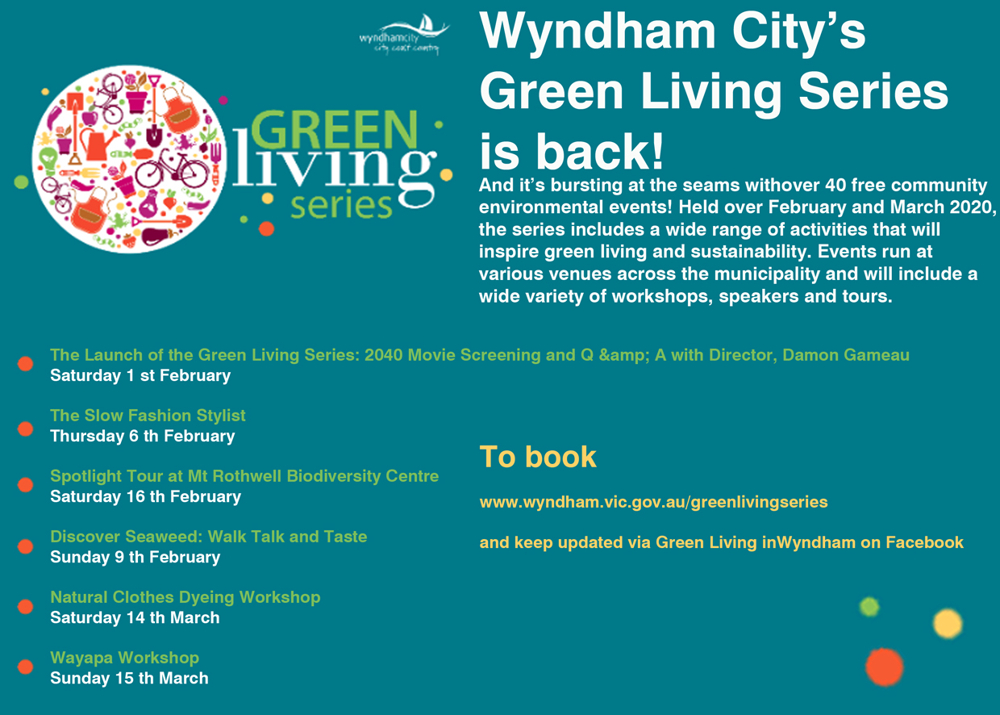

UPCOMING PROGRAM
Encompass Computer classes and Employment pathways
Encompass College of training provides the below program for free. These programs would suit people who would like to learn how to use computers and people who are looking to get into workforce. The programs depend on number of enrolments or students booked in. Please contact the number provided below to know about the start date of the programs.
All the programs will be delivered form Manor Lakes Community Learning Centre.

For any enquiries regarding the programs please contact:
Encompass Community Services
Phone: 5222 3377
Website: www.encompass-cs.org.au
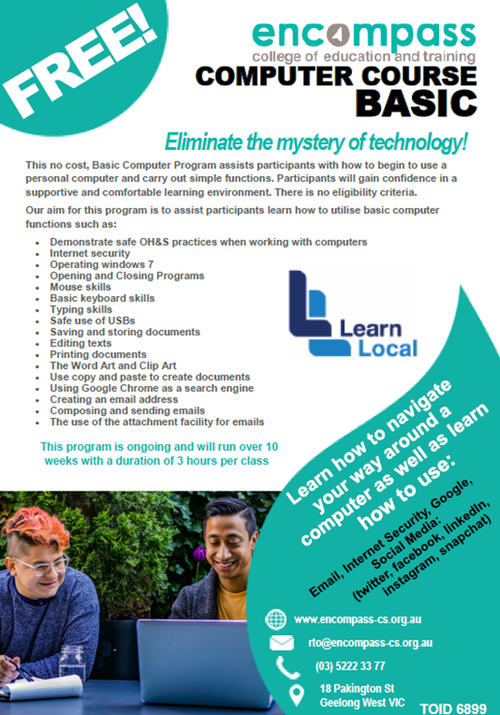
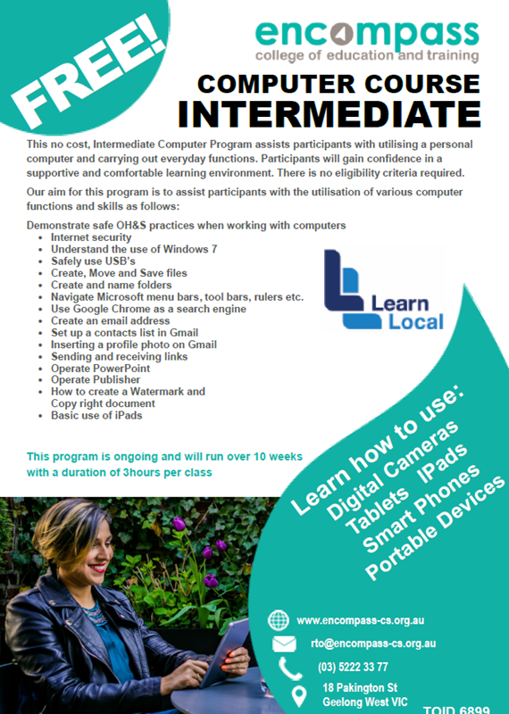

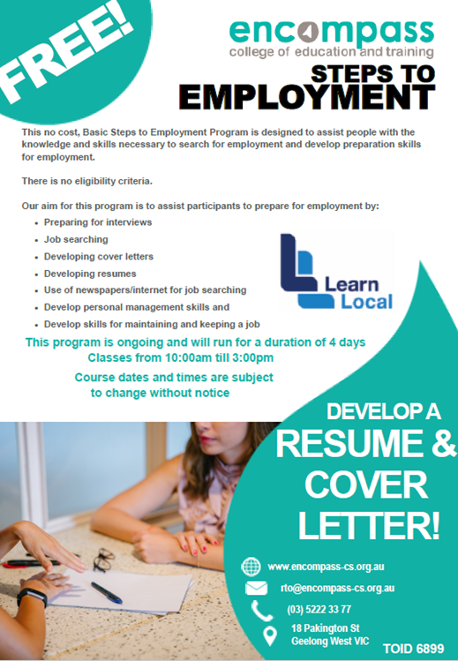

Community Centre’s inspiring lives - Learn, Create, Connect
Farsana Iqbal story...
Farsana is a qualified early educator and an amazing craft artist. In early days, she started volunteering with supported playgroups. Slowly she gained her confidence in her area and started facilitating multi—cultural playgroups across community centres in Wyndham. She is such a lovely person to talk. Farsana has emerged as a confident person, who is now running school holiday programs across centres. All the school holiday programs are a great hit among the community, because of her interest to teach children commitment to the workshop. She is very organised and make sure she delivers the best craft programs for the children.
When we asked about how are things different now and how important is that to you. She happily told us:
“I am more confident after I joined the centre. I'm now ready for any challenges and opportunities that will arise in the near future. Also, my communicating skills have gotten much better after interacting with people from different cultures, race and religion. my back from the start. When I started to do playgroup with little kids and their parents. After a few sessions of doing playgroup, the parents came up to me and told me about their kids really enjoying this and being excited to come. That gave me confidence to continue to do what I’m doing now. Each day I try to improve more and more to make the playground fun to the kids and my confidence kept increasing. The change happened when I first started doing crafting activities with adults in various cultures. I had to interact with them so my interpersonal skill improved, hence boosting my confidence. Betty Luong the Children & Family Cultural Liaison Officer helped me achieve my goals and other staff members also supported me and had my back since the start. I wouldn’t be in the position I am today without them, I’m really grateful for them. It was important to me because they have always been with me and always encouraging me have helped me getting into this position which I am today which made them really happy.

DO YOU WANT TO MAKE A DIFFERENCE?

Wyndham Waste Watchers
Keen to learn how to reduce your household waste?

Wyndham City Council has called on Wyndhamvale/Manor Lakes residents to take the six-week Wyndham Waste Watcher Challenge.

After a successful Waste Watchers trial last year, Council decided to roll out its practical waste education sessions to the growing Tarneit community and 17 families have volunteered to have their rubbish bins monitored.
We are looking for 20 families from Manor Lakes/Wyndham Vale to take part in Waste Watchers, a program helping to reduce the amount of waste coming out of households.
Why you should take part:
Participants will be equipped with knowledge and resources so they can better manage and reduce their waste, including:
Free Training Session
Tools to help reduce waste including kitchen caddy and Keep Cup
Ongoing support to help with their waste reduction journey

Start Date: Wednesday, 12th February 2020
Time: 6:00 PM – 7:30 PM
Location: Manor Lakes Library
86 Manor Lakes Blvd, Manor Lakes VIC 3024

Places are limited! To register, please email
May at may.toke-nawnyo@wyndham.vic.gov.au or
call 03 8734 5488.

Do you want to receive an update on What’s on at the centre?

Would you like to keep updated with what’s happening in Manor Lakes Community Learning Centre. You can join our mails, so that you will receive updates on new programs and events happening at the centre.

If you would like to know what's going on in community centres around Wyndham let us know in your email. We can add to our community centre’s mailing list.

Email us at:
manorlakesclc@wyndham.vic.gov.au
For any enquiries, call:
8734 8934

