Wyndham Disability Expo

I am going to the Expo with my family

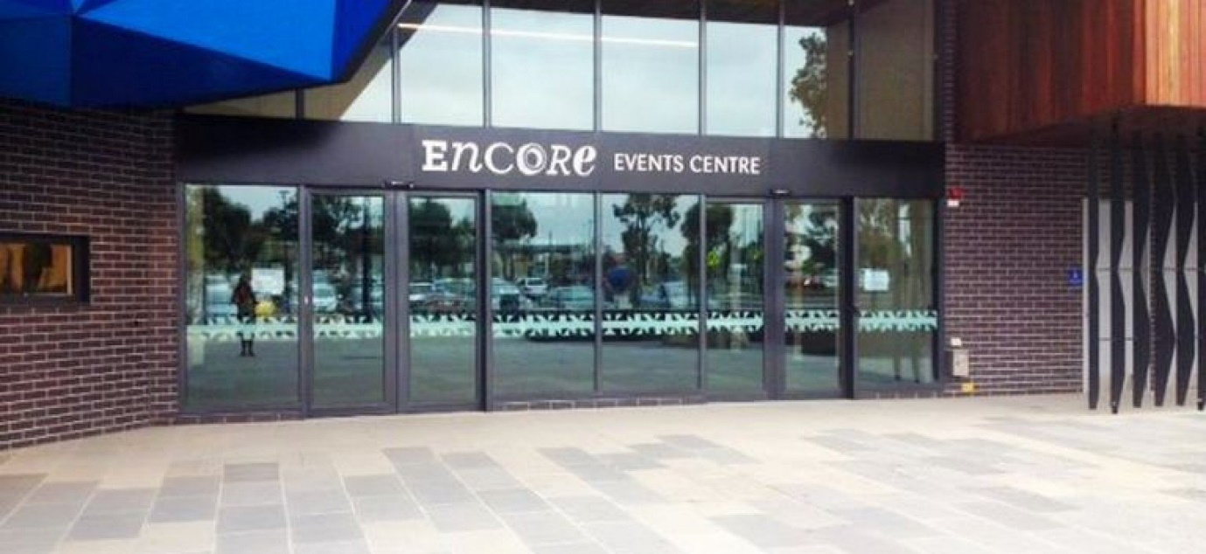

The Expo is at
Encore events centre

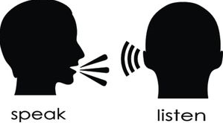

I will see, hear and do many things during my visit

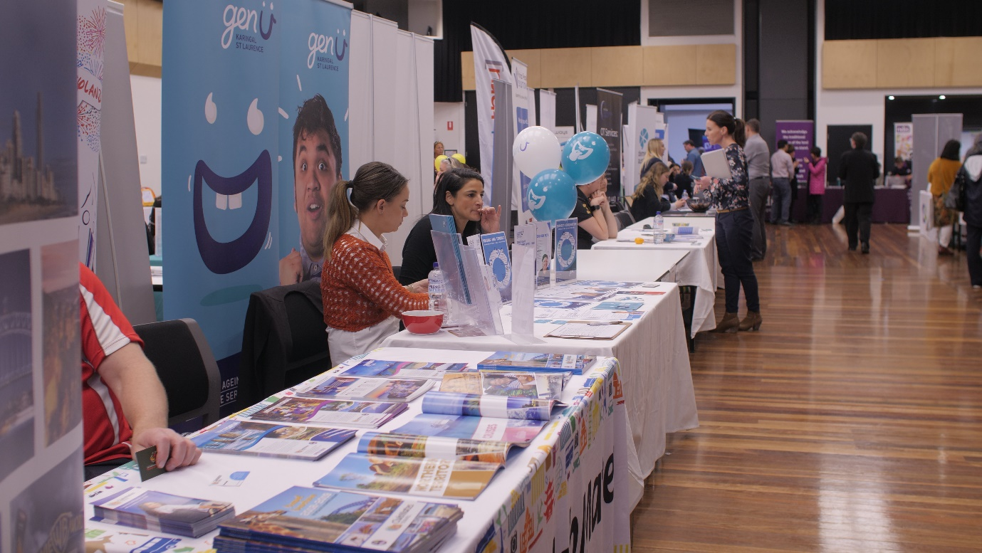

I will see people and stalls everywhere

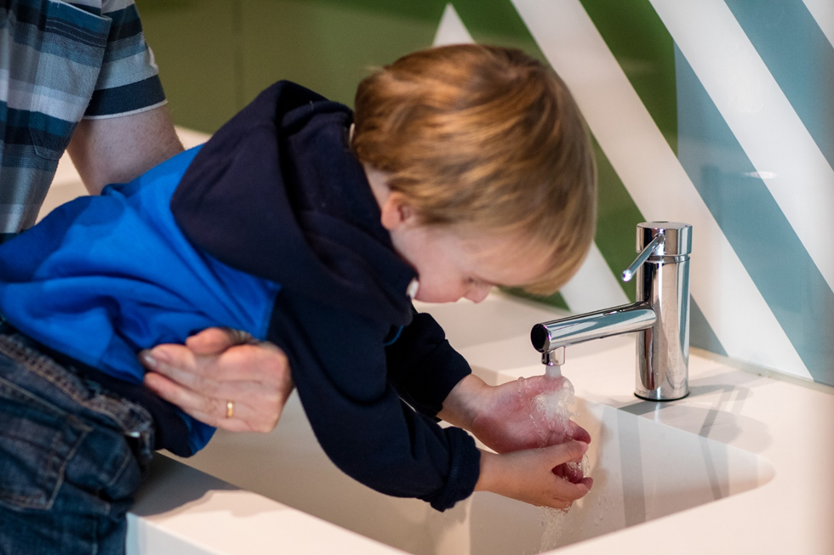
If I need to go to the toilet, there are loud hand dryers in the toilet.
I do not have to use them.

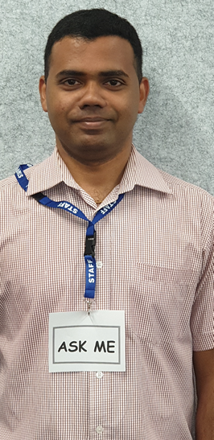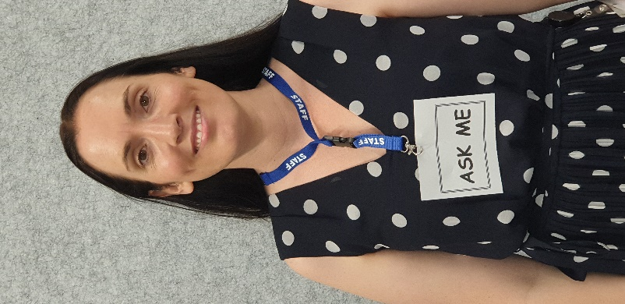

If I need help, I can talk to a helper, they are wearing a strap around their necks.

I can bring a snack and water bottle from home

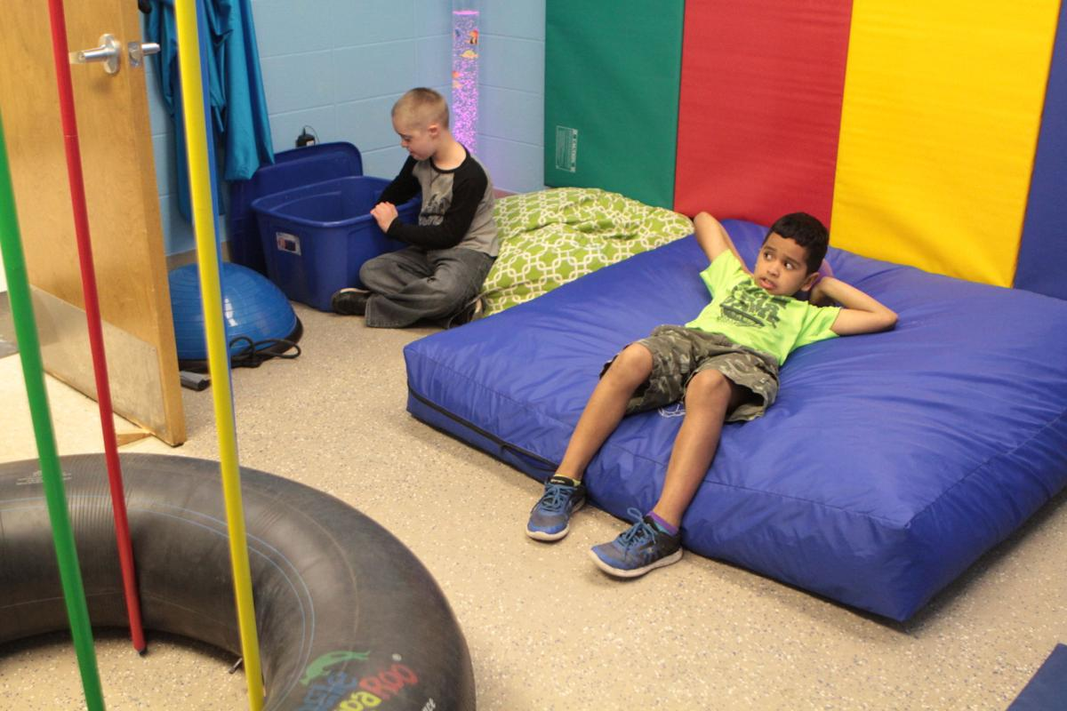

I can relax in the chill out zone or lounge area if I feel tired or upset.

This will be a fun day out with my family

