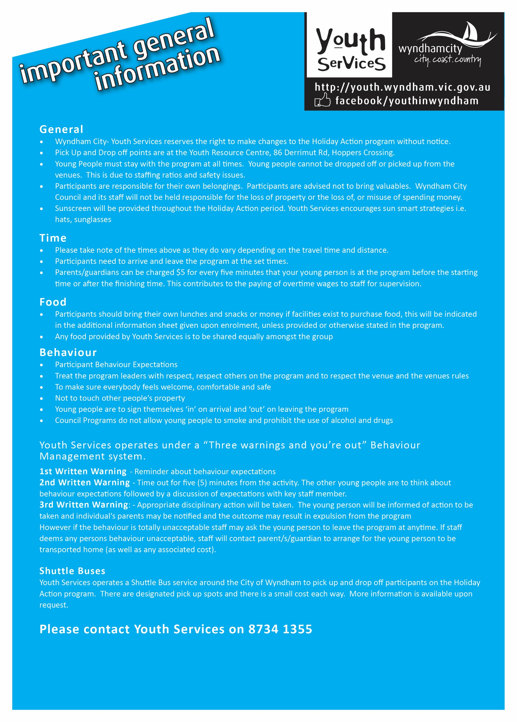

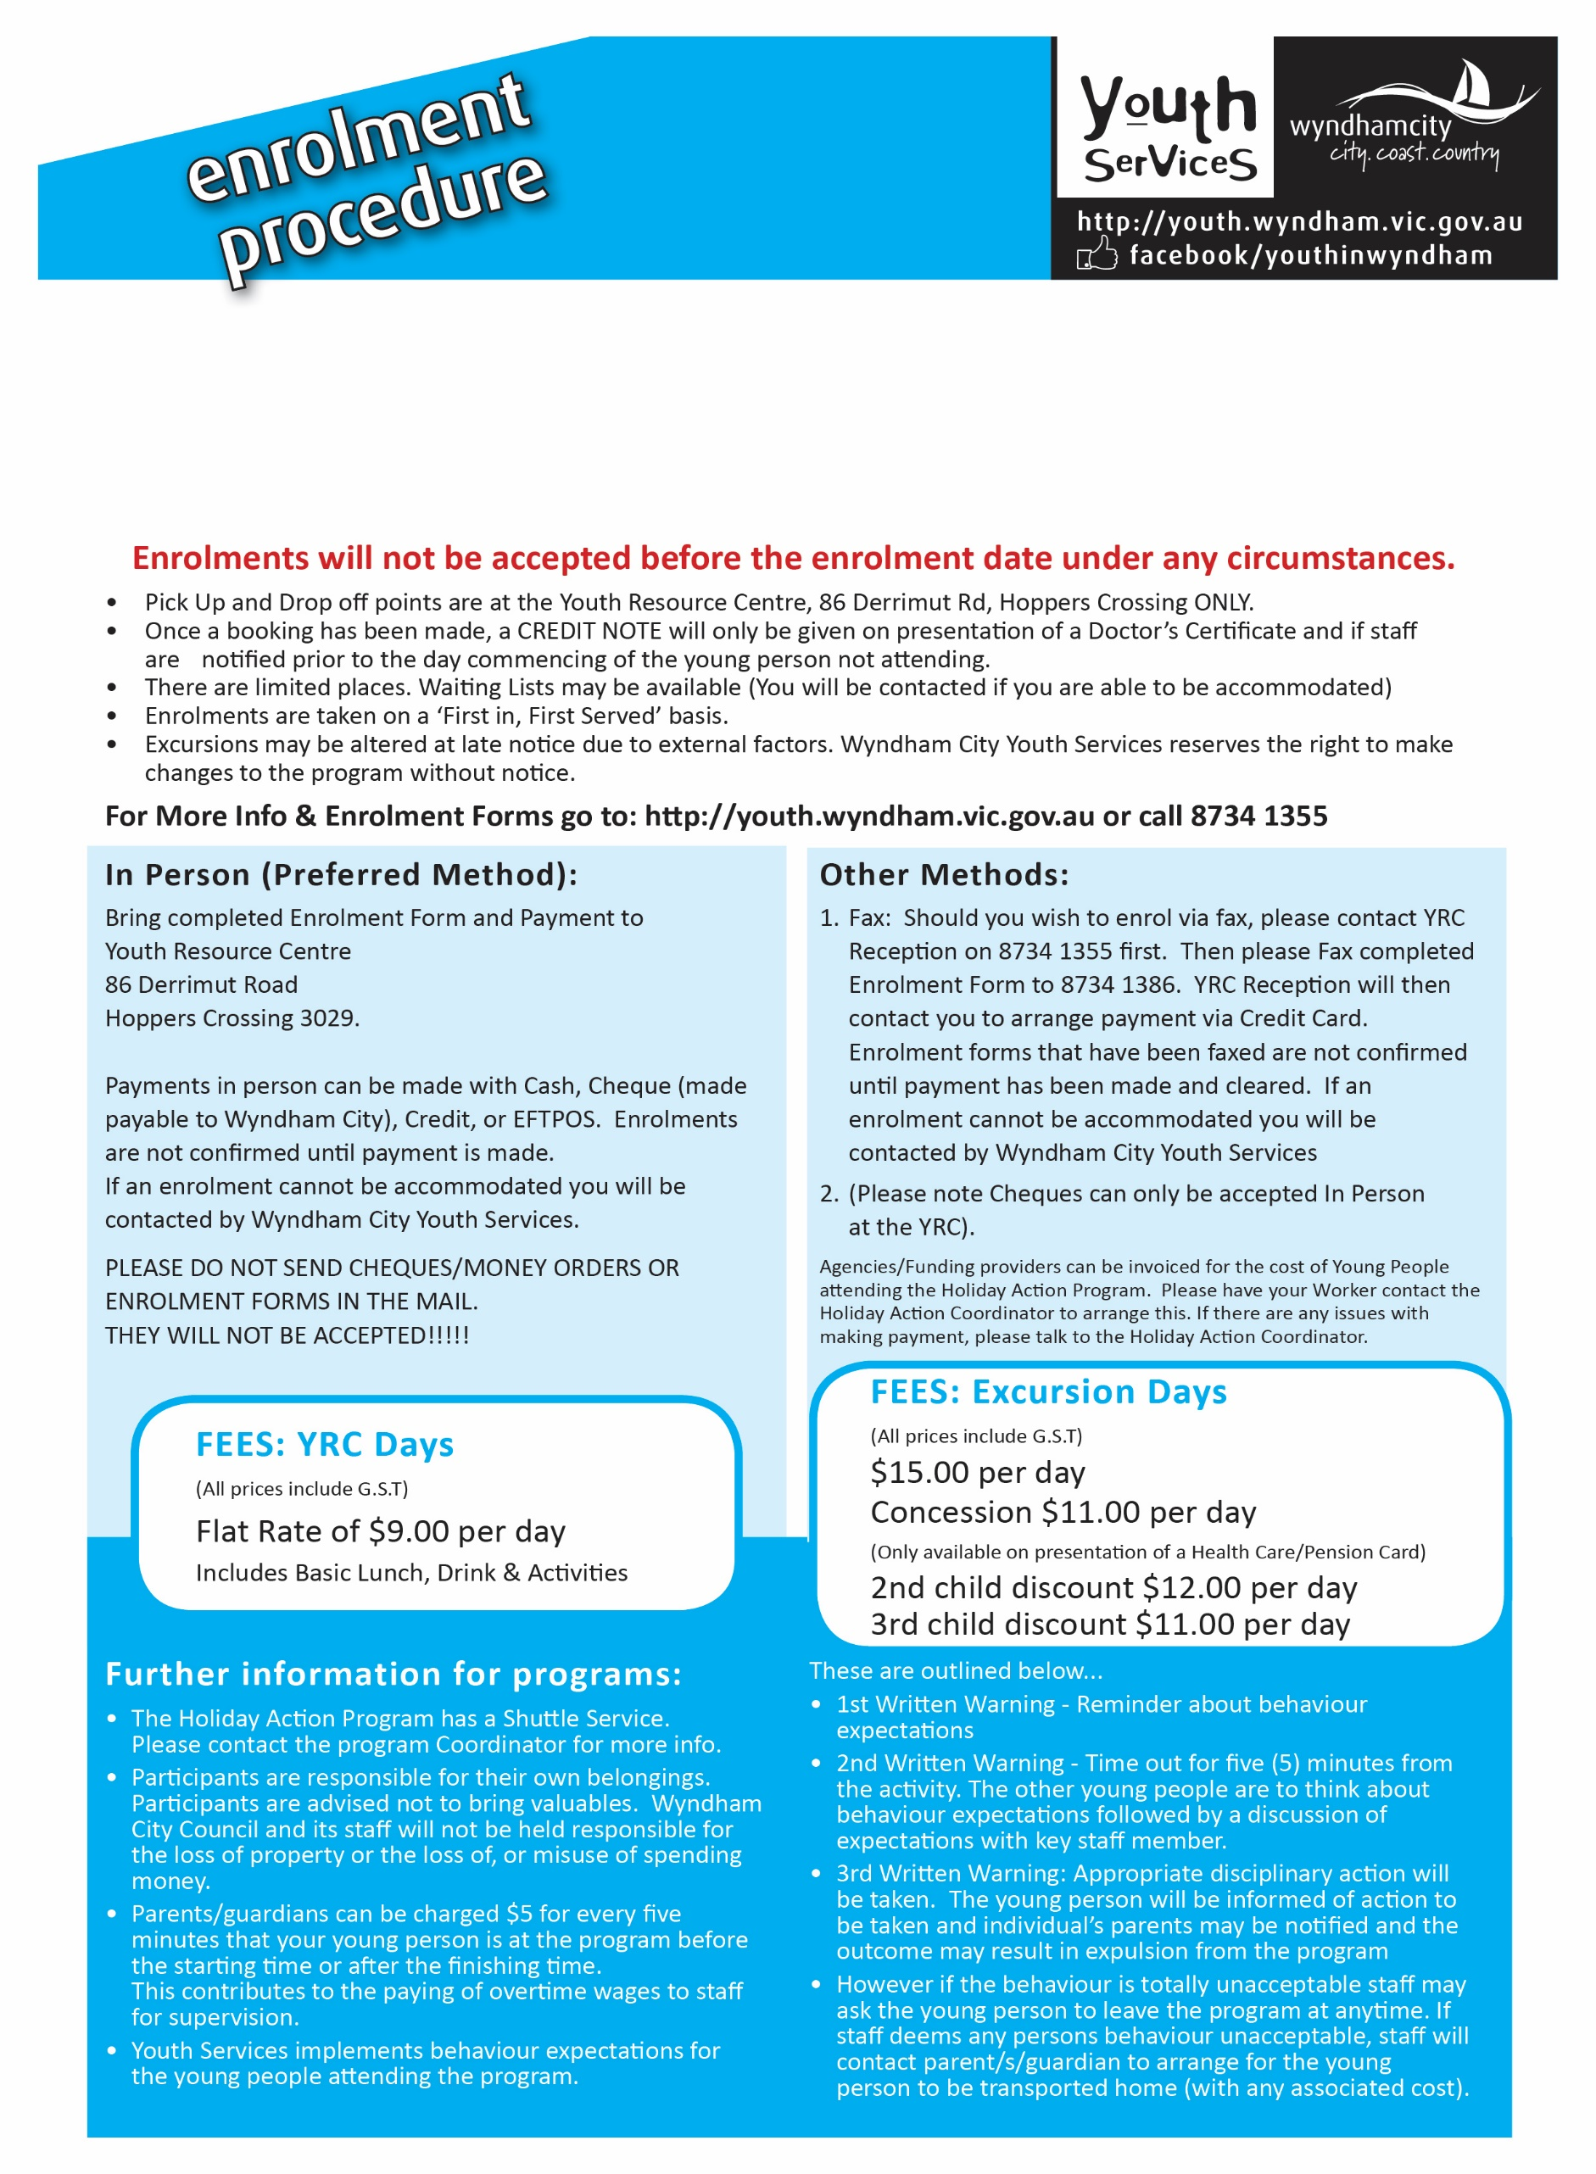

Once a booking has been made, a CREDIT NOTE will only be given on presentation of a Doctors Certificate and if staff are notified prior to the day commencing of the young person not attending.

**FEES**

**YRC DAYS** $9 Inc GST includes Basic Lunch, Drink and activities

**EXCURSION DAYS** $15 Inc GST, CONCESSION $11 PER DAY (only available with the presentation of a health care card)

**For more Info & enrolments forms go to** [**http://bit.ly/holaction**](http://bit.ly/holaction) **or call 8734 1355**

**Other methods:**

1. **Fax:** Should you wish to enrol via fax send the completed relevant forms to 8734 1386. YRC reception will then contact you to arrange payment via Credit Card.

NOTE: Enrolment forms that have been faxed are not confirmed until payment has been made. If an enrolment cannot be accommodated you will be contacted by Wyndham Youth Services Staff.

NOTE: Cheques can only be accepted in person at YRC

1. **Email:** Should you wish to enrol via email send all completed relevant forms to [holidayactionenquiries@wyndham.vic.gov.au](mailto:holidayactionenquiries@wyndham.vic.gov.au)

Youth Services Staff will then contact you to arrange payment Via credit card.

NOTE: Enrolment Forms will NOT be accepted before 9am on the opening date. Enrolments are not final until payment has been made.

PAYMENT NEEDS TO BE MADE TO SECURE THE POSTION BY THE END OF THE NEXT BUSINESS DAY.

**In person**

Bring completed enrolments forms and payment to Youth Resource Centre, 86 Derrimut Rd Hoppers Crossing 3029

Payments in person can be made with Cash, Cheque (made payable to Wyndham City) Credit, or EFTPOS. Enrolments are not confirmed until payment is made. If an enrolment cannot be accommodated you will be contacted by Wyndham City Council Youth Services.

PLEASE DO NOT SEND CHEQUES/MONEY ORDERS OR ENROLMENT FORMS IN THE MAIL. THEY WILL NOT BE ACCEPTED

**ENROLMENTS OPEN: Monday 9nd September 2019 at 9am**