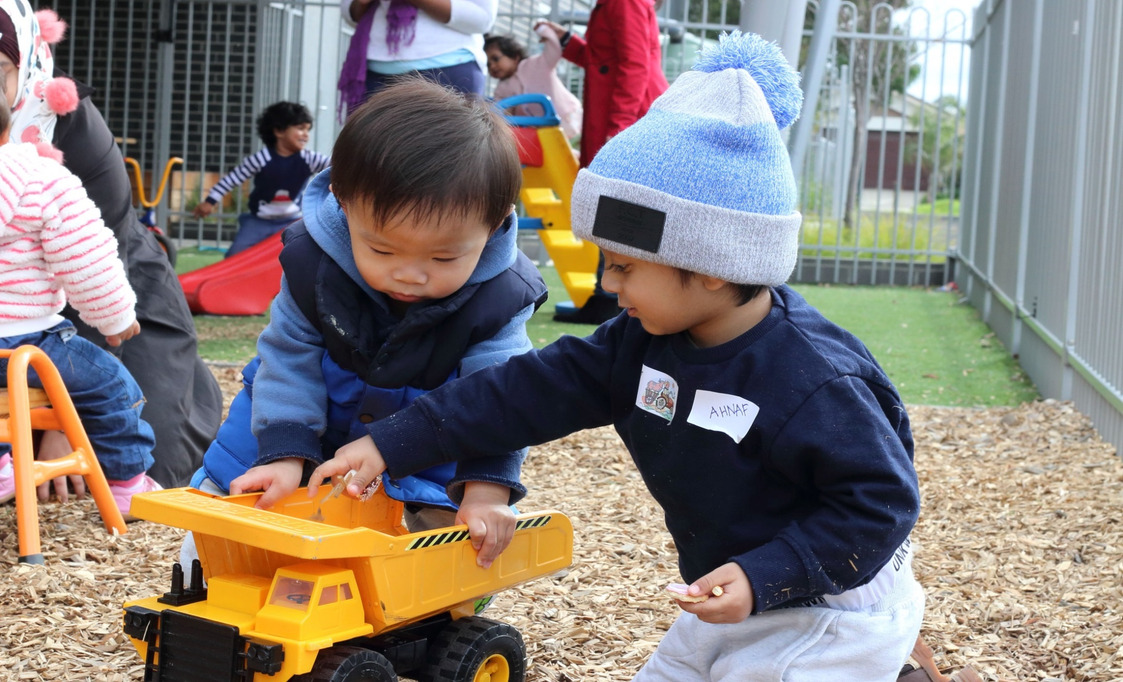

TARNEIT

COMMUNITY LEARNING

CENTRE

**Council works to ensure activities in community centres meet local needs and interests. With projected growth in population in the coming years, we are focussed on reaching out to new residents and communities who we haven’t met yet. Priorities for activities have been developed for each community centre based on local demographic data, what residents have told us is important to them along with an assessment of current activities. This fact sheet provides an overview of all this information and the related local priorities.**



Who lives in and

Around Tarneit?



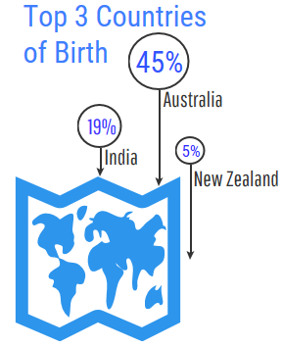

Countries of birth outside of Australia

India 11.9% | New Zealand3.9%| Philippines 3.2%



38,619 residents   
 in Tarneit in 2019



More than half (52%)

of households in Tarneit are couples with children

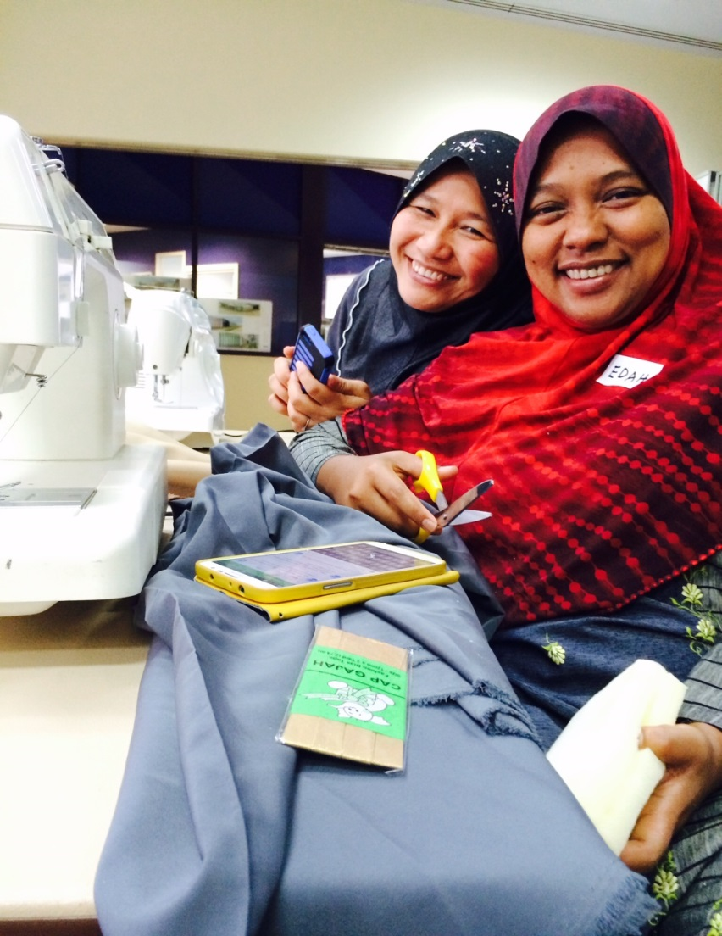

Tarneit Residents Value

**“Quality Education”**

**“Local Services”**

**“A Place to Bring-up a Family”**

***Wyndham 2040***

What We’re Hearing…

“Diversity is important, and we are trying to unite as one and learn from each other”

“We highly value opportunities to learn”

“Let’s do things with the whole family!”

“I want to attend activities that support my health and wellbeing”



* Programs that provide opportunities to learn.
* Activities and events that the whole family can enjoy together.
* Activities that improve health and wellbeing.
* Opportunities that provide support and connection that enhance the lives of our diverse and vulnerable communities.

**ACTIVITY PRIORITIES FOR 2020**