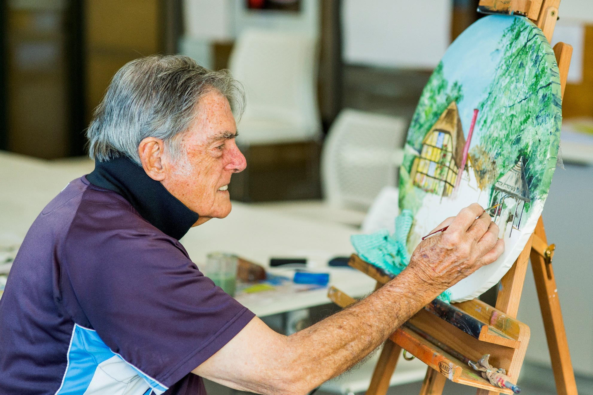

SALTWATER COMMUNITY

CENTRE

**Council works to ensure activities in community centres meet local needs and interests. With projected growth in population in the coming years, we are focussed on reaching out to new residents and communities who we haven’t met yet. Priorities for activities have been developed for each community centre based on local demographic data, what residents have told us is important to them along with an assessment of current activities. This fact sheet provides an overview of all this information and the related local priorities.**



Who lives in and

Around Point Cook?



63,802 residents   
in Point Cook in 2019

Countries of birth outside of Australia

India 12.8% | China 5.5% | New Zealand

and Philippines 4% | England 2.9%

More than half (54%)  
of households in Point Cook are couples  
 with children



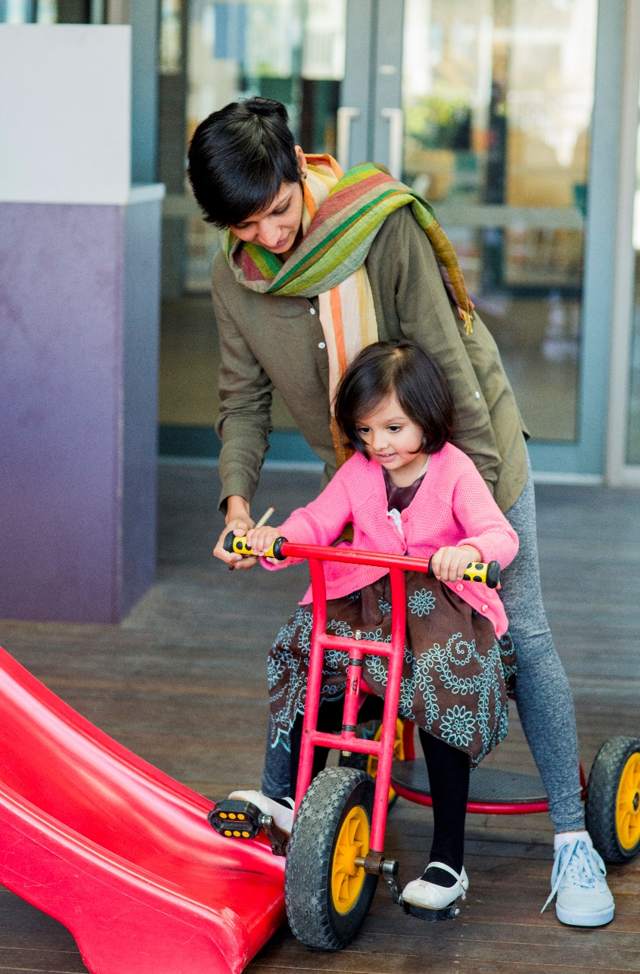

Point Cook Residents Value

**“Quality Education”**

**“Local Services”**

**“A Place to Bring-up a Family”**

***Wyndham 2040***

What We’re Hearing…

“Programs activities and events for the whole family including playgroups, children and parent activities, arts based programs”

“More outdoor activities for children and physical activities for older people”

“Activities and events that bring people from different cultures together”

“Arts based classes for children”

“Educational opportunities for adults”



**NEIGHBOURHOOD ACTIVITY PRIORITIES FOR 2020**

* Performance based activities like theatre and music.
* Outdoor events and activities for young people.
* Activities that encourage and celebrate cultural diversity and inclusion.
* Indoor and outdoor programs and events that promote physical activity for older people.