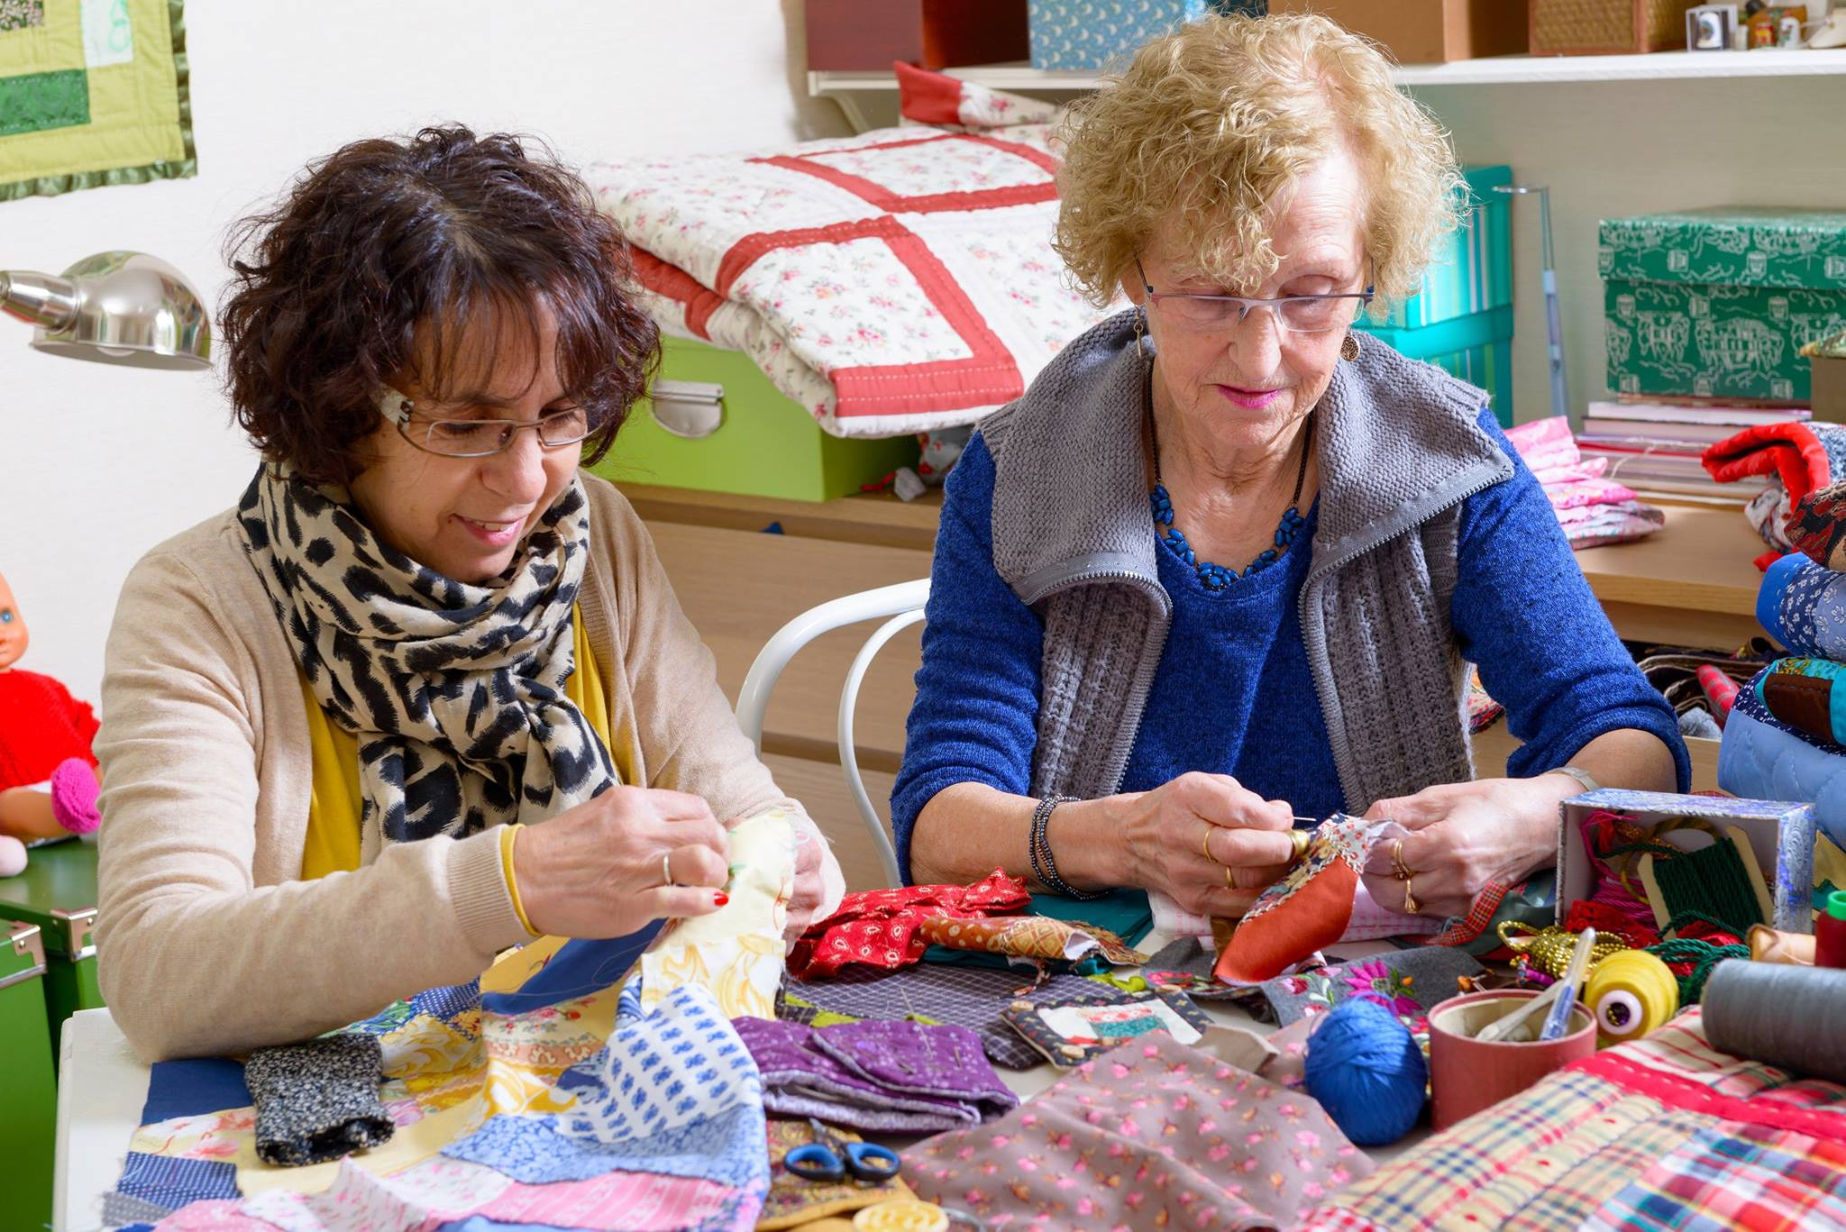

POINT COOK

COMMUNITY LEARNING

CENTRE

**Council works to ensure activities in community centres meet local needs and interests. With projected growth in population in the coming years, we are focussed on reaching out to new residents and communities who we haven’t met yet. Priorities for activities have been developed for each community centre based on local demographic data, what residents have told us is important to them along with an assessment of current activities. This fact sheet provides an overview of all this information and the related local priorities.**

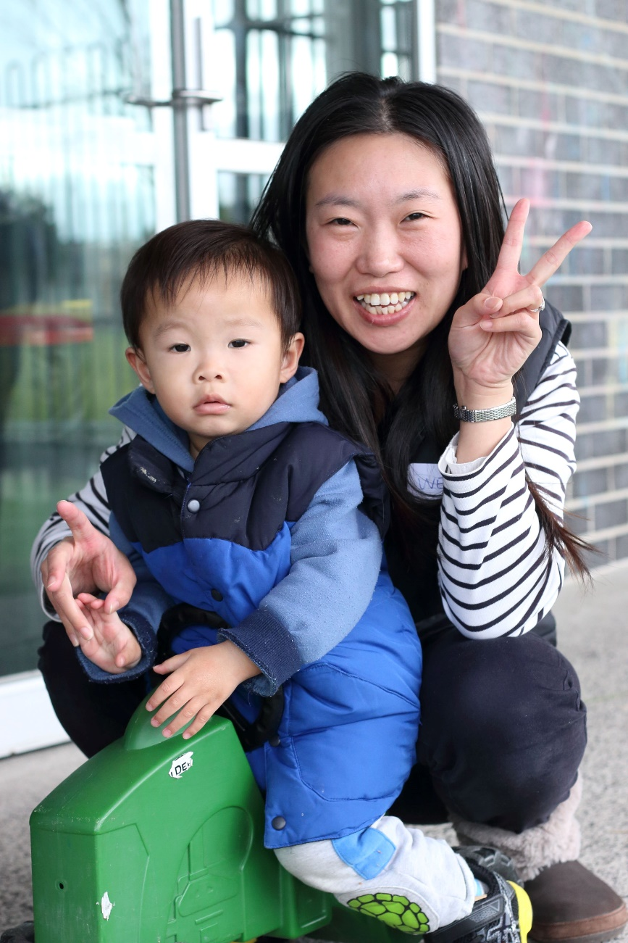

Who lives in and

Around Point Cook?

63,802 residents   
in Point Cook in 2019

Countries of birth outside of Australia

India 12.8% | China 5.5%, New Zealand

and Philippines 4% | England 2.9%

More than half (54%)  
of households in Point Cook are couples  
 with children







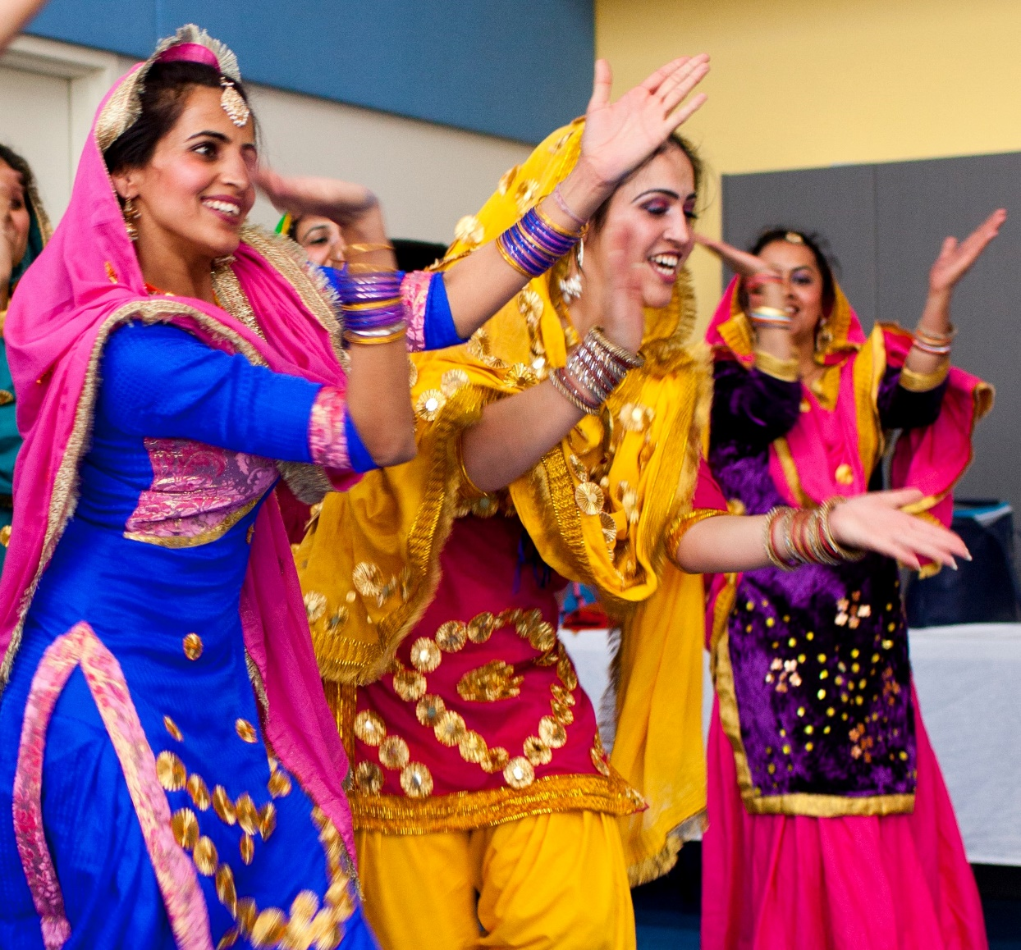

Point Cook Residents Value

**“Quality Education”**

**“Local Services”**

**“A Place to Bring-up a Family”**

***Wyndham 2040***

What We’re Hearing…

“We want activities that will keep children active and healthy”

Opportunities to connect with others, a place to come together, share food and drinks, exercise whilst creating a vibrant community with a strong sense of belonging.

Opportunities for adults to learn new skills for fun or for employment.



* Activities for children and their mothers from all cultures.
* Activities that bring everyone from different cultures together and improve health and wellbeing.
* Programs and activities to learn new skills including languages, arts and crafts, employment readiness, digital literacy.

**NEIGHBOURHOOD ACTIVITY PRIORITIES FOR 2020**