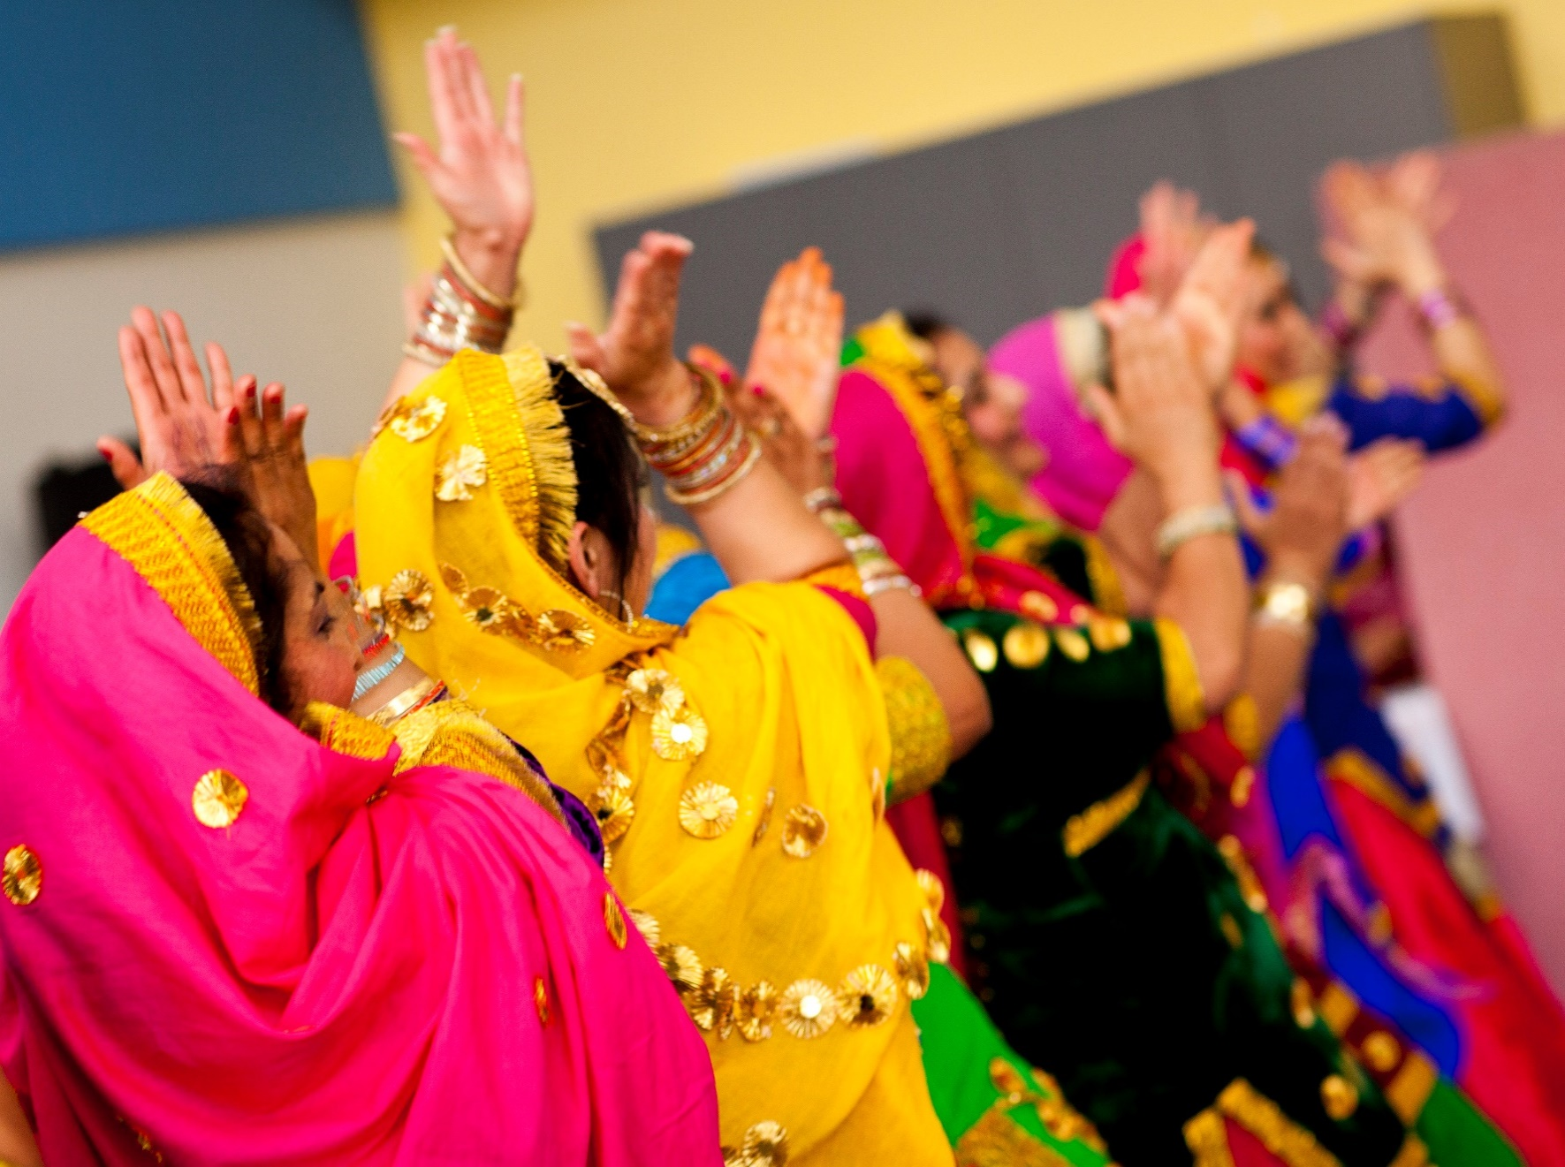

MANOR LAKES

COMMUNITY LEARNING CENTRE

**Council works to ensure activities in community centres meet local needs and interests. With projected growth in population in the coming years, we are focussed on reaching out to new residents and communities who we haven’t met yet. Priorities for activities have been developed for each community centre based on local demographic data, what residents have told us is important to them along with an assessment of current activities. This fact sheet provides an overview of all this information and the related local priorities.**

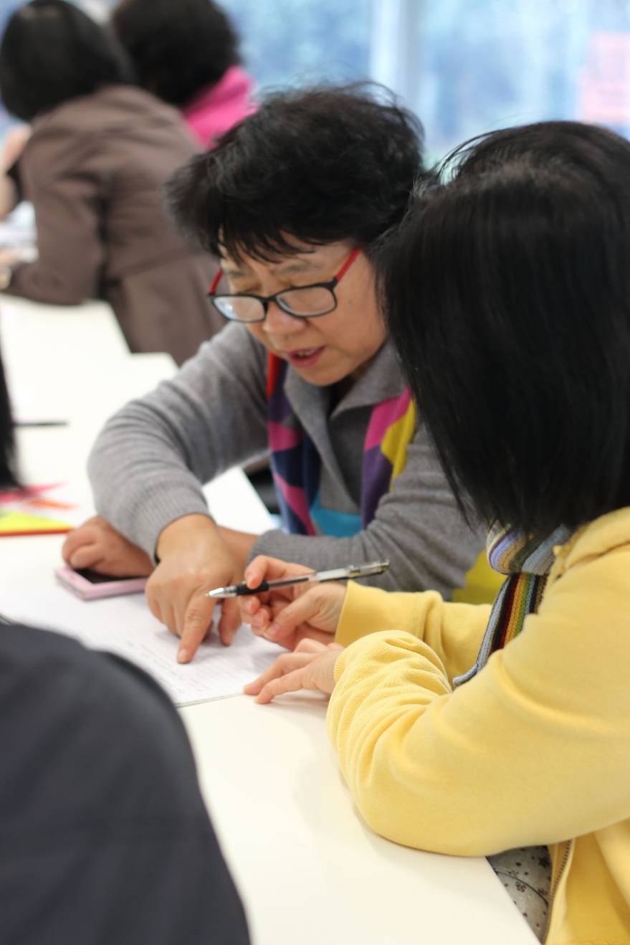

Who lives in and

Around Manor Lakes?

 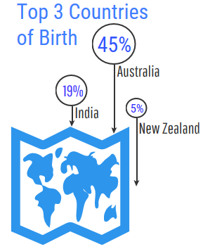

Countries of birth outside of Australia

India 5.8% | New Zealand 2.9%| England 2.8%

3.8% of Manor Lakes residents need assistance   
with basic services and activities including communication and self-care



More than half (52%)  
of households in Manor Lakes are couples  
 with children



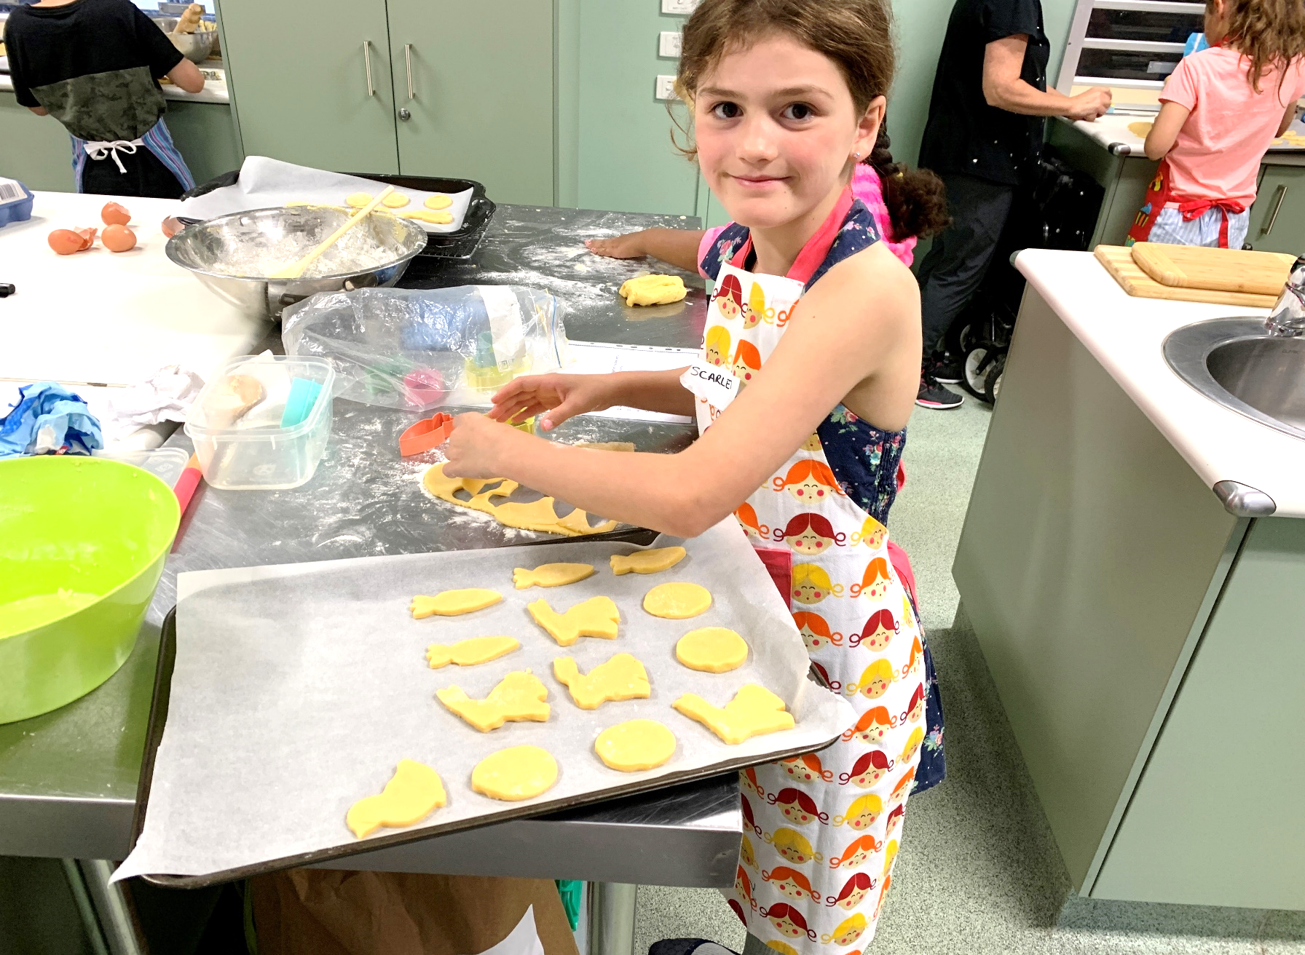

Manor Lakes Residents Value

**“Quality Education”**

**“Local Services”**

**“A Place to Bring-up a Family”**

***Wyndham 2040***

What We’re Hearing…

“We want to have after school activities for kids specially focussing on learning social skills”

“There is a lack of support and services for parents who have kids with disabilities”

“Programs that support mental health and wellbeing”

“I want to enrol in a course which will help me find a job or start my own business”



* Affordable after school activities for primary school aged children that develop social skills.
* Activities and programs that connect and support parents who have children with a disability.
* Programs and activities that support mental health and wellbeing.
* Programs and training that help people gain employment.

**NEIGHBOURHOOD ACTIVITY PRIORITIES FOR 2020**