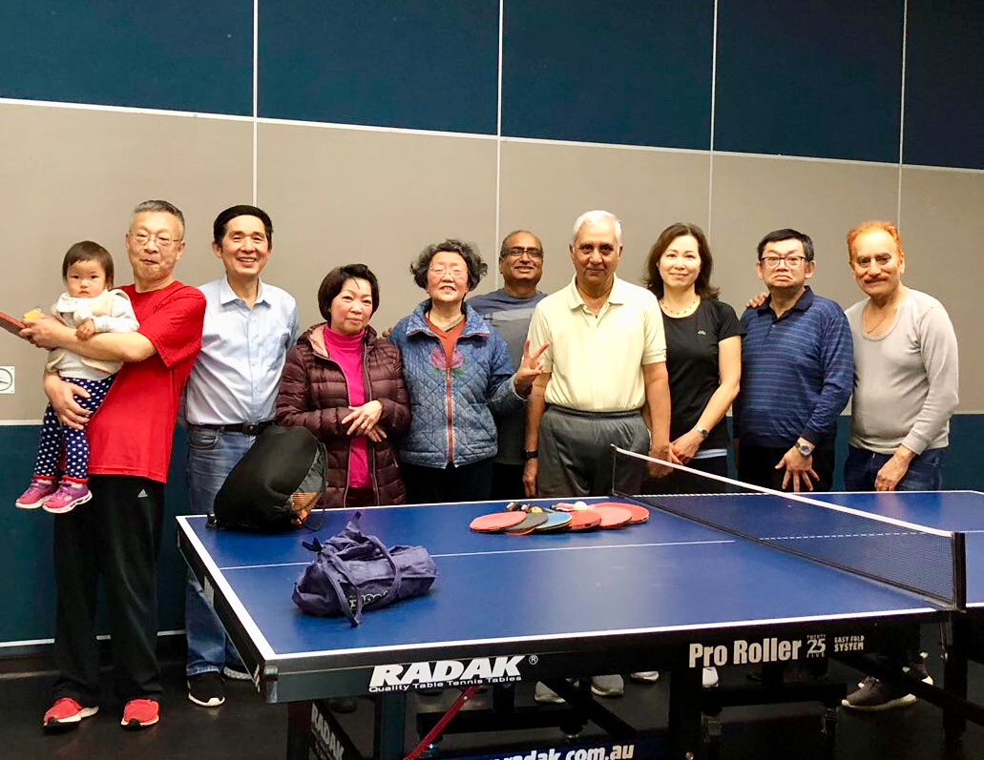

FEATHERBROOK

COMMUNITY CENTRE

**Council works to ensure activities in community centres meet local needs and interests. With projected growth in population in the coming years, we are focussed on reaching out to new residents and communities who we haven’t met yet. Priorities for activities have been developed for each community centre based on local demographic data, what residents have told us is important to them along with an assessment of current activities. This fact sheet provides an overview of all this information and the related local priorities.**

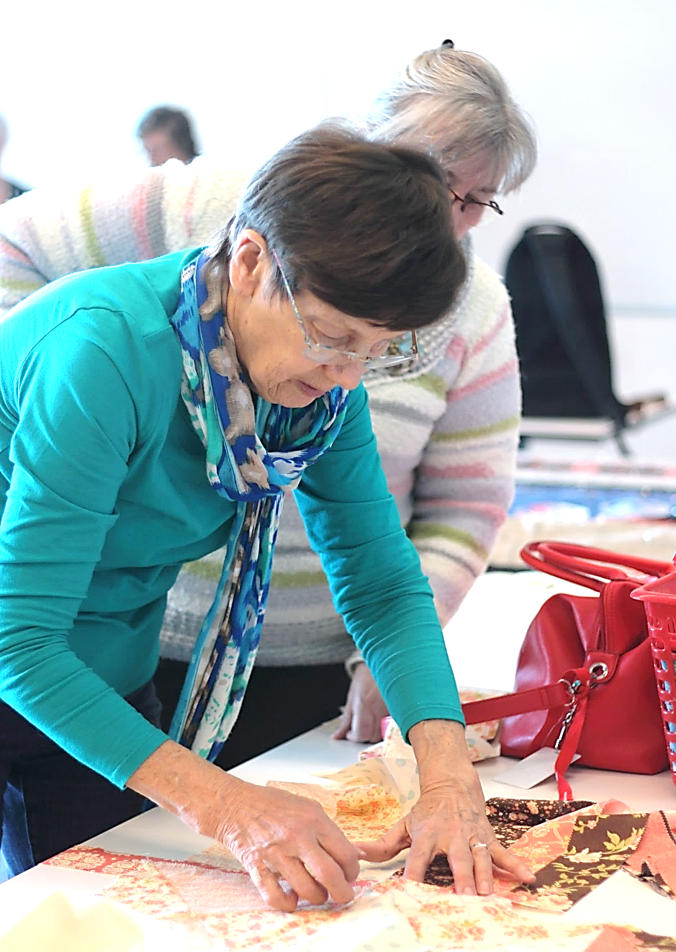

Who lives in and

Around Point Cook?

63,802 residents   
in Point Cook in 2019

Countries of birth outside of Australia

India 12.8% | China 5.5% New Zealand

and Philippines 4% | England 2.9%

More than half (54%)  
of households in Point Cook are couples  
 with children







**Point Cook: Age Profile**

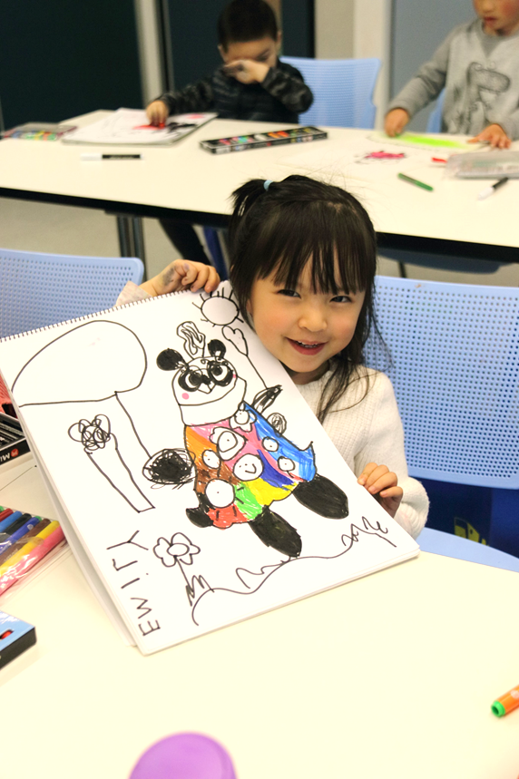

Point Cook Residents Value

**“Quality Education”**

**“Local Services”**

**“A Place to Bring-up a Family”**

***Wyndham 2040***

What We’re Hearing…

“We want to meet and get to know people, share our culture and food, dance and have fun together”

“We want a strong, healthy and connected community”

“We are worried about the environment but don’t know what to do”.

“Various Activities for kids, mums, families and seniors”



* Programs and events that support cross cultural sharing, strengthen relationships amongst our diverse peoples and a deeper connection to country.
* Programs and events that inform about our environment and how to care for it.
* Activities that enhance resilience, improve health & wellbeing and social connection.

**NEIGHBOURHOOD ACTIVITY PRIORITIES FOR 2020**