Tarneit & Sayers Road
Public Acquisition Overlay
FACT SHEET

What is the Public Acquisition Overlay?

- The Public Acquisition Overlay is a planning control which reserves land for a future public purpose.

- Council is proposing a Public Acquisition Overlay for a future service road along Tarneit and Sayers Road.

- The overlay requires anyone proposing a subdivision, buildings and/or works in that overlay area to obtain a planning permit.

- A planning permit will only be granted if the proposal does not prevent the land from being used or developed for its future public purpose.

Why is a service road required?

- Tarneit and Sayers Roads are main arterial roads which serve an important role in moving traffic in and around Wyndham. In the next 10-15 years, the total number of vehicle movements is expected to almost double to around 30,000 vehicle movements per day for both roads.

- Direct vehicle access for properties onto arterial roads is discouraged in new developments, as it can impact on how safe and efficient the arterial road can operate.

- The service road will improve access arrangements for landowners as well as the operation of Tarneit and Sayers Road, which will be particularly important long term as Wyndham continues to grow.

- An independent traffic assessment has been prepared which recommends a service road as the appropriate road access management strategy.

How many properties are affected?

- In total, 121 properties along Sayers and Tarneit Roads form part of the 'Tarneit and Sayers Road Precinct'. Of these, it is proposed that 97 will have a service road.

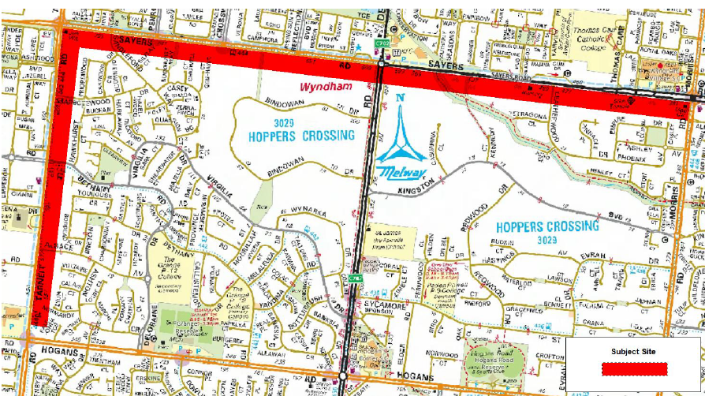

How much land will be required?

- The Public Acquisition Overlay will apply to the first 12 metres of land from the street frontage. This land includes the road pavement width of the service road, medians, concrete kerb, the nature strip and underground utilities.

- Any new development may be required to be setback from the new property boundary, to provide for an amenity/landscaping area.

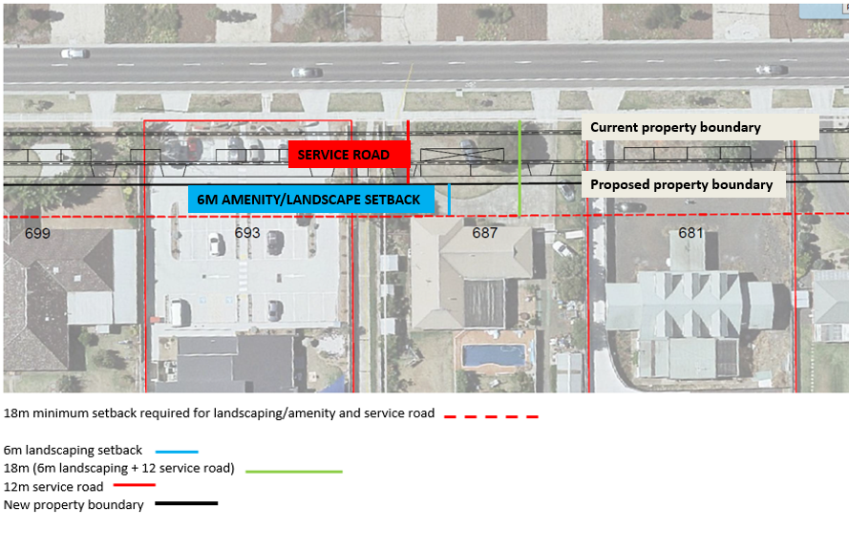

Community Consultation

- At a meeting held in March 2017, landowners raised concerns about the impacts of the service road on their properties and requested that Council investigate alternative traffic management options.

- Council officers have assessed the impacts of the service road on each property. In particular:
- Direct impact on an existing building;
- Impact of an existing buildings within eighteen metres (i.e. within six metres of the future service road);
- Impact on septic tank in the front yards of properties;
- Impact on car parking associated with a non-residential use or multi-dwelling development.

- Three information drop in sessions were held in May and June 2019 to enable Council officers to provide information on the planning, acquisition and compensation and engineering issues, and for landowners to ask questions and raise issues. Below is a list of the nature of issues raised by landowners.

Planning
- Timing of PAO
- Reduced lot sizes in the Low Density Residential Zone (LDRZ) and further subdivision
- Housing and Neighbourhood Character Study and impact on ability to develop
- Zoning of properties to maintain character of the area
- Definition of "Infrastructure Constrained”
- Potential for new sewer line

Property - Acquisition and Compensation
- Assessment of land value
- Impact of PAO on property values
- Timing between Amendment and Acquisition
- Reinstatement of landscaping and fencing
- Options for buildings within 6m setback from the service road

Service Road design
- Main objective of the service road
- Proposed 12m easement for service road, and potential use of centre median
- Option for service road to be narrower.
- Use of the existing road reserve for the service road
- Cost of relocating services vs cost of service road
- Clarification of service road access points
- Entry/exit point locations for commercial properties
- Impact of reduced parking for commercial operations and existing permit requirements
- location of service road exits and access to other lanes and central median breaks ( U-Turn facility)
- formalisation of U-turn provision at intersections.
- Interaction of signalised intersections (service lane access points located to align with intersections) and distances to U-turn points;
- Implications for properties with two crossovers and traffic signal access
- Parking along service road and management of on street parking
- Potential for on-street parking blocking access for emergency vehicles
Amenity concerns

- potential impact on locally significant trees within properties on Sayers Road
- Impact on existing large front yards, enjoyment of premises and future development potential

How has Council progressed the Amendment?

- At its February 2017 Ordinary Council Meeting, Council resolved to seek Authorisation from the Minister for Planning to prepare and exhibit Amendment C162. https://councilpapers.wyndham.vic.gov.au/Open/2017/ORD_07022017_MIN_2502_AT_WEB.HTM

- In July 2019 Wyndham City Council sought Authorisation from the Minister for Planning to prepare and exhibit Amendment C243 in accordance with the Planning and Environment Act 1987.

- The exhibition period is from Thursday 25th July 2019 until Monday 23 September 2019.

- Any person who may be affected by the amendment may make a submission to the planning authority about the amendment. Submissions must be made in writing giving the submitter’s name and contact address, clearly stating the grounds on which the amendment is supported or opposed and indicating what changes (if any) the submitter wishes to make.

- Name and contact details of submitters are required for council to consider submissions and to notify such persons of the opportunity to attend council meetings and any public hearing held to consider submissions. A submission must be sent to the Wyndham City Council, 45 Princes Highway, Werribee VIC 3030 or via email mail@wyndham.vic.gov.au with reference Amendment C243.

- Responses to issues raised in written submissions made during the public exhibition process of the planning scheme amendment to introduce the PAO into the planning scheme will be prepared as part of council’s consideration of submissions.

- The closing date for submissions is Monday 23 September 2019.

When will the service road be constructed?

- The construction of the service road may not be required in the immediate future.

- The timing of the service road is dependent on Council’s capital works and budget planning.

Will landowners be compensated?

When Council acquires the land, landowners will be compensated based on an independent assessment of the market value of the land, and other costs affected by the acquisition, in accordance with the Land Acquisition and Compensation Act 1986.

Further Information

- Further information on the Acquisition and Compensation Process is available on the Department of Environment, Land, Water and Planning’s website:

Using Victoria’s Planning System, Chapter 6 – Acquisition and Compensation
https://www.planning.vic.gov.au/guide-home/using-victorias-planning-system

- Alternatively contact Council’s Urban Futures Department on 03 9742 0777 or 9742 0792 or by email Diana.rice@wyndham.vic.gov.au or Kristien.vandenbossch@wyndham.vic.gov.au

