Hoppers Crossing Children’s Centre Handbook
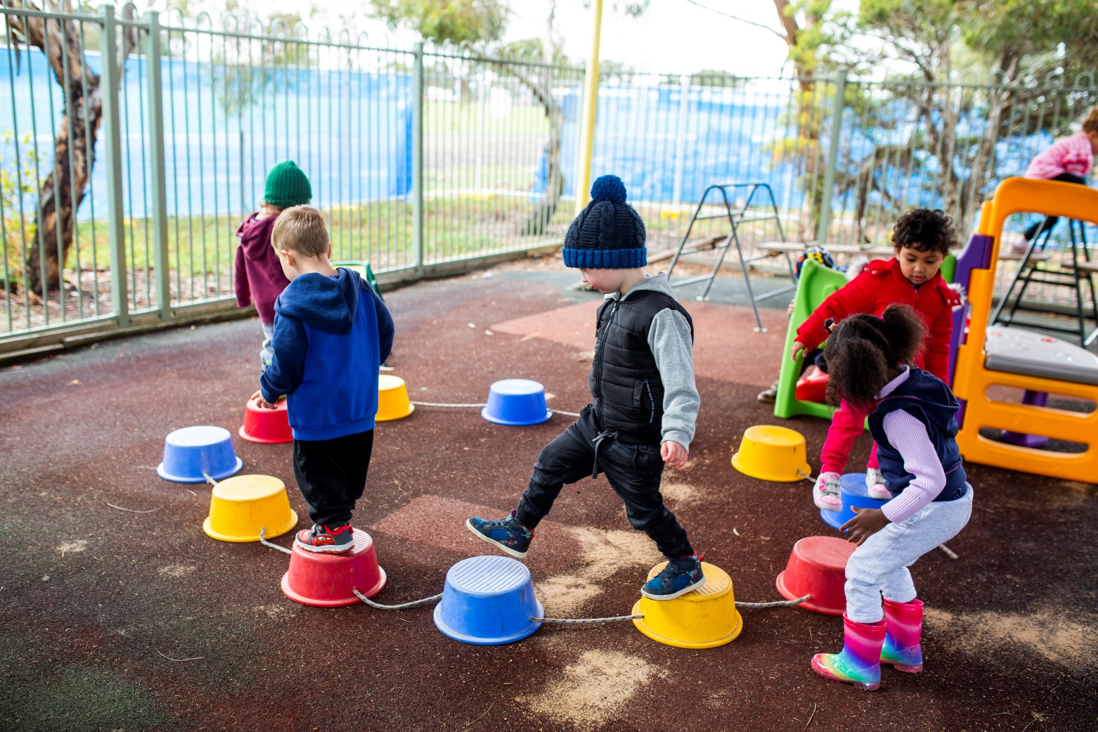

Contents

Contents
Welcome 5
Philosophy and Goals 5
Philosophy 5
Goals 6
Centre Timetable 7
Hoppers Crossing Children’s Centre 7
What is Occasional Care 7
Enrolment 8
Enrolment Form 8
Birth Certificate 8
Immunisation History Statement (ACIR) 8
Photography 8
Privacy 8
Children’s Program 9
National Quality Framework 9
Educational Program 9
Settling Children into the Centre 10
Guiding Behaviour 10
Life Events 11
Celebrations 11
Children’s Care and Comfort 12
Parent communication 12
Toys from home 12
Clothing and Footwear 13
Items to be brought with your Child 13
Children with Additional Needs 13
Children’s Centre Staff 14
Qualifications 14
Staff: child ratios 14
Relief staff (Emergency/Casual) 14
Students/Volunteers 14
Parent Partnerships 14

Communication 15
Collection of Household Items/Scrap Material for the Centre 15
Appointments with Staff 16
Compliments and Complaints 16
Arrival and Departure 16
Signing In and Out 16
Arrival 17
Departure 17
Parents under the influence of drugs or alcohol 17
Custody and contact 17
Late collection of children 18
Children not collected 18
Cancellations to Occasional Care Sessions 18
18
Health 19
Medication 19
Illness and Infectious Diseases 19
Immunisation 20
Chronic Conditions and Allergies 20
Anaphylaxis 20
Asthma 21
Accidents and Injuries 21
Minor Accidents 21
Medical Emergencies 22
Food Restrictions 22
Sun Protection 22
22
Nutrition and Dental Care 23
Wyndham City’s Smoking Policy 23
Safety 23
Building and Playground safety 23
Emergency Procedures and Equipment 23
Child Protection 24
Visitor’s Book 24
Centre Closure & Public Holidays 24

Fees 24
Accounts 24
Child Care Subsidy (CCS) 25
Allowable Absences 25
Cessation of care 25
Appendix 26
Appendix 1 – School Exclusion Table 26

Please note: The Policy and Procedures Manual is available at each centre. Please feel free to read through this document at a convenient time for you. If you would like a copy of specific policies please speak to the staff.

Last updated: July 2018

Welcome

Welcome to the Hoppers Crossing Children Centres. We strive to provide a welcoming, inclusive, family type environment in which families and children's individuality is embraced. We believe that families are the primary and most influential educators and nurturers of their child and that children’s learning and development takes place in the context of families. We will work with families to provide the highest quality program for children from casual Occasional Care, to their pre-4 year old kinder and pre-school year.

A dedicated team of Early Childhood Educators with qualifications and experience in early childhood education is employed to facilitate learning and nurture all children in care. The centres provide a thoughtfully planned curriculum and environment based on the developmental needs and interests of each child, and the culture and values of the families who use the centres. Challenging and stimulating indoor and outdoor experiences are incorporated into the curriculum.

We believe that by providing children with the foundations to learn and grow today will ensure they create a positive and successful future.

Please take the time to read through this package so that you can become familiar with our services, and can identify any area’s that you may need further information on before you commence. On the final page is an agreement for you to sign and return to us.

We sincerely hope that you and your family have enjoyable and memorable time with us.

Philosophy and Goals

Philosophy

At the Hoppers Crossing Children’s Centre, we believe:
- Children are unique and special, with the right to be safe, nurtured, respected and valued.
- Children’s self-esteem, self-worth and freedom of expression are imperative in a child’s development.
- Through developmental play experiences, it is essential that, children are allowed to learn at their own pace.
- Children need time to learn through exploration, creativity and experimentation.
- Recognising and supporting each child’s individuality and abilities will strengthen relationship with peers and educators.
- “The key characteristic to providing quality education and care is meeting the individual needs of children and families” (DEEWR, 2009, p54)
- When early childhood educators and families can openly discuss and negotiate ideas, views, concerns and questions, their relationship is strengthened and decisions can be made regarding the genuine needs of the child.
- Early childhood educators respect diversity, when embracing family’s culture by including and reflecting, children and family in their centre.
- Children feel included appreciated and learn respect diversity when play spaces reflect cultural diversity.
- Inclusion is the right of every child in respect for the child’s ability and cultural diversity.
- Early childhood educators provide high quality care and have the necessary skills to provide a stimulating and harmonious environment.
- Staff interactions are respectful, kind and collaborative with knowledge of curriculum frameworks and a personal desire to continue on-going personal development.

Goals

- To support children’s learning and development by providing a high quality environment, inclusive of Qualified Early Childhood Educators and the implementation of programs that are planned, documented and evaluated, based on children’s current developmental needs and interests.
- To provide families with an effective enrolment and orientation process to ensure a smooth separation transition for child and parent.
- To provide children and families with a safe, comfortable and nurturing environment, that provides high standards of supervision.
- To ensure that all spaces are organised to promote inclusiveness, independent exploration and learning through play.
- Provide families and children with Qualified Early Childhood Educators that are respectful and ethical, and ensuring that staff ratio is met.
- To encourage and provide opportunities for families to be involved in the program and the service activities.
- Ensure that all strategies for behaviour and development guidance preserve the dignity and rights of children and families at all times.
- To support families in their parenting role, respecting values, cultural background and belief regarding child rearing practices.
- To provide families with current information about the service.
- To provide opportunities and support for staff with continuous professional development and improvement.
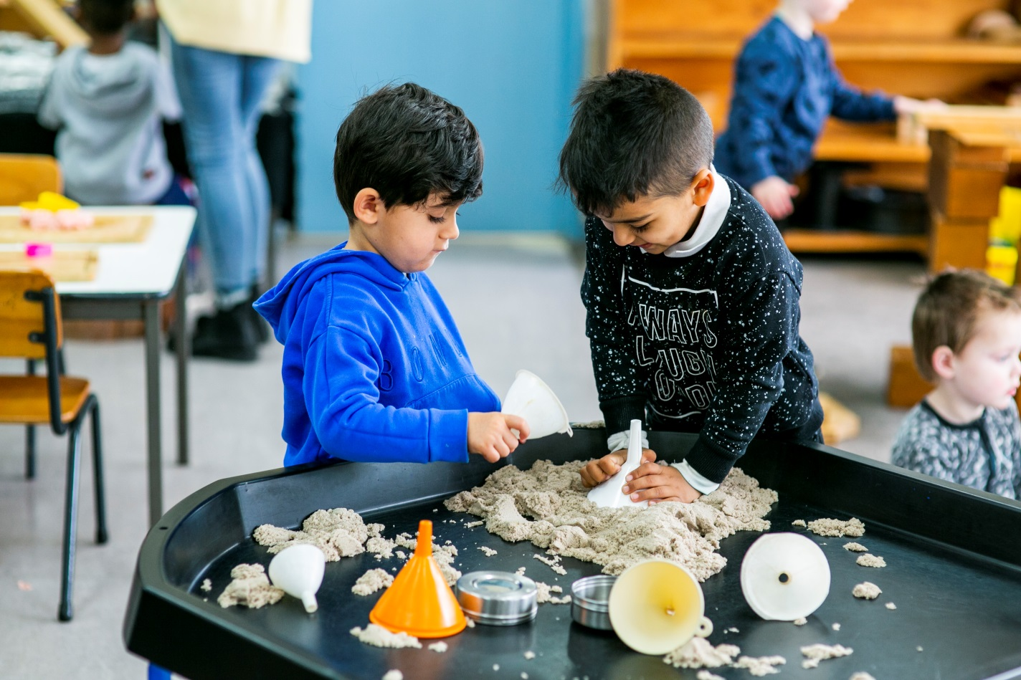

Centre Timetable

Hoppers Crossing Children’s Centre
Room | Monday | Tuesday | Wednesday | Thursday  Occasional Care | Friday  Occasional Care
Room1 | 9.30am – 1.30pm | 9.30am – 1.30pm |  | 3 Options | 3 Options
 | Pre-Kindergarten | Pre-Kindergarten | N/A | 9am – 11.30am  11.30am –2pm  9am – 2pm | 9am – 11.30am  11.30am –2pm  9am – 2pm
 |  |  |  | 3 Options  9am – 11.30am  11.30am –2pm  9am – 2pm | 3 Options  9am – 11.30am 11:30am –2pm  9am – 2pm
Room2 | 9.00am – 2.00pm | 9.00am – 12.00pm | 9.00am – 2.00pm
 | Pre-Kindergarten | Pre-Kindergarten | Pre-Kindergarten

What is Occasional Care

Occasional Care is a unique service that supports families by providing quality care for children from birth to school age. The flexible hours allow parents the opportunity to introduce their children to care by enrolling them for short periods of time. The weekly and four weekly booking systems allow many local families to utilise the service when they require care. Please note that as Occasional Care is a casual care service, care for any one child cannot be guaranteed every week.

Care will only commence once the child has participated in two orientation sessions. At the time of initial contact parents/carers are offered various times to orientate with their child/ren at the centre during session times. It is important and a requirement of our centre that orientation is completed prior to booking children into care. This allows time for the children to be introduced to the setting, staff and children at the centre while still having their parent/career with them. During this time the staff in the room will explain singing in/out procedures and inform Families of the daily operation of the room.

There are many reasons why families use Occasional Care, which can include:
- Providing Respite care for parents;
- Preparation and transition to Kindergarten;
- Assisting children in overcoming feelings of distress when experiencing separation anxiety; (Occasional Child Care is often the child’s first experience in separating from parents)
- Providing opportunities for children to socialise with other children;
- Stimulating children to develop to their fullest potential;
- Giving an opportunity for parents/carers to attend appointments;
- Allowing parents to study or gain casual/part-time work.;
- Allowing parents to seek employment.

Enrolment

Enrolment Form

It is a legislative requirement under the Children’s Services Regulations 2009 that an enrolment form is completed before your child starts care with us. It is important to make sure you complete all sections.

If any information changes, it is your responsibility to notify the Children’s Centre immediately. A Child cannot attend the Children’s Centre until the child’s parents or guardian signs and authorisation for staff to seek emergency, hospital, medical or ambulance services.

Parents should ensure that the educators have current information regarding custody issues and arrangements, changes of address and telephone numbers. If there is an emergency it is vital that you or your nominated emergency person can be contacted.

Birth Certificate

When enrolling your child into the Children’s Centre, you will be asked to provide their birth certificate. This is to ensure appropriate staff ratios are maintained according to the age of children being cared for.

Immunisation History Statement (ACIR)

An Immunisation History Statement from the Australian Childhood Immunisation Register must be produced prior to your child commencing care with us, showing immunisations are up to date. This is a condition of being able to commence in any of our groups.

Evidence of a catch-up program can be produced in cases where children are late with immunisations.

Photography

Please refer to the enrolment form for details relating to photography at the Children’s Centre. Photographs may be used to assist with programming, port folios and for promotional purposes. Written parent permission signed on enrolment form is required before any photographs can be taken and used for promotional purposes.

Privacy

The Centre’s Privacy policy describes procedures and practices for how personal information is handled. A Privacy statement is attached to your enrolment form for you to detach and retain for your information. Please refer to our enrolment policy and privacy policy available at the Children’s Centre.

Children’s Program

National Quality Framework

The National Quality Framework took effect on 1st January 2012 with key requirements being phased in overtime. Requirements such as qualifications, educator-to-child ratios and other key staffing arrangement will be phased in between 2012 and 2020.

The guiding principles of the National Quality Framework are:
- The rights and best interests of the child are paramount;
- Children are successful, competent and capable learners;
- Equity, inclusion and diversity underpin the framework;
- Australia’s Aboriginal and Torres Strait Islander cultures are valued;
- The role of parents and families is respected and supported; and
- Best practice is expected in the provision of education and care services.

The objectives of the National Quality Framework are:
- To ensure the safety, health and wellbeing of children attending educational and care
- services;
- To improve the educational and developmental outcomes for children attending educational and care services;
- To promote continuous improvement in the provision of quality educational and care services;
- To establish a system of national integration and shared responsibility between participating jurisdictions and the Commonwealth in the administration of the National Quality Framework;
- To improve public knowledge and access to information about the quality of educational and care services;
- To reduce the regulatory and administrative burden for education and care services by enabling information to be shared between participating jurisdictions and the Commonwealth.

Educational Program

The children learn and develop from the Educational Program that is planned, implemented and evaluated by the qualified Early Childhood Educator with the help of the qualified Co-workers.

The program is developed incorporating the Victorian Early Years Learning Frameworks (VEYLF).
This fosters children’s development and learning by planning within the Belonging, Being and Becoming, which fosters the 5 Learning Outcomes of the VEYLF
- IDENTITY – Children have a strong sense of identity;
- COMMUNITY – Children are connected with and contribute to their world;
- WELLBEING – Children have a strong sense of wellbeing;
- LEARNING – Children are confident and involved learners;
- COMMUNICATION – Children are effective communicators.

Staff also plan for individual children, taking observations, setting objectives, implementing the activity for the child and evaluate the child’s progress towards the objective. During group times the children listen to stories, sing along to songs, play group games, speak in front of a group, join in picture discussions, dance, role play, play with the instruments and a number of other stimulating and educational experiences.

Children thrive as learners in play based environments which foster their imagination and creativity. We pride ourselves in providing a high quality children’s program. Programs provided at the centre include:
- Planned and spontaneous experiences in small groups.
- Cosy, secure spaces to play alone or share with others.
- Experiences based on children’s needs and interests.
- Opportunity for repetition, choice and time.
- Inclusive experiences reflecting diversity of gender, culture, language and ability.
- Appealing, unstructured and safe outdoor natural environments.
- Access to sensory play experiences.
- Respectful communication.
- A strong, collaborative partnership with families.
- Programs reflective of the Early Years Learning Framework.

Settling Children into the Centre

The staff help settle children into care by encouraging parents and children to visit the centre prior to enrolment (this provides the families and their children with the opportunity to become familiar with the environment and the carers). Staff will observe how comfortable and confident the child is about separating. Children are settled into the centre at their own pace.

If children are unsettled staff will help them overcome any anxiety by reassuring the child that their parent will return. They will try distracting the child by trying to interest them in becoming involved in various play experiences. There are other strategies that staff are trained in to help children overcome separation anxiety. Parents are welcome and encouraged to ask staff for information regarding their child in these instances.

If the staff feels that your child is not settling, the staff will contact you to make arrangements to meet your child’s needs.

Guiding Behaviour

Guiding children’s behaviour can be challenging for both families and Early Childhood Educators (ECE). For children, learning to take control of their own emotions and responses, and understanding how their behaviour impacts on others is a lifelong process. It is important that families and ECE work together to support children to develop these skills.

We acknowledge that many factors can influence behaviour and base our understandings of children’s behaviour on:
- Individual levels of development.
- The child’s cultural and family practices.
- The physical environment.
- The child’s health and wellbeing.
- Knowing the individual child through developed staff/child relationships.

By implementing a ‘Guidance’ approach which is in line with the centre’s policies, we ensure that the children’s self-worth and wellbeing are always being looked after to create positive outcomes. A guidance approach to children’s behaviour is a 2 way learning process that involves both the child and the adult. It is not something that adults ‘do’ to children.

- The behaviour guidance approach recognises that a child displaying inappropriate or inconsiderate behaviour at times is ‘normal’.
- The guidance approach emphasises that the motivation for behaving considerately comes from within the child.
- The guidance approach is always empowering and respectful of children.

By working together and recognising that challenging behaviour is a normal part of each child’s development, families and ECE’s play and important role in supporting children to develop their social skills in ways that are responsive to individual children’s strengths and interests.

Reference- Dent, M. (2006). Nurturing Kids’ hearts and souls: Building emotional, social and spiritual competency. Pennington Publications.

Life Events

Families are encouraged to share any events that a child may be experiencing at home to staff members. Awareness of a situation can help the staff to deal with any changes or issues that the child may have.

Celebrations

We acknowledge the diversity of festivals and celebrations enjoyed by families and the community. Please inform staff at enrolment of any celebrations that have meaning for your family. They could be:
- Community or centre celebrations.
- Celebrations of children’s learning.
- Traditional celebrations.
- Celebrations significant to children and families.
Families may wish to celebrate their child’s birthday with the rest of the group. You are most welcome to come and share this day with your child. Families who do not celebrate birthdays or other celebrations are encouraged to notify staff at enrolment. If you wish to provide food for the children during these times, please inform staff. It is of the utmost importance that any food brought into the centre is discussed with staff due to children’s allergies, as well as individual cultural and/or family requirements. Please note that while all celebrations are welcomed into the centre, staff respects the children’s decisions as to their level of participation in celebrations.

Children’s Care and Comfort

Parent communication

Staff value open communication with parents. It is important that parent share information about their child with staff including:
- Interests and preferences.
- Favourite security items.
- Fears.
- Special routines.
- Special dietary requirements.
- Allergies (even if not severe).

Toys from home

Staff understand that children enjoy bringing in favourite toys from home. While at Pre‐Kinder children are encouraged to play with all equipment in positive ways. Parents can assist to maintain a calm and equitable play environment by limiting the amount of toys and the frequency with which their child brings them. At times, conflict can be caused by toys which have been brought from home. However, if your child is distressed and a toy will assist him/her to settle and provide comfort we will support this. At times staff may be able to incorporate favourite items into the program to encourage the children’s interest.

Alternative items which could be brought into Pre‐Kinder are:
- Nature items
- Postcards, posters, photos
- Brochures, catalogues and tickets

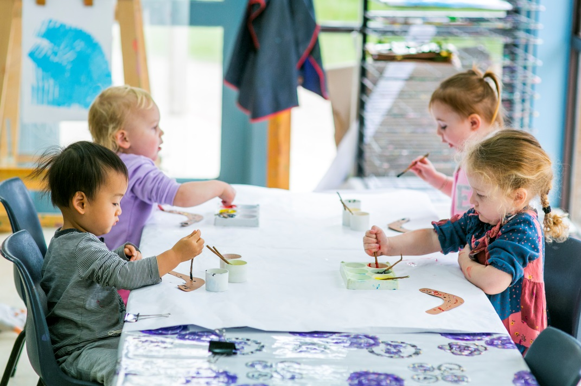
Please note that staff cannot accept responsibility for toys or items brought from home.

Clothing and Footwear

Please supply a complete change of clothing to leave in your child’s bag (including underwear and socks). Extra clothes allow staff to change your child in case of toileting accidents or if your child becomes wet or dirty during play, e.g. during water play or while playing in a damp sandpit. When staff can change your child into clean, dry clothes, the comfort of your child can be ensured. In winter please provide a warm coat and hat for your child. In summer please provide a wide brimmed sun hat and dress your child for sun protection, including application of sunscreen. Children need sturdy, safe and in‐closed footwear to allow freedom of movement for active play, e.g. climbing. Please do not send your child to Pre‐Kinder in thongs or ‘croc’ style slip on shoes. Children can have great difficulty climbing and running in these and they can be a tripping hazard.

Items to be brought with your Child

The following items need to be brought with children when attending the centre:
- A healthy snack/lunch in a named lunch box/container;
- A water bottle (juice or soft drink is not recommended due to the high sugar content);
- 2 complete changes of clothes including, shoes & socks (more sets are required if your child is toilet training – see below);
- Wide brim or legionnaire hat all year round;
- Coat and warm hat in cold weather;
- Sunscreen (if there is a preferred brand or if the child has an allergy or sensitivity to certain brands) to be applied before session by parent;
- No thongs or clogs are to be worn by the children (For safety reasons);
- Adequate supply of nappies (1 per hour in care) and baby wipes (if required);
- Occasional Care Only: Adequate number of prepared labelled bottles of formula or milk (if required). These need to be stored in the fridge and not in the children’s bag. All bottles need to have labelled caps fitted.

All items need to be clearly labelled with child’s name.

Please consider clothing to assist a child to gain independence in toileting and with dressing themselves. Overalls, long dresses, thongs, big boots, belts or suspenders are not recommended. Clothing should be suitable for messy play as this is often provided at the Centre. Please be mindful that clothes your child wear to the centre may get quite dirty during normal play.

Children with Additional Needs

Staff at the centre are happy to discuss additional care requirements that any child may have.

Children and Families from Culturally and Linguistically Diverse Backgrounds

The Centre has access to cultural services to assist as necessary. The diversity of cultures represented in the Centre are reflected in the programs.

The parents are encouraged to share information and assist staff in this area.

Children’s Centre Staff

Qualifications

Wyndham City Council employs staff with a variety of appropriate Early Childhood qualifications and experience that meets the Children’s Services Act 1996 and Children’s Services Regulations 2009. All staff hold current Working With Children Checks. Staff use their professional knowledge in combination with an understanding of each child’s skill and development to provide a rich learning environment.

Staff: child ratios

Ratios are maintained in accordance with the Children’s Services Act 1996 and the Children’s Services Regulations 2009.

Relief staff (Emergency/Casual)

At times regular staff may be absent for a variety of reasons such as illness, professional development or personal circumstances. Relief staff are engaged at these times and Wyndham City Council endeavours to employ familiar staff whenever possible.

Students/Volunteers

Wyndham City supports the education and training of students/volunteers in the Early Childhood Profession.

Students and volunteers are considered to be observers and are encourage to implement the Centre’s programs, under the supervision of centre staff. Students are not included in the child staff ratios and are never left responsible for the group.

Parent Partnerships

Partnerships with parents go beyond parent involvement. It is a relationship of mutual respect and trust between staff and families that promote the children’s wellbeing.

Parents are invited and encouraged to be involved in the Program.

Parents or family members are welcome to demonstrate a special skill for the children, i.e.: clay modelling, gardening, cooking, dancing, bathing baby, playing an instrument, painting or even just to read a story or to teach the children a new song.

Parents or family members that may work as Police officers, Nurses, Doctors, Ambulance officers, Teachers, Chefs are also encouraged to be involved at group time to talk about their occupation to the children.

Communication

Parents are encouraged to connect with the Children’s Centre and staff in many ways:
- Sharing family information.
- Discussing their child’s routine and needs.
- Providing feedback about the children’s program.
- Communicating with staff on a regular basis.
- Adding their ideas to children’s portfolios or similar documentation

Information will be provided to families on a regular basis. This will be done through notes, notice boards and face to face communication with the educators.

Parents are asked to read the notice board and program plans displayed at the centre in order to keep informed of the activities at the program. Families wishing to discuss matters of a more confidential nature are encouraged to make an appointment with the staff.

Collection of Household Items/Scrap Material for the Centre

Don’t throw it away – ask us if we want it first!

We can use:
- Strawberry tubs
- Lids of bottles
- Small cardboard boxes from shopping
- Foil, glad wrap and paper towel rolls
- Material off cuts;
- Any type of cut off you may get from factories or businesses, such as paper, cardboard, plastic, material, buttons, sample bench top cards etc.

For health reasons we cannot accept the following;
- Toilet rolls
- Egg cartons
- Laundry product packaging
- Soap packaging
- Cigarette packaging
- Medicine packaging
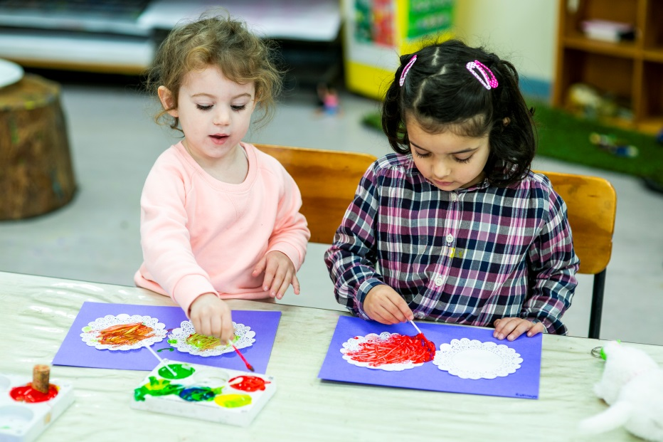

Appointments with Staff

Your questions are important, however, parents are requested to have very brief conversations with staff at the start or conclusion of a session or on the telephone during session times.

Staff are required to supervise the children at all times. The children may be at risk if staff are talking to parents when required to supervise. Parents should make an appointment to meet staff after the session or in staff program planning time.

Making appointments with staff also ensures staff and parents talk in private, ensuring confidentiality.

Compliments and Complaints

Should you have any concerns about your child or the Children’s Centre, please contact staff to discuss these issues on: Hoppers Crossing Children’s Centre

You may also wish to discuss your concerns with the Early Years Coordinator who can be contacted on 9742 8121 during business hours.

For concerns about health, safety or welfare of any children at the Centre, you may contact a Children’s Services Advisor from the Department of Education & Early Childhood Development on (03) 8397 0247.

We value receiving your feedback, both positive and negative. If you wish to provide feedback, please talk to the Children’s Centre staff or the Early Years Coordinator.

Arrival and Departure

Signing In and Out

The attendance record is a legal document and provides an essential record of children present at the Children’s Centre. It is a requirement of the Children’s Services Regulations 2009 that all children are signed in and out of the service by the person who delivers or collects the child. This person must sign in and out on arrival and departure. Only nominees on the children’s enrolment details will be approved to collect and drop off the child.

The daily attendance record is used by staff to:
- Conduct regular checks of children’s attendances throughout the day.
- Maintain correct staff and child ratios.
- Support evacuation of all in attendance in the event of an emergency.

Arrival

For children’s safety, please ensure that you securely close all gates and entrance doors as you come in. To maintain easy access please keep the main entrance/doorway clear.

Arrival is an important transition time for children. Parents can support their child by talking about the day before arriving and focusing on their child’s interests and abilities. We encourage parents to take advantage of arrival transition time by sharing details about the previous night/days with staff. This information will assist staff to meet your child’s individual interests and needs.

The staff in the room should be made aware of any medication your child may need to have administered. A medication consent form must be completed at arrival. Occasional Care Only: Details concerning the child are to be written on the whiteboard, name, age, departure time and any relevant comments. This allows the teacher to see relevant information at a glance.

Lengthy goodbyes should be avoided as they can be distressing to both child and parent. Parents are welcome to stay with their child but once a goodbye is said it is best if the parent leaves, even if the child is upset. Sneaking out should also be avoided as this affects the trust that the child has with the parent. Experience has shown that children do not stay upset for long. Staff will be there for your child, if they require support with settling.

Departure

Children can only be collected by parents/guardians or by persons authorised on the enrolment form. If another person is collecting your child, you must provide written authorisation. Whenever someone other than the regular person is collecting your child, please inform staff, and where possible, inform your child. If the person collecting your child is unfamiliar to staff, this person will need to provide a photo ID, such as a driver’s licence.

The authorised person collecting your child must be 18 years of age or older. Please discuss your family circumstances with staff as needed.

Parents under the influence of drugs or alcohol

Staff have a duty of care to the children. If a person arrives to collect your child and is under the influence of drugs or alcohol, staff will contact another authorised person to collect your child. Please be aware that late collection fees will apply in this instance.

Custody and contact

If custody and contact orders are applicable to your child, a copy must be provided to the Children’s Centre at the time of enrolment. Any changes to these orders must be provided to the Children’s Centre as soon as possible. Staff will always abide by the custody and contact orders provided to them. Unless a custody and contact order applies, both parents are deemed to be authorised to collect their child.

Late collection of children

It is the responsibility of parents/guardians to collect their child on time. Children can become distressed when they are collected late. Late collection of children may impact on staff and child ratios and on staff commitments. Parents must notify the Children’s Centre as soon as possible, if for any reason they are unable to collect their child on time. In these situations, parents must endeavour to contact other authorised persons to collect their child on their behalf. Children must be collected on time or a late collection fee may be incurred. The centre does have a policy on late collection of children, which includes a late fee. These fees are incurred from the time of conclusion of your child’s session.

Children not collected

In circumstances where a child is not collected, the following procedures apply:
- Staff will attempt to contact the parent/guardians, and continue to do so at regular intervals. If parents/guardians are unavailable, staff will attempt to contact authorised persons listed on the child’s enrolment form.
- Wyndham City will be notified to decide on further action. Depending on the circumstances,
- Child Protection Services may be notified to collect the child.

Cancellations to Occasional Care Sessions

If a child cannot attend a booked occasional child care session, the centre requires a minimum of 24 hours’ notice from the commencement time of the cancellation.

An answering machine is provided which notes the day and time of the call. This enables families to call at any time of the day or night to notify of cancellations.

If the 24 hours’ notice from commencement time is not received an absent fee of your full rate for the booking made will be charged.
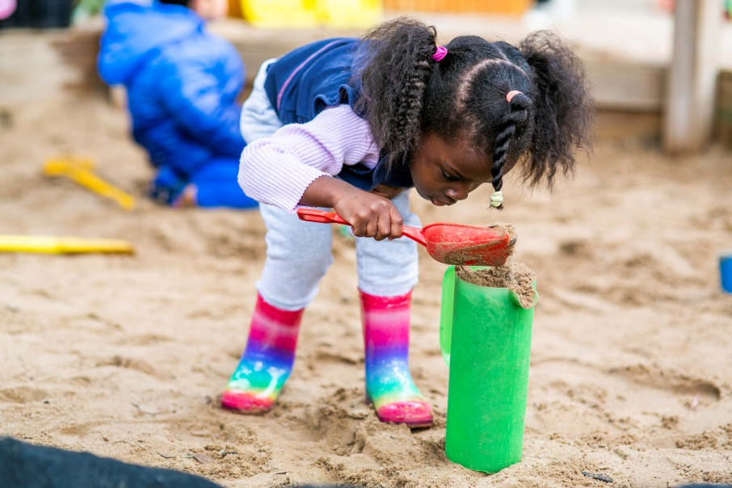

Health

Medication

If your child requires medication while at the Children’s Centre you must accurately inform staff of the administration requirements and give permission by completing a Medication Form. This form requires:
- Child’s name.
- Name of medication.
- Dosage required.
- Time/s when dosage to be administered.
- Date and time of last dosage.
- Authorisation of instructions by parent/guardian signature.

Clear instructions must be provided regarding administration requirements. Please note that staff will only administer medication from its original container, bearing the original label with the child’s name, instructions, and the expiry date.
- Only medication prescribed by a medical practitioner for that child will be administered.
- All medication requires parent/guardian authorisation including prescribed eye drops, asthma pumps, nappy rash creams, etc.
- No medication will be administered unless prior written authorisation has been given.

Medication must not be left in children’s bags or within reach of children. Please ensure medications are handed to a staff member when entering the room at the start of each session. Staff can then ensure medication is safely and appropriately stored.

Illness and Infectious Diseases

Wyndham City is committed to providing a safe and healthy environment for children, staff and families. Staff follow legislated procedures to promote children’s health and minimise the spread of infection. Please keep your child at home if he/she is unwell. We require that children with the following symptoms or illness must be kept at home until they are completely well:
- High temperature* (38c or Above).
- Vomiting*.
- Diarrhoea*.
- Unidentified rashes or skin irritations.
- Red, swollen or discharge from eyes, e.g. Conjunctivitis.
- Heavy nasal discharge.
- Are unusually tired, lethargic, have a loss of appetite and are not drinking.

- Note: Children can only return to the centre once they have been free from the symptoms for 24 hours.

If your child becomes ill while at the Children’s Centre, or develops any of these symptoms, staff will contact you to collect your child. Staff will closely monitor your child in the meantime and will complete the details of your child’s illness in the Illness Record. You will be required to read and sign this record when you collect your child.

Under health regulations, children with a diagnosed infectious illness must not attend the Children’s Centre. Please refer to appendix 1‐ School Exclusion Table. This table lists applicable infectious diseases and exclusion times. Please contact your medical practitioner for further advice.

Please inform staff as soon as possible if your child is diagnosed with an infectious illness. Staff are required to alert all families at the Children’s Centre in this instance. Confidentiality will be respected at all times.

Immunisation

As of 1 January 2016, all children attending Hoppers Crossing Children’s Centre are required to be fully immunised and provide the centre with an up to date Immunisation History Statement before they can commence (No Jab, No Play legislation). Please refer to appendix 2 – Victorian National Immunisation Program.

In the event of an outbreak of an infectious disease, a child or staff member who has not been immunised in accordance with the national immunisation schedule will be excluded from the Children’s Centre for the recommended period of exclusion (please refer to enrolment form for further details).

Chronic Conditions and Allergies

Please inform the Children’s Centre staff of your child’s chronic conditions or allergies. Staff will outline the centre’s procedures for safe and effective management of chronic conditions. Ongoing communication between parents and staff is critical to ensure the health of all children. If your child has been diagnosed with a chronic condition or allergy, you may be required to complete one or more of the following:
- Action Plan for Allergic Reactions.
- Care plan/s for Eczema.
- Asthma Action Plan.
- Action Plan/s for Anaphylaxis (see below for further details on Anaphylaxis procedures).
- Action Plan for Epilepsy.
- A Risk Minimisation Plan.

Anaphylaxis

Anaphylaxis is a severe allergic reaction which can be life threatening. If your child has been diagnosed as an anaphylactic you must complete an Action Plan for Anaphylaxis. This plan must be signed by your child’s medical practitioner.

If your child has an EpiPen it must be available at the Children’s Centre at any time your child is in attendance.
To maintain a safe environment, we encourage all families to be ‘allergy aware’. Please contact staff before bringing food, drink or recycled materials into the Children’s Centre. Please do not bring in egg cartons.
Some children may have allergies to food that is potentially life threatening. In some cases, particular foods may be excluded as a service to provide a safe environment.

Asthma

Asthma is a chronic condition which can be life threatening. If your child has been diagnosed as an asthmatic, you must complete an Asthma Action Plan. This must be signed by your child’s medical practitioner and given to staff at the Children’s Centre when your child commences Pre‐Kinder. If your child has prescribed asthma medication it must be available at the Children’s Centre at all times your child is in attendance. Please ensure medication is handed to a staff member for safe and appropriate storage at the beginning of each session.

Accidents and Injuries

Hoppers Crossing Children’s Centre aim to provide a safe environment for all children, parents and staff. All staff hold current first aid qualifications which includes CPR and Anaphylaxis training. In

the event of a child sustaining an injury that requires medical attention, the service is required to notify the Department of Education and Early Childhood Development (DEECD) in accordance with the Children’s Services Regulations 2009.

At the time of enrolment, parents are required to sign an authority for staff to seek emergency, medical or ambulance assistance if necessary.

It is essential that if staff provide you with an Accident Form and you read and sign the Accident/Injury Record in the event of an accident or injury. Please inform staff as soon as practicable if your child’s condition changes after an accident occurs, or if any further medical advice was sought for them after the accident/injury.

Minor Accidents

If your child is involved in a minor accident, e.g. tripping over, staff will comfort your child, assess their condition and monitor their wellbeing.

Staff will record the details of the accident in the Accident and Injury Book and discuss the incident with you at pick up time. It is essential that if staff provide you with an Accident Form and you read and sign the Accident/Injury Record in the event of an accident or injury. Please inform staff as soon as practicable if your child’s condition changes after an accident occurs, or if any further medical advice was sought for them after the accident/injury.

If your child is involved in a more serious accident, e.g. bumping their head, staff will comfort your child, asses their condition, administer first aid as required and monitor their wellbeing.

Staff will contact you by phone to inform you of the accident. You may be required to collect your child and seek medical advice.

Medical Emergencies

The wellbeing of your child is our priority.

If your child is involved in a medical emergency staff will administer first aid as required, call emergency services and contact you. Staff will be directed by paramedics and if possible a staff member will accompany your child in the ambulance. We will endeavour to keep you informed of all actions until you are with you child. (Please note that all associated costs will be parent’s responsibility).

Food Restrictions
Please note that the Hoppers Crossing Children’s Centre is a nut and egg free centre. This includes all nuts, peanut butter, Nutella or any other products containing nuts and any whole egg products such as hard boiled eggs, quiche or egg sandwiches. In the event that a child in the centre has severe allergies to other foods, the product in question will be excluded from the centre for the duration of care provided to the child.

Sun Protection

The Hoppers Crossing Children’s Centre are committed to protecting all children and staff from skin damage caused by harmful UV sun rays.

Between 1st September and 30th April (Term 1 and Term 4) children and staff are required to:
  - Wear broad brimmed sun hat outdoors.
  - Apply SPF 30+ sunscreen prior to outdoor play and reapply sunscreen regularly.
  - Utilise shaded areas where possible
  - Wear appropriate clothing for sun protection, e.g. which covers shoulders.
  - We also recommend children and staff wear appropriate sunglasses when outdoors.

Nutrition and Dental Care

The Hoppers Crossing Children’s Centre complies with federally legislated standards and the state government’s food safety requirement.

Our staff promotes good nutrition and healthy bodies by:
- Encouraging parents to provide healthy meals and snacks.
- Ensuring drinking water is accessible to all children throughout the day.
- Providing a calm and flexible approach to serving and consuming food and drink.
- Role modelling healthy eating and drinking.

The Hoppers Crossing Children’s Centre staff foster good dental health and hygiene. Children are encouraged to:
- Drink water throughout the session.
- Eat healthy meals and snacks.
- Become involved in discussions and experiences that develop an understanding of good oral health, such as cooking, growing vegetables, etc.

We seek the assistance of parents to support and promote our healthy eating policy. Parents can do this by ensuring only healthy food is provided for snack at Pre‐Kinder. This could include sandwiches, fruit, vegetables, crackers, cheese, yoghurt, etc. Please do not send food such as chips, chocolate, cake, lollies, biscuits, etc.

Wyndham City’s Smoking Policy

All Wyndham City services are non‐smoking environments. Please refrain from smoking in the premises, which includes the entrance, foyer, hallways, garden areas, the building, storage sheds, outdoor play areas and toilets.

Safety

Building and Playground safety

The staff conduct daily safety inspections of the building and playground. Any hazards are removed or made inaccessible to children and reported to management for further action.

Emergency Procedures and Equipment

Fire extinguishers and First Aid kits are located within the service and are regularly maintained. Emergency evacuation procedures are clearly displayed.

Children’s Centre staff are required to regularly practice emergency evacuation procedures with the children. During these practice drills, children do not leave the licensed premises.

In the event of an emergency evacuation, the procedures outlined in the displayed information will be followed. Parents will be notified as soon as practicable to collect their child.

Child Protection

The Hoppers Crossing Children’s Centre follow child protection legislation, policies and procedures. In accordance with the Children, Youth and Young Person Act 2005 (section 1820) all Children’s Centre staff are mandated to report to Child Protection Services when, in the course of their professional duty, they form a belief that a child is in need of protection.

Visitor’s Book

For the security of children, parents and staff, all visitors must sign in and out in the visitor’s book when visiting the centre.

Visitors include any maintenance personnel, Wyndham City employees, government representatives, specialists, and parents assisting for the day, etc.

The visitor’s book provides a record of visitors on the premises in the event of an emergency evacuation.

Centre Closure & Public Holidays

The Hoppers Crossing Children’s Centre follow the Victorian School term dates each year. The centres are also closed for all gazetted Public Holidays.

Each year, all staff participate in the Kindergarten Conference held by Wyndham City Council. There will be no session on this date.

Fees

Accounts

Parents will be provided with fee information at enrolment, along with details of the fee paying procedure. Fees are charged termly, which is inclusive of Public Holidays and any days your child does not attend. Invoices will be issued at the end for the following term. For children starting mid-term a pro-rata fee will apply.

These invoices are required to be paid prior to the commencement of the school term. Failure to pay the term fees may result in the cancellation of your child’s spot.

The children’s centre is a cash free centre. Fees can be paid using EFTPOS, credit cards or over the phone payments only.

Child Care Subsidy (CCS)

The Hoppers Crossing Children’s Centre is an Australian Government approved child care facility. This allows us to receive the child care subsidy payment directly to reduce your fees.

Childcare Subsidy is a payment made by the Commonwealth Government to assist with the cost of childcare. To apply for Childcare Subsidy please contact your local Department of Human Services (DHS) on 136150 to register for childcare. Please note that you are unable to receive CCS without having first applied through the DHS.

When you have registered through the DHS for childcare, please provide this centre with your customer reference number and your child’s customer reference to receive CCS. It is important that parents sign and confirm the attendance register to enable families to claim their Childcare Subsidy entitlements for the day of attendance. If the register is not signed by the parent, the DHS can decline Childcare benefit component payment and full fees would apply.

Allowable Absences

In regards to the Pre‐Kindergarten sessions, the centre receives unlimited absences as long as care is pre‐booked and paid for. If care is not pre‐booked and paid for, the gap fee or full amount (in the case of families not receiving CCS paid to the service) will be charged. This also applies to occasional care bookings which are cancelled without giving 24 hours’ notice.

Cessation of care

Cessation of Care is a Government legislation that states CCS cannot be claimed for children before their first physical day of care, or after their last physical day of care.

For example, if a child was to start on a Monday, however did not attend the centre until Wednesday, the Monday cannot attract CCS.

Families who wish to cancel their child’s place from their allocated session will be required to give 2 weeks’ notice to the centre.
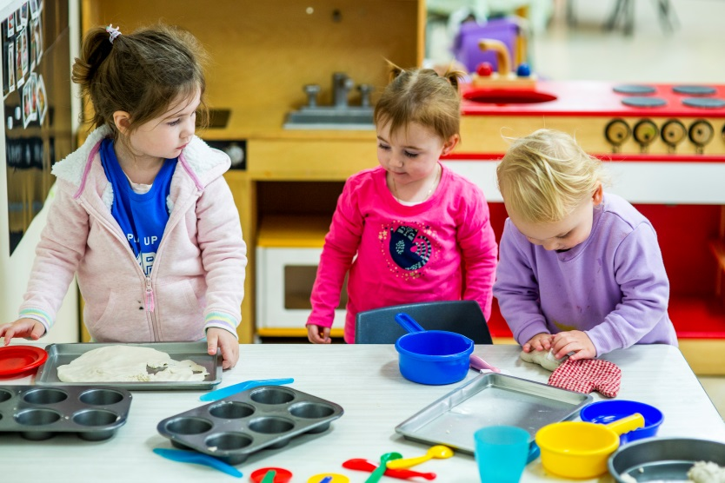

Appendix

Appendix 1 – School Exclusion Table

Schedule 7 Minimum Period of Exclusion from Primary Schools and Children’s Services Centres for Infectious Diseases Cases and Contacts (Public Health and Wellbeing Regulations 2009)
In this Schedule, medical certificate means a certificate of a registered medical practitioner.

Condition | Exclusion of Cases | Exclusion of Contacts
Amoebiasis | Exclude until there had not been a | Not excluded.
(Entamoeba | loose bowel motion for 24 hours.
Histolytica)
Campylobacter | Exclude until there had not been a | Not excluded.
 | loose bowel motion for 24 hours.
Chickenpox | Exclude until all blisters have dried. | Any child with an immune deficiency (for example
 | This is usually at least 5 days after the | leukaemia) or receiving
 | rash appears in unimmunised children, | chemotherapy should be excluded for their own
 | but may be less in previously immunised children. | protection. Otherwise not excluded.
Conjunctivitis | Exclude until discharge from eyes has | Not excluded.
 | ceased.
Diarrhoea | Exclude until there had not been a | Not excluded.
 | loose bowel motion for 24 hours.
Diphtheria | Exclude until medical certificate of | Exclude family/household contacts until cleared
 | recovery is received following at least | to return by the Secretary.
 | two negative throat swabs, the first
 | not less than 24 hours after finishing a
 | course of antibiotics and the other 48
 | hours later.
Hand, Foot and | Exclude until all blisters have dried. | Not excluded.
Mouth disease.
Haemophilus | Exclude until at least 4 days of | Not excluded.
influenza type b | appropriate antibiotic treatment has
(Hib) | been completed.
Hepatitis A | Exclude until a medical certificate or | Not excluded.
 | recovery is received, but not before 7
 | days of the onset of jaundice or illness.
Hepatitis B | Exclusion is not necessary. | Not excluded.
Herpes (“cold | Young children unable to comply with | Not excluded
sores”) | good hygiene practices should be
 | excluded while the lesion is weeping.
 | Lesions to be covered by dressing,
 | where possible.

Human Immuno‐ | Exclusion is not necessary. | Not excluded.
deficiency Virus
Infection
(HIV/AIDS)
Impetigo | Exclude until appropriate treatment | Not excluded.
 | has commenced. Sores on exposed
 | surfaces must be covered with a
 | watertight dressing.
Influenza and | Exclude until well. | Not excluded unless considered necessary by the Secretary.
Influenza like
illnesses
Leprosy | Exclude until well. | Not excluded.
Measles* | Exclude for at least 4 days after onset | Immunised contacts not excluded.
 | of rash. | Unimmunised contacts should be excluded until 14 days after
 |  | the first day of appearance of rash
 |  | in the last case. If unimmunised,
 |  | contacts are vaccinated within 72 hours of their first contact with
 |  | the first case, or received NHIG
 |  | within 144 hours of exposure,
 |  | they may return to the facility.
Meningitis | Exclude until well. | Not excluded.
(bacteria – other
than
meningococcal
meningitis)
Meningicoccal | Exclude until adequate carrier | Not excluded if receiving carrier eradication
Infection* | eradication therapy has been completed. | therapy.
Mumps* | Exclude for 9 days or until swelling | Not excluded.
 | goes down (whichever is sooner).
Pertussis* | Exclude the child for 21 days after the | Contacts aged less than 7 years in the same room as the case who
(whooping cough) | onset of cough or until they have | have not received three effected
 | completed 5 days of a course of | doses of pertussis vaccine should be excluded for 14 days after
 | antibiotic treatment. | the last exposure to the infectious
 |  | case, or until they have taken 5
 |  | days of a course of antibiotic treatment.
Poliomyelitis* | Exclude for at least 14 days from | Not excluded.
 | onset. Re‐admit after receiving
 | medical certificate of recovery.

Ringworm, | Exclude until the day after appropriate | Not excluded.
scabies, | treatment has commenced.
pediculosis (head
lice)
Rubella (german | Exclude until fully recovered or for at | Not excluded.
measles) | least four days after the onset of the
 | rash.
Salmonella, | Exclude until there has not been a | Not excluded.
Shigella | loose bowel motion for 24 hours.
Severe Acute | Exclude until medical certificate of | Not excluded unless considered necessary by
Respiratory | recovery is produced. | the Secretary.
Syndrome (SARS)
Streptococcal | Exclude until the child has received | Not excluded.
Infection | antibiotic treatment for at least 24
(including scarlet | hours and the child feels well.
fever)
Tuberculosis | Exclude until receipt of a medical | Not excluded.
 | certificate from the treating physician
 | stating that the child is not considered
 | to be infectious.
Typhoid fever | Exclude until approval to return has | Not excluded unless considered necessary by
(including | been given by the Secretary. | the Secretary.
paratyphoid fever)
Verotoxin | Exclude if required by the Secretary | Not excluded.
 | and only for the period specified by
 | the Secretary.
Worms | Exclude until there has not been a | Not excluded.
(Intestinal) | loose bowel motion for 24 hours.

The Public Health and Wellbeing Regulations 2009 are available from the Victorian Legislation and Parliamentary Documents website maintained by the Department of Premier and Cabinet. Other vaccines listed on the National Immunisation Program can be found on the Victorian Government’s Immunisation schedule Victoria1

1 http://health.vic.gov.au/immunisation/factsheets/schedule-victoria.htm

Age | Disease(s) protected against | Vaccine brand name
2, 4 and 6 months | Diphtheria, Tetanus, Pertussis (whooping cough), Polio, Haemophilus Influenza B, Hepatitis B  Pneumococcal Rotavirus | Infanrix Hexa Prevenar 13 Rotateq
12 months | Measles, Mumps, Rubella  Haemophilus Influenza B, Meningococcal C | Priorix/MMRII Menitorix
18 months | Varicella (chicken pox), Measles, Mumps, Rubella | Priorix Tetra
4 years | Diphtheria, Tetanus, Pertussis (whooping cough), Polio Measles, Mumps, Rubella (until 2015) | Infanrix IPV  Priorix/MMRII (until 2015)
Year 7 Secondary School Program | Varicella (Chicken Pox) Human Papillomavirus (HPV) | Varilrix Gardasil
Year 10 Secondary School Program | Diphtheria, Tetanus, Pertussis (whooping cough) | Boostrix

