The Buzz at Saltwater Community Centre

Term 3, 2019

Contact Details:
For the Community Centre
153 Saltwater Promenade, Point Cook, VIC 3030
Phone 8376 5504
Email saltwatercc@wyndham.vic.gov.au
For the Kindergarten, Phone 9742 8147
For Maternal & Child Health Services, call 9742 8148

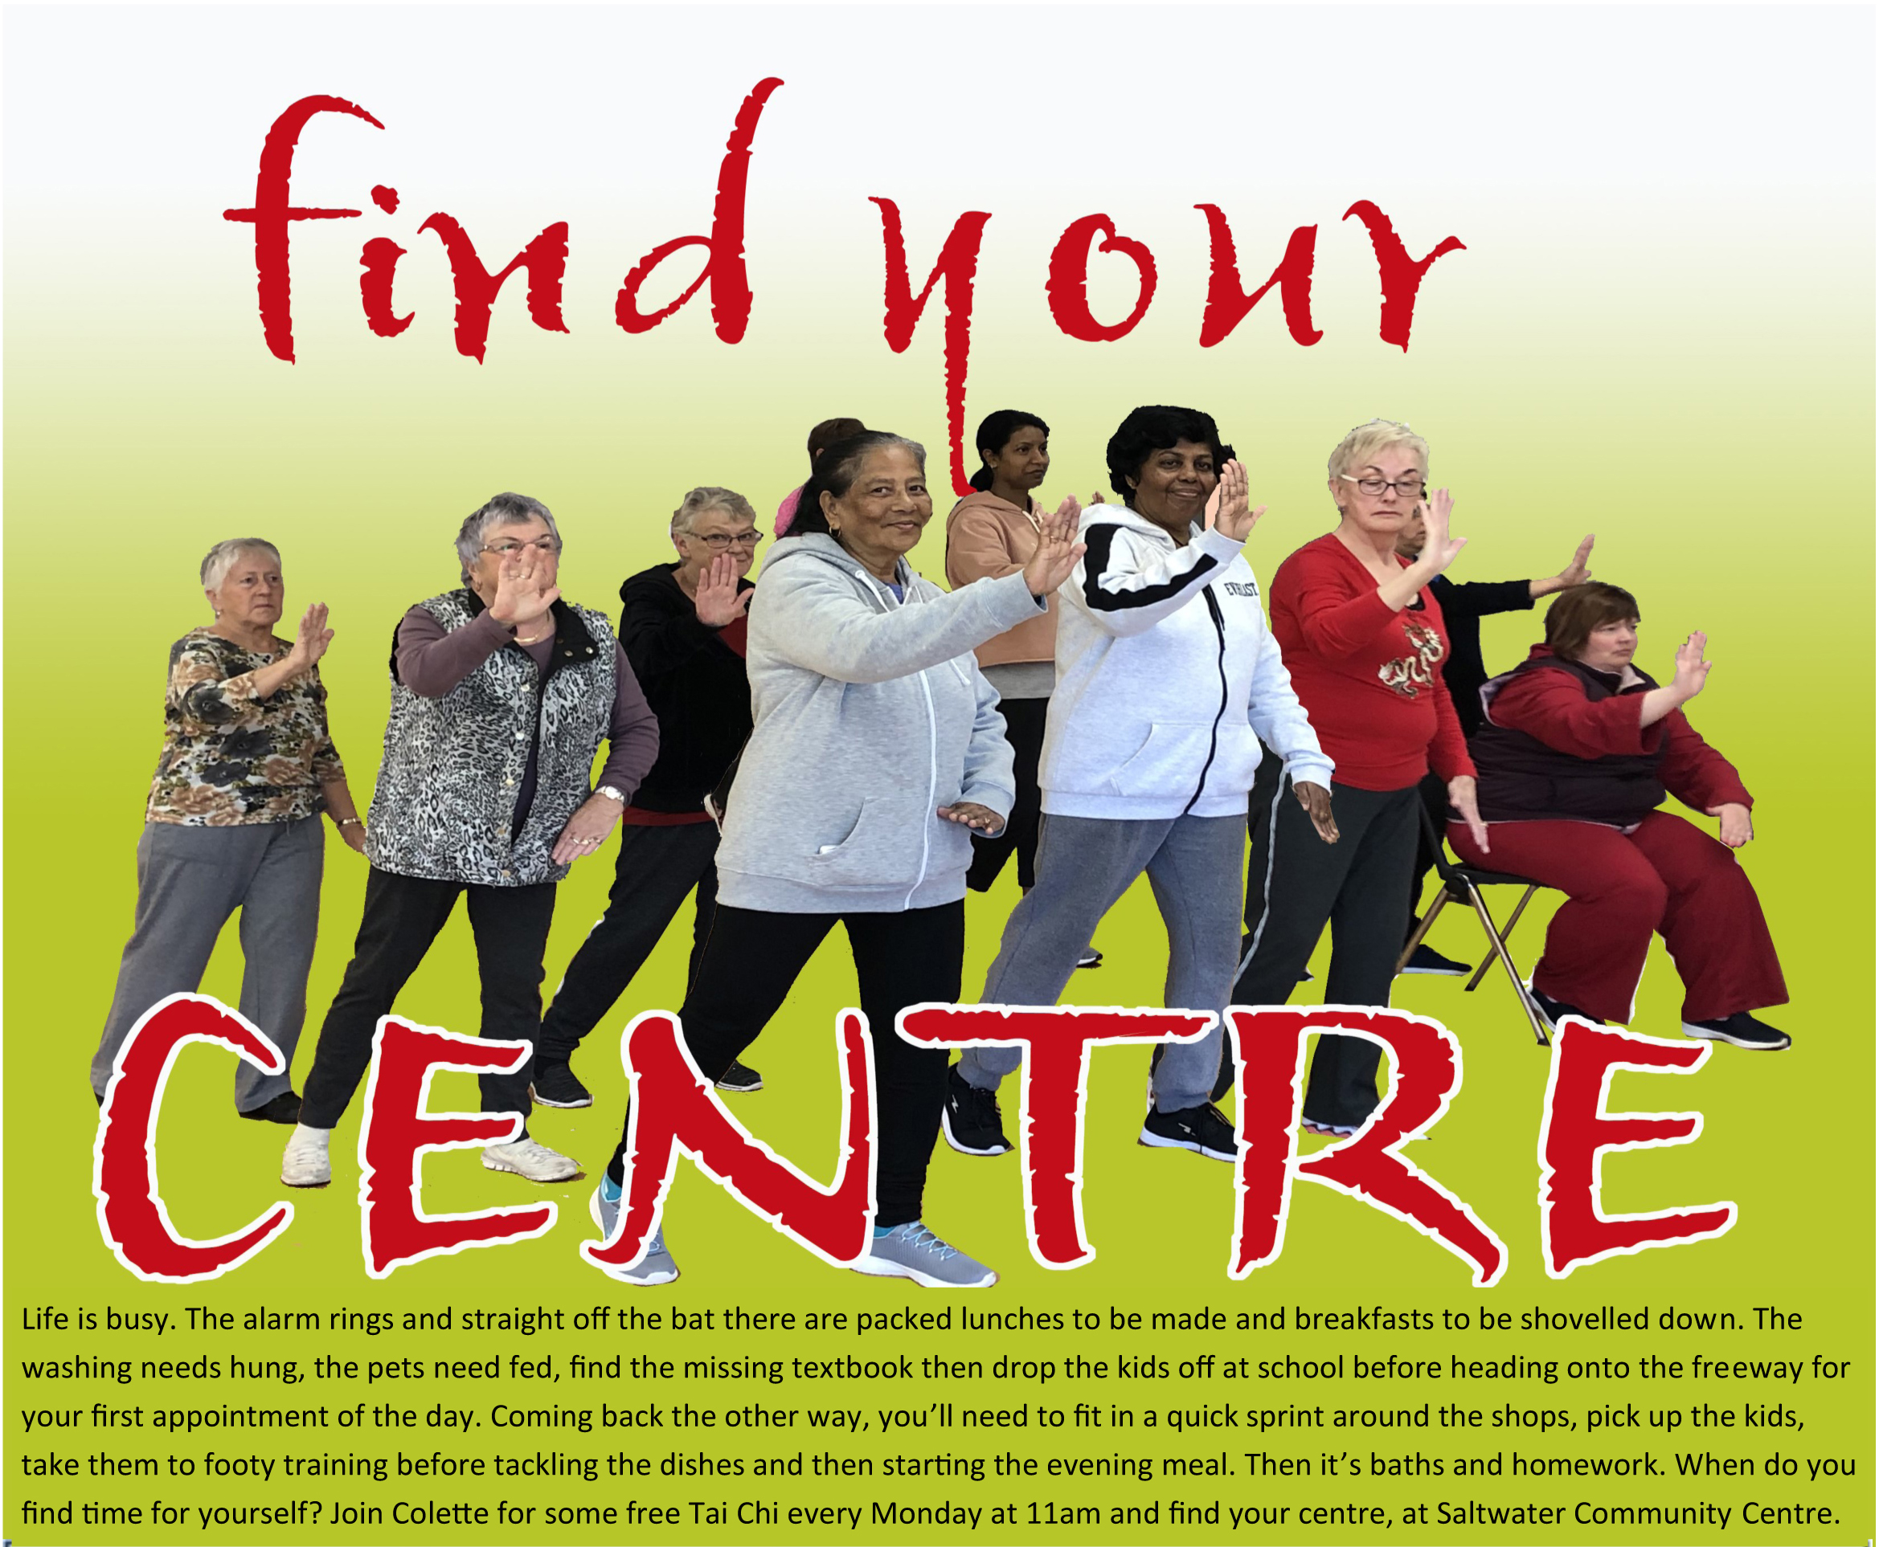Section 1: Programs and Activities

EARLY YEARS AND KIDS | DAY AND TIME | CONTACT |  | COST
First Time Parents Group  Meet friendly local parents, talk about your kids and have fun! Share experiences, get advice, give support and make new friends. | Monday  1:30pm-3:30pm | Contact: Maternal and Child Health  9742 8148  www.wyndham.vic.gov.au select ‘Maternal & Child Health Services |  | No cost
Maternal & Child Health Services  Professional nursing support and advice for parents with children from birth to school age. | By appointment only | Contact: Maternal and Child Health  9742 8148 wwww.wyndham.vic.gov.au
Immunisations  Free childhood immunisations.  No appointment required | Tuesdays  1pm-2pm  6 August  3 September  8 October | Contact: Environmental Health Department 9742 0736  www.wyndham.vic.gov.au/Immunisation
Kindergarten  Wyndham City Council Kindergarten Services for 4 year olds. | Weekly sessions | Contact : Kindergarten Services  9742 8172 |  | Fees apply
Pre-School Songs & Story  Enjoy a fun way to develop early literacy skills in young children aged 1-4 with song, stories, puppets, body movement and more. | Fridays  Session 1  9:30am-10am  Session 2  10:15am-10:45am | Contact: Saltwater Community Centre  8376 5500 saltwatercc@wyndham.vic.gov.au  Bookings essential |  | Fees apply
Saltwater Multicultural Playgroup  From newborn to pre schoolers they all have different needs and eagerness' to learn. Come and meet other families from local community. | Thursdays  10am-11:30am |  |  | $40 per Term
Saltwater Chinese Playgroup  A fun and supportive place for mum’s, female carers and pre-schoolers to enjoy crafts, stories, play and freindships. | Wednesdays  9:30am-11am | Contact : Jieling  0423 439 626 / jielingli.dne@hotmail.com  $40 per Term  Bookings essential |  | $40 per Term
Ummi & I Muslims Playgrou  For mums, dads, grandparents and carers with kids aged 0-5years. Come and enjoy rhyme time, story time and activities with other families. | Wednesdays  11am-1pm | Contact: Khushi  0425 844 513  Bookings essential |  | $40 per Term
South African Playgroup / Suid Afrikaanse Speelgroep  Anybody is welcome to come and enjoy in our fun activitis.  Almal is welkom om te kom deel in ons pret aktiwiteite. | Tuesdays  9:30am-11am | Contact : Bianca  0413 079 117  southafricanplaygroup@gmail.com |  | $50  per family
Tiny Tutus  Tiny Tutus is the perfect place for your ballerina to dance, with classes for baby ballerinas as young as 16 months and for princesses up to 5 years of age! Beautiful early childhood ballet lessons, taught by our quality Tiny Tutus trained specialist teachers with Mums and Dads more than welcome to stay and watch! | Fridays  9.15am-11:30am | Contact : 1300 245 060  www.tinytutus.com.au  $50 yearly registration fee which includes your ballerinas gorgeous class tutu |  | Fees apply
Hey Dee Ho  Educational music program for children 6 months to 5years. Parent and child classes, have no more than 12 children. Creating a fun filled interactive 45 minutes musical play date! We have puppets, instruments and so much more. | Wednesdays  10:10am-10:55am | Contact : Melissa Smile  0457 301 878 heydeehomusicwyn@gmail.com  www.heydeehomusic.com.au |  | Fees apply  Free trial Class
Unite Dance Studio  AtDance Studio, we providethe highest quality dance tuition to our students, in a safe, positive and supportive learning environment. We're for community, and strive to unite people by making dance accessible for all to enjoy! We offerin Jazz, Ballet, Hip Hop, Tap, Contemporary, Lyrical and more. | Tuesdays  Primary Ballet  4pm - 4:45pm  Primary Tap  4:45pm- 5:15pm  Youth Hip Hop  5:15pm - 6pm  Junior Jazz + Tap  6pm- 6:45pm  Junior Ballet  6:45pm- 7:30pm  Adult Tap  7:30pm- 8:30pm  Wednesdays  Pre School Ballet  4pm- 4:30pm  Pre School Jazz/Hip Hop 4:30pm - 5pm  Primary Hip Hop  5pm - 5:45pm  Junior Hip Hop  5:45pm - 6:30pm  Junior Contemporary  6:30pm - 7:15pm  Open Contemporary  7:30pm - 8:30pm  For more information Contact : Rachel 0419375797 unite.dance@outlook.com |  |  | Fees apply
Kangatraining  A fun, safe, multi award-winning postnatal workout incorporating babywearing, cardio and dance. An amazing way to meet Mums & Bubs in your community. | Mondays  9:45am—10:45am |  | Contact : Belinda  belinda.j@kangatraining.com.au | First session $5 (includes carrier hire if needed) Term fees apply thereafter
School Panda Kids Latin & Ballroom Dance  Latin and ballroom squad training for children aged 5-16 years to help children to build their confidence physical wellbeing, elegance and resilience. | Saturdays  4pm -5:30pm |  | Contact : Crystal  0415 705 258  schoolpanda@outlook.com | Fees apply
Shiamak Davar Bollywood Dance Classes  Bollywood, Jazz Contemporary & Hip Hop dance for kids, teens and adults. | Mondays  5:30pm - 9:30pm  Fridays  5:30pm - 9:30pm |  | Contact : Darshan/Vihang  0499 888 115  www.melbourne@shiamak.com | Fees apply
Point Cook Dance  Point Cook Dance classes are serious fun. They love dance, drama and singing and want everyone from the age of 3 through to teenagers to experience the thrill that dance can bring. | Saturdays  10-11am - Grade 3 Ballet  11-11:45am - Grade 3 Tap  11:45am -2:30pm Level 2 Combo (Jazz, Ballet & Tap) |  | Contact : Mandy Croker  0416 679 911  info@pointcookdance.com.au | Fees apply
Global Art  Art and Craft classes for kids 4yo and above transforming the way children learn art through its award-winning international art program. Our courses are designed to be a one-stop shop to develop Drawing, Painting, Colouring, Composition and Craft making abilities. | Thursdays  4pm-5:30pm |  | Contact : Edmund  0432513344  Edmund@globalartaustralia.com.au | Fees apply

EDUCATION & TRAINING | DAY & TIME | INFORMATION | COST
Abacus Training Centre by Sempoasip  Improves children’s focus and brain concentration by developing both the left and right of the brain. | Mondays  4-5.30pm  Wednesdays  4.30-6pm | Contact : Munita  0433 551 979  www.facebook.com/sempoaSIPAustralia | Fees apply
TeKids  Jedi Junior Robotics class for kids from  grade 1 to grade 5. Teach kids to build robots and how to do coding. | Saturdays  10:15am-11am  11:30am—12:15pm  1pm-1:45pm  2pm-2:45pm | Contact : Parth Verma  0435 023 078  tekidsaustralia@gmail.com | Fees apply
Targeted English for Advancement  English lessons by Veronica Stark (BA, Dip Ed, IB Dip, Reg teacher).NAPLAN and general improvement.SELP/Scholarship Examination preparations | Mondays  6-7pm  7:15-8:15pm | Contact : Veronica Stark  0422 951 708  veronica.stark@hotmail.com | Fees Apply
English Conversation  Come along and enjoy learning basic English in a friendly environment. This is a free program for non-English speaking adults. | Tuesdays  1-2:30pm | Contact: Saltwater Community Centre  8376 5500 saltwatercc@wyndham.vic.gov.au  Bookings essential | No cost
Computer Skills— Introduction to Excel  This 10 week program is designed to teach students Introduction to Excel and further creating worksheets and charts etc. | Thursdays  12:30pm-3:30pm  18 Jul—19 Sep | Contact: Saltwater Community Centre  8376 5500 saltwatercc@wyndham.vic.gov.au  Bookings essential  Or  enquiries@wyndhamcec.org.au | $40/$25 concession
Introduction to MYOB  Practical hands on course designed to teach computerised accounted package MYOB  - Creating a new data file Creating the Chart of accountsEntering Sales and PurchasesMaking and receiving paymentsBank reconciliationCreating inventory Creating Card FilesPayroll ModuleBusiness Activity Statement (BAS)Backing up and restoring files | Thursdays  9:15am-12:15pm  18 Jul—19 Sep |  | $40/$25 concession  $65 for study book &DVD

FAITH, CULTURAL & COMMUNITY GROUPS | DAY & TIME | INFORMATION | COST
Justice of Peace  If you need to get your documents attested, witnessed and certified, please come and see our friendly Justice of Peace—Patricia Hume. | Wednesdays  1-2pm | Contact : Patricia Hume  0416 245 121 | No Cost
Saltwater Seniors Group  Lets get social, make new friends, play some games, have some laughs over a cuppa. Visiting parents, grandparents are welcome. | Wednesdays  11am—1pm | Contact:Saltwatercc@wyndham.vic.gov.au 8376 5500 | No Cost
CWA Point Cook Branch  Our programme is member led and consists of speakers, demonstrations and fun-raising events. We support many charities mostly in our own area. We offer friendship and support to women in our community. | Thursdays  7pm Monthly  (3rd Thurs of very month) | Contact : Rosmary Renden  0477 777 836  Rosemary.redden@icloud.com | Membership may apply
Wyndham Happy Life Association  The Wyndham Chinese Happy Life Association is a non-profit organisation. It promotes Chinese senior residents and other neighbourhoods mental and physical health in Wyndham City. We have several volunteer teachers and team leaders to teach the community members exercises such as singing, dancing, Tai Chi, square dancing, bowling, cooking, playing table tennis and gardening. | Wednesdays  1 – 3pm  Fridays  12 – 4:30pm | Contact : Yun Yun  0421 899 399  yunyun@live.com.au | Membership  may apply
Christ New Creation Fellowship Church  A non-sectarian, non-denominational, evangelistic and missionary-sending church. We aim to encourage everyone to build a strong relationship with God, and to grow and participate in fulfilling their calling and purpose in the Lord. | Sundays  9-1pm | Contact : Dennis Ferrer  0416850191  dennis.ferrer@hotmail.com.au | No cost
Point Cook Adventist Community Church  Our programs are extensive, including an inter-generational worship service every Saturday afternoon. Further, we run age-appropriate children’s programs, fundraising concerts, free community dinners, and monthly free community support, such as gardening and household chores. We regularly run educational programs on parenting, relationships, health, including depression, as well as prophecy seminars. | Saturdays  3-6:30pm | Contact : Danijela  9395 6399 | No cost
Global Organisation for Divinity Australia  Gopa Kuteeram classes and Satsang for adults in Saltwater community centre on last Sunday of every month. This year we are teaching Ramayanam, Bhagavad Gita and Bhagavatham. Classes are offered on a NO FEE basis to the participating children. All classes are conducted in English. Currently we offer classes for children in the school year group from K – Year 10. | Last Sunday of the month  4-5:30pm | Contact : Vidya  0425 770 971  https://godivinity.us3.list-manage.com/subscribe?u=d0820cc2d1e034d17ecb02063&id=00ae637c12 | Donations are welcome
Australian Malay Foundation  Provide Malay cultural awareness, youth development, social welfare and assistance for families in the community. | Sundays  1—4pm | Contact : Haji Rashid  0468 712 755  muhammadrashid09@yahoo.com | No cost
Mustard Seed Chapel International  Worship and teaching services | Thursdays  6-10pm  Sundays  9am – 12pm | Contact : Sam Poku-Bonsu  0416 881 681 | No cost

SALTWATER ART STUDIO | DAY & TIME | CONTACT |  | COST
Open Studio  Not enough space to paint or create at home? Open Studios is for anyone to come and work on their own projects in a studio environment. | Tuesdays  9am-12pm  Fridays  9am-4:30pm | Contact : 8376 5500 saltwatercc@wyndham.vic.gov.au |  | No cost
Friday Night Life Drawing  Join us every third Friday of the month for Friday Night Life Drawing, with professional models and optional tutoring by local artist Nick Shepherd. Ages Strictly 18+ | Jul 19  Aug 16  Sep 20  7:30-10pm | Nick Shepherd  Saltwaterartstudio@gmail.com  For more info visit www.saltwaterartstudio.net |  | Fees Apply
Abstract Watercolour  Have you ever wanted to play with watercolours? In this three hour class we will explore different watercolour techniques while creating some fun abstract watercolours ready to be framed and hung on your wall. No experience necessary, just bring along your open mind and a passion to try something different. All art supplies will be provided. | Saturday  Aug 10  1:30-4:30pm | Instruction : Lindsey Giroux  inkythumbstudio@gmail.com  For more info visit www.saltwaterartstudio.net
Take it off Auto  Do you own a DSLR camera but have never taken it off Auto? Join Imran Abul Kashem and learn the language of photography as we unpack the 3 fundamental ingredients required to craft a photographic image. |  | Instructor : Imran Kashem  info@westendphotography.com.au  For more info visit www.saltwaterartstudio.net
Date Night Taster  Know your camera : This workshop is intended for the beginners just starting out on their photographic journey. Join Imran Abul Kashem, professional Photographer to unlock the full potential of your camera, let Imran guide you through the camera and customise the camera for your specific shooting style. | Friday  Aug 9  7-9:30pm
Date Night Taster  Professional watercolour artist David Becerra will share basic technical knowledge of water-soluble mediums including gouache, Indian ink, acrylic Ink, ball pen, fountain pen ink. You will have the chance to paint wet on wet, dry on wet and finally dry on dry techniques on different types of Professional Watercolour paper. | Tuesdays  July 5  7-9:30pm | Instructor : David Becerra  davidb323@gmail.com  For more info visit www.saltwaterartstudio.net
SASsy Student DisplayEvery term you will have the chance to see fabulous artworks made by wonderful students of Saltwater Art Studio in our SASsy Student Display. On show in the community centre foyer. | Aug 19 - Sep 12 | For more info please visit www.saltwaterartstudio.net |  | Fees Apply
Ceramics—Handbuilding with Clay  Each week this term there will be a lesson on something different to create from clay, from bead making to sculpture, all without the pottery wheel! Come to one or all! Which will you choose?  Adults class | Tuesdays  7:30 - 9:30pm  Aug 13— Sep 17  Thursdays  11am—1pm  Aug 15—Sep 19 | Carolyn Warren-Langford  claysanctuaryinfo@gmail.com  For more info visit www.saltwaterartstudio.net |  | Fees Apply
Casual Clay  Casual clay sessions are perfect for people to drop in which ever week they like and work independently on their own projects in a studio environment. These sessions are not tutored. Adults class. | Tuesdays  7:30 - 9:30pm  Aug 13— Sep 17  Thursdays  11am—1pm  Aug 15—Sep 19 | Carolyn Warren-Langford  claysanctuaryinfo@gmail.com  For more info visit www.saltwaterartstudio.net |  | Fees Apply
Dynamic Figure Drawing  This course is for those who wish to improve their skills in drawing the human form. Subjects covered include form drawing, anatomy, foreshortening, lighting and tone. Open to all skill levels from complete beginners to advanced artists looking to sharpen their practice. Ages 10years + | Wednesdays  4-6pm  July 24—Sep 11 | Instructor : Nick Shepherd  dabura666au@yahoo.com  For more info visit www.saltwaterartstudio.net |  | Fees Apply
Inky Thumbs Kids Art Class  Get ready to have some fun in this weekly one-hour kids art class. We'll explore a variety of different types and styles of art including painting, ink, printmaking, collage, chalk pastels. Each artwork will be an expression of the artists' personal style and skills. Ages 6-12 years | Tuesdays  4:15-5:15pm  Jul 30-Sep 17 | Instruction : Lindsey Giroux  inkythumbstudio@gmail.com  For more info visit www.saltwaterartstudio.net |  | Fees Apply
Oil Pastels for Kids  Take a step up from pencils to oil pastels. Oil pastels have soft oil based texture and are great for blending and smudging. Students will be taught about layering and balancing tones. Ages 5+ years | Mondays  6:45-7:45pm  June 17-July 15 | Instruction : Madhubani Dhutta  m.dutta4944@gmail.com  For more info visit www.saltwaterartstudio.net |  | Fees Apply
Beginners Wheel Throwing  This course is for beginners to develop skills to create work on the potter's wheel. As there are only 4 students in the class, personal attention will be given to master the wheel throwing technique and pursue your own artistic creation. All skill levels are accommodated and welcome. This is an enjoyable and social class.  Ages 15 + years. | Wednesdays  6:30-9pm  Jul 17– Aug 28  Thursdays  6:30- 9pm  Jul 18-Aug 29  Saturdays  9:30am - 12pm  Jul 20-Aug 31 | Instructor : Nandita Nadkarni  0432 266 229  nandita.nadkarni@gmail.com  For more info visit www.saltwaterartstudio.net |  | Fees Apply
Pencils—Graphite, Watercolour & Coloured  In these relaxed and fun weekly classes learn how to draw from start to finish using a variety of pencil types: including graphite, watercolour and coloured pencils. Creating art helps reduce stress and anxiety, while fostering productivity, creativity, connection and confidence. Adults class | Mondays  Jul 22—Aug 26  7-9pm | Instruction : Michelle Ripari  https://michelleripariart.com  For more info visit www.saltwaterartstudio.net |  | Fees Apply
Watercolour Painting  These watercolour painting classes start from basic sketches with washes, moving through a variety of water-soluble techniques and their correct use and application under the expert guidance of professional artist David Becerra. You can join in on any week until the class is full. Adults class  (Tuesday classes—First class on Wednesday 3 July, followed by classes on Tuesday from July 9 onwards) | Tuesdays  July 9 - Aug 6  7 -9pm  Mondays  Sep 2 - Oct 7  7-9pm | Instructor : David Becerra  davidb323@gmail.com  For more info visit www.saltwaterartstudio.net

Section 2: Adverts for Program and Activities
