Tarneit & Sayers Road
Public Acquisition Overlay
FACT SHEET

What is the Public Acquisition Overlay?

- The Public Acquisition Overlay is a planning control which reserves land for a future public purpose.

- Council is proposing a Public Acquisition Overlay for a future service road along Tarneit and Sayers Road.

- The overlay requires anyone proposing a subdivision, buildings and/or works in that overlay area to obtain a planning permit.

- A planning permit will only be granted if the proposal does not prevent the land from being used or developed for its future public purpose.

Why is a service road required?

- Tarneit and Sayers Roads are main arterial roads which serve an important role in moving traffic in and around Wyndham. In the next 10-15 years, the total number of vehicle movements is expected to almost double to around 30,000 vehicle movements per day for both roads.

- Direct vehicle access for properties onto arterial roads is discouraged in new developments, as it can impact on how safe and efficient the arterial road can operate.

- The service road will improve access arrangements for landowners as well as the operation of Tarneit and Sayers Road, which will be particularly important long term as Wyndham continues to grow.

- An independent traffic assessment has been prepared which recommends a service road as the appropriate road access management strategy.

How many properties are affected?

In total, 121 properties along Sayers and Tarneit Roads form part of the 'Tarneit and Sayers Road Precinct'. Of these, it is proposed 102 will have a service road.
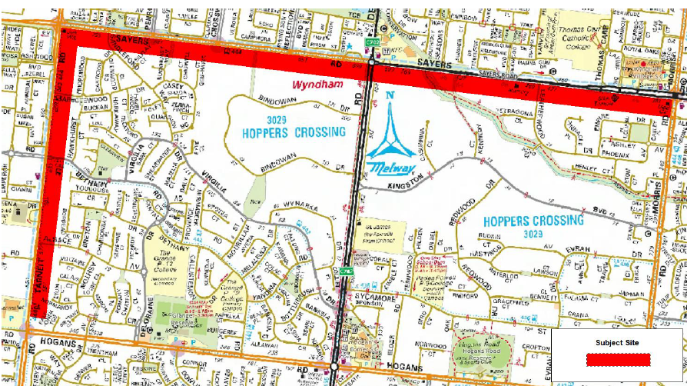

How much land will be required?

The Public Acquisition Overlay will apply to the first 12 metres of land from the street frontage. This land includes the road pavement width of the service road, medians, concrete kerb, the nature strip and underground utilities.

Any new development may be required to be setback an additional 6 metres from the new property boundary, to provide for an amenity/landscaping area (see diagram below)

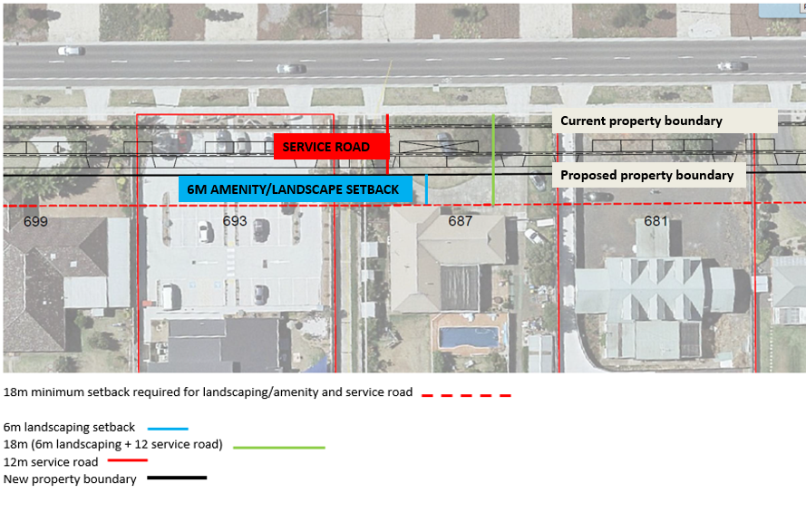

How has Council progressed the Amendment?

- At its February 2017 Ordinary Council Meeting, Council resolved to seek Authorisation from the Minister for Planning to prepare and exhibit Amendment C162. https://councilpapers.wyndham.vic.gov.au/Open/2017/ORD_07022017_MIN_2502_AT_WEB.HTM

- At a meeting held in March 2017, landowners raised concerns about the impacts of the service road on their properties and requested that Council investigate alternative traffic management options.

- Council officers have assessed the impacts of the service road on each property. In particular:

- Direct impact on an existing building;
- Impact of an existing buildings within eighteen metres (i.e. within six metres of the future service road);
- Impact on septic tank in the front yards of properties;
- Impact on car parking associated with a non-residential use or multi-dwelling development.

- At upcoming meetings, Council will be providing landowners and occupiers with information on the progress of the Amendment and its findings.

- Following meetings with residents, Council will submit an Authorisation request to the Minister for Planning. Once this is received, Council will formally exhibit the Amendment.

When will the service road be constructed?

- The construction of the service road may not be required in the immediate future.

- The timing of the service road is dependent on Council’s capital works and budget planning.

Will landowners be compensated?

When Council acquires the land, landowners will be compensated based on an independent assessment of the market value of the land, and other costs affected by the acquisition, in accordance with the Land Acquisition and Compensation Act 1986.

Further Information

- Further information on the Acquisition and Compensation Process is available on the Department of Environment, Land, Water and Planning’s website:

Using Victoria’s Planning System, Chapter 6 – Acquisition and Compensation
https://www.planning.vic.gov.au/guide-home/using-victorias-planning-system

- Alternatively contact Council’s Urban Futures Department on 03 9742 0792 or Kristien.vandenbossch@wyndham.vic.gov.au

