3-YEAR-OLD KINDERGARTEN
REGISTRATION FORM
2020
Register Online
Do you have an email address and easy access to the internet?
An online portal is available for families registering with Wyndham City’s Central Registration System.
To register your child online visit https://kindergarten.wyndham.vic.gov.au
A paper registration form is not required if using the online portal.
The collection and handling of personal information is in accordance with Council’s Privacy Policy which is displayed on Council’s website and available for inspection at, or collection from, Council’s Civic Centre or Community Centres
If you require assistance with this document, the information can be translated by contacting Translating and Interpreting Services on 131 450.  (Ask to be connected to Wyndham City on 9742 0777) |  |  |  |  |  |  |  |  |  |  |  |  |  |  |  | If you have any further questions, please feel free to contact a Community Support and Enrolment Officer on 9742 8147.
OFFICE USE ONLY
Application Number: |  |  |  |  |  | Receipt Number: |  |  |  |  |  |  |  |  |  |  |  |  | Receipt Date:
Will your child be aged three years by 30/04/2020?* |  |  |  |  |  |  |  |  |  |  |  |  |  |  |  |  |  |  |  |  |  |  |  |  | Yes |  | No
* To be eligible to attend a participating kindergarten program, a child must be three years old on or before 30 April in the year that they are to attend the program. However, please be aware, children are not able to commence in a kindergarten place until they are three years of age. Do not complete this form if your child will not be three years of age by this date.
Please note:
Registrations lodged on or after 1 June 2019 will be considered late and therefore processed after all forms received between 1 April and 31 May 2019.

Completion of this registration form does not guarantee a placement in a kindergarten program.
CHILD’S DETAILS
Given Names (as stated on Birth Certificate):
Family Name/Surname:
Date of Birth (dd/mm/yy): Please attach a copy of your child’s birth certificate
Gender: |  |  |  |  |  |  |  |  |  |  |  | Male |  |  |  |  | Female |  |  |  |  | Other
Country of birth:
Cultural Background:
Is your child of Australian Aboriginal or Torres Strait Islander descent? (Please tick one box only) |  |  |  |  |  |  |  |  |  |  |  |  |  |  |  |  |  |  |  |  |  |  |  |  |  |  |  | No
 |  |  |  |  |  |  |  |  |  |  |  |  |  |  |  |  |  |  |  |  |  |  |  | Yes, Australian Aboriginal
 |  |  |  |  |  |  |  |  |  |  |  |  |  |  |  |  |  |  |  |  |  |  |  | Yes, Torres Strait Islander
 |  |  |  |  |  |  |  |  |  |  |  |  |  |  | Yes, both Australian Aboriginal and Torres Strait Islander
PARENT / LEGAL GUARDIAN DETAILS (Please be advised all correspondence will be sent to Parent 1)
This form should be completed and signed by both parents and/or legal guardians of the child unless there is only one parent/guardian.
Parent / Legal Guardian 1
Title: |  |  | Mr |  | Mrs |  |  |  | Ms |  |  |  |  | Miss |  |  |  | Dr |  | Other Please specify:
Given Name:
Family Name / Surname:
Date of Birth (dd/mm/yy):
Gender: | Male |  |  | Female |  |  |  | Other |  |  |  |  | Relationship to child:
Country of Birth:
Language spoken at home: |  |  |  |  |  |  |  |  |  |  |  | Interpreter Required: |  |  |  |  |  |  |  |  | Yes |  |  |  |  | No
Email:
Telephone: Home: |  |  |  |  |  |  | Work: |  |  |  |  |  |  |  |  |  |  |  |  |  | Mobile:
Address: |  |  |  |  |  |  |  |  |  |  |  |  |  |  |  | Suburb: |  |  |  |  |  |  | Postcode:
Postal Address: (If different from above) |  |  |  |  |  |  |  |  |  |  |  |  |  |  |  | Suburb: |  |  |  |  |  |  | Postcode:
Parent / Legal Guardian 2
Title: |  | Mr |  |  |  | Mrs |  |  |  | Ms |  |  | Miss |  |  |  | Dr |  | Other Please specify:
Given Name:
Family Name / Surname:
Date of Birth (dd/mm/yy):
Gender: | Male |  |  | Female |  |  |  | Other |  |  |  |  | Relationship to child:
Country of Birth:
Language spoken at home: |  |  |  |  |  |  |  |  |  |  |  | Interpreter Required: |  |  |  |  |  |  |  |  | Yes |  |  |  |  | No
Email:
Telephone: Home: |  |  |  |  |  |  | Work: |  |  |  |  |  |  |  |  |  |  |  |  |  | Mobile:
Address: |  |  |  |  |  |  |  |  |  |  |  |  |  |  |  | Suburb: |  |  |  |  |  |  | Postcode:
Postal Address: (If different from above) |  |  |  |  |  |  |  |  |  |  |  |  |  |  |  | Suburb: |  |  |  |  |  |  | Postcode:
LIVING, WORKING OR STUDYING IN WYNDHAM
Please tick only one of the following which applies to you:
I/We live in Wyndham (please attach a copy of a rates notice, lease agreement or utilities invoice in your name)
I/We are moving to Wyndham (please attach a copy of the building permit or rates notice in your name)
I/We do not live in Wyndham, but I/we work/study in Wyndham for a minimum of 3 days per week (please attach a copy of your payslip or evidence of your school/university enrolment)
I/We do not live in Wyndham, but my child attends child care in Wyndham for a minimum of 3 days per week (please attach a copy of your child care receipt)
SIBLINGS
Does your child have any siblings who will be attending 3-year-old kindergarten in the same year?  Please Note: A separate form for each child needs to be completed |  |  |  |  |  |  |  |  |  |  |  |  |  |  |  | Yes | No
Older /Younger Sibling |  |  | Twin |  | Triplets | Other. Please specify:
Sibling’s Name: |  |  |  |  |  |  | Age: |  |  |  |  | Gender: Male Female Other
Sibling’s Name: |  |  |  |  |  |  | Age: |  |  |  |  | Gender: Male Female Other
INFORMATION ABOUT YOUR CHILD
Is your child’s immunisation history up to date? |  |  |  |  |  |  |  |  | Yes, 18 months |  |  |  |  |  | No
Please attach the Immunisation History Statement from the Australian Childhood Immunisation Register showing that your child is up to date with their immunisation. For further information and a list of immunisation sessions please visit https://www.wyndham.vic.gov.au/services/childrens-services/immunisations/about-immunisations
Does your child have any of the following medical conditions?
Asthma | Epilepsy | Diabetes |  | Anaphylaxis |  |  |  | Other Please specify: |  |  |  |  |  |  |  |  |  | No
Does your child have a diagnosed disability or disorder?  If Yes, please provide any supporting documentation |  |  |  |  |  |  |  |  |  | Yes |  |  | No |  |  | Awaiting a diagnosis
Does your child have additional needs, supported by a National Disability Insurance Scheme Plan or a referral from a Pre School Field Officer or a Maternal and Child Health Nurse?  If yes, please provide supporting documentation |  |  |  |  |  |  |  |  |  |  |  |  |  |  |  | Yes |  | No
Are there any specialist agencies involved with you or your child?  e.g. Noahs Ark, IPC, Anglicare, Scope, RCH?  If Yes, please provide contact details below and attach any supporting documentation  Agency & Contact Name:  Contact Number: |  |  |  |  |  |  |  |  |  |  | Yes |  |  | No |  | On a waiting list
Is your child currently in an Out of Home Care arrangement, including kinship care? Or are they known to Child Protection?  Out of home care is the term used to describe the placement of children away from their parents, due to concern they they are at risk of significant harm.  If Yes, please provide details: |  |  |  |  |  |  |  |  |  |  |  |  |  |  |  | Yes |  | No
Is the Department of Health & Human Services (DHHS) or a similar support agency involved with your child?  If Yes, please provide contact details below and attach any supporting documentation  Agency & Contact Name:  Contact Number: |  |  |  |  |  |  |  |  |  |  |  |  |  |  |  | Yes |  | No
Are there any court orders, parenting orders or parenting plans in place?  If yes, please attach any supporting documentation. |  |  |  |  |  |  |  |  |  |  |  |  |  |  |  | Yes |  | No
Do you have any concerns about delays in your child’s development?  If yes, please provide details and attach any supporting evidence |  |  |  |  |  |  |  |  |  |  |  |  |  |  |  | Yes |  | No
Does your child live in a single parent / guardian household? |  |  |  |  |  |  |  |  |  |  |  |  |  |  |  | Yes |  | No
Please Note: A Council officer may call you to discuss your child’s medical condition(s) or development need(s) in further detail to assist in your child’s enrolment process.
2020 FEE SCHEDULE
Note: Fees are subject to change in July each year in accordance with Council budget requirements

3-hour group = $335.00 per term / $1,340 per year
5-hour group = $535 per term / $2,140 per year
6-hour group = $635 per term / $2,540 per year

** There are no term fee subsidies available for 3-year-old kindergarten **
HOW TO FILL IN YOUR PREFERENCES
- Please select a maximum of 4 preferences.
- Start with number 1 for your most preferred group.
- Number your preferences in order from 1 to 4 for groups you are willing to accept. If you are not willing to accept the kindergarten group do not select it.
NOTE: PREFS = Preferences. Please number your preferences, do not tick.
2020 3-YEAR-OLD KINDERGARTEN TIMETABLE
HOPPERS CROSSING KINDERGARTENS
KINDERGARTEN | PREFS | GROUP | PLACES | HOURS | MONDAY | TUESDAY | WEDNESDAY | THURSDAY | FRIDAY
Karobran  64 Spring Drive  Hoppers Crossing 3029 |  | Kookaburra | 22 | 3 |  |  | 1:30 – 4:30
Wilmington  7-13 Wilmington Ave  Hoppers Crossing 3029 |  | Bunjil | 22 | 3 |  |  |  |  | 8:30 – 11:30
Yerambooee  55 Maple Crescent  Hoppers Crossing 3029 |  | Cockatoo | 22 | 5 | 9:00 – 2:00
 |  | Bilby | 22 | 5 |  |  | 9:00 – 2:00
WERRIBEE KINDERGARTENS
College Road  34 College Rd  Werribee 3030 |  | Wombat | 22 | 3 |  |  | 9:00 – 12:00
Thomas Chirnside  85-95 Walls Rd  Werribee 3030 |  | Cassowary | 22 | 3 | 9:00 – 12:00
MANOR LAKES KINDERGARTENS
Manor Lakes  86 Manor Lakes Blvd  Manor Lakes 3024 |  | Koala | 22 | 3 |  |  |  |  | 1:30 – 4:30
POINT COOK KINDERGARTENS
Featherbrook  33-35 Windorah Drive  Point Cook 3030 |  | Echidna | 22 | 6 | 2:00 – 5:00 |  | 2:00 – 5:00
Jamieson Way  59 Jamieson Way  Point Cook 3030 |  | Pelican | 22 | 5 |  |  |  |  | 9:00 – 2:00
Saltwater  153 Saltwater Prom  Point Cook 3030 |  | Koala | 22 | 3 |  |  |  |  | 1:30 – 4:30
TARNEIT KINDERGARTENS
Penrose  83 Penrose Promenade  Tarneit 3029 |  | Koala | 22 | 3 |  |  |  |  | 1:30 – 4:30
TRUGANINA KINDERGARTENS
Arndell Park  29-49 Federation Blvc  Truganina 3029 |  | Koala | 22 | 3 |  |  |  |  | 1:30 – 4:30
* The timetable may be subject to change at short notice

ADDITIONAL GROUP
Children can attend multiple groups of three-year-old kindergarten. Additional groups will only offered to children if there is a position vacant at a service and only after other registered children have received an offer, utilising the Kindergarten priority of access criteria. Fees for additional groups are subject to full term fees. Please visit https://www.wyndham.vic.gov.au/services/childrens-services/kindergarten/kindergarten-registration-process to obtain a 2020 3 Year Old Kindergarten Additional Group Form
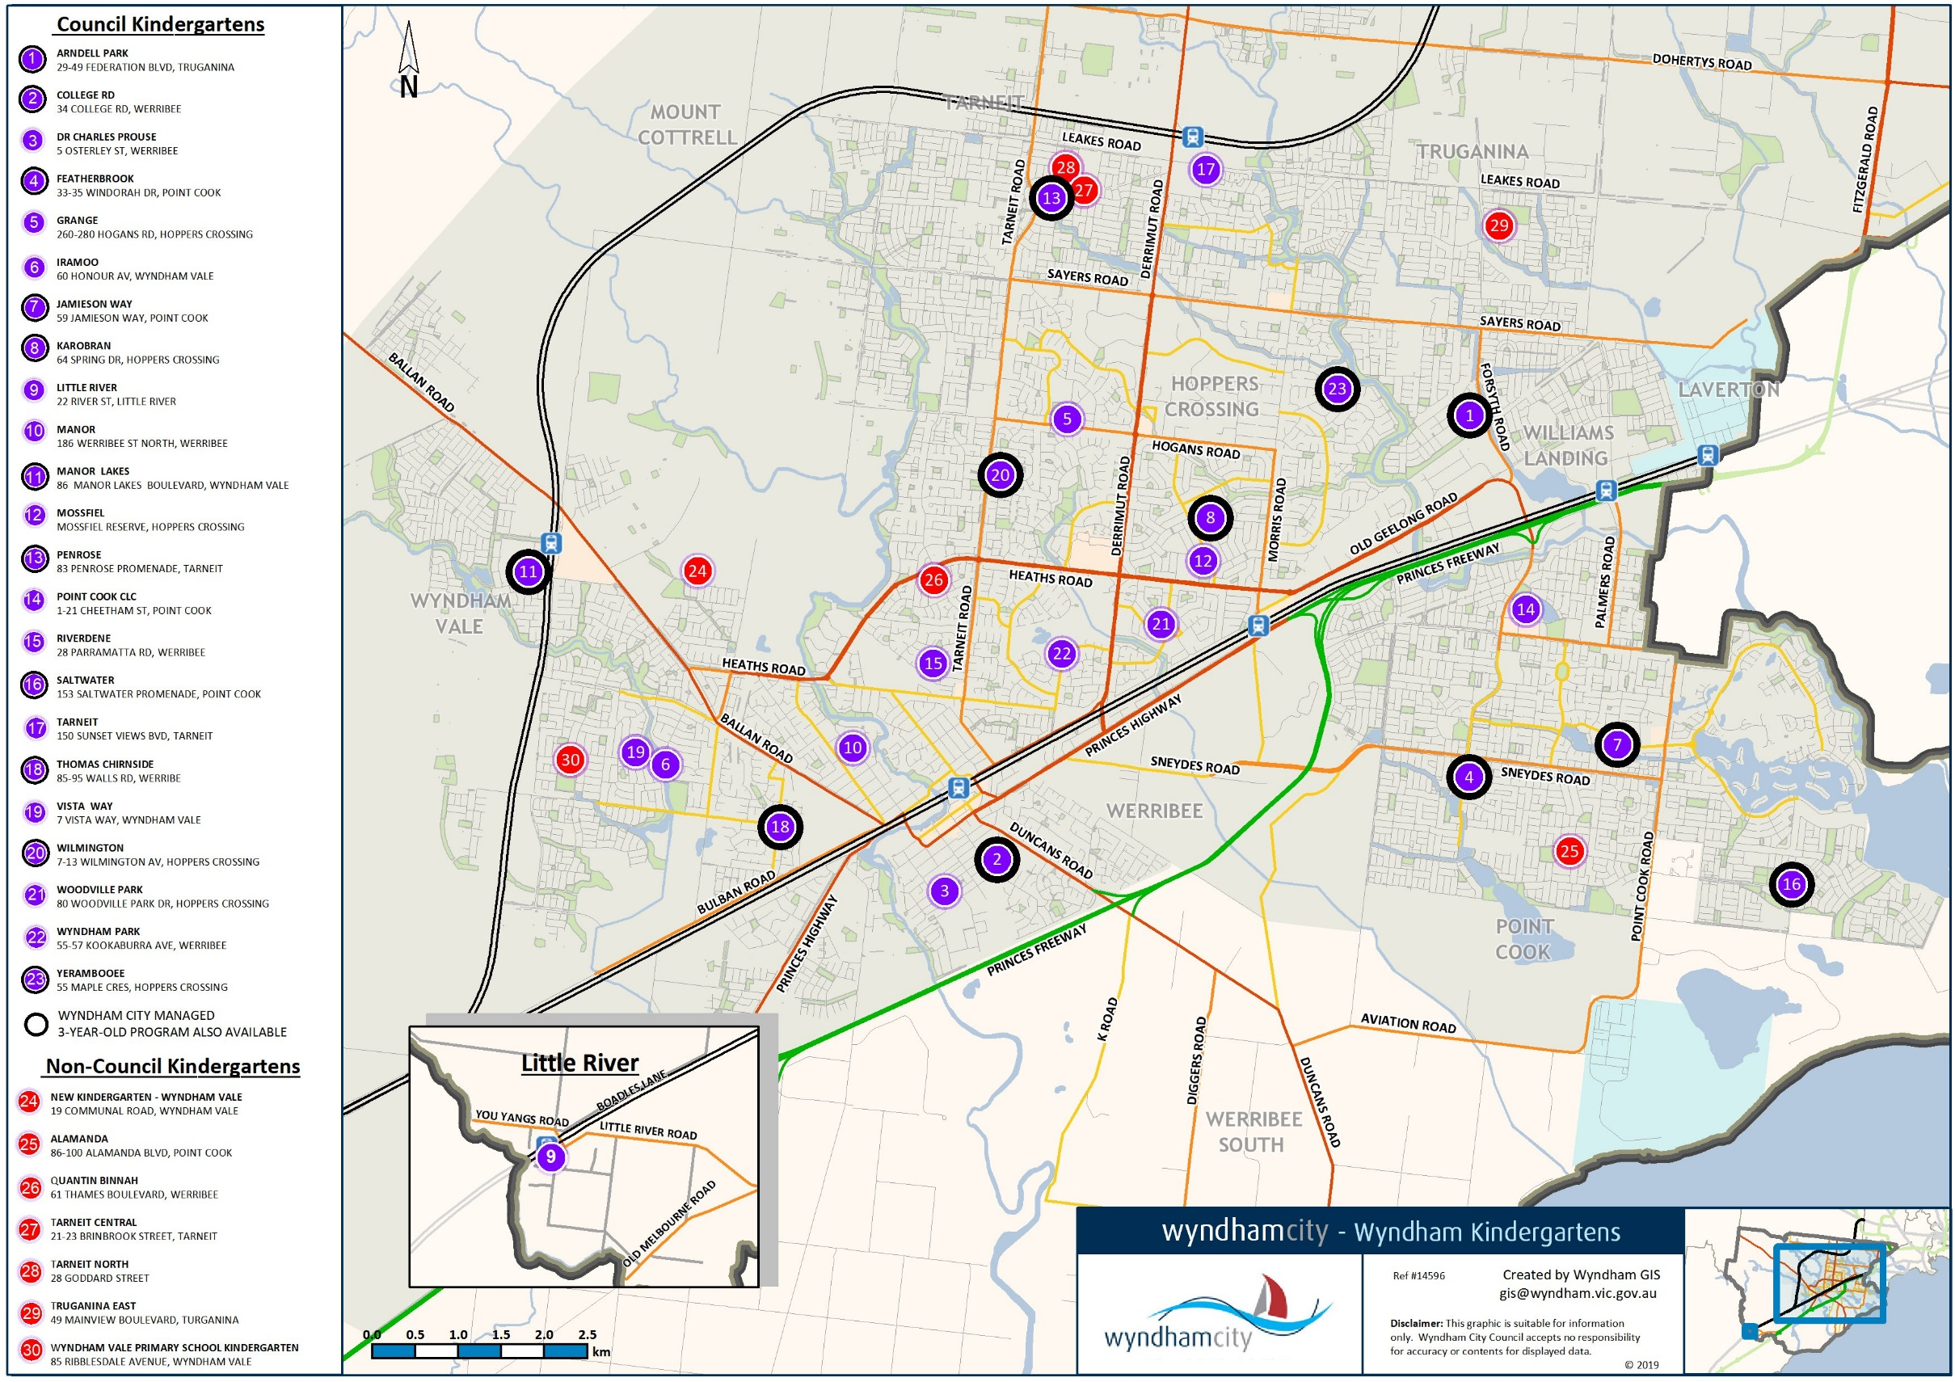

PRIVACY NOTIFICATION
Wyndham City Council is bound by the Privacy and Data Protection Act 2014 and the Health Records Act 2001. Your consent is required for the collection and use of your personal and/or health information and that of your child. The personal and health information requested on this form is being collected by Council for the purpose of planning and delivering proper health and developmental care and education services to your child while obtaining and/or attending Wyndham services (which includes MCH, Kindergarten, PFSO Services). The information will be used by Council and it may be shared with Educators, early intervention, health and welfare service providers for the purposes mentioned. Your information will be stored in Council’s Customer Database and used to identify you when communicating with Council and for Council to deliver services and information to you. The information will only be disclosed to other persons or agencies if consented to by both parents; or the authorised parent/guardian; or as permitted by law. For further information on how your personal and health information will be handled, see Council’s Privacy Policy on its website. Authorised parents and guardians may apply for access and/or amendment of the information. Requests for access and/or amendment of the information should be made in writing to Council’s Privacy Officer.
Please Note: Any documented proof of living, working, studying or using childcare in Wyndham is required to confirm your priority level when allocating Kindergarten places. If a copy is provided to Council, that document will be securely destroyed once sighted.
AUTHORISATIONS
I/We declare that information contained in this enrolment application is true and correct and undertake to immediately inform Early Education and Care Services in the event of any change to the information. I consent to the collection and use of personal and health information on this form as outlined above in the Privacy Notification section.

Parent / Legal Guardian 1 Name:
Signature: | Date: / /
Parent / Legal Guardian 2 Name:
Signature: | Date: / /
HOW TO SUBMIT THIS FORM:
Please sign and return this form with the required documentation and payment via any of the following methods:
- In person at the Civic Centre, 45 Princes Highway, Werribee (cash, cheque, money order, credit card); or
- In person at Manor Lakes Community Centre, 86 Manor Lakes Blvd, Manor Lakes (credit card); or
- In person at Tarneit Community Centre, 150 Sunset Views Blvd, Tarneit (credit card); or
- In person at Point Cook Community Centre, 1-21 Cheetham Street, Point Cook (credit card); or
- By mail to: Wyndham City Council, P.O. Box 197, Werribee 3030 (cheque, money order, credit card); or
- By email to kinderenrolments@wyndham.vic.gov.au (credit card)
 | Contact Us
 | Civic Centre |  | 45 Princes Highway, Werribee, Victoria 3030, Australia |  |  |  |  |  |  |  |  |  |  | Postal Address |  |  | PO Box 197, Werribee, Victoria 3030, Australia
 | Telephone |  | (03) 9742 0777 |  |  | Fax | (03) 9741 6237 |  |  |  |  | TTY | 133 677 |  | TIS | 13 14 50
 | Website |  | www.wyndham.vic.gov.au |  |  |  |  | Email |  | mail@wyndham.vic.gov.au
 | ABN |  | 38 393 903 860

CHECKLIST
If you answer Yes to any of the below, you must provide the supporting documentation in for your registration to be completed and actioned by our Community Support and Enrolment team. Failure to provide the required documents may affect your priority of access criteria.

- Have you provided a proof of date of birth of your child?
One of the following copies required:
- Birth Certificate;
- Passport (This is accepted at the time of registration only – birth certificate will be required at enrolment)
- Travel document

- Have you paid a Non-Refundable Registration Fee of $25 per registration (if applicable)?
Registration fees are waived:
- If the child is eligible for Early Start Kindergarten (ESK)
- If the child, parent or guardian is of Aboriginal or Torres Strait Islander descent
- If the child, parent or guardian has refugee or asylum seeker status
- If the child is in an Out of Home Care arrangement including kindship care or is known to Child Protection
- If the child, parent or guardian has a Commonwealth Health Care/Pension Card/Disability Pension or Visa (A photocopy of the card/visa must be attached)

- Have you provided a copy of your child’s Immunisation History Statement from the Australian Immunisation Register?

- Do you live in Wyndham?
- Provide a copy of Driver’s License/Health Care card/Pension Concession card
- Provide a copy of Rates Notice/Utility Bill i.e. Electricity Bill (within 3 months of issue); or

- Do you work, study or use childcare in Wyndham?
- Provide copy of a payslip/letter from employer;
- Provide copy of a school/university enrolment;
- Provide copy of a childcare payment receipt

- Have you provided any supporting documentation?
- National Disability Insurance plan, referral letter from MCH/PSFO or other specialist agencies
- Referral or letter from Child Protection, Child FIRST/Family Services, Maternal and Child Health Nurse;
- Additional needs diagnosis documentation
- Medical condition documentation
- Court Orders

Credit Card Payment
Form

3-Year-Old Kindergarten
Registration Form
2020

TO: Wyndham City Council

PAYMENT FOR: 2020 3YO Kindergarten Registration Fee for
_________________________(CHILD NAME)

AMOUNT: $25.00

CARD TYPE: Mastercard Visa

CARD NUMBER:
EXPIRY DATE: /

CARD HOLDER NAME:
CARD HOLDER ADDRESS: __________________________________
__________________________________
CARD HOLDER MOBILE: __________________________________

SIGNATURE:
(I declare that the information supplied is true and correct)

DATE: / /

