Thursday 21st March 2019
Wyndham Workers
with Young People Network

Minutes
- Welcome & Introductions
by Trudy Chitty, Youth Project Officer – Wyndham City Council Youth Services

Acknowledgement of the Kulin Nation
“I wish to acknowledge the peoples of the Kulin Nation as the Traditional Owners of the land on which we are gathered and pay respect to their elders, past and present. I also wish to pay respect to any Elders from other communities and acknowledge any future young leaders who are here”

- Presentation – Tuning Into Teens
Presented by Gee Bilal
Phone: 8734 1355
Email: tuningintoteens@wyndham.vic.gov.au
Website: https://www.wyndham.vic.gov.au

Emotional Intelligence
- Can be trained and developed
- Is a greater predictor of job and career success than intelligence.
- Emotional Intelligence is taught by:
  - Modelling of emotionally intelligent behaviour.
  - Reactions to our emotions.
  - Discussion about our emotions.
- This places all of us in a good position to help young people develop this core skillset.

Tuning Into Teens Program
- 8 session program
  - Each session is 2 hours long
  - Sessions occur weekly
- Groups are limited to 8-12 parents
- Topics covered include:
  - Foundations of emotion coaching teens
  - Connecting with your teen & accepting emotions
  - Building intimacy & showing empathy
  - Emotion coaching worry & sadness
  - Emotion coaching anger
  - Emotion coaching into the future
- Program is evidence-based.
- Developed in Melbourne.
- Used internationally.
- The content is taught through:
  - Teaching content
  - Skills practice
  - Relaxation strategies
  - Take home exercises

Next Program
Point Cook Youth Services, 2nd April - 6pm to 8pm (8 weeks)

Please contact Gee Bilal or Anthony Hurst for further information.

‘Presentation Attached’

- Presentation – Job Labs
Presented by Tania (for Greg Blake – Youth Now)
Phone: (03) 8311 5800 or 0439 636 682
Email: info@youthnow.org.au
Website: http://www.youthnow.org.au/

Develop Your Work Skills and Knowledge

- What do employers want from me?
- How can my resume and cover letter stand out?
- How do I find work, besides online?
- What are my rights and responsibilities at work?

Sunshine:
Every Tuesday and Thursday at Youth Now – 9.30am to 12.30pm
@ Visy Cares Hub, Level 2, 80B Harvester Road

Werribee
Every Wednesday at Youth Resource Centre – 10.30am to 3.30pm
@ 86 Derrimut Road, Hoppers Crossing

Registrations to YouthNow:
Email: info@youthnow.org.au
Phone: (03) 8311 5800
Mobile: 0439 636 682

- Presentation – NDIS Plan Management and Support
Presented by Caroline Dixon (Intercare)
Phone: 1300 002 221 or Direct: (03) 9069 5188
Email: caroline@instacare.com.au
Website: www.instacare.com.au

NDIS, the process and Instacare

NDIS Participant process
- Check availability
  - Inner East
  - LAC partner Latrobe Community Health
  - Age/residency/disability/early interventions
- Complete Access Request Form
  - NDIA must respond within 21/7
  - Once approved LAC will contact for Planning meeting
- Planning meeting
- Plan finalised

What is the process?
- Access
  - National Access Team determines eligibility
- Plan Meeting
  - Information Gathering session
- Build Budget
  - Use the information gathered to build the First Plan
- Budget Approval
  - Approve Plan
- Implement & Monitor
  - Handover Plan to LAC or support coordinator to implement
- Review Plan
  - Review Plan with Participant (scheduled) or if there is a significant change (unscheduled)

Planning Meeting
- Gather Supporting Documents (if any)
- About the NDIS and the role of Local Area Coordinators
- Living Arrangement / Participant Statement
- Reasonable and Necessary / Goals
- WHODAS / Other indication tools
- Questionnaires
- Plan Management / NDIA Management / Self – Management
- What happens next?

Plan Set-up - Main Set Ups

Core Supports
  - Assistance with daily life
  - Transport
  - Consumables
  - Assistance with social and community participation
Capital Supports
  - Assistive Technology
  - Home Modifications
Capacity building
  - Coordination of supports
  - Improved living arrangements
  - Increased social and community participation
  - Finding and keeping a job
  - Improved relationships

Review process
- Scheduled plan reviews
- Unscheduled plan reviews
- Review of a reviewable decision (internal review)
- AAT - Administrative Appeals Tribunal - if then unhappy with outcome, submit this within 28/7

About Instacare
- We make plan management simple for our clients, so they can take care of life!
- Instacare offers a premium plan management and support coordination solution to maximise participant’s choice and control over their NDIS plan and supports.
- Our goal is to reduce the pressures associated with paying service providers, recordkeeping and the management of a participant’s NDIS plan.

Registered NDIS Provider - Plan Management Services - Support Coordination Services
Located in Scoresby and Sunshine - Modern, accessible offices and meeting spaces
Servicing Victoria, SA, NSW and Queensland - We support the whole of Victoria for both services

‘Presentation Attached – for further information’

- Information Sharing:

Name: Trudy Chitty
Agency: Wyndham City Council Youth Services
Position: Youth Project Officer
Email: trudy.chitty@wyndham.vic.gov.au
Website: www.wyndham.vic.gov.au/WayOutWest

- Photography workshops taking place
- Looking to engage youth that wouldn’t normally engage
- Travelling Exhibition

‘Flyer Attached’

Name: Kelly Ardonis & Vicky Walsh
Agency: Uniting
Email: kardonis@vt.uniting.org
Website: https://uniting.org/

- Current information on our School Leaver Employment Support Program SLES (Pathways to Employment) and information on other Uniting Services including Employment Disability Service.
- We are based in Werribee, Hoppers Crossing, Melton, Cranbourne, Broadmeadows and Footscray
- We have new sites developing in 2020 in Officer, Sunbury and Heidelberg

‘Flyer Attached’

Name: Halema Saaoud
Agency: Australian Muslim Women’s Centre for Human Rights
Position: Youth Worker
Email: halema@muslimwomenscentre.org
Website: http://ausmuslimwomenscentre.org.au/

- Happy to work with non-religious people
- Newly arrived women
- Programs are available in Carlton
- Willing to create groups in locations as needed

Name: Michelle Fry
Agency: VUT (Victorian University of Technology)
Position: Teacher
Email: michelle.fry@vu.edu.au
Website: https://applynow.vu.edu.au

- Diploma of Youth Work
- Diploma of Community Services & Development
- Seeking work placements for current students

‘Flyer to follow’

Name: Cath Guerrieri
Agency: Uniting
Position: Youth & Family Mediator
Email: cath.guerrieri@uniting.org
Website: https://uniting.org/

- Youth Homelessness Day
- 16th April 2019
- Free Event

‘Flyer to follow’

Name: Michelle Read
Agency: Wyndham City Council Youth Services
Position: Youth Development Officer/Youth Project Officer
Email: michelle.read@wyndham.vic.gov.au
Website: https://www.wyndham.vic.gov.au/whats-on/holiday-action-youth-resource-centre

- 12 to 15 year old programs
- Running in the April School holidays
- Applications are now online (bookings from 25th March 2019)

Name: Gee Bilal
Agency: Wyndham City Council Youth Services
Position: Team Leader – Wyndham
Email: youthcounselling@wyndham.vic.gov.au
Website: https://www.wyndham.vic.gov.au/services/youth-services/services-programs/youth-counselling-support-services

- Youth Counselling now has an 8 week wait
- We have started a new Youth Counsellor to bring the waiting list down
- Please make contact for further information

Name: Andrea Owens
Agency: Wyndham City Council Youth Services
Position: Administration Officer
Email: andrea.owens@wyndham.vic.gov.au
Website: http://ysd.wyndham.vic.gov.au/

- Youth Services Directory
- List of Services/Agencies for Youth across the Municipality
- Also good for being able to direct Youth clients in the right area
- Please contact me if you would like to add services/or amend your services already listed
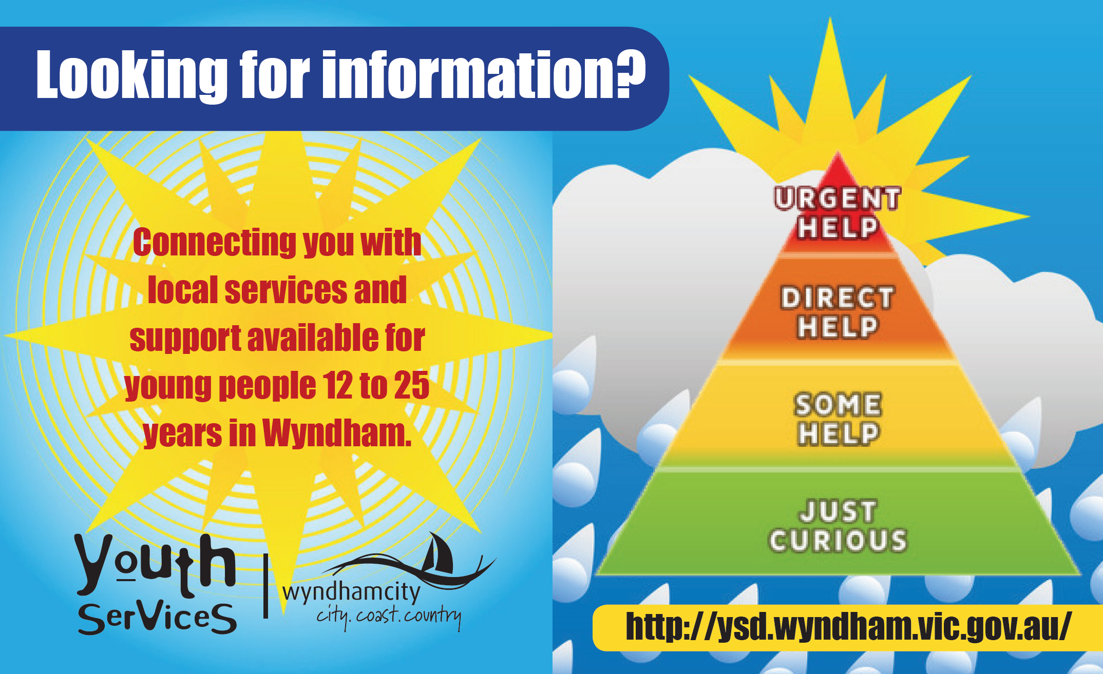

Please contact Wyndham’s Youth Project Officer for further information regarding this network or to present: lisa.wyhte@wyndham.vic.gov.au or trudy.chitty@wyndham.vic.gov.au or 8734 1355

For information sharing please email: wyndhamyouthnetwork@wyndham.vic.gov.au
Website: Wyndham Workers with Young People Network – click here

Youth in Wyndham has a Facebook Page
https://www.facebook.com/youthinwyndham

Youth in Wyndham has an Instagram Page https://www.instagram.com/youthinwyndham/

