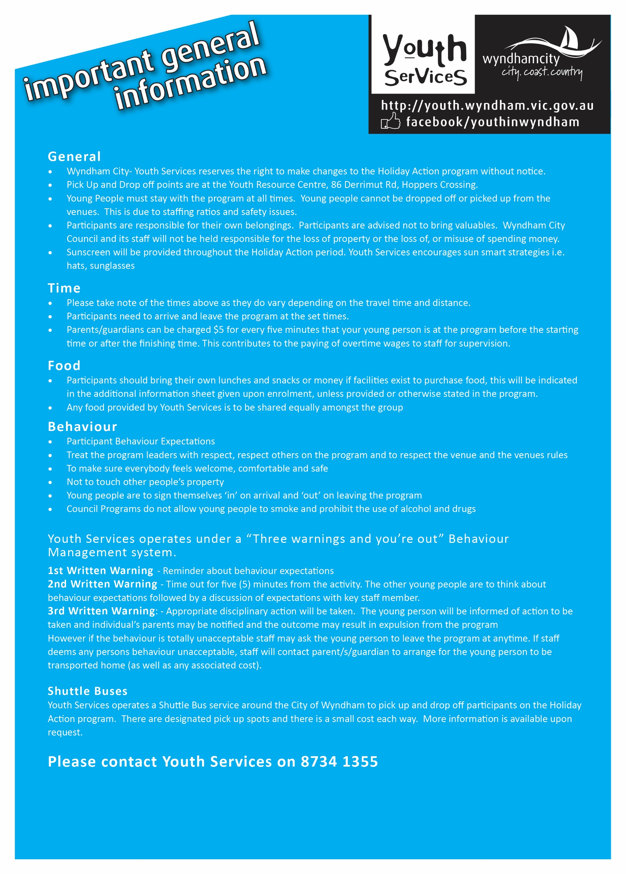

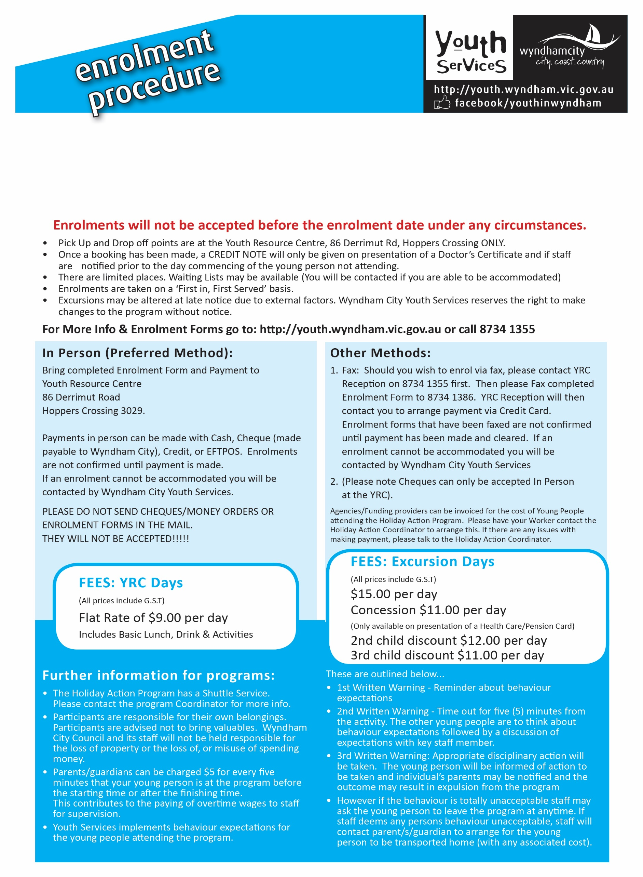

**ENROLMENTS OPEN: Monday 25th April 2019  
*9.30am until 5.30pm weekdays only*** *(excluding public holidays)*