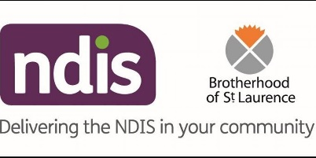  13 | EARLY CHILDHOOD EARLY INTERVENTION (ECEI)

Wyndham commenced transition to the National Disability Insurance Scheme (NDIS) in October 2018 and means there are changes in the way Early Childhood Intervention Services are accessed and the funding arrangements for service providers. Children can no longer apply for state funded ECIS and will now apply for Early Childhood Early Intervention (ECEI) funding under the NDIS.

ECEI services support children 0-6 years with a severe disability or developmental delay in Western Melbourne.

You do not need to wait for a diagnosis before referring

Children who are currently receiving state funded ECIS, or children deemed eligible but waiting for ECIS, will have a supported pathway into the scheme.

WHAT IS EARLY CHILDHOOD EARLY INTERVENTION (ECEI)?
The word ‘Intervention’ can mean many things to different people. When the word is used when talking about early childhood development it can describe all different types of services that you can access.

ECEI is designed to promote learning, development, well-being and participation in the community.

Early Childhood Early Intervention support aims to:
- promote the child’s learning, development and ability to participate in family, early childhood education and care settings and broader community life
- Assist parents and families to have the knowledge, skills and support to respond to the needs of their child

ECEI support can be delivered by a range of professionals with specialist qualifications who apply their knowledge and expertise to support children to learn and develop. The professionals supporting a child may include:

Occupational therapist– Their specialist knowledge can contribute to supporting the development of a child’s independence in everyday activities including eating, dressing, toileting and a range of activities that are part of family life.
Physiotherapist- Their specialist knowledge can contribute to supporting a child’s development in the areas of movement, posture and balance.
Speech pathologist– A speech pathologist will work in supporting a child who has difficulties talking, understanding speech, stuttering, eating and drinking, swallowing or drooling.
Psychologist– Their specialist knowledge can assist families to support a child’s social, emotional and overall development. They can provide advice and assistance to families including offering behaviour management guidance.
Specialist Early Childhood Educators– Professionals who are trained in early years education are often part of ECEI teams and assist families to understand their child’s needs and to provide opportunities and experiences that support their learning and development.

WHO PROVIDES EARLY CHILDHOOD EARLY INTERVENTION SERVICES IN THE WESTERN REGION?
The NDIS has engaged Early Childhood Partners around Australia to deliver the ECEI approach. Early Childhood Partners are experienced in providing early childhood intervention. The Brotherhood of St Laurence is the Early Childhood Partner for Wyndham and their contact details are:

The Brotherhood of St Laurence
Level 1, 236 Hoppers Lane, Werribee
Tel – 1300 275 323
Email – communications.ndis@bsl.org.au

HOW DOES IT WORK?
You can contact the Brotherhood of St Laurence if you have concerns about your child’s development. They can help you to get information and access to supports. The referral form can be completed online or on paper – please see link below.

You and other caregivers will be provided with ideas on ways to help your child with their everyday living.

As every child is different, the Brotherhood of St Laurence will tailor support to your child’s individual needs and circumstances.

The ECEI team will:

- Complete a screening assessment and talk to you and others involved with your child to get a full picture of their strengths and challenges.
- Connect you and your child with the most appropriate supports in your area, such as the community health centre (IPC Health), educational setting and playgroup.
- Provide some short-term early intervention where it has been identified as the most appropriate support.
- Help you to request NDIS access if your child requires longer-term early childhood intervention supports. If your child becomes an NDIS participant, the Early Childhood Partner will work with you to develop an NDIS plan.
- Develop your plan: help you to work out your goals and identify the supports you need to help reach those goals.
- Get your plan going: once your plan has been approved, the ECEI team will work with you to help you get your supports set up and working. They might help you to set up your MyGov and NDIA portal account and show you how to set up a service booking.
- Keep in touch with you, if you need help with your plan: ECEI will keep in touch with you and check in to see how things are going once your plan is implemented.

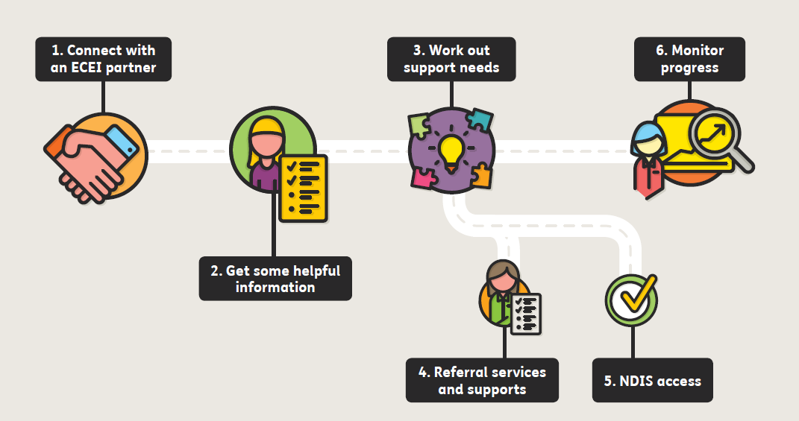

WHO CAN REFER TO ECEI?
- Early Childhood Educators (with parent permission)
- Parents
- Other service professionals (with parent permission), such as MCH Nurses, GP’s, PSFOs.

EARLY CHILDHOOD EARLY INTERVENTION CONTACT DETAILS:

The Brotherhood of St Laurence
Level 1, 236 Hoppers Lane, Werribee
Tel – 1300 275 323
Email – communications.ndis@bsl.org.au

USEFUL LINKS:

NDIS ACCESS CHECKLIST: https://www.ndis.gov.au/ndis-access-checklist.html

REFERRAL FORM: https://ndis.bsl.org.au/early-childhood-early-intervention/referral-form/

The Association for Children with a Disability site: www.ndis4kids.org.au

