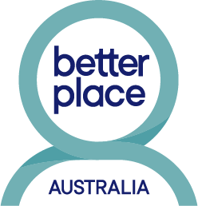
BETTER PLACE AUSTRALIA
(formerly FMC Mediation)

510 Ballan Road (co-located with IPC Health), Wyndham Vale, Vic 3024
Tel: (03) 9355 4700 Monday-Thursday (late Thursday)
Website: www.betterplaceaustralia.com.au

Sometimes children, like adults, can benefit from counselling.

Children and teens face a range of issues such as family conflict, loss of loved ones, change of school, exams, puberty and peer pressure.

Sadly, every year many are affected by the breakdown of their parent’s relationship.

Better Place Australia is one of only two organisations funded by the Federal Government to deliver a program especially for supporting children and teens whose families have separated or are going through relationship difficulties.

Going through the counselling process has many benefits. A skilled child/youth counsellor can help children and young people:

- vent their feelings in a safe place and manage strong emotions such as blame, guilt and anger
- understand how to express themselves and relate positively to others
- understand their family and friend relationships as they are now and how they change
- use a range of age appropriate coping skills
- become flexible, resilient and emotionally stable young people and adults.

We use a range of counselling styles depending on the age and issues of the people concerned.
All of our counsellors are appropriately skilled and qualified.

What does it cost?

The cost of some services is partially funded by the Federal Government. The balance is covered by minimal fees which are based on a sliding scale. We discuss this with you prior to counselling but we do not refuse our services to those who can demonstrate a genuine inability to pay.

Bulk billing may be available under a GP referral through a Mental Health Care Plan.

