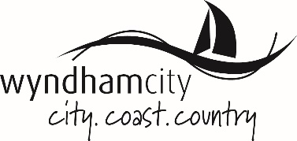
ADDENDUM TO

MINUTES OF ORDINARY COUNCIL MEETING
TUESDAY 5 FEBRUARY 2019

RESPONSE TO QUESTIONS TAKEN ON NOTICE

ITEM 10: QUESTIONS WITH NOTICE FROM PUBLIC GALLERY

10.1 | Question received from Lisa Heinrichs
Question: | Could council please provide statistics on how many meetings this current council have held since the 2016 election including briefings and how many of them has Josh Gilligan and Intaj Khan attended. Full meetings and just turning up to certain items on agenda and including how many times an apology has not been given.
Answer: | CEO, Kelly Grigsby advised that under the Local Government Act (1989) Councils are required to be transparent on Councillor attendances at Ordinary Council Meetings. All of the information requested is publicly available and is published in the minutes of the Ordinary Meetings of Council. The CEO will provide this information in writing.
Additional Information provided in writing | The information you requested is publicly available as it is published in the Minutes of Council Meetings which can be downloaded from Council’s website - www.wyndham.vic.gov.au. Given that Councillor attendance at Ordinary Meetings of Council is a requirement under the Local Government Act 1989, I advise that of the twenty five Ordinary Meetings of Council held since November 2016 (including February 2019), Councillor Gilligan has attended twenty five and Councillor Khan has attended eighteen.

