

July to September 2018

**Quarterly Growth Indicators**

Figure : New dwelling approvals, requests for new garbage services and birth notices, July to September 2018

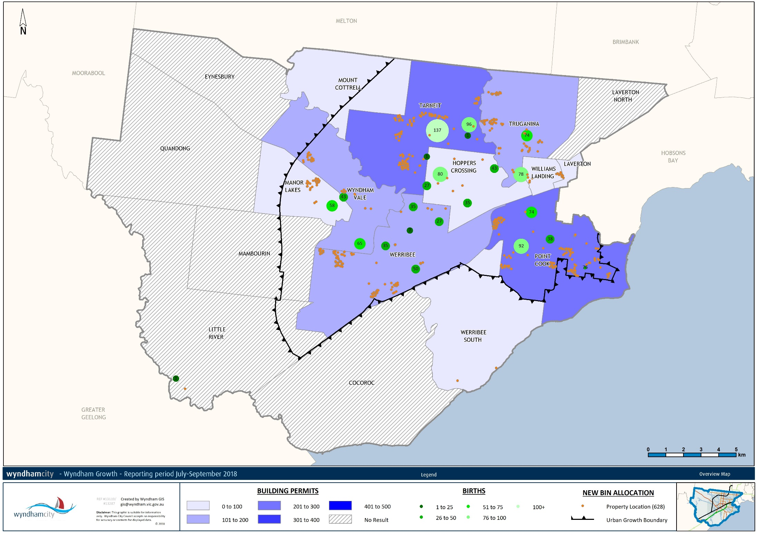

Between 2016 and 2017 Wyndham was one of the fastest growing municipalities in Victoria, growing by 13,814 persons to 241,902 residents[1]. Over the next 20 years growth is expected to remain strong – the projected population in 2041 is 489,379[2]. Large and unevenly dispersed population growth presents opportunities and challenges for service delivery and planning.

The Quarterly Growth Indicators keep track of where the growth in the city is taking place based on new dwelling approvals, requests for new garbage service, and births[3]. The map above shows for the July-September 2018 quarter:

* Dwelling approvals are in the blue shading. Over a fifth of the 1,135 dwelling approvals were granted in Tarneit (254) and another fifth in Point Cook (236). The next largest suburbs were Truganina (193) and Werribee (183) and just under one in five in Werribee (214).
* The requests for new bins (the orange pins) indicate that residents are moving into new developments across the city. People are moving into the boundaries of suburbs for the most part, and particularly into new developments in South Tarneit and West Werribee.
* Of the 1,174 births registered at Wyndham Maternal and Child Health (MCH) centres (in the green circles) almost half were in the Northern and Eastern suburbs. Given the estimated future growth in these areas as well as their current size, they will likely remain the largest suburbs for births for a while.

All three indicators have seen decreases with respect to the previous quarter:

* The number of building permits has dropped slightly from the previous quarter. Between April and June 2018 there were 1,195 dwelling permits – 60 more than in the most recent quarter.
* There were more than twice as many new bin requests in July-September 2018 compared with the previous quarter.
* There were 1,194 births between January and March 2018. This dropped slightly to 1,174 in the most recent quarter. That is 90 births per week on average.

From the July-September 2017 quarter to the current quarter the following trends arise:

* In July-September 2017 Tarneit had the highest number of dwelling approvals. After a sharp decline it had been briefly overtaken by dwelling approvals in Point Cook and Werribee, though in the most recent quarter has seen the largest number of approvals again. Point Cook will see continued decreases as it is close to being fully established, and Werribee will likely see more development on the Western growth front.
* The most recent quarter has seen a sharp upturn in the number of bin requests. As Werribee and Tarneit start to experience stronger growth in the next few years further upturns may be expected.
* Werribee has seen a sharp decline in births in the most recent quarter whereas in previous quarters it has seen the only consistent increases in the city. This underlines the nature of Wyndham’s growth as taking place at several growth fronts.

1. Australian Bureau of Statistics. (2018). Regional Population Growth, Australia. Cat 3218.0.
2. .ID Population Forecast. (2018). *City of Wyndham Population and Household Forecasts 2016-2041*.
3. **New dwelling approvals** identify where dwelling permits have been approved in the quarter. This indicator identifies areas where residents are expected to move in the next year. This data is available at the suburb level. Once residents move into a new dwelling they lodge a **request for new garbage services**. This data is available at the address level. Lastly, **birth notices** are available in terms of the number of births that have been registered with centres.