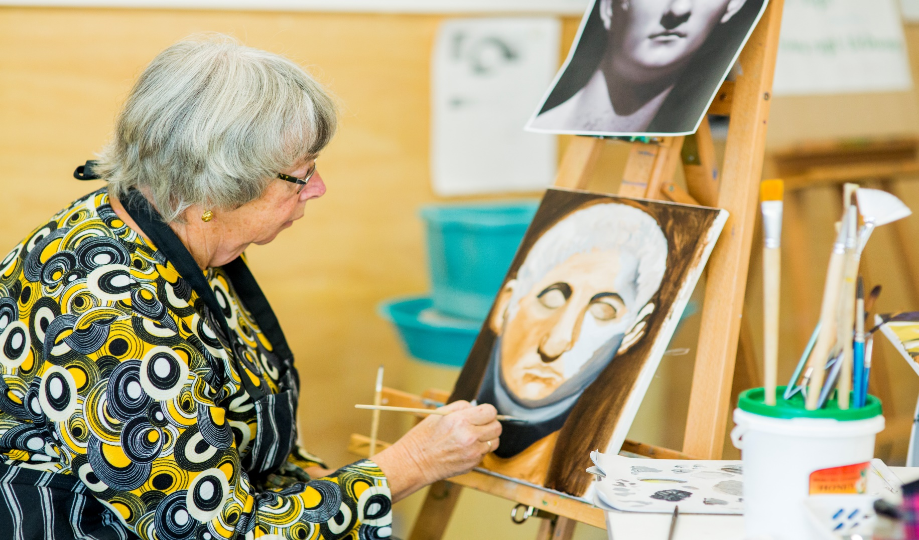

SALTWATER COMMUNITY

CENTRE

**Council works to ensure activities in community centres meet local needs and interests.**

**Priorities for activities have been developed for each community centre based on local**

**demographic data, what residents have told us is important to them along with an assessment**

**of current activities. This fact sheet provides an overview of all this information and the related**

**local priorities.**

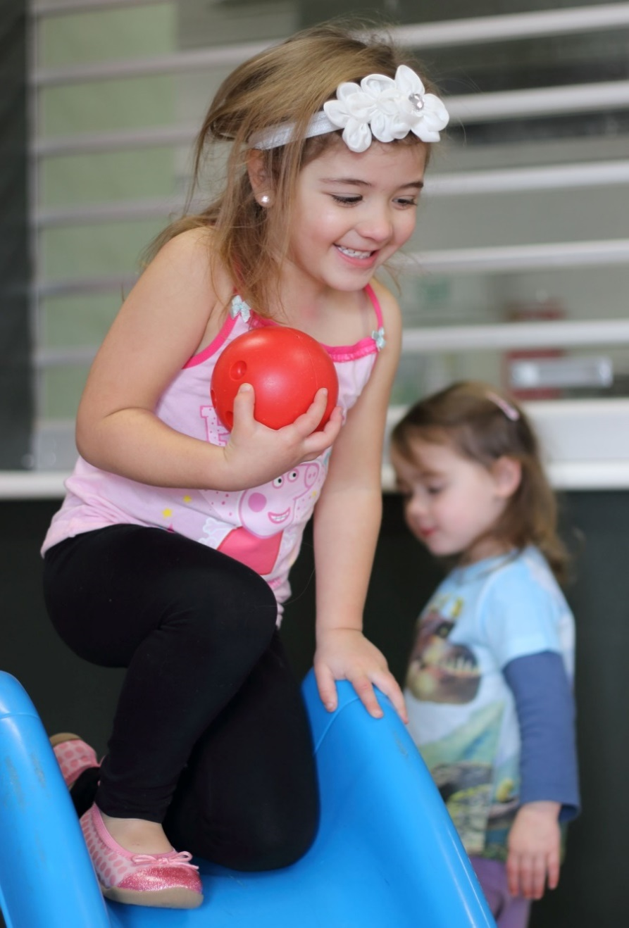

Who lives in and

Around Point Cook?



48,972 residents   
in Point Cook in 2016

Countries of birth outside of Australia

India 14% | China, New Zealand

and Philippines 4% | England 3%

More than half (52%)  
of households in Point Cook are couples  
 with children



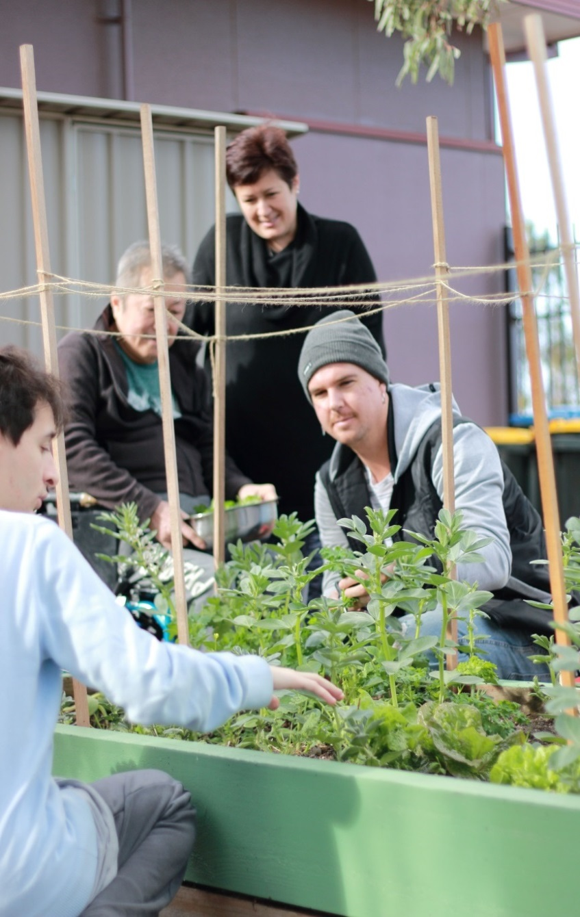

Point Cook Residents Value

**“Quality Education”**

**“Local Services”**

**“A Place to Bring-up a Family”**

***Wyndham 2040***

What We’re Hearing…

Provide engaging after school programs and activities for children, to connect with families and children from the newly opened school.

Accessible programs and workshops for people of all abilities.

A greater offering and range of art classes.

Events and celebrations that bring the community together.



**NEIGHBOURHOOD ACTIVITY PRIORITIES FOR 2019**

* Family activities which include playgroups and parent groups in the morning and after school activities including: arts, gardening, cooking, dance, theatre and homework.
* Performance based activities like theatre, music and art that can make use of the amphitheatre space.
* Activity that brings service areas, centre spaces and user groups together.