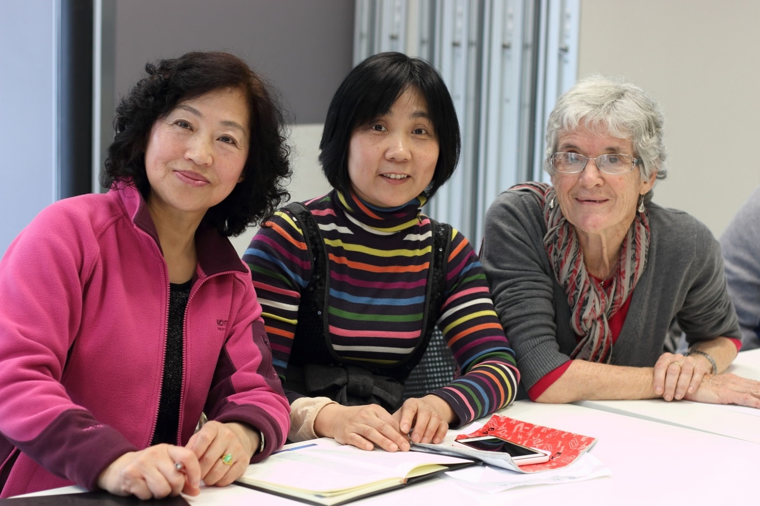

POINT COOK

COMMUNITY LEARNING

CENTRE

**Council works to ensure activities in community centres meet local needs and interests.**

**Priorities for activities have been developed for each community centre based on local**

**demographic data, what residents have told us is important to them along with an assessment**

**of current activities. This fact sheet provides an overview of all this information and the related**

**local priorities.**

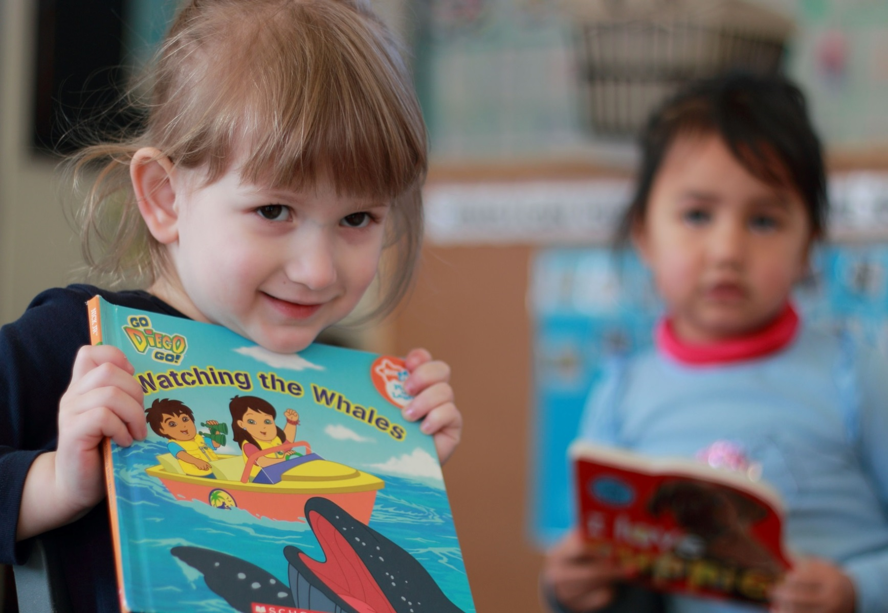

Who lives in and

Around Point Cook?

48,972 residents   
in Point Cook in 2016

Countries of birth outside of Australia

India 14% | China, New Zealand

and Philippines 4% | England 3%

More than half (52%)  
of households in Point Cook are couples  
 with children







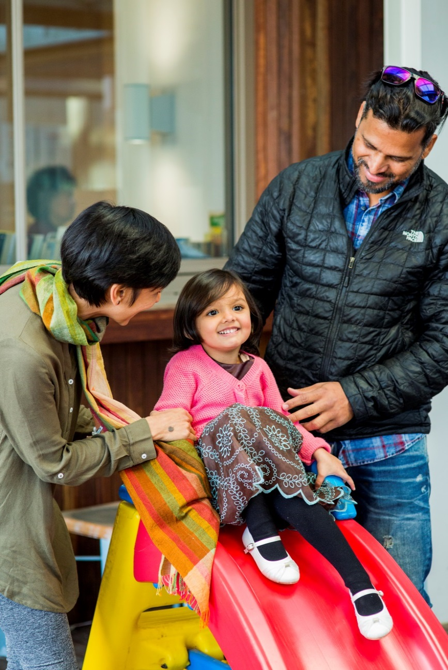

Point Cook Residents Value

**“Quality Education”**

**“Local Services”**

**“A Place to Bring-up a Family”**

***Wyndham 2040***

What We’re Hearing…

Activities promoting social contact and connection to community is important for young families and seniors.

Providing services, activities and programs to engage young people.

Opportunities to develop skills for employment and local business growth.



* Events and activities that bring together people from different cultures and connect seniors from all backgrounds.
* Programs and activities for young families.
* Activities to connect young people with the wider community.
* Skill development and support for all ages including job seekers, newly arrived migrants and young people.

**NEIGHBOURHOOD ACTIVITY PRIORITIES FOR 2019**