

PENROSE PROMENADE

COMMUNITY CENTRE

**Council works to ensure activities in community centres meet local needs and interests.**

**Priorities for activities have been developed for each community centre based on local**

**demographic data, what residents have told us is important to them along with an assessment**

**of current activities. This fact sheet provides an overview of all this information and the related**

**local priorities.**

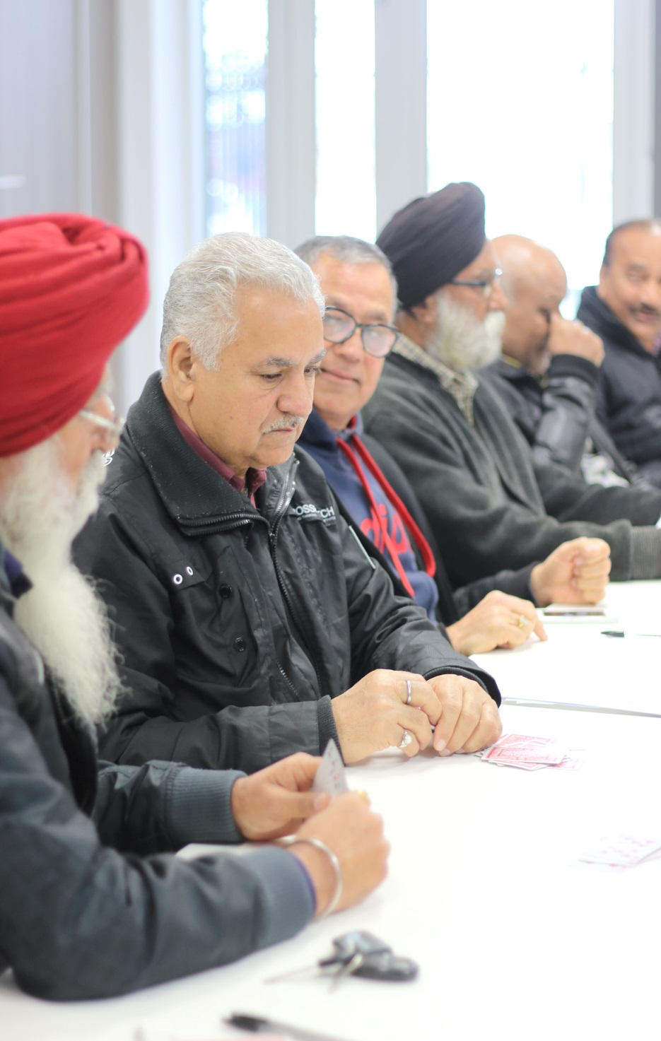

Who lives in and

Around Tarneit?



53% of Tarneit residents were born overseas   
and speak languages other than English at home



Top Countries of Birth

India 13% | Phillipines 4% |New Zealand 4%



35% attend school or a tertiary institution

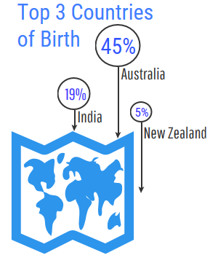



Tarneit Residents Value

**“Quality Education”**

**“Local Services”**

**“A Place to Bring-up a Family”**

***Wyndham 2040***

What We’re Hearing…

“We’d love to learn how to sew and encourage other women of migrant background to get involved in wider community life.”

“More markets, movie nights, playgroups & school holiday programs!”

“We want our children to enjoy their school work and have something constructive to do in the afternoons.”

“I’d love to join a fitness class or start a course, but I work during the day.”



* Low-cost day time social activities for stay-at-home parents and retirees.
* Adult wellbeing and skill development classes in the evening and at weekends.
* Activities and programs that connect and support young families from diverse cultural backgrounds.
* Affordable after-school activities and learning support for young people.

**NEIGHBOURHOOD ACTIVITY PRIORITIES FOR 2019**