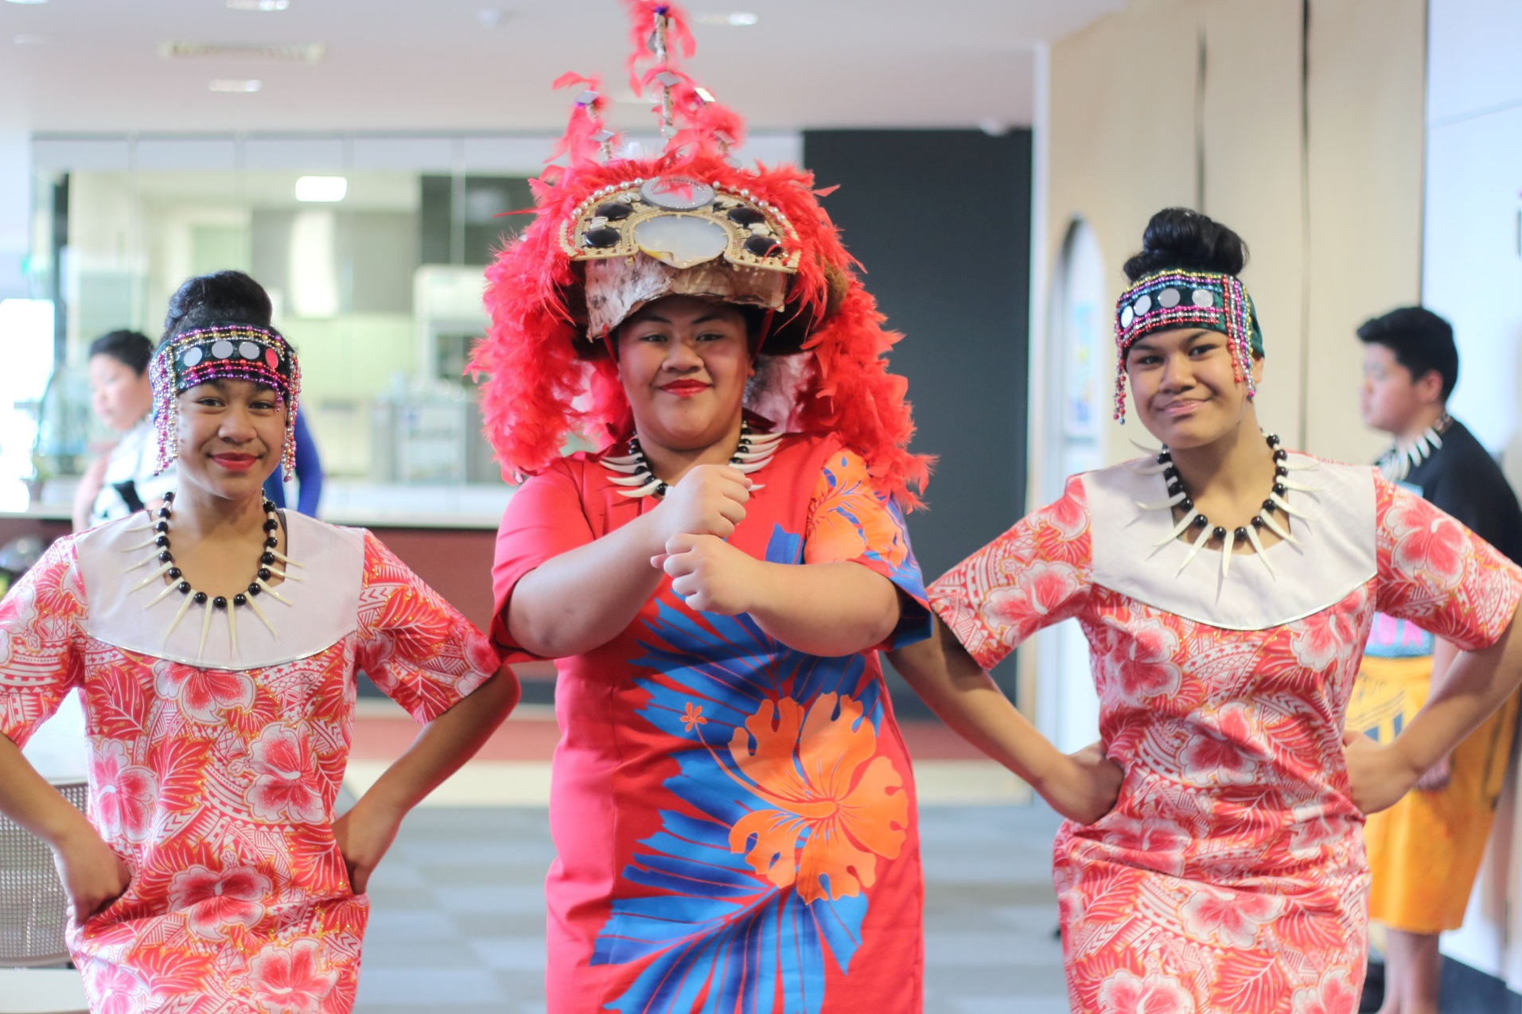

MANOR LAKES

COMMUNITY LEARNING CENTRE

**Council works to ensure activities in community centres meet local needs and interests.**

**Priorities for activities have been developed for each community centre based on local**

**demographic data, what residents have told us is important to them along with an assessment**

**of current activities. This fact sheet provides an overview of all this information and the related**

**local priorities.**

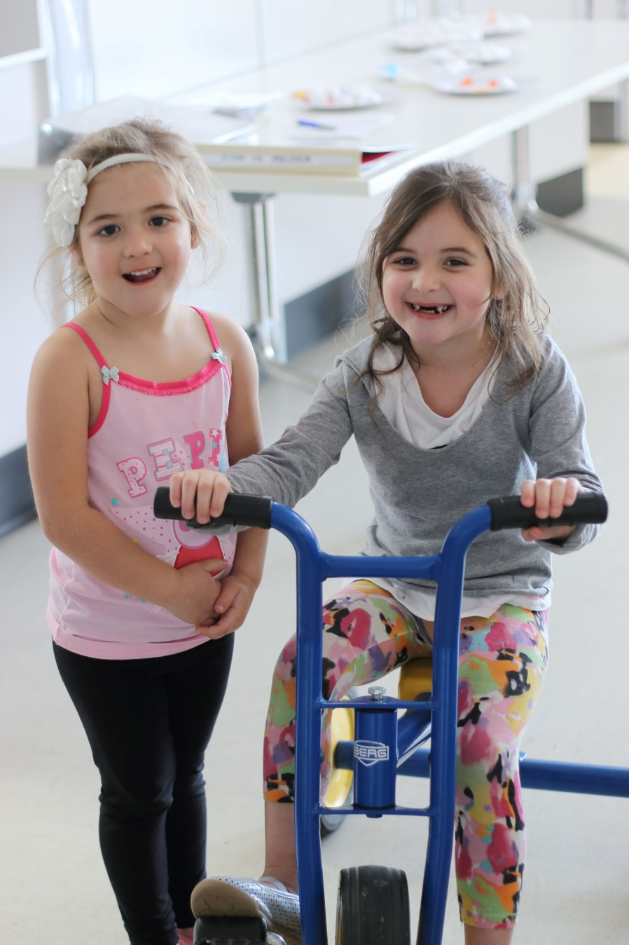

Who lives in and

Around Manor Lakes?

Countries of birth outside of Australia

India 13.2% | New Zealand 4.1%| Philippines 4%

4% of Manor Lakes residents need assistance   
with basic services and activities including communication and self-care



10.9% of residents experience   
mortgage stress

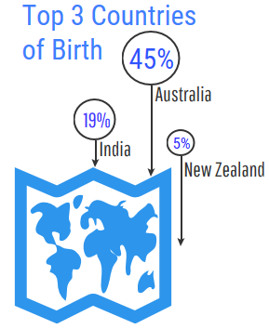



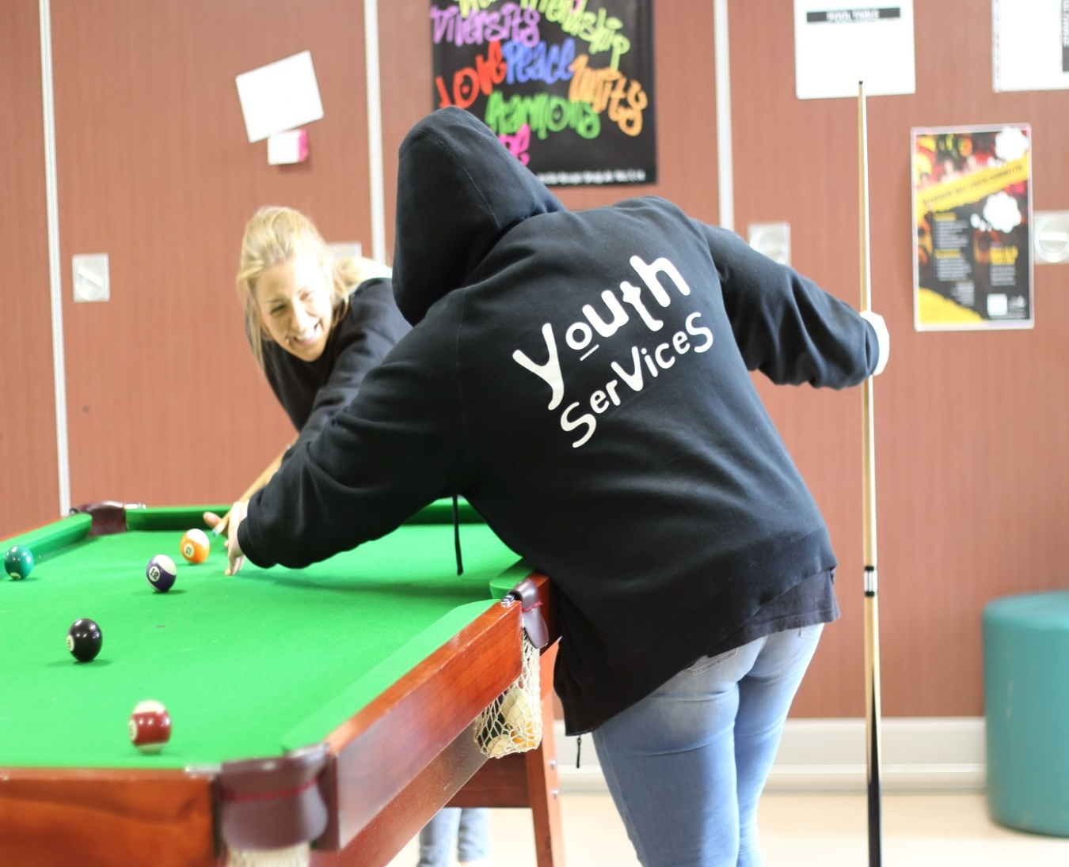

Manor Lakes Residents Value

**“Quality Education”**

**“Local Services”**

**“A Place to Bring-up a Family”**

***Wyndham 2040***

What We’re Hearing…

“Do you have fun things for my kids to do after school?”

“Manor Lakes has so much cultural diversity!”

“1 in 5 people of Wyndham’s population live with a disability or impairment”



* Affordable activities for children aged 5-11 years after school hours.
* Activities celebrating and sharing diverse cultures, including Karen and other communities from South East Asia, which are currently underrepresented at the centre.
* Events and programs embracing and supporting community members of all abilities.

**NEIGHBOURHOOD ACTIVITY PRIORITIES FOR 2019**