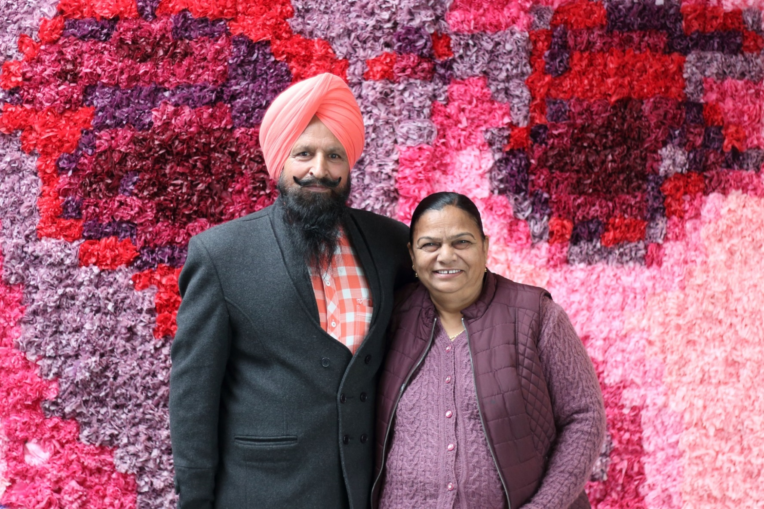

ARNDELL PARK

COMMUNITY CENTRE

**Council works to ensure activities in community centres meet local needs and interests.**

**Priorities for activities have been developed for each community centre based on local**

**demographic data, what residents have told us is important to them along with an assessment**

**of current activities. This fact sheet provides an overview of all this information and the related**

**local priorities.**

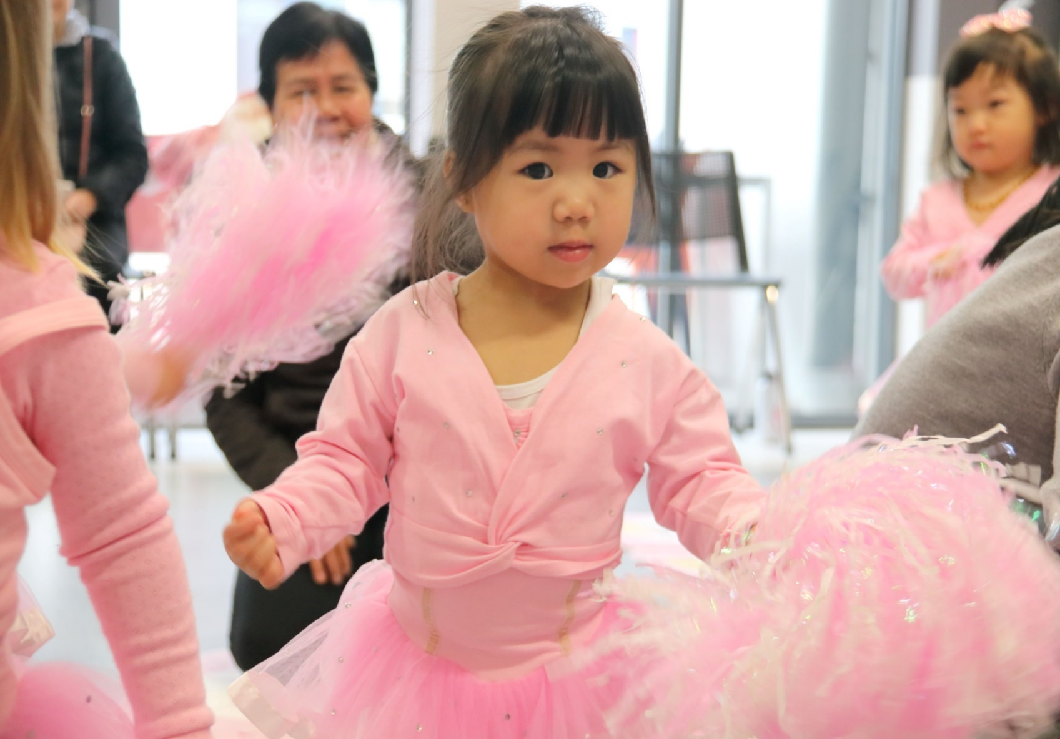

Who lives in and

Around Truganina?

41% of households are couples with children

More than half (53%)   
of Wyndham East residents were   
born overseas

72% employed  
in the adult population of Wyndham East

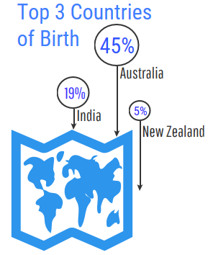





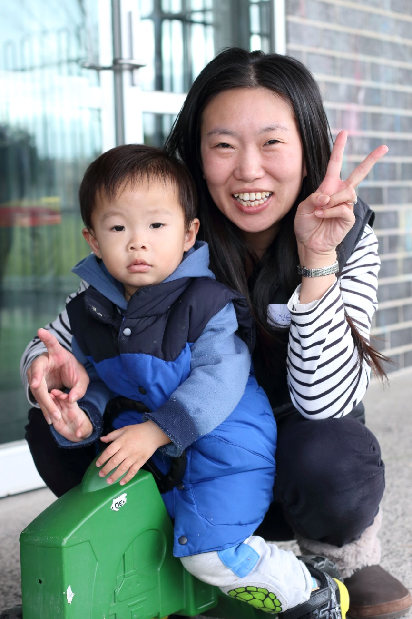

Truganina Residents Value

**“Quality Education”**

**“Local Services”**

**“A Place to Bring-up a Family”**

***Wyndham 2040***

What We’re Hearing…

“We should try and attract allied health providers to deliver services from the Hub”

“More physical activities for kids would be great.”

“I would like to see more afterschool activities for kids. Activities with a creativity focus.”

“Community Groups with a focus on bringing people together and connecting is needed.”



* Activities that encourage and celebrate cultural diversity and inclusion.
* Activities and programs focused on connecting and supporting young families from early childhood development through to leadership skills for young people.
* Projects which bring the local community together to build and strengthen relationships.

**NEIGHBOURHOOD ACTIVITY PRIORITIES FOR 2019**