People with a Disability and Carers

Census 2016 - Counting People With a Disability
The ABS Census count of people with a need for assistance with core activities identifies those with profound or severe core activity limitations, meaning that they always or sometimes need help with communication, body movement or self-care. In this sense it undercounts the number of people who need assistance. Despite the restrictive definition of the Census question, the information gleaned from it is still relevant for service planning purposes as those with a profound or severe disability are more likely to need community infrastructure and assistance. A more accurate count comes from the Survey of Disability, Ageing and Carers (SDAC) run by the ABS every five years, which is separate from the Census. Based on 2015 SDAC figures, around 12.6% of Wyndham’s population are estimated to have a disability.
According to 2016 Census data, a total of 8,458 people in Wyndham need assistance with core activities, amounting to 3.9% of the total population. The number of people who require assistance with core activities increased by 3,021 from 2011 to 2016. This 55.5% increase is larger than the increase in total population over the same period, which was 34.4%. Wyndham’s growth far exceeds that of Greater Melbourne, where population increase was at 12.1% and the increase in the number of people who require assistance was 21.9%. The proportion of people who require assistance is increasing at a greater rate than population growth.

Age Profile
The number of people with a need for assistance differs greatly by age group, and largely increases by age. Figure 1 below summarises the data for Wyndham by age group. The blue columns represent the number of people who need assistance in each age group, and the red line denotes the percentage of people in each age group who require assistance.
The largest group of residents who require assistance are aged 65 to 74 years (1,313) followed closely by those between 5 to 14 years (1,258) and 75 to 84 years (1,210). This marks a significant departure from 2011, when the three largest age groups were those aged 75 to 84, 55 to 64, and 65 to 74. The group of residents aged 65 to 74 becoming the largest of all is likely related to the group of those aged 55 to 64 being the largest five years ago. The substantial increase in the number of residents aged 5-14 years is due in part to the way the Census asks the question regarding reasons for assistance, which lists ‘young age’ as a potential reason, and in part to the influx of young families in Wyndham’s growth areas.
Naturally, the percentage of people who require assistance within each age group increases as residents grow older, the small bump in the group of 4-14 year olds notwithstanding. More than a quarter of 75 to 84 year olds require assistance, and over 50% of those aged 85 and above. Within all age groups under 75 years, the percentage of residents who require assistance has increased since 2011.

Figure 1: Wyndham Residents who Require Assistance by age Group, 2016
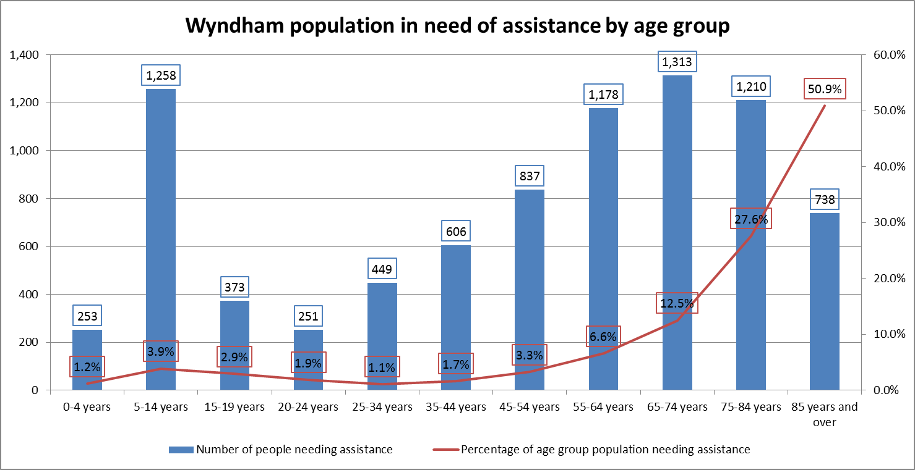
Compared with Greater Melbourne, the population of those who need assistance is generally younger in Wyndham. Figure 2 summarises this comparison. The blue columns (denoting Wyndham) represent the number of residents who need assistance within that age group as a percentage of all those who need assistance. The red columns display the same information for the Greater Melbourne area. Only 38.6% of Wyndham residents who need assistance are aged 65 and older, whereas for Greater Melbourne this is 55.9%.
Figure 2: Distribution of Those who Require Assistance in Wyndham and Greater Melbourne, 2016
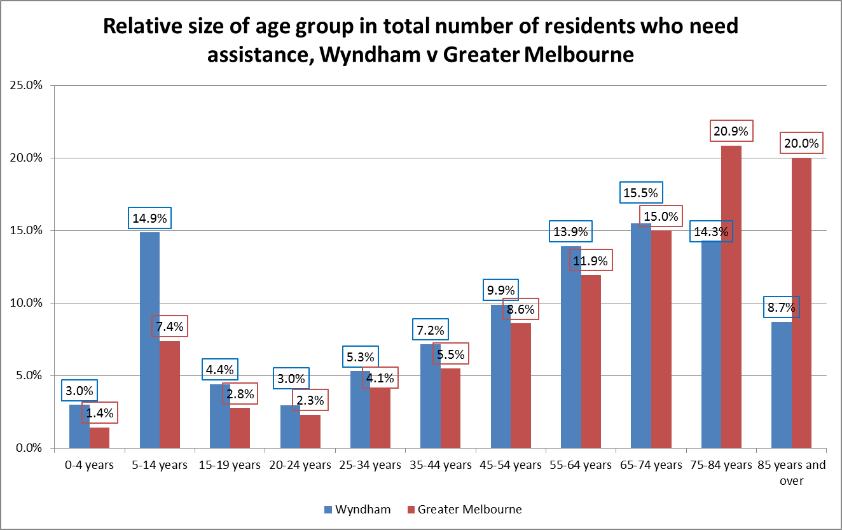

Population Characteristics of People who Need Assistance
When comparing those needing assistance in Wyndham with those needing assistance in Greater Melbourne, several points of differentiation exist.
First, as indicated in Figure 2 already, Wyndham residents who need assistance are substantially younger than those in Greater Melbourne. While 25% of those needing assistance in Wyndham are 24 or younger, for Greater Melbourne only 14% are 24 or younger. Similarly, half of Wyndham residents are 56 or younger, while for Greater Melbourne only a third are under 56 years old.
Second, a larger proportion of Wyndham residents in 2016 report nil income compared with Greater Melbourne as Figure 3 indicates. While in 2011 there was little difference in average income between Wyndham and Greater Melbourne as Figure 4 suggests, income levels have now diverged.
Figure 3: Income Distribution of Those Needing Assistance, 2016
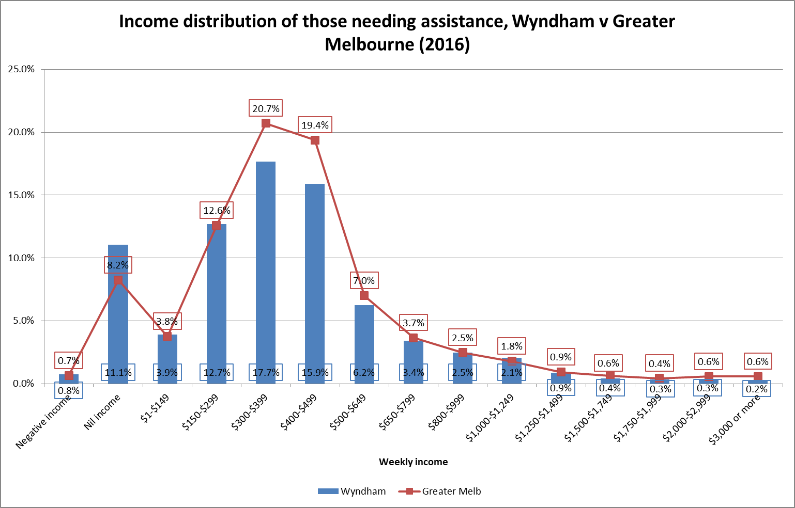
Figure 4: Income Distribution of Those Needing Assistance, 2011
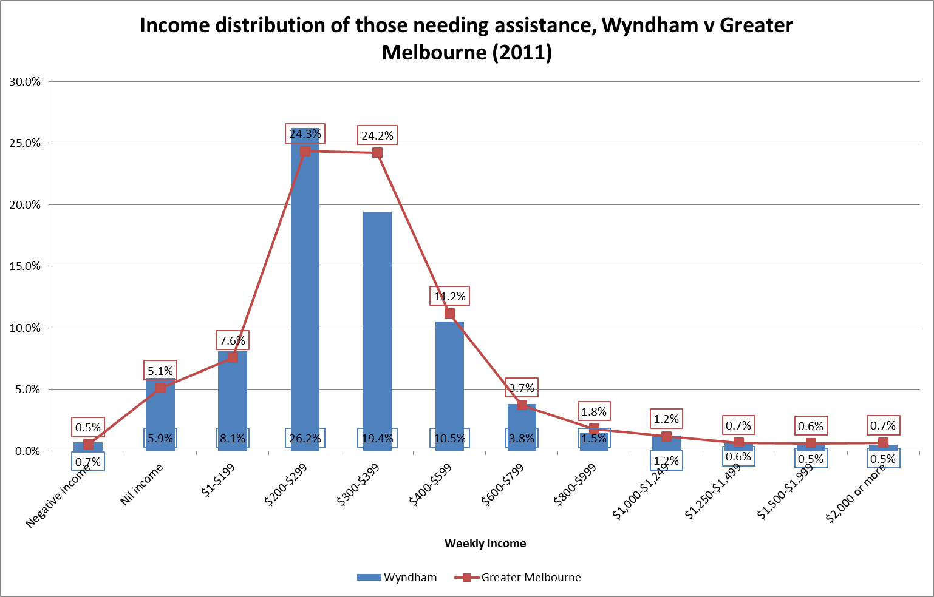
Third, Wyndham residents who require assistance with core activities are 2.5 times less likely to live in institutional accommodation such as nursing homes and supported residential accommodation than Greater Melbourne residents who need assistance. Of all Wyndham residents who need assistance in 2016, 5.9% reside in non-private dwellings, compared with 14.8% of Greater Melbourne residents. The Wyndham figure has also decreased since 2011, when 8.5% of residents lived in non-private dwellings. This decrease indicates that greater proportions of these residents are living in the community and require community support to do so.
Fourth, the majority of Wyndham residents who require assistance were born in Australia. The percentage for 2016, 57.5%, is similar to that in 2011(59%). The most common country of birth outside Australia in 2016 was the United Kingdom (4.8%), followed by India (4.2%), Italy (2.8%) and Malta (2.1%). This is a departure from 2011, when Italy was the most common country of birth outside Australia at 5%, and Malta was third at 3%. This reflects the changing demographic of the general Wyndham population, where the Indian community is one of the fastest growing.

Educational attainment
Educational outcomes among those with a need for assistance are provided in Figure 5. Compared with those who do not require assistance, those who do require assistance are more likely to not have finished high school, and are less likely to have obtained a Bachelor degree or higher.
While 7.2% of those not needing assistance have completed school up to or including Year 9, this is more than a quarter (27.4%) of those with a need for assistance. The proportions of those who have completed Years 10, 11 or 12 are roughly similar between the two groups, and there is a small gap when it comes to Certificate Level education (12.5% and 15.7% for those who do and do not require assistance, respectively). When it comes to (Advanced) Diplomas, the proportion of those needing assistance who have attained this educational outcomes is just over half the proportion of those who do not need assistance. Lastly, just under 8% of those needing assistance have attained a Bachelor degree or higher compared with just under 27% of those who do not require assistance.
Figure 5: Highest Level of Education Achieved by Core Assistance Needed, Wyndham, 2016
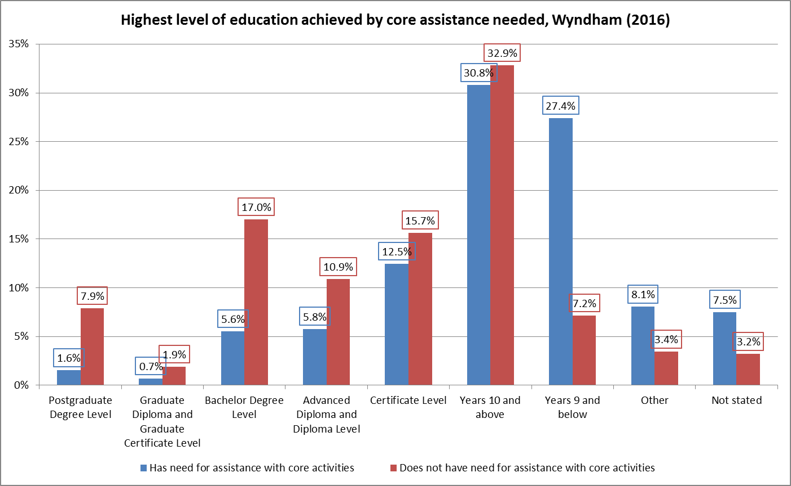

Employment
Many of those needing assistance with core activities are not in the labour force, although the proportion is lower in Wyndham than in Greater Melbourne (Figure 6), with 84.8 and 88.6% respectively. A larger proportion of Wyndham residents are working fulltime, part-time, are employed but away from work, or are unemployed and looking for work.
Figure 6: Labour Force Status of Those Needing Assistance, Wyndham and Greater Melbourne, 2016
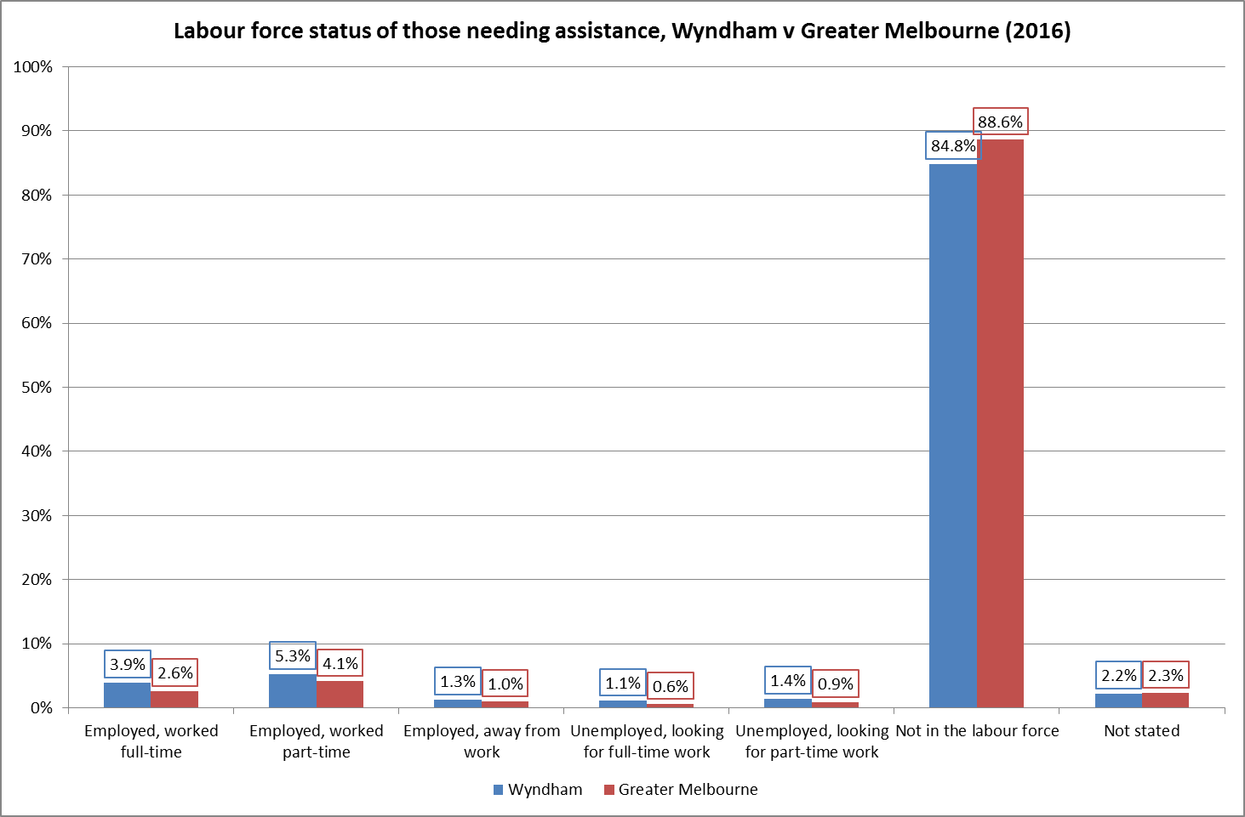

Carers
The count of people who provided unpaid assistance is based on all those who in the two weeks before the census had assisted family members or others because of a disability, long term health condition or age-related problem. For this question, the Census only counts people aged 15 and over.
In 2016, there are 17,821 people who provided unpaid assistance. This is 10.9% of the total population of residents aged 15 and older; an increase of 45.1% from 2011. Similar to the growth in the number of people who require assistance, the growth in the number of carers was higher than population growth (32.5% for those aged 15 and over).
Figure 7 summarises the data. The blue columns represent the number of people who provided assistance by age group, and the red line denotes this as a percentage of the total population within that age group. The largest group of residents who provided unpaid assistance were aged 35 to 44 (4,451), followed by those aged 45 to 54 (3,629) and 25 to 34 (3,569). This distribution is largely the same as in 2011.
Figure 7: Wyndham Residents who Provided Assistance by age Group, 2016
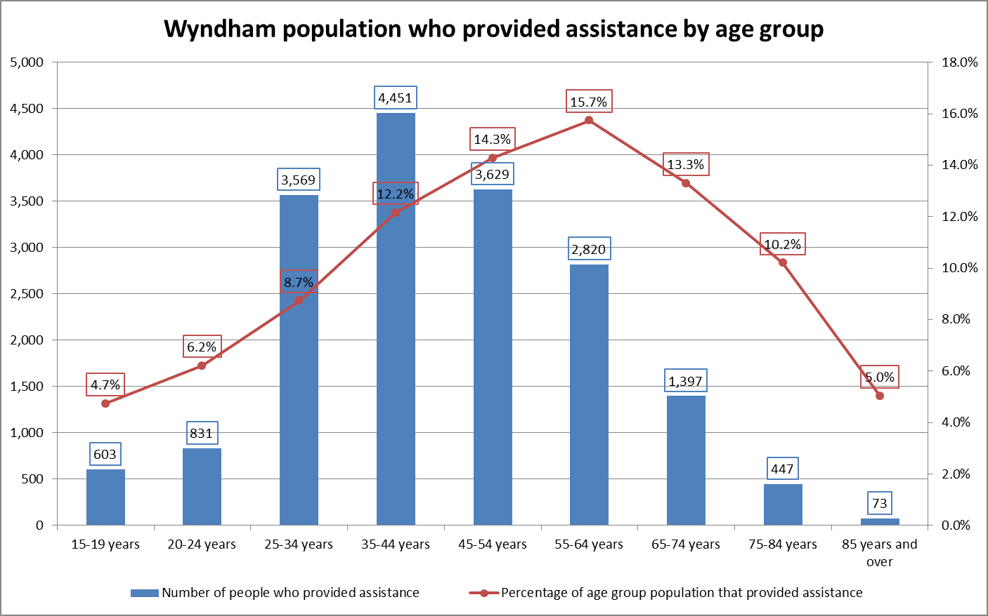
Compared with Greater Melbourne, the percentage of people who provided unpaid assistance is 11.3%, highly comparable to Wyndham’s 10.9%. The key point of differentiation is the largest age group providing the assistance. Whereas in Wyndham the 35 to 44 year age group is the largest, in Greater Melbourne it is the 45 to 54 year age group (Figure 8).
Figure 8: Distribution of Those who Provided Assistance in Wyndham and Greater Melbourne, 2016
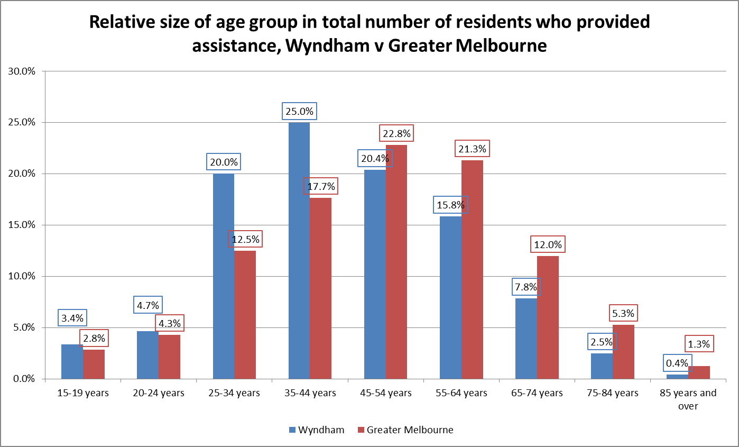
The language profiles of carers and those who need assistance are highly similar. Across both groups, English is the most commonly spoken language, followed by Mandarin, Hindi, Punjabi and Italian. The declining percentage of Italian speakers is not due to their migration elsewhere, but to the rapidly growing populations of immigrants from China and India. Almost 6% of Wyndham carers do not speak English well or at all. This has gone up since 2011, when it was 4%. Similarly, a large proportion of carers (38.5%) can speak another language and English well or very well – up from 28% in 2011. This is reflective of the general demographic shift that has taken place in Wyndham over the past five years.

Australian Bureau of Statistics (2012). Survey of Disability, Ageing and Carers (SDAC) - Release 4430.0.
Demographic data sources for this profile are the Australian Bureau of Statistics. (2011 and 2016). Census of Population and Housing unless otherwise specified.

