Migration Profile

Table of Contents
Contents
Introduction 3
Overall migration patterns 4
City-wide 4
Suburbs 5
Age 6
Country of birth 7
Education 9
Employment 14
Labour force status 14
Industry 17
Occupation 21
Income 24
Visas 28

Table of Figures and Tables
Figure 1: Current location of residents who arrived from overseas between 2011 and 2016 6
Figure 2: Per cent of the population that is born in India, 2016 9
Figure 3: Per cent of the population that speaks Mandarin at home, 2016 9
Figure 4: Migration flow by educational attainment, Wyndham 10
Figure 5: Distribution of educational attainment by arrivals and departures, Wyndham, 2011-2016 11
Figure 6: Distribution of educational attainment by arrivals from overseas and from elsewhere in Australia, Wyndham, 2011-2016 12
Figure 7: Proportion of the population with a Bachelor degree or higher over all arrivals and departures in cities with large migration flows with Wyndham, 2011-2016 13
Figure 8: Migration flow by labour force status, Wyndham 14
Figure 9: Distribution of labour force status by arrivals and departures, Wyndham, 2011-2016 15
Figure 10: Distribution of labour force status by arrivals from overseas and from elsewhere in Australia, Wyndham, 2011-2016 16
Figure 11: Proportion of the population that has full-time employment over all arrivals and departures in cities with large migration flows with Wyndham, 2011-2016 17
Figure 12: Migration flow by industry, Wyndham 18
Figure 13: Distribution of industry of employment by arrivals and departures, Wyndham, 2011-2016 19
Figure 14: Distribution of industry of employment by arrivals from overseas and from elsewhere in Australia, Wyndham, 2011-2016 20
Figure 15: Migration flow by occupation, Wyndham 21
Figure 16: Distribution of occupation by arrivals and departures, Wyndham, 2011-2016 22
Figure 17: Distribution of occupation by arrivals from overseas and from elsewhere in Australia, Wyndham, 2011-2016 23
Figure 18: Proportion of the population that are managers and professionals over all arrivals and departures in cities with large migration flows with Wyndham, 2011-2016 24
Figure 19: Distribution of income levels by arrivals and departures, Wyndham, 2011-2016 26
Figure 20: Distribution of income levels by arrivals from overseas and from elsewhere in Australia, Wyndham, 2011-2016 26
Figure 21: Proportion of the population that have high personal income over all arrivals and departures in cities with large migration flows with Wyndham, 2011-2016 27
Figure 22: Proportion of the population that have low personal income over all arrivals and departures in cities with large migration flows with Wyndham, 2011-2016 28

Table 1: Migration flow breakdown by origin and destination, 2011-2016 5
Table 2: Migration to and from other municipalities in Victoria 5
Table 3: Migration patterns by Wyndham suburbs 6
Table 4: Median age and most common age groups by suburb, 2011-2016 7
Table 5: Migration flows by country of birth, 2011-2016 7
Table 6: Most popular suburbs for recent arrivals by country of birth, 2011-2016 8
Table 7: Most popular suburbs for recent arrivals by educational attainment, 2011-2016 13
Table 8: Educational attainment of recent arrivals in Wyndham suburbs, 2011-2016 13
Table 9: Labour force status of recent arrivals in Wyndham suburbs, 2011-2016 17
Table 10: Most common industries of employment of recent arrivals in Wyndham suburbs, 2011-2016 21
Table 11: Most common occupations of recent arrivals in Wyndham suburbs, 2011-2016 24
Table 12: Income level details for recent arrivals, Wyndham 25
Table 13: Income level details for recent arrivals by suburb, Wyndham, 2011-2016 28

Introduction
This profile focuses on migration - the movement of residents into Wyndham with the intent to reside here and the movement of residents from Wyndham with the intent to reside elsewhere. Migration is one of three significant components of population change in Australia alongside births and deaths. This profile covers the three types of migration: between-state migration, within-state migration and overseas migration. For all migration streams the profile covers inward and outward flows. The exception is overseas migration for which only data on inward flows is available.
Identifying patterns in residential inward and outward migration is pertinent in the Wyndham context. The arrival of new residents and the departure of others affect the city’s population and, potentially, the demand for services and infrastructure. With Wyndham’s growth rate and the volatility of migration, identifying recent trends in migration patterns may inform how migration is likely to impact the community, and whether specific groups are leaving or coming in to the city.
Key points from this profile are:
- Just under 60,000 residents arrived in Wyndham during the past five years, and just over 24,000 moved elsewhere.
- Around a third of those who arrived in Wyndham between 2011 and 2016 lived overseas before moving to Wyndham.
- Net migration to most Victorian municipalities was positive; a larger number of people arrived than left. Notable exceptions are Melton and Greater Geelong – these municipalities had high numbers of residents moving to Wyndham, but even higher numbers going in the opposite direction.
- Almost two thirds of those who arrived in Wyndham settled to Point Cook, Tarneit and Truganina.
- There is little difference in the median age of those who arrive and depart Wyndham.
- More than two thirds of those who left Wyndham were born in Australia. Moreover, Australian-born residents form 1.3% of net migration.
- As for education and employment outcomes, net migration is positive for virtually all categories. However, differences exist between those who move in and out of Wyndham and between those who arrived from overseas and from other locations in Australia:
  - A larger proportion of highly educated, full time employees are moving out of Wyndham compared to moving in. Those moving out also have higher income levels than those moving in.
  - A higher proportion of Managers, Professionals, Clerical and Administrative Workers and Technicians and Trades Workers moved away from Wyndham than into Wyndham. In contrast, there were more arrivals than departures of Machinery Operators and Drivers and Labourers.
  - Compared with those who arrived from within Australia, a larger proportion of those who arrived from overseas have a Bachelor Degree or have finished up to high school, and a lower proportion have a Certificate level degree.
  - Residents who arrived from overseas are more likely to have higher levels of education than those have arrived from Local Government Areas across Australia.
  - Levels of unemployment are higher amongst arrivals from overseas compared to those who arrived from across Australia.
  - A larger proportion of those who arrived from overseas work as Professionals and Labourers. Residents who arrived from another place in Australia are more likely to work as Clerical and Administrative Workers, Managers and Technicians and Trades Workers.
  - A large proportion of Wyndham residents who are highly educated, have full-time education, work as professionals and managers, and have higher income levels left for municipalities close to Wyndham.
  - Residents with high education levels and white collar occupations mainly choose to reside in Point Cook, Williams Landing and Tarneit.
- As for the data on visa holders:
  - 4,711 Wyndham residents were granted a visa in the past 12 months, the most common being family visas.
  - An approximately even split of visa recipients were male (2,281) and female (2,429).
  - English proficiency was the poorest amongst Humanitarian visa holders, of which 347 of a total 381 spoke poor or no English.
  - Skilled visa holders were most likely to speak Punjabi or English as their preferred language
  - Arabic and Karen were the most common languages spoken amongst humanitarian visa holders.
  - Tertiary qualifications were highest amongst Skilled visa holders.

Overall migration patterns

City-wide
A total of 58,174 people moved into Wyndham between 2011 and 2016 from locations overseas, other states within Australia, or from within Victoria. Over the same period, 24,217 people moved from Wyndham to other cities in Victoria or to other states in Australia. The number of people who left to go overseas is unknown. Migration to and from Wyndham intensified over the years: almost a third (32.6%) of those who moved to Wyndham since 2011 did so in 2015. Of all those who left since 2011, 41 per cent did so in 2015.
Table 1 breaks down in- and outflows for the 2011-2016 period. Of the nearly 60,000 people who moved into Wyndham, half moved from another location in Victoria. A further 36 per cent arrived from overseas. The remaining 13% arrived from interstate. Conversely, just over 80 per cent of people who moved from Wyndham to another location stayed within Victoria. Overall, the number of those who moved into Wyndham was around two and a half times larger than the number of those who moved out. In all cases in Table 1 there was net positive migration – the number of people moving in exceeded the number of people leaving.
Because other cities in Victoria represent the majority of those who come in and moved out, Table 2 below provides additional detail of cities within Victoria that Wyndham residents have moved to and from between 2011 and 2016. The table also indicates what proportion of these flows have taken place in 2015.
Table 1: Migration flow breakdown by origin and destination, 2011-2016
 | Number of people who moved in | Number of people who moved away | Net migration
Total | 58,174 | 24,217 | 33,957
Overseas | 20,952 | - | -
Victoria | 29,497 | 19,539 | 9,958
New South Wales | 2,975 | 1,341 | 1,634
Queensland | 1,935 | 1,712 | 223
South Australia | 882 | 391 | 491
Western Australia | 814 | 649 | 165
Tasmania | 451 | 182 | 269
Northern Territory | 283 | 147 | 136
Australian Capital Territory | 380 | 256 | 124
Other Territories | 5 | 0 | 5
Not stated | 13,364 | - | -

Hobsons Bay and Brimbank, both adjacent to Wyndham, have been the largest origins for most of Wyndham’s arrivals in the past five years. Almost one third of the five-year inwards migration flow is from those two municipalities. As for people leaving Wyndham, Hobsons Bay is still the most popular destination, followed closely by Melton and Greater Geelong. In addition, more people left Wyndham to go to Melton and Greater Geelong than vice versa.
Table 2: Migration to and from other municipalities in Victoria
 | Number of people who moved to Wyndham (2011-2016) | Number of people who moved from Wyndham (2011-2016) | Net migration (2011-2016) | Proportion of arrivals that took place in 2015 | Proportion of departures that took place in 2015
Hobsons Bay (C) | 5,332 | 2,283 | 3,049 | 35.6% | 45.2%
Brimbank (C) | 3,996 | 1,058 | 2,938 | 31.8% | 50.8%
Maribyrnong (C) | 2,386 | 835 | 1,551 | 29.4% | 43.5%
Melbourne (C) | 1,248 | 586 | 662 | 45.3% | 55.6%
Melton (C) | 1,094 | 1,976 | -882 | 35.7% | 40.3%
Greater Geelong (C) | 1,078 | 1,918 | -840 | 45.8% | 37.2%
Moreland (C) | 1,046 | 329 | 717 | 40.9% | 52.9%
Moonee Valley (C) | 968 | 490 | 478 | 31.7% | 39.6%
Glen Eira (C) | 941 | 280 | 661 | 33.7% | 45.4%
Monash (C) | 820 | 479 | 341 | 35.6% | 45.7%
Other | 10,588 | 10,864 | -276 | 34.4% | 33.5%

Suburbs
Identifying where those moving into Wyndham come from is one half of a two-part story. The other half is in Table 3 below – the destinations of choice in terms of Wyndham suburbs. Almost a third (29.6%) of those who have moved to Wyndham between 2011 and 2016 have moved into Point Cook. Another approximate third (32.5%) have moved into Tarneit and Truganina. The table also shows what per cent of arrivals between 2011 and 2016 took place in 2015. For most suburbs around a third of arrivals took place in that year. In Werribee South and Laverton around half of the arrivals took place in 2015. Lastly, the table shows the proportion of migrants in the total population. Truganina and Williams Landing are suburbs where a large proportion of the population – more than 40 per cent – consists of recent arrivals.
Along the above theme, Figure 1 below indicates the current locations of residents who arrived from overseas between 2011 and 2016. The map illustrates the pattern identified in Table 3 and highlights pockets in all suburbs where a large proportion of migrants from overseas now live. In all suburbs except Little River and Werribee South there are areas where up to half of all residents have arrived from overseas between 2011 and 2016.
Table 3: Migration patterns by Wyndham suburbs
 | Number of migrants who moved in (2011-2016) | Per cent of arrivals that took place in 2015 | Per cent of total arrivals | Per cent of suburb's population
Point Cook | 17,202 | 30.7% | 29.6% | 34.4%
Tarneit | 10,321 | 32.6% | 17.7% | 29.9%
Truganina | 8,625 | 32.1% | 14.8% | 41.7%
Werribee | 7,030 | 36% | 12.1% | 17.4%
Hoppers Crossing | 6,603 | 33.7% | 11.3% | 17.1%
Wyndham Vale | 5,081 | 33.1% | 8.7% | 21.8%
Williams Landing | 2,910 | 31.5% | 5.0% | 43.8%
Werribee South | 241 | 44.4% | 0.4% | 13.6%
Little River | 103 | 20.4% | 0.2% | 13.4%
Laverton | 67 | 52.2% | 0.1% | 31.5%

Figure 1: Current location of residents who arrived from overseas between 2011 and 2016
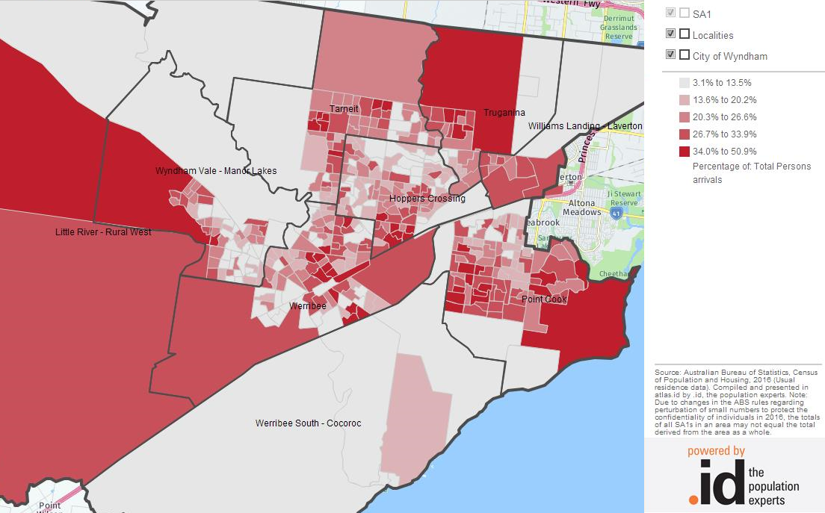

Age
The median age of those who move in to Wyndham and those who move out is almost identical. Half of those who moved in were younger than 31.9 years old, and half of those who moved away from Wyndham were 32.7 years old. Some small differences exist between those moving in from overseas and from within Australia: the median age among those who arrived from overseas is 30.1 years, compared to 32.2 years for those arriving from within Australia
The median age and largest age groups of those moving into Wyndham differ by suburb as Table 4 indicates. Those moving into Point Cook and Williams Landing have higher median ages than those moving into other suburbs. The table also indicates the age groups with the largest number of residents who moved in between 2011 and 2016. The results are consistent with Wyndham’s status as a growth area and point to young families moving in.
Table 4: Median age and most common age groups by suburb, 2011-2016
 | Hoppers Crossing | Little River | Point Cook | Tarneit | Truganina | Werribee | Werribee South | Williams Landing | Wyndham Vale
Median age | 30 | 29 | 34 | 32 | 30 | 30 | 31 | 34 | 32
Most common age group | 30-34 years | 10-14 years | 30-34 years | 30-34 years | 30-34 years | 25-29 years | 25-29 years | 30-34 years | 30-34 years
Second most common age group | 25-29 years | 5-9 years | 35-39 years | 35-39 years | 25-29 years | 30-34 years | 30-34 years | 25-29 years | 25-29 years
Third most common age group | 35-39 years | 30-34 years | 25-29 years | 25-29 years | 35-39 years | 35-39 years | 35-39 years | 35-39 years | 5-9 years
Per cent of total migrant population | 39.5% | 42.1% | 41.1% | 47.2% | 52.3% | 38.3% | 33.5% | 48.3% | 42.4%

Country of birth
Wyndham’s multicultural character is strongly reflected in the country of birth of residents who have moved in and out of Wyndham between 2011 and 2016. Table 5 summarises the data for the 20 largest countries of birth in terms of residents who moved in. The table also lists the number of residents who moved out of Wyndham over the same period and the net population growth from these migration flows. Lastly, the table indicates the number of people born in each country as a proportion of total in- and outflows.
Australia, India, New Zealand, China and the Philippines are the most common countries of birth of residents who moved into Wyndham between 2011 and 2016. These five countries of birth account for more than two thirds (67.8%) of those who moved in between 2011 and 2016. As for people who moved away from Wyndham, the top five countries of birth are Australia, India, New Zealand, England and China – totalling 81.6 per cent. Internal and external migration is almost the same for residents born in Australia. Almost all of Wyndham’s total net migration (some 98.7 per cent) is the result of people who were born in countries other than Australia.
Table 5: Migration flows by country of birth, 2011-2016
Country of birth | Number of people who moved in | Number of people who moved away | Net migration | Per cent of those who moved in | Per cent of those who moved out
Australia | 16,761 | 16,330 | 431 | 28.8% | 67.4%
India | 13,820 | 1,250 | 12,570 | 23.8% | 5.2%
New Zealand | 3,561 | 776 | 2,785 | 6.1% | 3.2%
China (excludes SARs and Taiwan) | 3,326 | 671 | 2,655 | 5.7% | 2.8%
Philippines | 1,986 | 338 | 1,648 | 3.4% | 1.4%
England | 1,311 | 740 | 571 | 2.3% | 3.1%
Pakistan | 1,224 | 93 | 1,131 | 2.1% | 0.4%
Bangladesh | 930 | 79 | 851 | 1.6% | 0.3%
Myanmar | 926 | 91 | 835 | 1.6% | 0.4%
Malaysia | 899 | 231 | 668 | 1.5% | 1.0%
Sri Lanka | 896 | 180 | 716 | 1.5% | 0.7%
Vietnam | 643 | 199 | 444 | 1.1% | 0.8%
Indonesia | 591 | 152 | 439 | 1.0% | 0.6%
Thailand | 583 | 113 | 470 | 1.0% | 0.5%
South Africa | 526 | 172 | 354 | 0.9% | 0.7%
Ethiopia | 475 | 73 | 402 | 0.8% | 0.3%
Korea, Republic of (South) | 418 | 126 | 292 | 0.7% | 0.5%
Singapore | 366 | 109 | 257 | 0.6% | 0.5%
Fiji | 361 | 75 | 286 | 0.6% | 0.3%
Sudan | 337 | 29 | 308 | 0.6% | 0.1%
As much as there is variation in where new residents were born, so too there will be variation in the suburbs those residents reside in. As Table 6 indicates, residents born in Australia, New Zealand and the Philippines have relatively low proportions of people moving into any one particular suburb – movement into Point Cook is broadly consistent with that suburb’s total population growth.
Residents born in China, England and Myanmar tend to have moved to Point Cook. For example, more than half of residents born in China (56.1%) and around 49% of residents born in England who moved to Wyndham in the past five years moved into Point Cook). Almost three quarters of Myanmar-born residents who moved here in the past five years now reside in Werribee and Hoppers Crossing (74.4%).
Note also that there is a tendency for residents from the Indian subcontinent to move into Tarneit or Truganina: this is the case for 48.2 per cent of Indian-born residents, 51.7 per cent of Pakistan-born residents, 43.3 per cent of Sri Lanka-born residents and 48.8 per cent of Bangladesh-born residents. The map in Figure 2 shows the location of Indian-born residents in Wyndham. The China-born population resides principally in Point Cook and Williams Landing as Figure 3 shows.
Table 6: Most popular suburbs for recent arrivals by country of birth, 2011-2016
Country of birth | Most popular suburb | Second most popular suburb | Third most popular suburb | Other suburbs
Australia | Point Cook | Werribee | Wyndham Vale | Other suburb
 | (24.5%) | (20.1%) | (14.2%) | (41.3%)
India | Tarneit | Truganina | Point Cook | Other suburb
 | (28.4%) | (19.8%) | (18.7%) | (33.1%)
New Zealand | Point Cook | Tarneit | Werribee | Other suburb
 | (28.8%) | (22.0%) | (12.2%) | (37.0%)
China (excludes SARs and Taiwan) | Point Cook | Williams Landing | Truganina | Other suburb
 | (56.1%) | (11.0%) | (10.4%) | (22.5%)
Philippines | Truganina | Tarneit | Point Cook | Other suburb
 | (21.0%) | (19.5%) | (18.5%) | (41.0%)
England | Point Cook | Werribee | Wyndham Vale | Other suburb
 | (48.9%) | (15.6%) | (9.4%) | (26.2%)
Pakistan | Tarneit | Truganina | Point Cook | Other suburb
 | (28.1%) | (22.6%) | (15.6%) | (33.7%)
Myanmar | Werribee | Hoppers Crossing | Wyndham Vale | Other suburb
 | (41.9%) | (32.5%) | (10.8%) | (14.8%)
Sri Lanka | Tarneit | Point Cook | Truganina | Other suburb
 | (22.3%) | (21.0%) | (17.4%) | (39.3%)
Bangladesh | Truganina | Tarneit | Werribee | Other suburb
 | (26.0%) | (22.8%) | (14.1%) | (37.1%)

Figure 2: Per cent of the population that is born in India, 2016
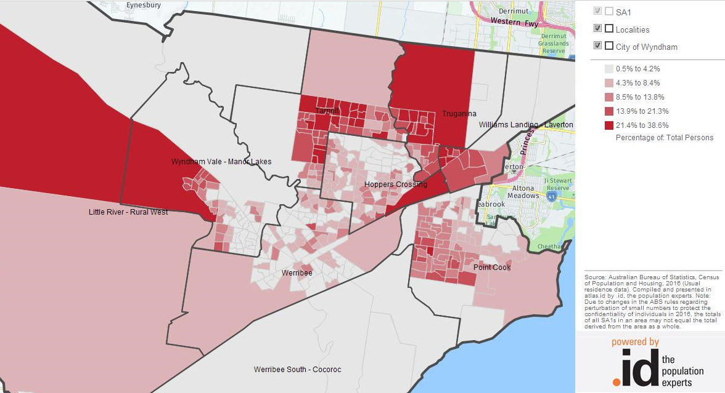
Figure 3: Per cent of the population that speaks Mandarin at home, 2016
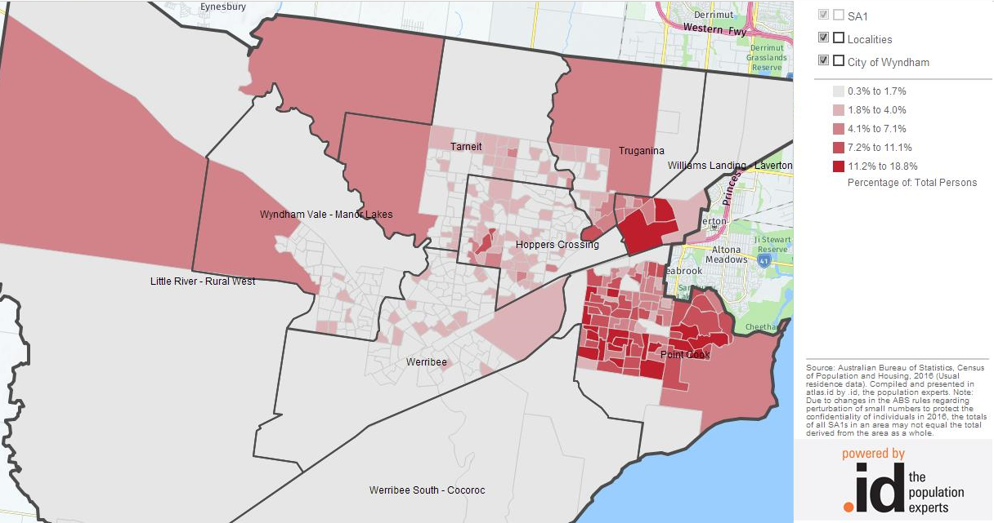

Education
The migration flow might indicate whether Wyndham is attracting a highly skilled workforce, or whether such a workforce is predominantly leaving. Overall, as Figure 4 suggests, in all categories of educational attainment Wyndham has seen a net positive migration flow. Those who moved into Wyndham primarily had a high school education, a Bachelor degree, or a Postgraduate degree. Among those who left Wyndham between 2011 and 2016, the second-largest group was those who have a Certificate Level education.
Figure 4: Migration flow by educational attainment, Wyndham
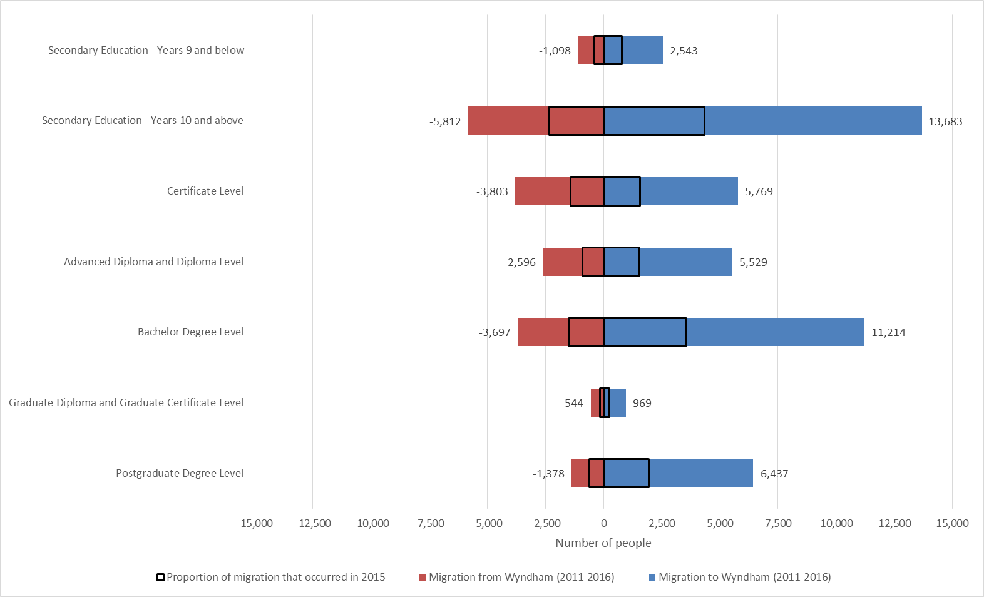
While net migration was positive and Wyndham saw an increase in the number of people in all educational attainment levels, the educational attainment of those moving in was different from those moving out as Figure 5 shows. Those with a Bachelor or Postgraduate degree formed a larger proportion of those leaving Wyndham (38.4%) than those coming in (26.8%). On the other hand, the relative number of people who moved to Wyndham and had a Certificate level is larger than people who have a certificate level education and who moved elsewhere between 2011 and 2016. In other words, a larger proportion of those leaving Wyndham was highly educated.
Figure 5: Distribution of educational attainment by arrivals and departures, Wyndham, 2011-2016
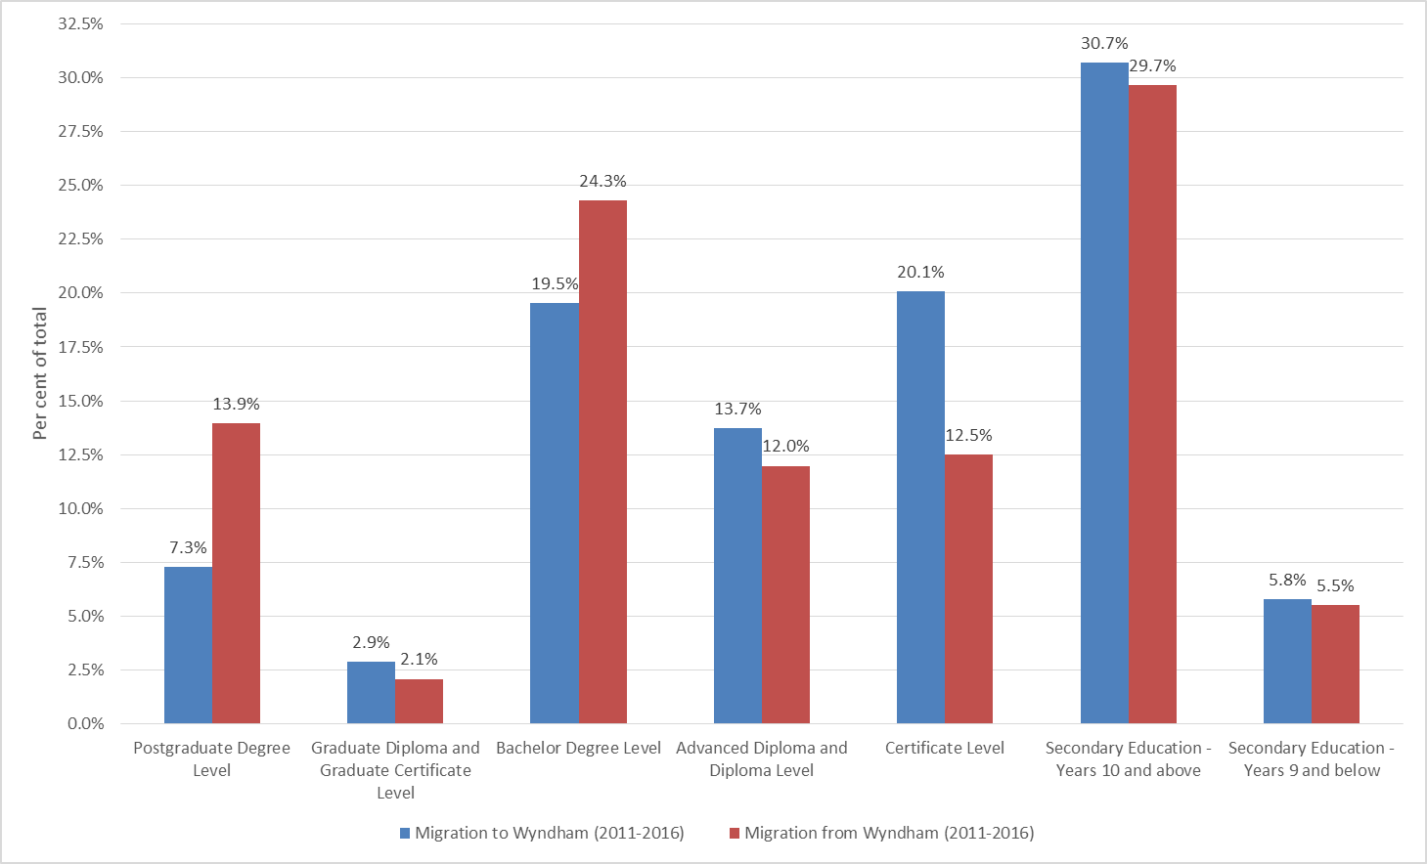
There are differences in the educational attainment of people who moved to Wyndham from overseas, and those who came from areas across Australia. (Figure 6). For example, a higher proportion of those who have moved to Wyndham from overseas have a Bachelor degree, and a higher proportion have high school as their highest level of education. Conversely, a higher proportion of those who moved to Wyndham from another location in Australia have a certificate. The pattern of educational attainment among those who arrived from overseas likely reflects in part a skilled migration inflow (potentially including lower-skilled spouses), and in part a humanitarian migration inflow.
Figure 6: Distribution of educational attainment by arrivals from overseas and from elsewhere in Australia, Wyndham, 2011-2016
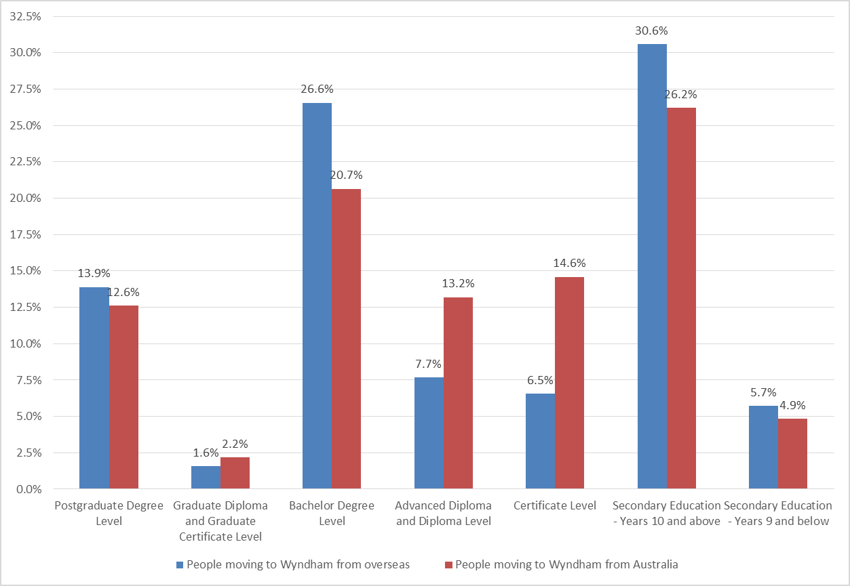
As previously mentioned, there are substantial differences in educational attainment levels between those who move to and away from Wyndham. Figure 7 below shows for ten selected municipalities that have high migration numbers (either to or from Wyndham) the percentage of people who have a Bachelor degree or higher. In all ten municipalities, there are proportionally more people with a Bachelor degree or higher who have left. This difference is largest in Hobsons Bay, which is directly adjacent to Wyndham in the direction of the Melbourne CBD.
Figure 7: Proportion of the population with a Bachelor degree or higher over all arrivals and departures in cities with large migration flows with Wyndham, 2011-2016
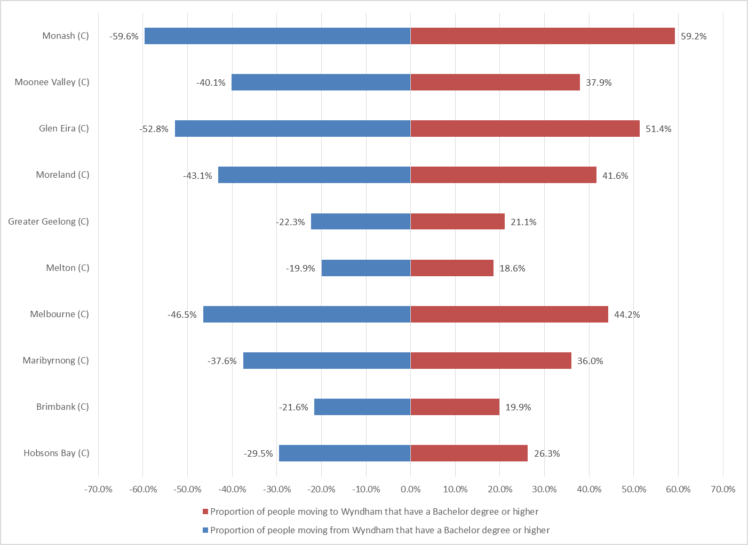
There appears to be a relationship between educational attainment and suburb of preference (Table7 7). The most attractive suburb for those with a Bachelor degree or higher is Point Cook where almost a third of those with this level of education settled.
Table 7: Most popular suburbs for recent arrivals by educational attainment, 2011-2016
Education | Most popular suburb | Second most popular suburb | Third most popular suburb | Other suburbs
Bachelor degree or higher | Point Cook | Tarneit | Truganina | Other
 | (31.0%) | (18.0%) | (15.4%) | (35.7%)
Secondary school | Point Cook | Werribee | Tarneit | Other
 | (23.2%) | (17.7%) | (16.2%) | (42.9%)
Certificate level | Point Cook | Werribee | Tarneit | Other
 | (22.2%) | (19.2%) | (15.1%) | (43.5%)

In Point Cook, Wyndham Vale and Truganina those with a Bachelor degree or higher form the largest group of recent arrivals (Table 8). In Hoppers Crossing, Little River, Werribee, Werribee South and Wyndham Vale those with a secondary education form the largest group of recent arrivals.
Table 8: Educational attainment of recent arrivals in Wyndham suburbs, 2011-2016
 | Hoppers Crossing | Little River | Point Cook | Tarneit | Truganina | Werribee | Werribee South | Williams Landing | Wyndham Vale
Bachelor degree or higher | 22.8% | 14.5% | 38.6% | 34.6% | 40.7% | 21.1% | 20.0% | 48.1% | 24.9%
Secondary school | 42.2% | 37.6% | 32.1% | 34.6% | 30.3% | 41.8% | 46.0% | 28.8% | 38.1%
Certificate level | 17.3% | 28.1% | 12.3% | 13.0% | 10.4% | 18.3% | 21.1% | 8.2% | 19.4%

Employment
While educational attainment, described above, indicates the skills that residents have, the other side of the coin are employment outcomes. This section describes the migration patterns to and from Wyndham in terms of labour force status, industry of employment, occupation and income. All data refers to residents aged 15 years and over unless otherwise stated.

Labour force status
Across all labour force status categories more people have moved to Wyndham than from Wyndham between 2011 and 2016. The two largest categories by far are those employed full-time and those not in the labour force (Figure 8). Almost half of those unemployed or not in the labour force have arrived in 2015.
Figure 8: Migration flow by labour force status, Wyndham
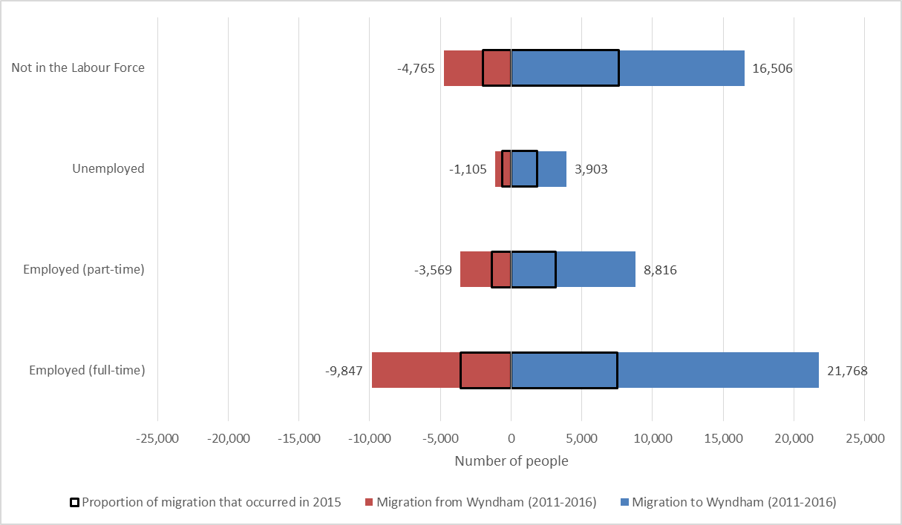
The pattern of migration among those who move to Wyndham and those who moved away is shown in Figure 9. Over half of those who move away from Wyndham have full-time employment (51.1%). In contrast, 42.7 per cent of those moving to Wyndham are full-time employed. The opposite is true for those not in the labour force where a greater proportion moving in are not in the labour force (32.4%) compared with those moving out (24.7%).
Figure 9: Distribution of labour force status by arrivals and departures, Wyndham, 2011-2016
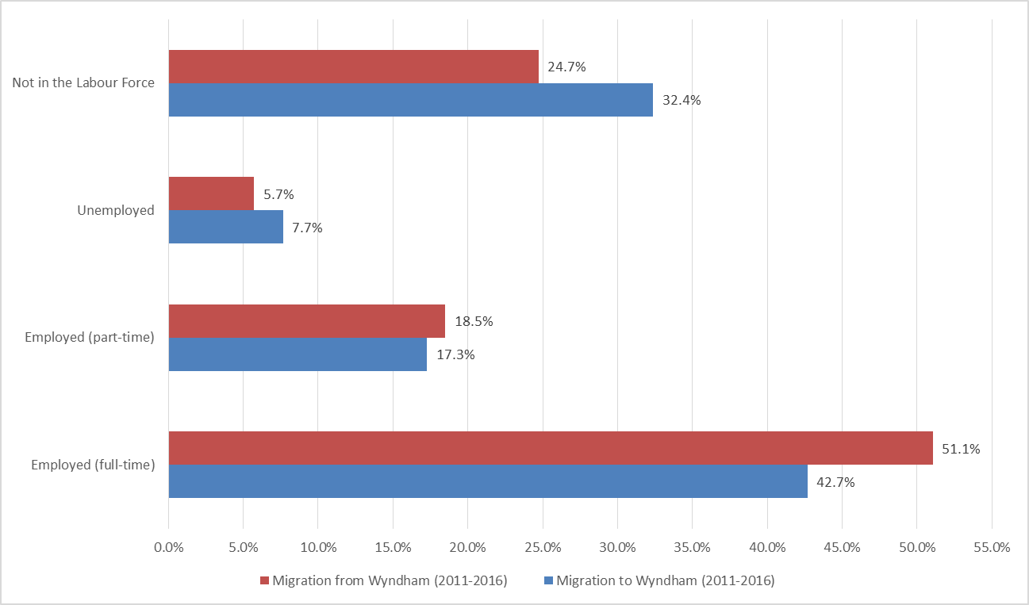
Labour force status also differs among those who have different places of origin. Figure 10 below indicates that compared with those who arrived in Wyndham from another place in Australia, those who arrived from overseas are less likely to have full-time employment, more likely to have part-time employment or not be in the labour force.
Figure 10: Distribution of labour force status by arrivals from overseas and from elsewhere in Australia, Wyndham, 2011-2016
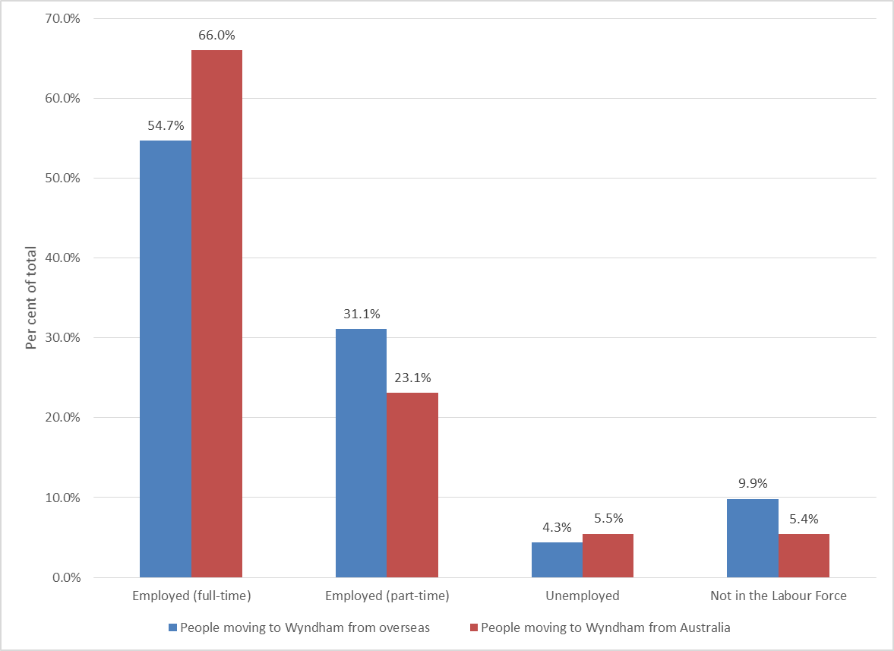
As previously mentioned, there are substantial differences in labour force status between those who move to and away from Wyndham. Figure 11 below shows for 10 selected municipalities that have high migration numbers (either to or from Wyndham) the percentage of people who have full-time employment. Proportionally more full-time employed residents are moving to the nearby municipalities of Hobsons Bay, Maribyrnong, Melbourne, Melton and Moonee Valley. Proportionally more residents with full-time employment arrive in Wyndham from Glen Eira, Brimbank and Monash.
Figure 11: Proportion of the population that has full-time employment over all arrivals and departures in cities with large migration flows with Wyndham, 2011-2016
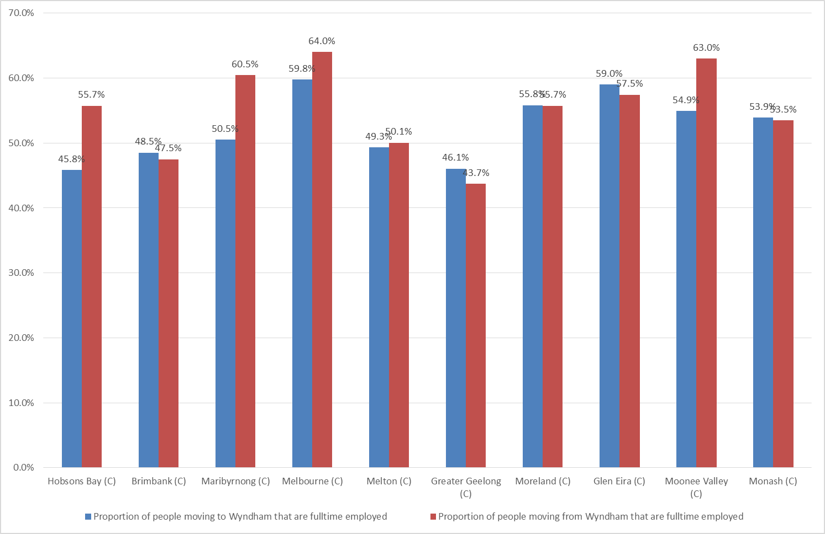
The migrant population in the suburbs is as in Table 9. In Williams Landing almost half of all those who moved there between 2011 and 2016 were full-time employed. At the same time, that suburb also has the largest proportion of those not in the labour force. This is likely due to families where one parent works. Werribee and Hoppers Crossing have the lowest proportions of full-time employed recent arrivals and the highest proportion of unemployed recent arrivals – along with Little River.
Table 9: Labour force status of recent arrivals in Wyndham suburbs, 2011-2016
 | Hoppers Crossing | Little River | Point Cook | Tarneit | Truganina | Werribee | Werribee South | Williams Landing | Wyndham Vale
Full-time employed | 39.1% | 40.2% | 47.7% | 44.1% | 46.0% | 39.3% | 41.0% | 49.5% | 45.3%
Part-time employed | 18.9% | 21.9% | 16.9% | 18.7% | 18.0% | 18.1% | 17.5% | 18.0% | 17.7%
Unemployed | 8.2% | 7.6% | 6.2% | 7.1% | 6.3% | 7.6% | 5.7% | 6.6% | 7.1%
Not in labour force | 30.7% | 23.2% | 26.0% | 26.6% | 25.7% | 31.9% | 31.6% | 22.8% | 26.8%

Industry
In all industries of employment more residents have moved to Wyndham than away from Wyndham. The one exception is the mining industry, where 90 residents left and 70 residents arrived (Figure 12). The three industries with the highest net migration were Transport, Postal and Warehousing, Health Care and Social Assistance, and Retail Trade.

Figure 12: Migration flow by industry, Wyndham
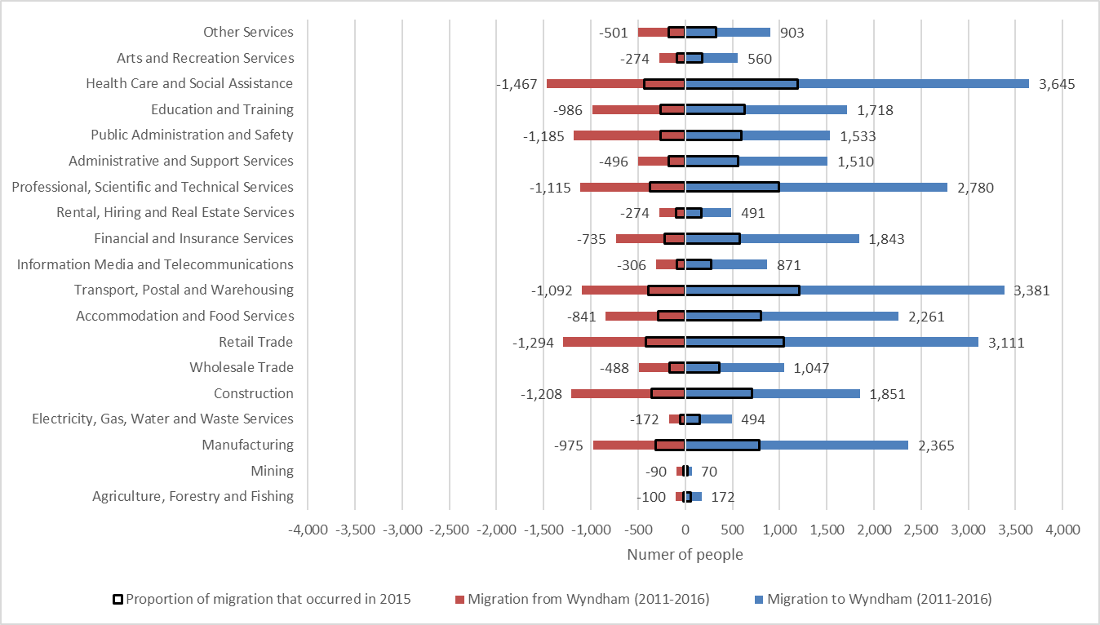
In several industries, proportionally more people have arrived in Wyndham between 2011 and 2016 than left. Figure 13 summarises the data for all industries. The Construction, Public Administration and Safety, and Education and Training industries have seen relatively large proportions of employees move away from Wyndham. Industries with proportionally large migration into Wyndham were the Transport, Postal and Warehousing, Administration and Support Services and Electricity, Gas, Water and Waste Services industries.
Figure 13: Distribution of industry of employment by arrivals and departures, Wyndham, 2011-2016
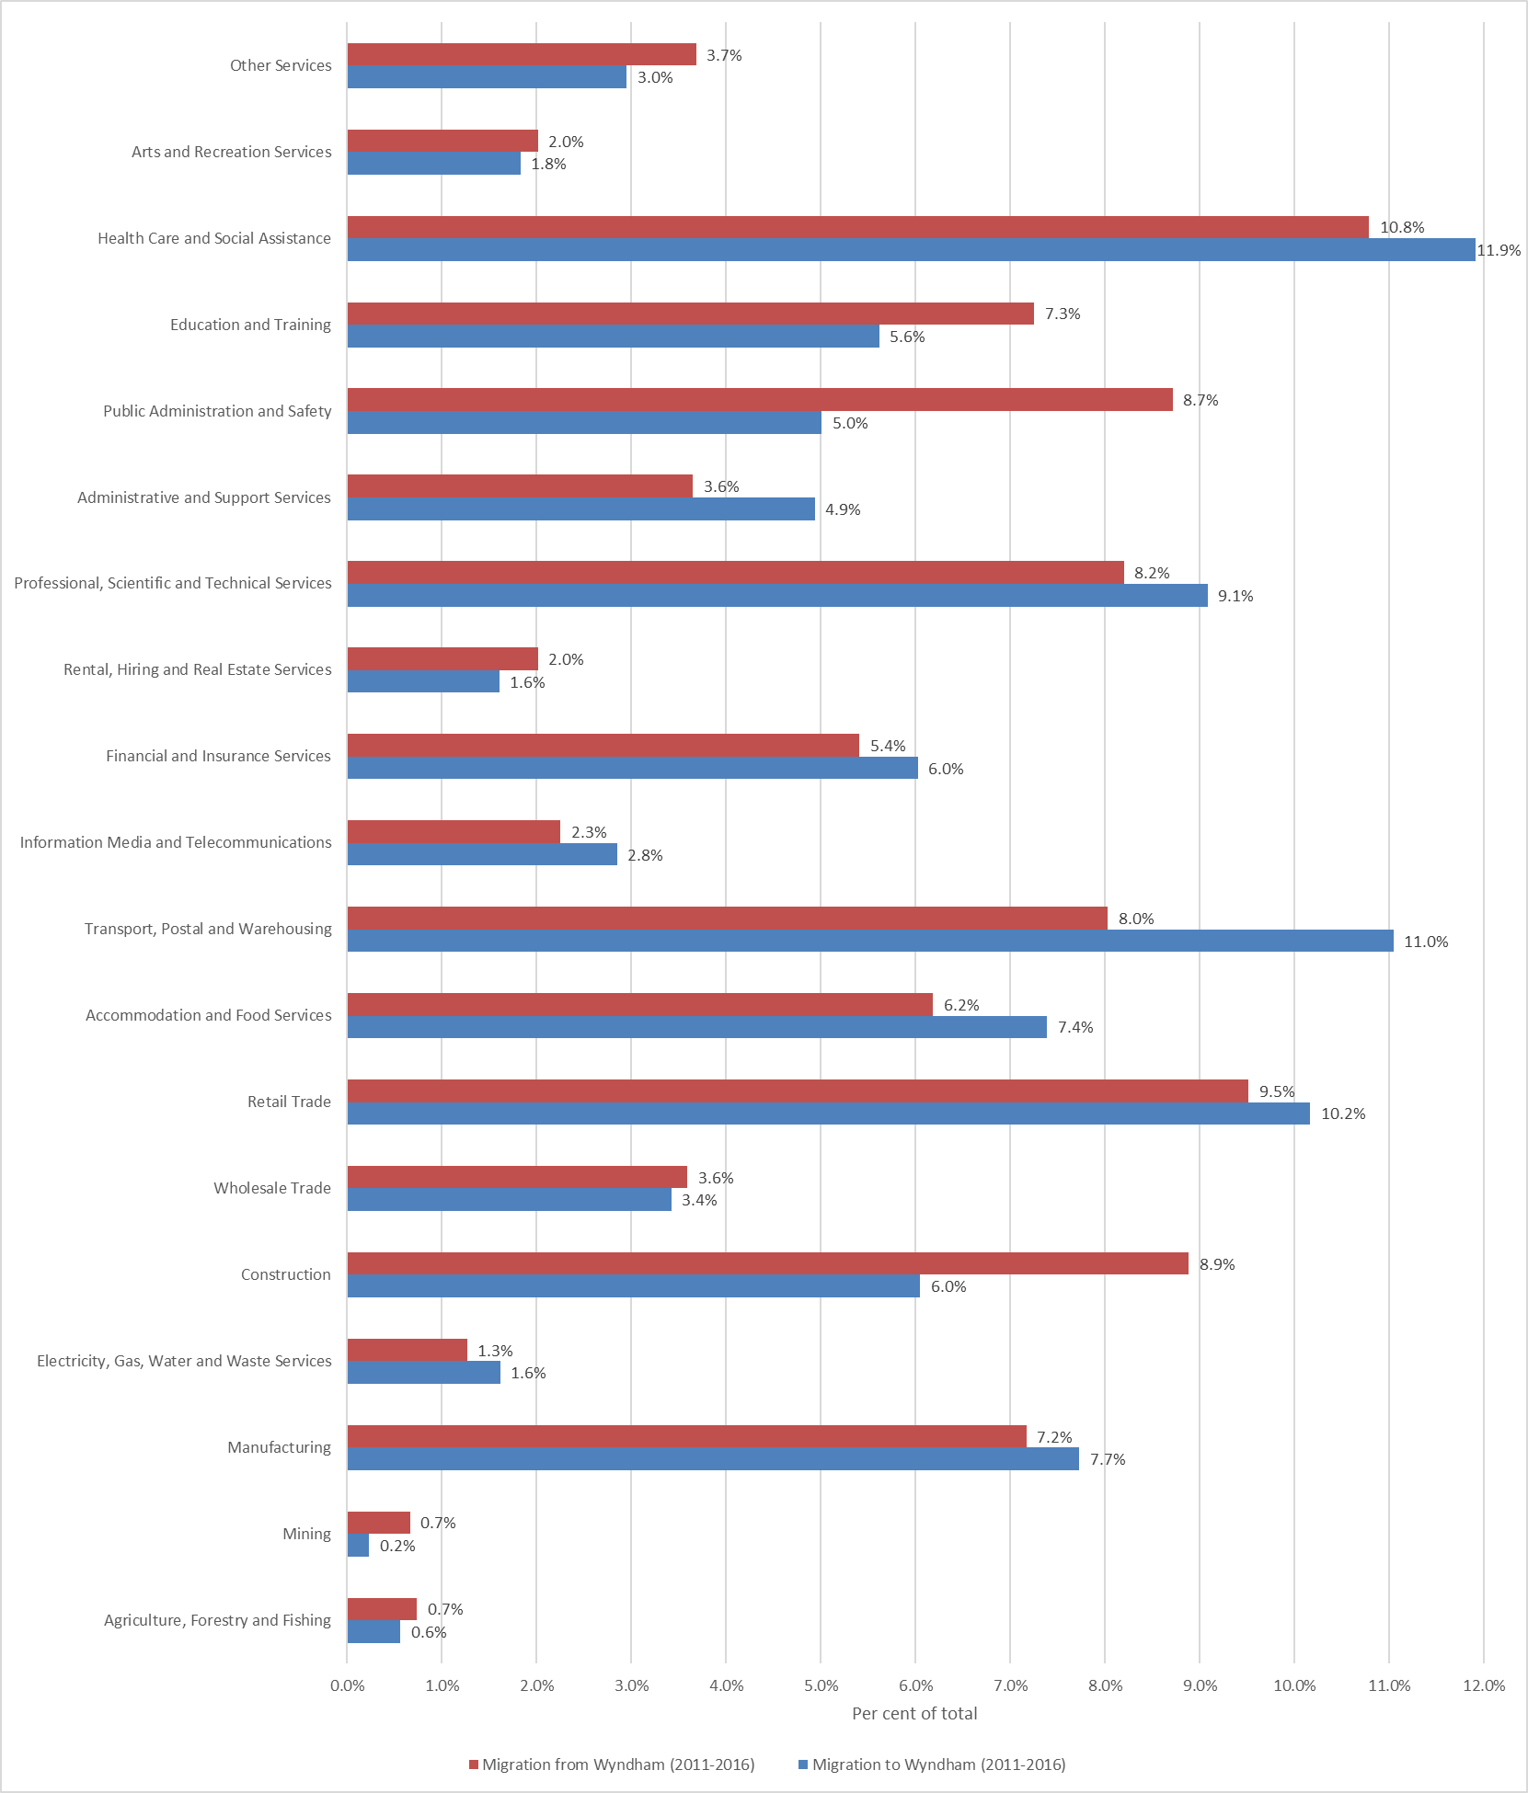
The key differences between those who arrive in Wyndham from overseas and those who arrive from other places in Australia is that a larger proportion of those who arrived from overseas work in service industries: Professional Scientific and Technical Services, Accommodation and Food Services, and Administrative and Support Services. Those who arrived from another place in Australia are proportionally more skilled in the Public Administration and Safety, Financial and Insurance Services, and Construction industries. These substantial differences are likely due to Australia's visa program being a primarily skills-based program.
Figure 14: Distribution of industry of employment by arrivals from overseas and from elsewhere in Australia, Wyndham, 2011-2016
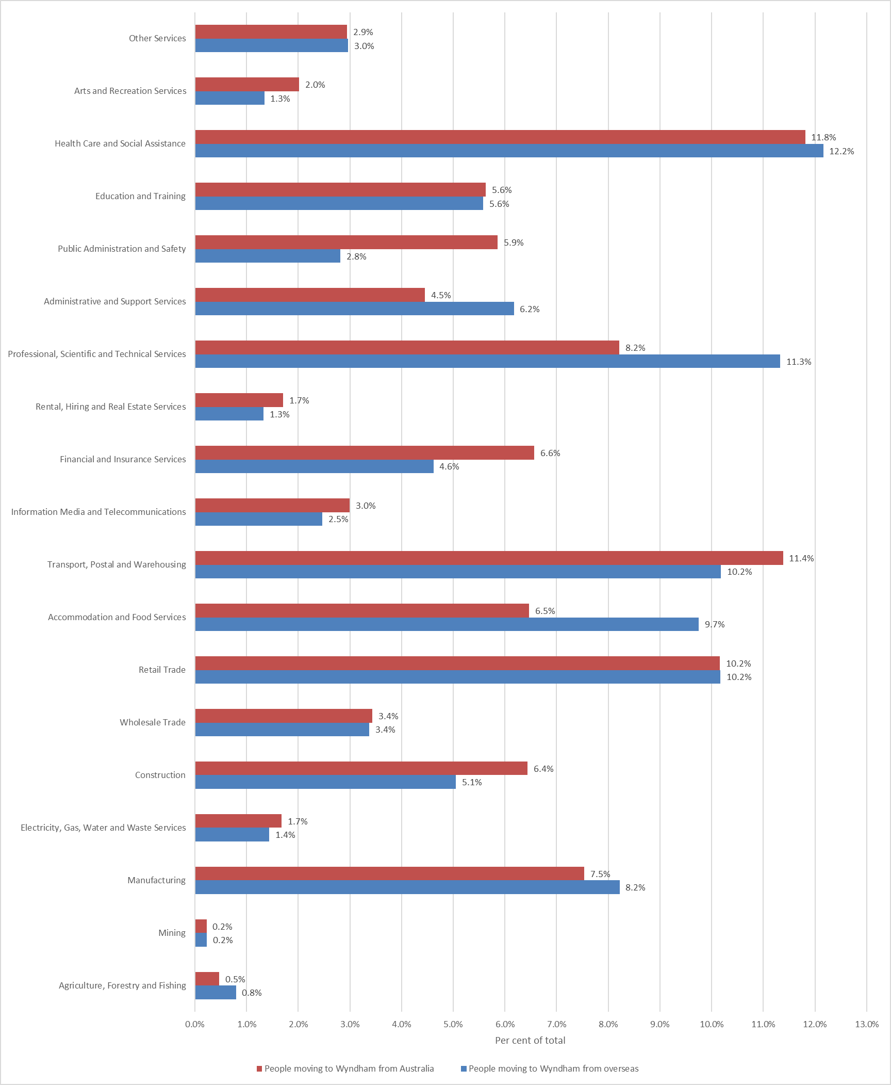
Migrants working in particular industries also exhibit preferences to reside in particular suburbs. The most common industries of working residents in Point Cook and Williams Landing are Professional Services, Health Care, and Retail (Table 10). In many of the other suburbs, the Transport sector is one of the three most common industries. The patterns in Table 10 are consistent with educational attainment patterns observed in Table 8.
Table 10: Most common industries of employment of recent arrivals in Wyndham suburbs, 2011-2016
Hoppers Crossing | Little River | Point Cook | Tarneit | Truganina | Werribee | Werribee South | Williams Landing | Wyndham Vale
Health Care and Social Assistance | Construction | Professional, Scientific and Technical Services | Transport, Postal and Warehousing | Transport, Postal and Warehousing | Retail Trade | Construction | Professional, Scientific and Technical Services | Health Care and Social Assistance
Transport, Postal and Warehousing | Health Care and Social Assistance | Health Care and Social Assistance | Health Care and Social Assistance | Health Care and Social Assistance | Health Care and Social Assistance | Transport, Postal and Warehousing | Health Care and Social Assistance | Retail Trade
Retail Trade | Manufacturing | Retail Trade | Retail Trade | Retail Trade | Transport, Postal and Warehousing | Retail Trade | Retail Trade | Transport, Postal and Warehousing

Occupation
In all occupations, more residents have moved to Wyndham than away from Wyndham (Figure 15). The three industries with the highest net migration were Professionals, Machinery Operators and Drivers, and Labourers. While there were 4,419 Clerical and Administrative Workers who moved to Wyndham, around half that number also left Wyndham. A similar ratio exists among Professionals. As for Managers, net migration is about one third of all arrivals – while 3,261 Managers arrived in Wyndham, just over 2,000 left Wyndham over the same period.
Figure 15: Migration flow by occupation, Wyndham
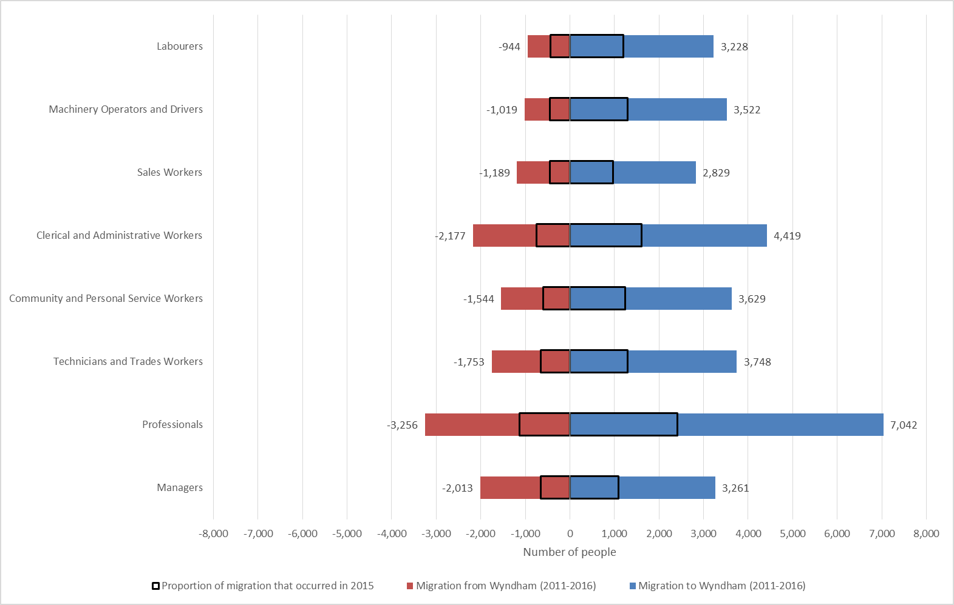
Figure 16 below shows for each occupation the proportion of total arrivals and departures. The figure points to the different characteristics of those who moved to Wyndham between 2011 and 2016 and those who moved away in the same period. A higher proportion of Managers, Professionals, Clerical and Administrative Workers and Technicians and Trades Workers moved away from Wyndham. The gap is particularly large when it comes to Managers. Machinery Operators and Drivers as well as Labourers are the occupations where proportionally more arrivals than departures took place.
Figure 16: Distribution of occupation by arrivals and departures, Wyndham, 2011-2016
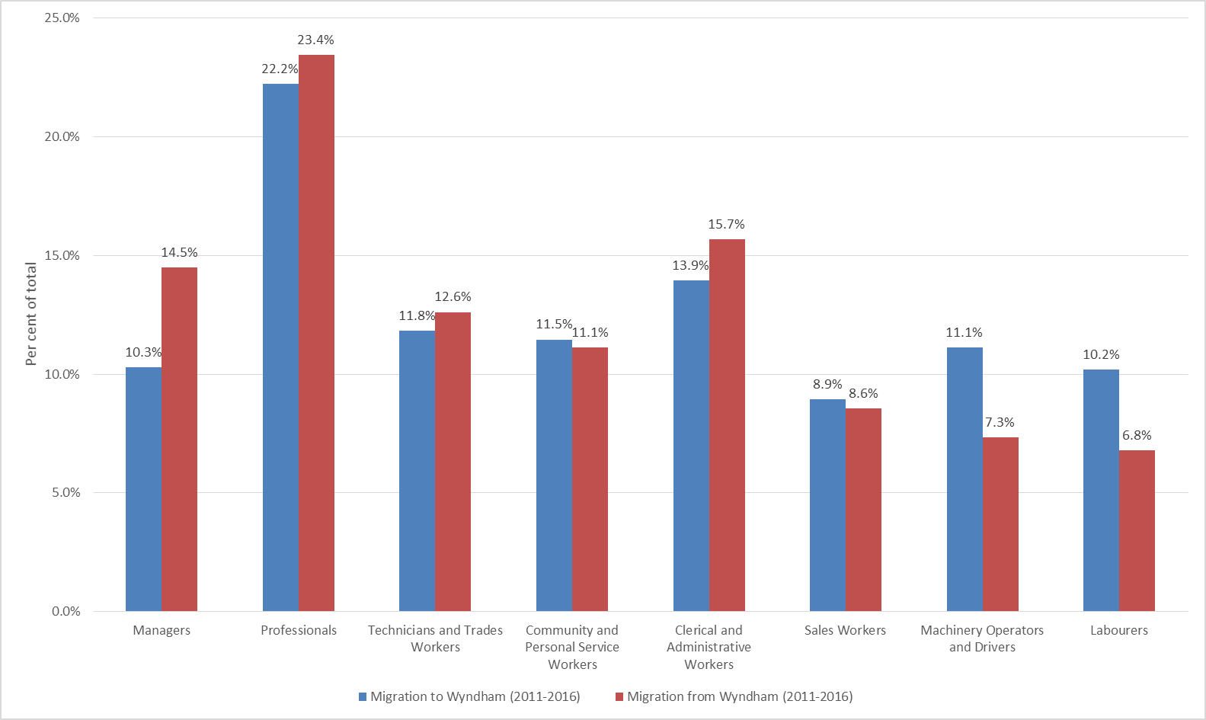
The key differences between those who arrive in Wyndham from overseas and those who arrive from other places in Australia is that a larger proportion of those who arrived from overseas work as Professionals and Labourers. Residents who arrived from another place in Australia are more likely to work as Clerical and Administrative Workers, Managers and Technicians and Trades Workers.
Figure 17: Distribution of occupation by arrivals from overseas and from elsewhere in Australia, Wyndham, 2011-2016
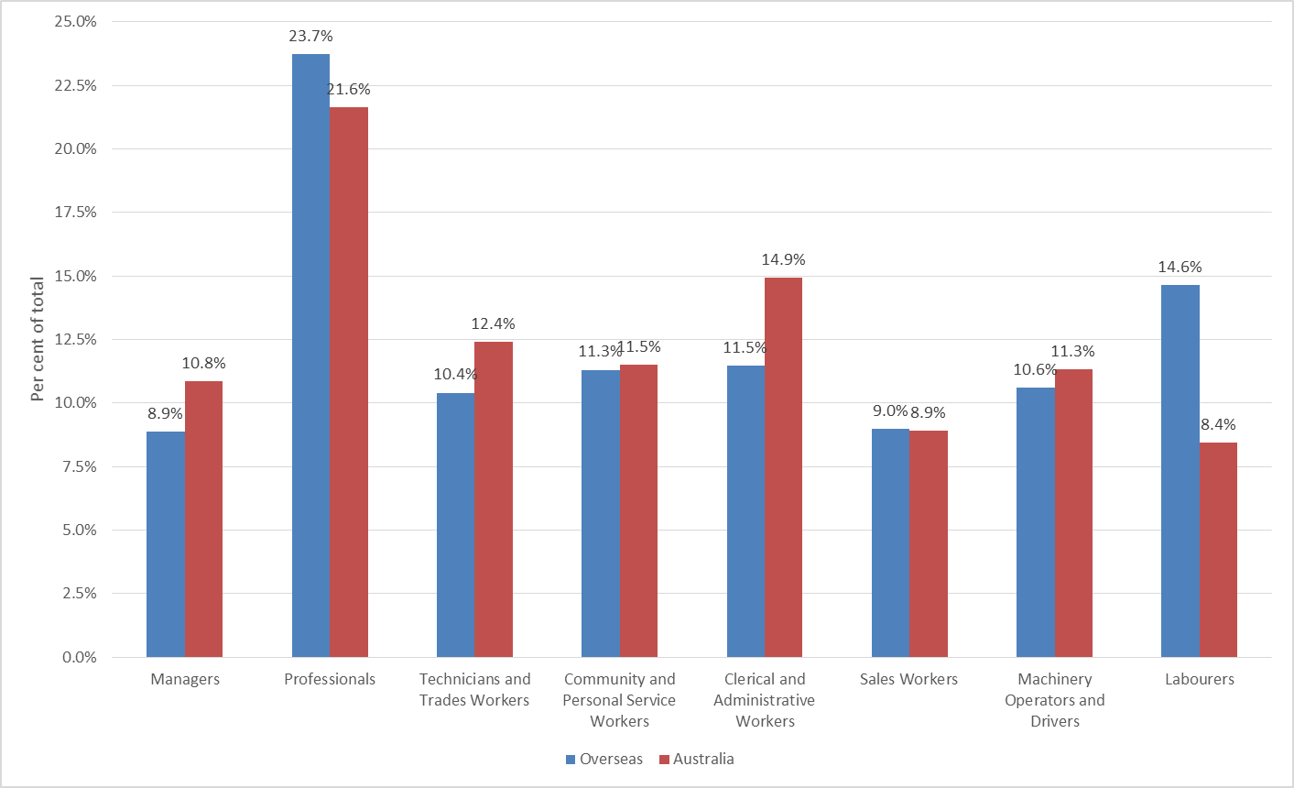
Managers and Professionals form a substantially larger proportion of those who left Wyndham for other municipalities in Victoria than those who arrived in Wyndham between 2011 and 2016. The only exception among the ten largest migration arrival and departure locations is the City of Melbourne. As indicated in the Housing profile, more than 80 per cent of housing in Melbourne consists of apartments. The movement of residents with Manager and Professional occupations from Melbourne to Wyndham is possibly in part driven by housing affordability, and in part by Melbourne residents having to move elsewhere if they do not want to live in an apartment. Migration of residents in these same occupations from Wyndham to other municipalities as Figure 18 indicates is likely driven by lifestyle choices.
Figure 18: Proportion of the population that are managers and professionals over all arrivals and departures in cities with large migration flows with Wyndham, 2011-2016
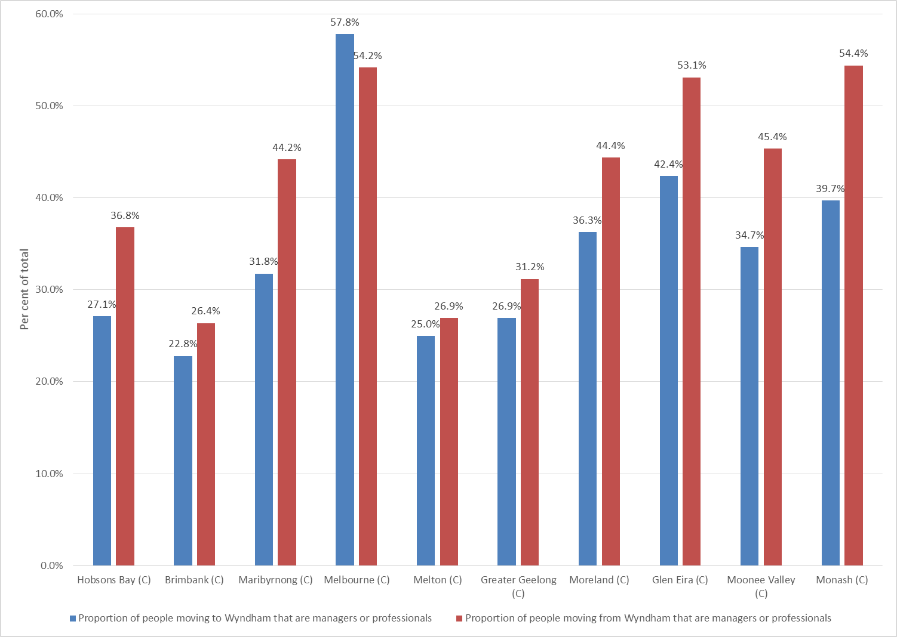
In all suburbs except Hoppers Crossing and Little River the largest occupation of recent arrivals is Professionals. In Hoppers Crossing and Little River it is Technicians and Trades Workers. Note also that Point Cook and Williams Landing are the only suburbs where Managers are among the top three most common occupations of recent arrivals. In neither of these suburbs, as well as in Wyndham Vale, are there any blue-collar occupations in the top three.
Table 11: Most common occupations of recent arrivals in Wyndham suburbs, 2011-2016
Hoppers Crossing | Little River | Point Cook | Tarneit | Truganina | Werribee | Werribee South | Williams Landing | Wyndham Vale
Technicians and Trades Workers | Technicians and Trades Workers | Professionals | Professionals | Professionals | Professionals | Professionals | Professionals | Professionals
Professionals | Clerical and Administrative Workers | Managers | Machinery Operators and Drivers | Clerical and Administrative Workers | Technicians and Trades Workers | Technicians and Trades Workers | Clerical and Administrative Workers | Clerical and Administrative Workers
Machinery Operators and Drivers | Professionals | Clerical and Administrative Workers | Clerical and Administrative Workers | Machinery Operators and Drivers | Clerical and Administrative Workers | Managers | Managers | Community and Personal Service Workers

Income
Differences in industries and occupations as identified above have ramifications for income levels among the migrant population. Table 12 below highlights the median incomes (among those who had a positive income) and the proportion of residents with negative or nil income for the 2011-2016 and 2015-2016 periods. Key highlights are:
- Residents who moved away had a higher median income than those who arrived in Wyndham ($955 per week compared with $868 per week).
- Residents who moved to Wyndham from overseas had a lower median income than those who arrived from elsewhere in Australia ($749 per week compared with $915 per week).
- A larger proportion of residents who have moved to Wyndham had negative or nil income compared with those who moved away (18.1 per cent compared with 9.2 per cent).
- Almost one third of residents who moved to Wyndham had negative or nil income (31.4%) compared with just over a tenth of those who arrived here from elsewhere in Australia (10.7%).
- Over the one-year period of 2015-2016, median incomes were lower on all accounts, and the proportion of residents with negative or nil income was higher.
Table 12: Income level details for recent arrivals, Wyndham
 | 2011-2016 period |  | 2015-2016 period
 | Median income | Proportion of residents with negative or nil income | Median income | Proportion of residents with negative or nil income
Residents who moved to Wyndham | $868 per week ($45,125 per year) | 18.1% | $831 per week ($43,223 per year) | 24.9%
Residents who moved away from Wyndham | $955 per week ($49,666 per year) | 9.2% | $873 per week ($45,372 per year) | 11.8%
Residents who moved to Wyndham from overseas | $749 per week ($38,927 per year) | 31.4% | $617 per week ($32,077 per year) | 51.5%
Residents who moved to Wyndham from within Australia | $915 per week ($47,590 per year) | 10.7% | $869 per week ($45,164 per year) | 14.3%

Figures 19 and 20 below detail the income distributions for migrant groups described in Table 12 for the 2011-2016 period. The distribution of those who arrived in Wyndham and those who left (Figure 19) indicates that in all income categories above the $1,000-$1,249 bracket the proportion of those who left is higher than the proportion of those who arrived. For most income groups from $1,000-$1,249 and below the opposite is true.
The higher median income levels for local arrivals compared to overseas arrivals does not arise from a particularly high difference in high income levels as Table 12 identifies. Rather, those who arrived from elsewhere in Australia have substantially higher proportions of residents in middle income groups, i.e. those between $800 and $1499 (37.1 per cent versus 28 per cent). More than half of residents who arrived from overseas have income levels below $800 (53.5%) compared with those who arrived from elsewhere in Australia (42.1%).
Figure 19: Distribution of income levels by arrivals and departures, Wyndham, 2011-2016
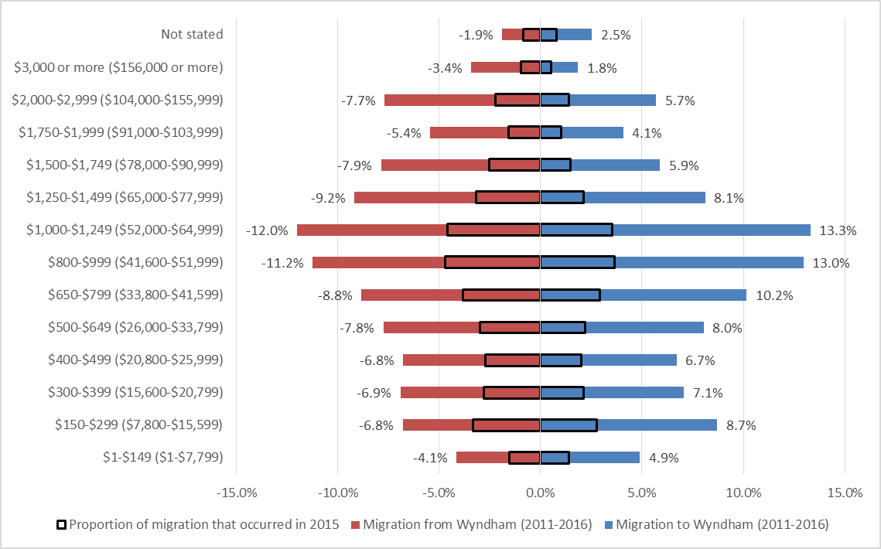
Figure 20: Distribution of income levels by arrivals from overseas and from elsewhere in Australia, Wyndham, 2011-2016
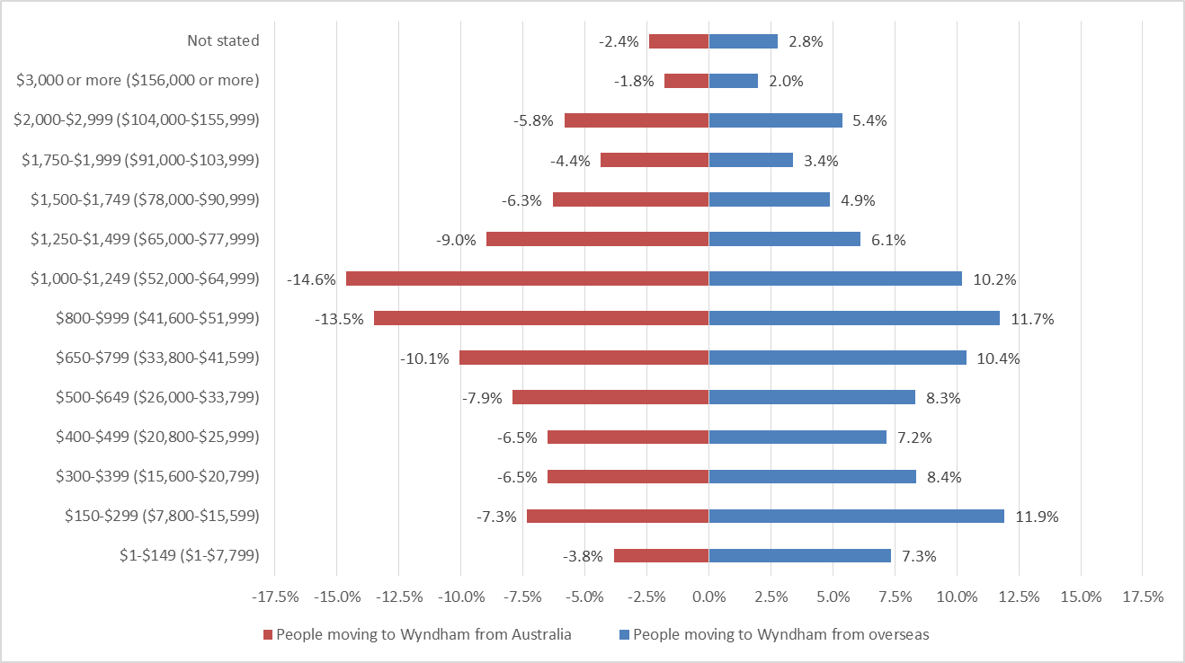
To identify whether there are patterns among those who have high and low incomes in relation to moving to and from other Victorian municipalities, Figures 21 and 22 show the proportion of residents who moved to and from the ten largest migration destinations and origins that have high (Figure 21) and low incomes (Figure 22). In determining high and low income levels, the ABS metric of high income being the top 20 per cent of earners and low income being the bottom 3 to 18 per cent of earners applies. Applied to Wyndham, those who have high personal weekly income have an income of $1,250 or higher. Those with low income levels have weekly incomes between $150 and $399.
In relation to all the ten largest municipalities, when it comes to migration patterns, all except Glen Eira and Melbourne receive proportionally more high income earners from Wyndham than they send. The difference between the proportion of those with high income levels who are leaving compared with those who are coming are highest in Greater Geelong, Hobsons Bay and Moreland. Looking at low income earners (Figure 22), most cities are proportionally larger origins for Wyndham residents than destinations. A higher proportion of low income earners move to Brimbank, Greater Geelong and Hume than arrive from these locations. Taken together, Wyndham is proportionally losing high income earners to neighbouring municipalities while gaining a proportionally high amount of low income earners. The move to Wyndham is likely largely motivated by housing affordability, while the move away from Wyndham is likely caused by wealth accumulation over time which in turn allows residents to move to municipalities for lifestyle reasons.
Figure 21: Proportion of the population that have high personal income over all arrivals and departures in cities with large migration flows with Wyndham, 2011-2016
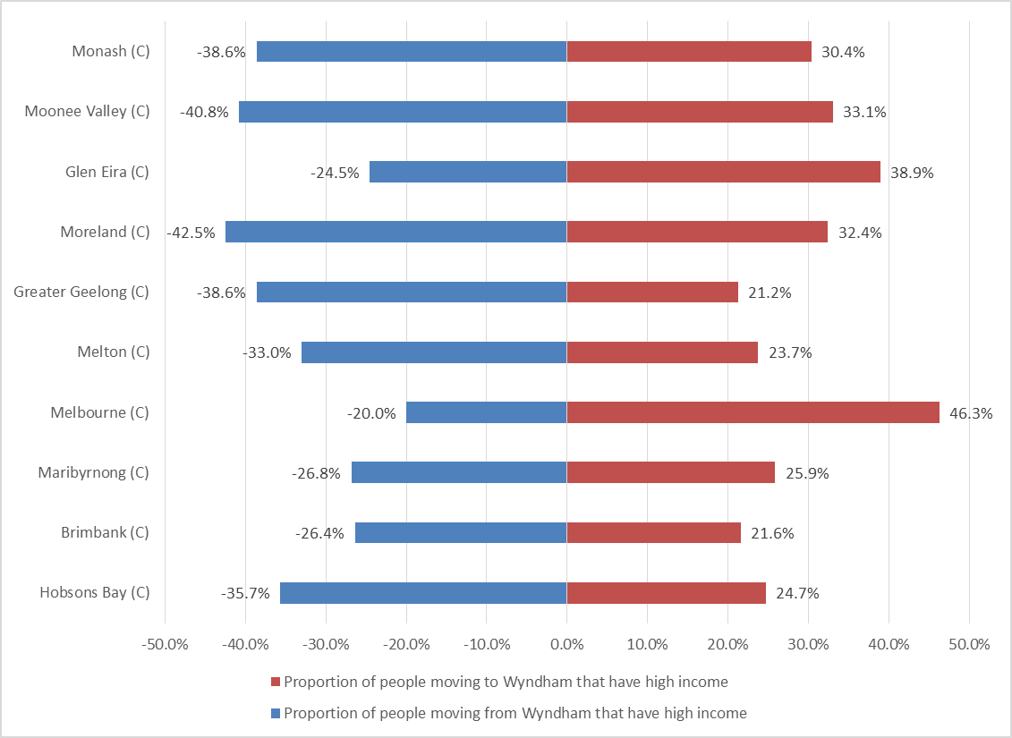
Figure 22: Proportion of the population that have low personal income over all arrivals and departures in cities with large migration flows with Wyndham, 2011-2016
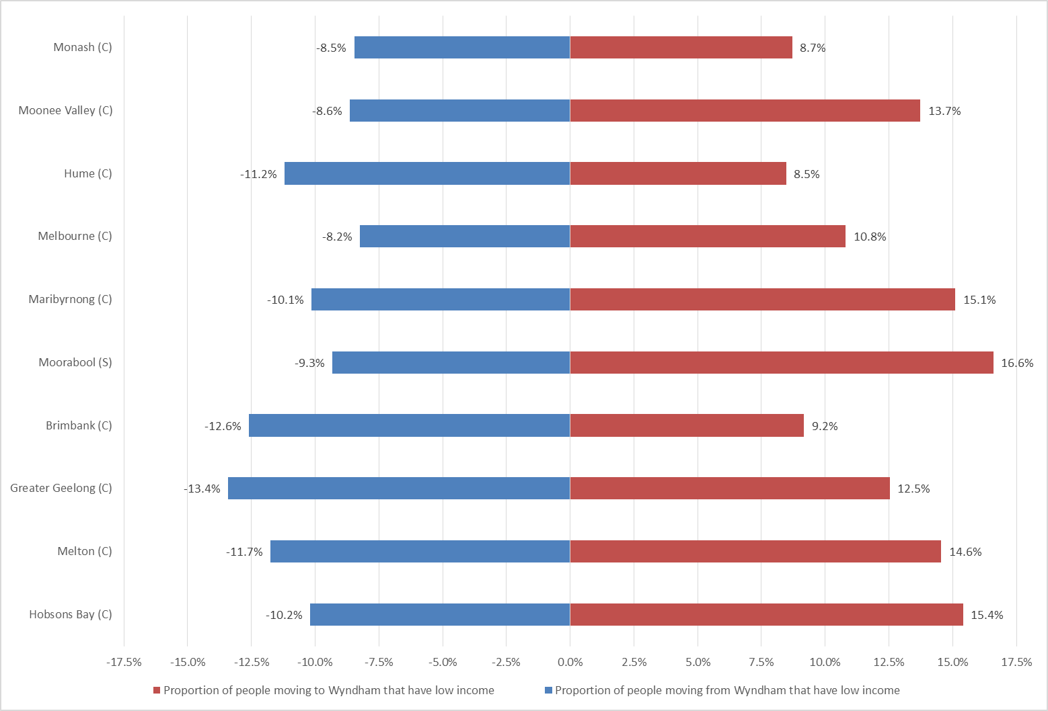
In alignment with education, industry and occupation, some suburbs attract recent arrivals with higher income levels. Table 13 shows that residents in Williams Landing and Point Cook have the highest median income levels among recent arrivals, while Hoppers Crossing and Werribee have the lowest median income levels.
Table 13: Income level details for recent arrivals by suburb, Wyndham, 2011-2016
 | Hoppers Crossing | Little River | Point Cook | Tarneit | Truganina | Werribee | Werribee South | Williams Landing | Wyndham Vale
Proportion those who arrived and have nil or negative income | 17.1% | 9.2% | 17.7% | 18.5% | 17.5% | 12.6% | 12.9% | 18.1% | 14.2%
Median income among those who arrived | $750 per week  ($39,000 per year) | $825 per week  ($42,894 per year) | $1,017 per week ($52,901 per year) | $859 per week  ($44,644 per year) | $895 per week  ($46,529 per year) | $744 per week  ($38,712 per year) | $888 per week  ($46,188 per year) | $1,042 per week  ($54,174 per year) | $836 per week  ($43,459 per year)

Visas
The department of Social Services (DSS) developed the Settlement Reporting Facility (SRF) which uses the Settlement Database to provide statistical data on permanent settles to Australia since 1991. The SFR brings together data from various sources such Medicare and the Department of Immigration and Border Protection. The data presented is downloaded to the SFR in the first week of each month, so the information is continuing to be updated. However, because of 2012 changes to some skilled visas subclasses, these visas are not being categorised correctly and consequently a large proportion of data is ‘unknown’. Furthermore, some of the data collected is voluntary again leaving a lot of missing data. Other limitations to the data include no adjustment for those who have permanently departed Australia or deceased.
In the past 12 months, it is estimated that just over 4,700 Wyndham residents were granted a visa, the most common of these being family visas. An approximately even split of visa recipients were male (2,281) and female (2,429). English proficiency was the poorest amongst Humanitarian visa holders, of which 347 of a total 381 spoke poor or no English. Skilled visa holders were most likely to speak Punjabi or English as their preferred language, while Arabic and Karen were the most common languages spoken amongst humanitarian visa holders. Tertiary qualifications were highest amongst Skilled visa holders.

All data comes from the ABS Census of Population and Housing (2016) unless otherwise stated.
The patterns present in the country of birth flows are highly similar to the patterns observed in the language spoken at home and ancestry variables. These two variables are therefore not discussed in this profile.

