Older Adults Profile

65+ years

Contents
Executive Summary 2
Population 3
Forecast 3
Indigenous Status 0
Country of Birth 0
Language spoken at home 0
English Proficiency 1
Religion 2
Education 2
High School 2
Higher Education 3
Employment 3
Volunteering 4
Assistance with Core Activities 5
References 5

Executive Summary
Wyndham has a relatively young population. Less than 10% are over 65 years of age, compared to around 14% of the population of Greater Melbourne.
The over 65s population in Wyndham is, like all other age groups, growing at a rapid rate. Between 2016 and 2041, the population is forecast to grow by 260%, from 17,333 people to 62,428.
Indigenous residents account for less than 1% of the total over 65s age group living in Wyndham.
In 2016, less than half of older adults in Wyndham and across Greater Melbourne were born in Australia (42% and 45% respectively).
Older adults in Wyndham and Greater Melbourne share a similar language profile, where Italian, Maltese, Mandarin, and Greek are in the top 5 most commonly spoken languages other than English.
In Wyndham and Greater Melbourne, around 20% of older adults are dual or multilingual, and can speak English very well or well.
Unlike the entire population of Wyndham, there are high rates of religious affiliation amongst older adults. In 2016, 76% of people were affiliated with a religion; 70% of all people 65+ years were affiliated with a Christian religion.
Just over a quarter of Wyndham residents over 65 years of age have completed year 12 or equivalent, compared to nearly 32% of older adults across Greater Melbourne.
13% of Greater Melbourne older adults have achieved a bachelor degree or higher. This is higher than the Wyndham proportion of 8%.
Just over 11% of Wyndham older adults are still engaged in the workforce; 5% in full time positions.
In 2016, almost 12% of Wyndham older adults volunteered compared to nearly 16% across Greater Melbourne.
Compared to Greater Melbourne there are a slightly larger proportion of older adults in Wyndham who require assistance with core activities and a lower proportion providing unpaid assistance.

Population
In 2016, nearly 8% of the population of Wyndham was aged 65 years and over, equating to around 16,346 residents. The proportion of over 65s across Greater Melbourne (14%) is almost double that observed in Wyndham.
The number of older adults in Wyndham has been growing steadily. Interestingly, the proportion they contribute to the total overall population of Wyndham hasn’t changed significantly over time. This highlights how over the past 10 years, the population of Wyndham has remained relatively young.
Figure 1: Total Population Aged 65 Years and Over, Wyndham and Greater Melbourne 2016

Forecast
Figure 2: Forecast Population, Wyndham, 2016 to 2036

The over 65s population in Wyndham is, like all other age groups, growing at a rapid rate. Between 2016 and 2041, the population is forecast to grow by 260%, from 17,333 people to 62,428.
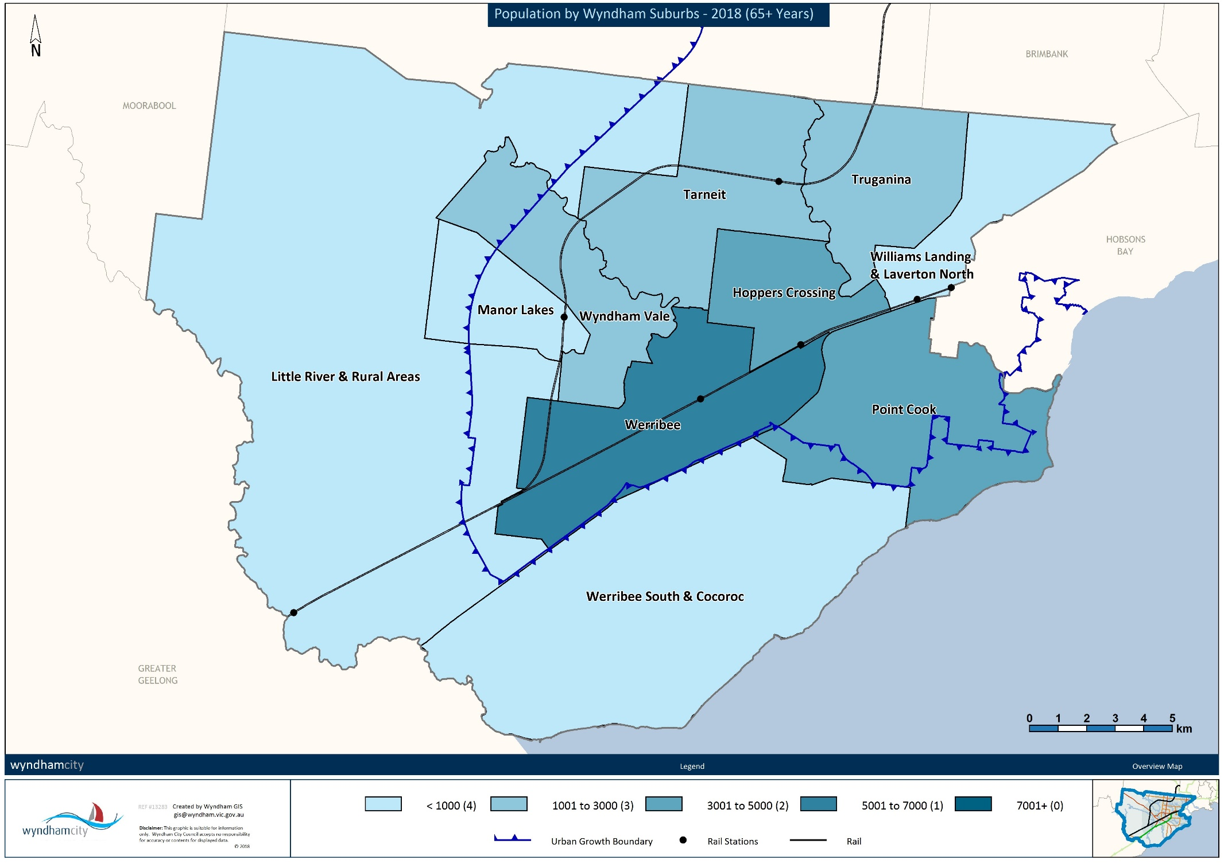
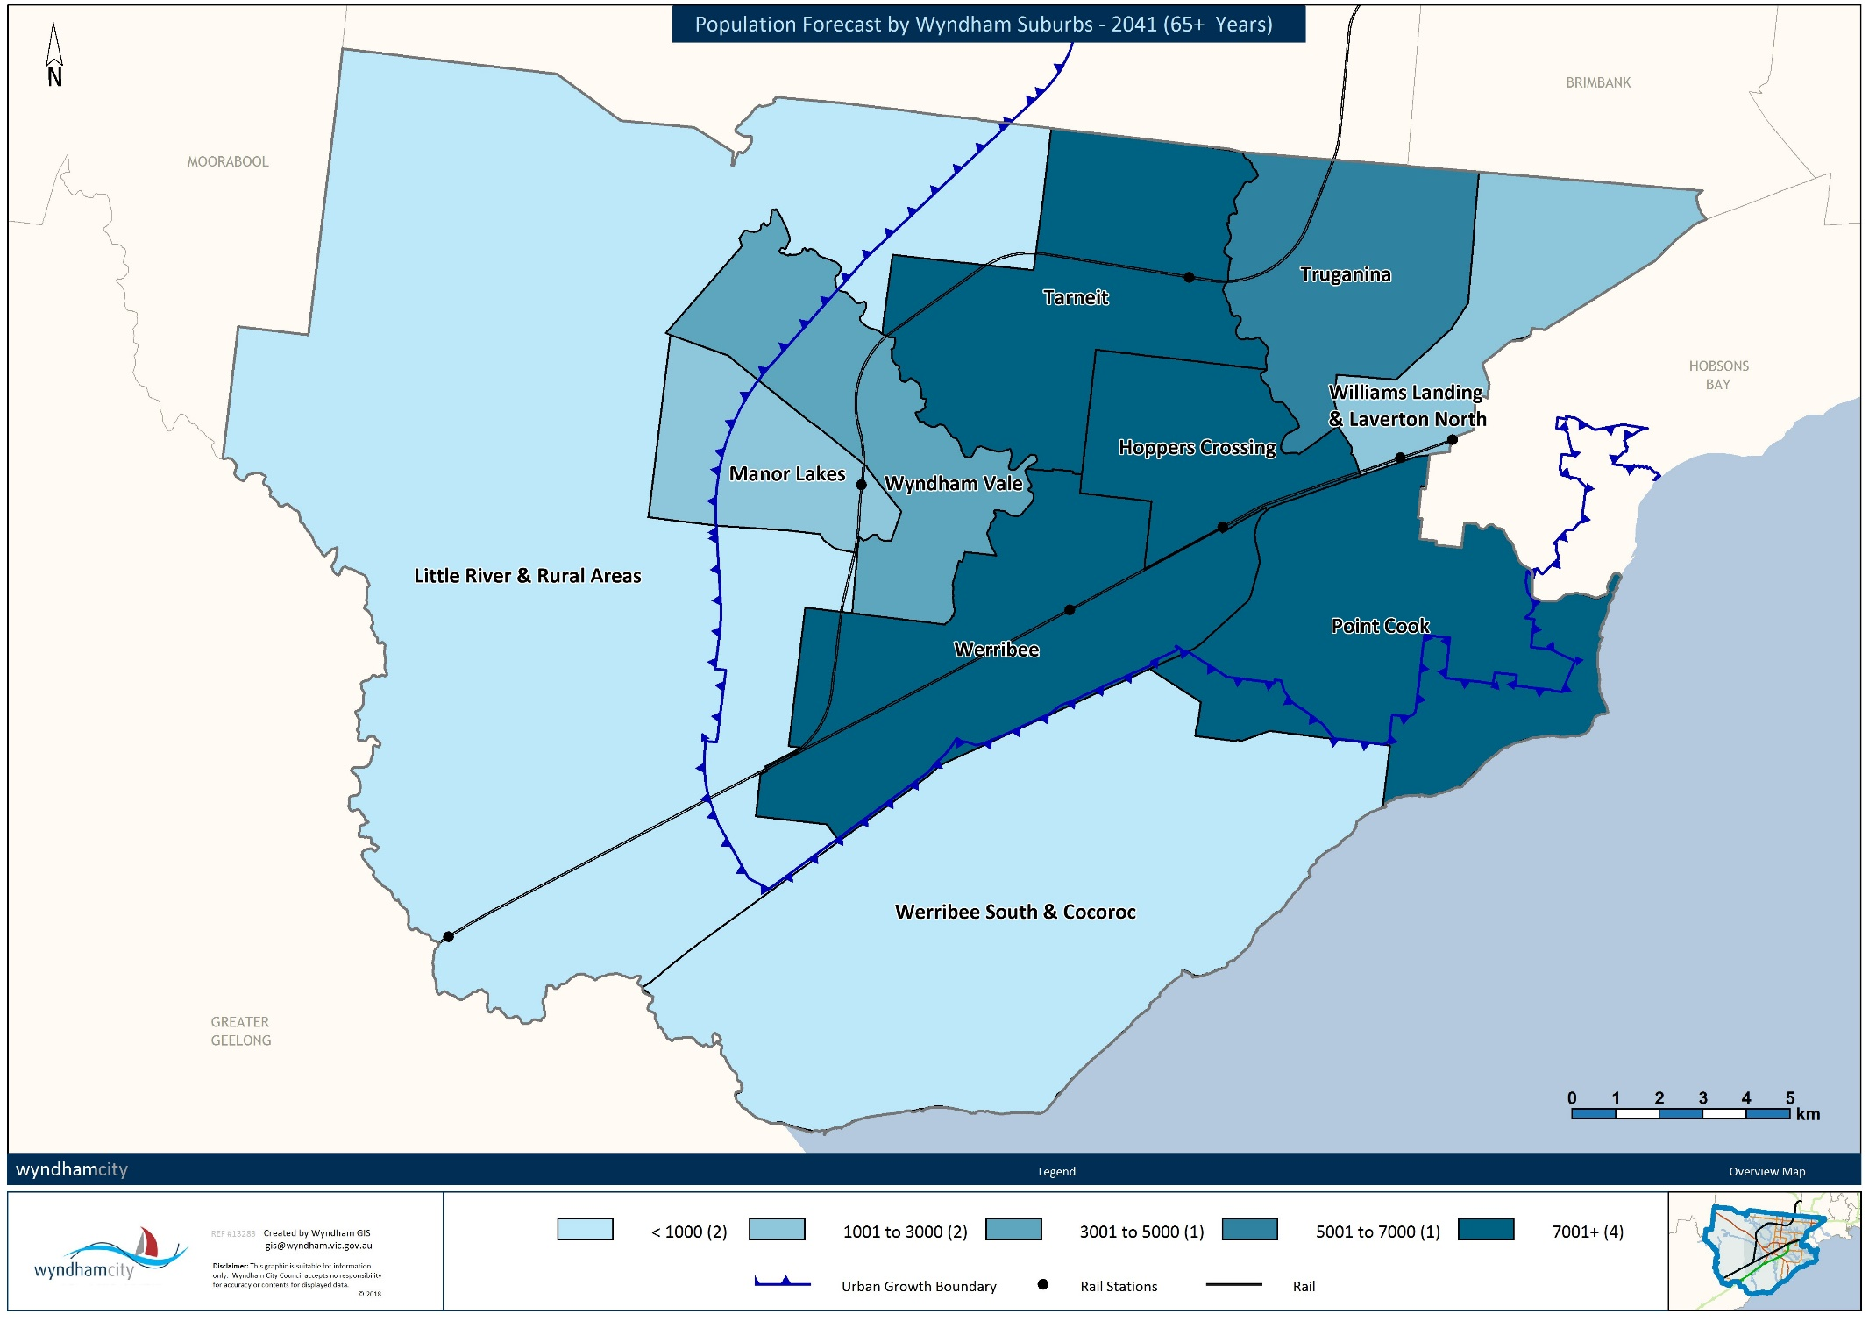

Indigenous Status
There is a very small population of Indigenous residents aged 65 years and over living in Wyndham. At the 2016 Census, there were 38 Aboriginal people and 3 Torres Strait Islander residents. In total, Indigenous residents account for less than 1% of the total over 65 age group living in Wyndham, and 2.4% of the total Indigenous population.

Country of Birth
Table 1: Country of Birth, Wyndham and Greater Melbourne, 2016
Wyndham |  |  | Greater Melbourne
Country |  | % | Country |  | %
Australia |  | 42.3% | Australia |  | 45.1%
1 | England | 7.6% | 1 | Italy | 6.8%
2 | Italy | 6.3% | 2 | England | 6.6%
3 | India | 3.3% | 3 | Greece | 4.8%
4 | Malta | 3.2% | 4 | China | 1.9%
5 | Scotland | 2.0% | 5 | Germany | 1.7%
In 2016, less than half of older adults in Wyndham and across Greater Melbourne were born in Australia (42% and 45% respectively). In Wyndham, England, Italy, India, Malta and Scotland were the most common countries of birth outside Australia. Across Greater Melbourne, Greece, China and Germany were in the top 5.

Language spoken at home
Table 2: Language Spoken at Home, Wyndham and Greater Melbourne, 2016
Wyndham |  |  | Greater Melbourne
English |  | 62.0% | English |  | 62.9%
1 | Italian | 6.5% | 1 | Italian | 6.7%
2 | Maltese | 2.4% | 2 | Greek | 5.4%
3 | Mandarin | 1.6% | 3 | Cantonese | 1.6%
4 | Spanish | 1.4% | 4 | Mandarin | 1.5%
5 | Greek | 1.4% | 5 | Maltese | 1.2%

There are similar proportions of English-only speakers in Wyndham and Greater Melbourne (62% and 63% respectively). Interestingly, the language profiles differ slightly to the country of birth. In Wyndham, Greek is in the top 5 most commonly spoken languages other than English, despite not making the top 5 most common countries of birth. A similar pattern has occurred across Greater Melbourne where there were a large number of German born residents, but a small proportion of German speakers. Instead Maltese is a more commonly spoken language. Some cultural groups may be more protective of their culture and language and continue to cultivate them outside their country of birth.

English Proficiency
Figure 3: English Speaking Proficiency, Wyndham and Greater Melbourne, 2016
English speaking proficiency is relatively high amongst multilingual speakers in Wyndham and across Greater Melbourne. In Wyndham, around 20% of older adults are dual or multilingual, and can speak English very well or well. Almost 8% cannot speak English well and 3% cannot speak any English. A similar trend is observed across Greater Melbourne.

Religion
Figure 4: Religious Affiliation, Wyndham and Greater Melbourne, 2016
Unlike the entire population of Wyndham, there are high rates of religious affiliation amongst older adults. In 2016, 76% of older adults were affiliated with a religion. Christian religions were the most popular with just over 70% of 65+ year olds affiliated with one of the many Christian denominations. A similar trend exists across Greater Melbourne.

Education

High School
Figure 5: Highest Year of School Completed, Wyndham and Greater Melbourne, 2016
Overall, education attainment is lower amongst Wyndham older adults compared to older adults across Greater Melbourne. Just over a quarter of Wyndham residents over 65 years of age have completed year 12 or equivalent, compared to nearly 32% in Greater Melbourne.

Higher Education
Figure 6: Qualifications, Wyndham and Greater Melbourne, 2011
A greater proportion of older adults across Greater Melbourne have achieved a higher education qualification compared to older adults in Wyndham (34% and 28% respectively). Around 13% of Greater Melbourne older adults have a bachelor degree or higher compared to 8% of older adults from Wyndham. Certificate level qualifications were more common amongst Wyndham over 65s compared to those across Greater Melbourne (15% and 13% respectively).

Employment
Figure 7: Employment Status, Wyndham, 2011
Just over 11% of Wyndham older adults are still engaged in the workforce; 5% in full time positions. Not surprisingly, the majority of adults of retirement age (65+ years) are not in the labour force (80%).

Figure 8: Total Personal Weekly Income, Wyndham and Greater Melbourne, 2016

Older adults across Greater Melbourne are earning more each week compared to those in Wyndham. A third of Greater Melbourne older adults (33%) are receiving $500+ personal income per week compared to just over 26% of older adults Wyndham wide. Nearly 10% of Wyndham older adults have a negative or nil weekly income.

Volunteering
Figure 9: Volunteers, Wyndham and Greater Melbourne, 2016

In 2016, almost 12% of Wyndham older adults volunteered compared to nearly 16% across Greater Melbourne.

Assistance with Core Activities
Figure 10 & 11: Receiving and Providing Assistance with Core Activities, Wyndham and Greater Melbourne, 2016
Need for assistance with core activities | Provides unpaid assistance
Compared to Greater Melbourne there are a greater proportion of older adults who require assistance with core activities and a smaller proportion providing unpaid assistance.

References
Australian Bureau of Statistics, Census of Population and Housing (2016). Analysed by Wyndham City Council via TableBuilder
ID Consulting. (2016). Population Forecasts - Wyndham

